Course Title: CONVENTIONAL RADIOLOGICAL PROCEDURE & CLINICAL PRACTICE
MID TERM ASSIGNMENT

NAME: MAAZ ULLAH
ROLL# 14907
DEGREE: BS.RADIOLOGY (4th SEM)
DATE: 18th April, 2020
Q1: Explain the different positions used to take films for barium meal?
Positions Used To Take Film for Barium Meal
- Image for stomach:
For stomach image, the patient should be laid on the following positions.
- RAO (Right Anterior Oblique): To show the Antrum and Greater Curve.
- Supine: To demonstrate the Antrum and Body.
- LAO (Left Anterior Oblique): To show the lesser curve.
- Left Lateral Tiled: head up to 45 degree, in this condition the gas comes in the fundus part, which demonstrate the Fundus part.
- Image for Duodenal Loop:
For the demonstration of duodenum loop, the patient should be laid on the prone condition.
- Image for Duodenal Cap:
For Duodenum Cap the patient should be laid on the following conditions:
- Prone
- RAO (Right Anterior Oblique)
- Supine
- LAO (Left Anterior Oblique)

Q2: A patient came with complaint of difficulty in swallowing; which imaging procedure is best for its diagnosis and what are the standard protocols for this procedure?
Dysphagia (Difficulty in swallowing)
Diagnosis of Dysphagia be determine by the types of swallowing problem, we use a variety of tests to see the cause of swallowing problem. The following tests may include:
- X-ray with contrast Material:
This is Barium X-ray.
- Taking Barium Solution which shows changes in esophagus.
- Taking Swallow Solid Food or a pill coated with Barium, shows any blockages in esophagus.
- Dynamic Swallowing Study (Barium-coated Food):
This test shows the image of food going through the Throat, and determine the problems in mouth and throat muscle.
- Endoscopy:
An endoscopy is passed into the throat to see the esophagus clearly, and determine the inflammation, narrowing or tumor.
- FEES (Fiber-optic Endoscopic Evaluation of Swallowing):
In this test the throat is showing through camera and Endoscope.
- Manometry:
This small tube is connected to the pressure recorder, which measure the contraction of muscles of esophagus.
- Imaging Scans:
In this procedure we are doing CT-scan to show image of Bones and soft tissues, and MRI-Scan for image of organ and tissue.

Q3: Write the general classification of contrast agents used in conventional radiological procedures also explain each classification.
CONTRAST AGENTS:
A compound used to increase the visibility of the internal body structure in an image.
Classification of Contrast Media:
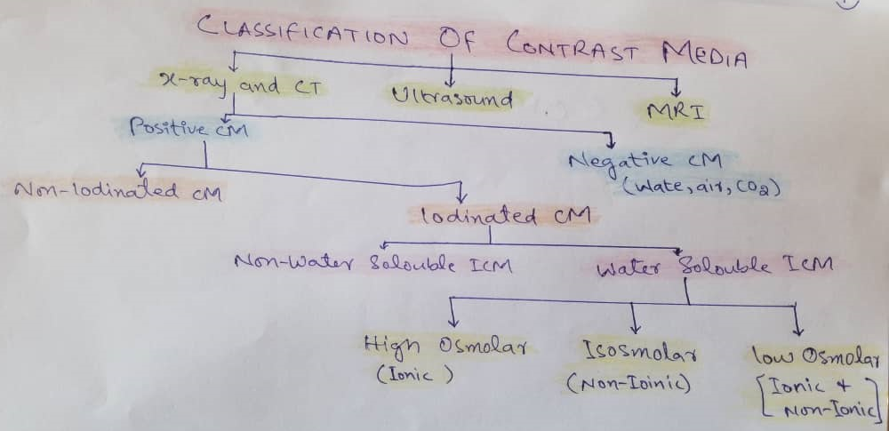
- Positive Contrast Media:
- Having high atomic number elements.
- Contrast material is more radiopaque to X-ray.
- White appearance on the film.
- E.g. Barium and iodine: Barium and iodine compounds can be injected into blood vessels.
- Barium Based: (BaSO4)
- Used for the examination of GI tract.
- Iodine Based:
- Used for:
- Angiography: For the visualization of blood vessels.
- Intravenous and Retrograde Urography: For the detail image of Ureters and Kidney.
- Hysterosalpingography: For the examination of shape and potency of Uterus and Fallopian Tube.
- Sialography: For the Examination of Salivary Tract.
- Myelography: For the examination of Spinal Cord.
- Cholangiography: For the examination of Bile Ducts.

- Negative Contrast Media:
- They are Radiolucent.
- Having low atomic number.
- Black or Dark appearance on film.
- X-ray penetrate easily.
- E.g. Air, Water and Carbon-dioxide (CO2)

- High Osmolality Contrast Media (HOCM):
- Having seven times the osmolality of plasma.
- Most of them are ionic.
- Low Osmolality Contrast Media (LOCM):
- Having two times the osmolality of blood.
- Less Nephrotoxic.
- Non-separating.
- They may be ionic and non-ionic.
- Isosmolar Contrast Media:
- Having same osmolality as plasma and blood.
- They are Non-ionic.

