Name. Saifullah Khan
ID . 14068
Dept. . Radiology

Q NO1: What is dental OPG? Describe the positioning and patient positioning technique in detail?
Answer;
OPG dental x-ray…
An OPG is a panoramic or wide view x-ray of the lower face, which displays all the teeth of the upper and lower jaw on a single film. It demonstrates the number, position and growth of all the teeth including those that have not yet surfaced or erupted.
*Position of Patient and Image Receptor
1) Any bulky clothing and radio-opaque objects, such as jewellery,
dentures or hearing aids should be removed from the imaged area.
2)The equipment is brought to the start position and careful
explanation is given to the patient.
3) A 15 30 cm image receptor is used on many machines; however,
Direct Radiography (DR) technology may be utilized on newer
equipment.
4) The patient walks into the machine, holding the handles and
adopting a ‘skiing’ position.
5) The head is tilted downwards until the Frankfort plane is parallel
with the floor and the machine height adjusted to allow the patient
to bite into the bite block, with upper and lower incisors within
the grooves. The chin should be placed on the rest.
6)Ensure the patient is not rotated by ensuring the sagittal plane light
runs down the middle of the face. Close the head restraints.
7) The patient is asked to place their tongue on the roof of their
mouth to reduce the air shadow and is asked to keep still for
20 seconds.
8)The exposure is taken. Observe the patent carefully.

*Direction and Centering of X-ray Beam
1)The anterior-posterior light should be centered distally to the upper
lateral incisor. This allows optimal positioning of the ‘focal trough’
the zone of focus outside of which the anatomical detail becomes
blurred.
*Essential Image Characteristics
1)Correct anatomical coverage, which should include the entire
mandible and tempura-mandibular joints.
2) There should be good contrast and density between the enamel
and dentine. The anatomical detail should be clearly defined with
optimal resolution if the focal trough has been carefully placed in
position.
3) Edge-to-edge incisors.
4)No removable metallic foreign bodies.
5) No evidence of movement unsharpness.
6) No evidence of positioning errors, including rotation and errors
within the occlusal plane (both external edges of the rami should
be parallel to each other).
7)The spinal shadow should be minimized.
8)The air shadow at the roof of the mouth should be minimized if
the tongue was placed correctly.

*Additional Considerations
1) Problems can occur with producing an optimal image with this
technique, due to a number of factors, including patient movement
and positioning errors.
2) It is essential that the patient is able to co-operate and stay still for
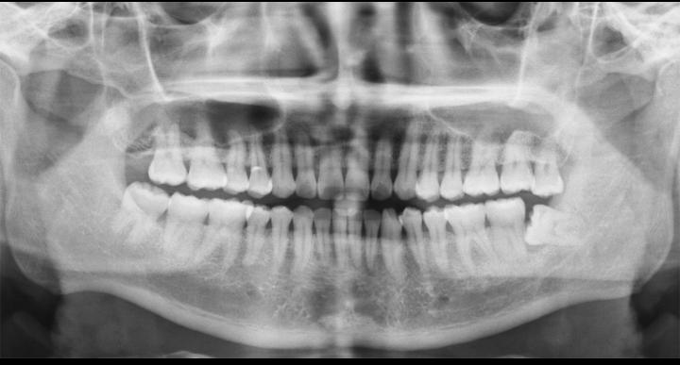
up to 20 seconds for a successful examination to take place.

QNO2: How will you scan a patient with lower back pain .write a basic view for lumber X-rays?
Answer;
The are two basic view for lumber
- Antero posterior
- Lateral

Antero posterior.

*Position of Patient and Image Receptor
1) The patient lies supine on the Bucky table, with the median sagittal
plane coincident with, and at right-angles to, the midline of the
table and Bucky.
2) The anterior superior iliac spines should be equidistant from the
tabletop.
3) The hips and knees are flexed and the feet are placed with their
plantar aspect on the tabletop to reduce the lumbar arch and bring
the lumbar region of the vertebral column parallel with the image
receptor.
4) The image receptor should be large enough to include the lower
thoracic vertebrae and the sacro-iliac joints and is centered at the
level of the lower costal margin.
5) The exposure should be made on arrested expiration allowing the
diaphragm to move superiorly. The air within the lungs would
otherwise cause a large difference in density and poor contrast
between the upper and lower lumbar vertebrae.
*Direction and Centering of X-ray Beam
1) Direct the central ray towards the midline at the level of the lower
costal margin (L3).
*Essential Image Characteristics
1)The image should include from T12 down to the bottom of the
sacro-iliac joints.
2)Rotation can be assessed by ensuring that the sacro-iliac joints are
equidistant from the spine.
3) The exposure used should produce a density such that bony detail
can be discerned throughout the region of interest.
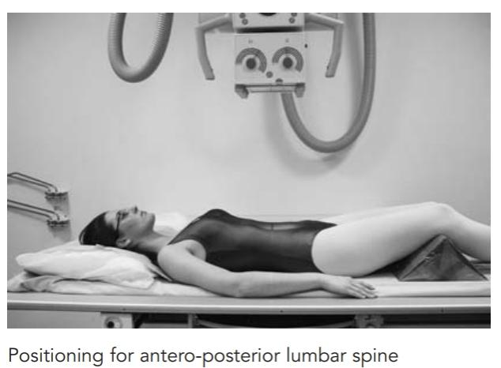
- Lateral view for lumber basic
*Position of Patient and Image Receptor
1) The patient lies on their side on the Bucky table. If there is any
degree of scoliosis, then the most appropriate lateral position will
be such that the concavity of the curve is towards the X-ray tube.
2)The arms should be raised and resting on the pillow in front of the
patient’s head. The knees and hips are flexed for stability.
3) The coronal plane running through the center of the spine should
coincide with, and be perpendicular to, the midline of the Bucky.
4)The image receptor is centred at the level of the lower costal
margin.
The exposure should be made on arrested expiration.
5)This projection can also be undertaken erect with the patient
standing or sitting.
*Direction and Centering of X-ray Beam
1) Direct the central ray at right-angles to the line of spinous
processes and towards a point 7.5 cm anterior to the third lumbar
spinous process at the level of the lower costal margin.

*Essential Image Characteristics
1)The image should include T12 downwards, to include the lumbar
sacral junction.
2) Ideally, the projection will produce a clear view through the center
of the intervertebral disc spaces, with individual vertebral endplates
superimposed.
3) The cortices at the posterior and anterior margins of the vertebral
body should also be superimposed.
4) The imaging factors selected must produce an image density
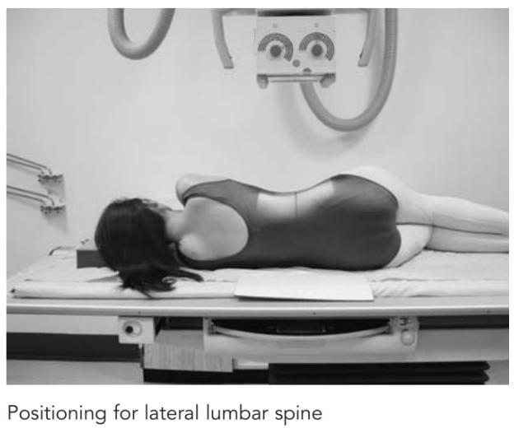
5)sufficient for diagnosis from T12 to L5/S1, including the spinous processes.

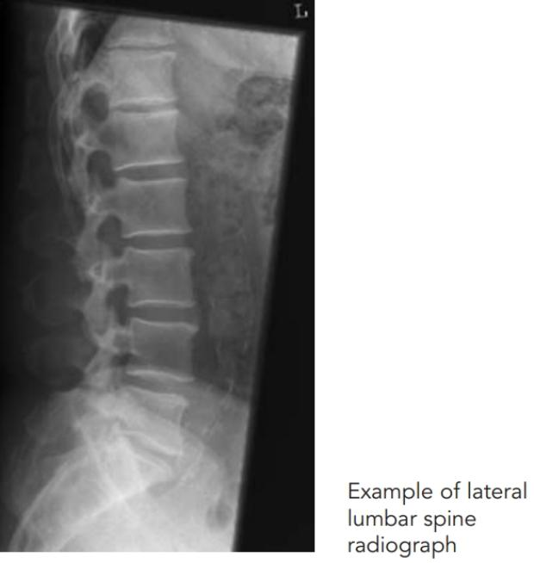

QNO.3: A patient fell from the bike after being hit by a car, has now complained of headache, what are the x-rays prescribed for a skull.
Answer;
Generally speaking, most doctors are likely to order at least an X-ray to check for any hidden fractures or other damage. X-rays are relatively inexpensive and can convey a lot of information very quickly to your doctor. You can think of X-rays as a good place to start. An X-ray can help rule out things such as broken bones, dislocated joints, bone fragments, and some other internal injuries.
For a more in-depth look however, the doctor is likely to order more advanced imaging procedures, such as a CT (computed tomography), or MRI (magnetic resonance imaging) which can detect herniated discs, torn tendons, muscle tears, cartilage damage, organ injuries, and more detailed soft tissue damages that do not show up as well on an X-ray. Your doctor can also advise you about any warning signs and symptoms that you need to be on the lookout for.
Here is a list of symptoms to be aware of and report to your doctor following a bike accident:
- Headache
- Clouded thinking
- Nausea
- Blurry vision
- Fatigue, or sleeping more or less than usual
- Dizziness
- Pain and stiffness
- Neck and back pain
- Numbness
- Swelling and or bruising
- Abdominal pain or swelling
- Any other worrisome symptom that causes you concern
*For more deep investigation
Use
1) CT SCAN
2) MRI

THE END

