DPT 2nd Semester (section A)

Course Title: Biomechanics-I Instructor: Ahmed Hayat
Assignment for VIVA

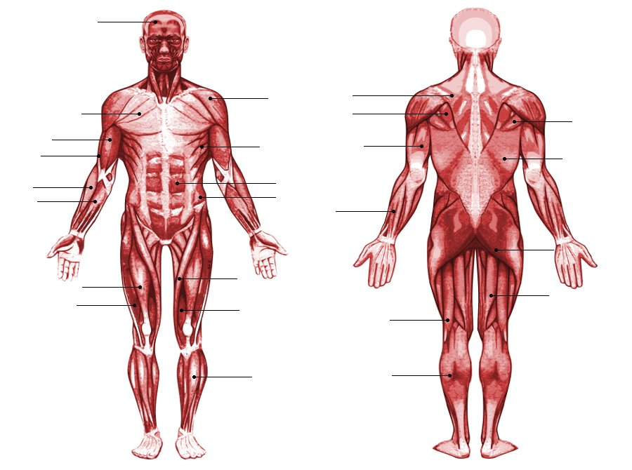
LABEL ANY 15 MUSCLES IN THE PICTURE.
Extensor Digitorum
Latissimus Dorsi
Teres Major
Serratus Anterior
Deltoid
Brachialis
Pectoralis Major
Frontalis
Semitendinosus
Gluteus Maximus
Tibalis Anterior
Vastus Medialis
Sartorius
Vastus Lateralis
Rectus Femoris

re

[Type a quote from the document or the summary of an interesting point. You can position the text box anywhere in the document. Use the Text Box Tools tab to change the formatting of the pull quote text box.]

