ANS NO 1
Part A: How do we improve soil through excavation and replacement? How and which property of soil are modified through additives, name a few additives with their function.

Techniques of Soil Improvement
There are various techniques used for the improvement of the soil based on the construction activity and type of soil. The soil improvement techniques are,
- Surface Compaction
- Drainage Methods
- Vibration Methods
- Recompression and consolidation
- Grouting and Injection
- Chemical Stabilization
- Soil Reinforcement
- Geo textiles and Geo membranes
- Other Methods

1. Surface Compaction
One of the oldest methods of soil densification is surface compaction. Construction of a new road, a runway, an embankment or any soft or loose site needs a compacted base for laying the structure. If the depth to be dandified is less, the surface compaction alone can solve the problem. The usual surface compaction devices are rollers, tampers and rammers. All conventional rollers like smooth wheel, rubber-tired, sheep foot, vibratory and grid rollers can be used.
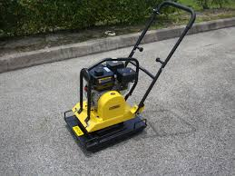
Fig 1: Plate Compactor
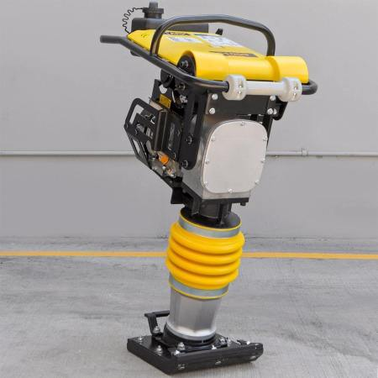
Fig 2 : Jack Jumping Rammer

2. Drainage Methods
Ground water is one of the most difficult problems in excavation work. The presence of water increases the pore water pressure and decreases the shear strength. Further heavy inflow of water to the excavations is liable to cause erosion or collapse of the sides of open excavations. Certain methods are available to control the ground water and ensure a safe and economical construction scheme.
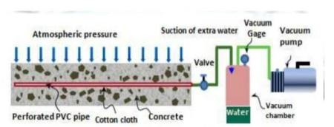
Fig 3: Vacuum Dewatering system

Why Buy When You Can Rent
Common drainage methods are Well-point Systems, Deep- well Drainage, Vacuum Dewatering system, Dewatering by Electro-osmosis etc.

3. Vibration Methods
Vibration methods can be effectively used for rapid densification of saturated non-cohesive soils. Vibrations and shock waves in loose deposits of such materials cause liquefaction followed by densification accompanying the dissipation of excess pore water pressures. Some of the mostly adopted vibration methods are blasting, Vibrating probe, Vibratory rollers, Vibrio-displacement Compaction Piles, Vibrofloatation, and Heavy Tamping etc.
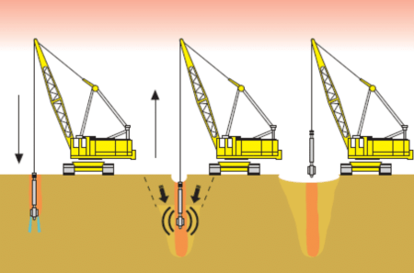
Fig 4: Vibroflotation

4. Pre-Compression and Consolidation
This method aims to consolidate the soil before construction. Various techniques adopted are Preloading and Surcharge Fills, Vertical Drains, Dynamic Consolidation, Electro osmotic Consolidation etc.
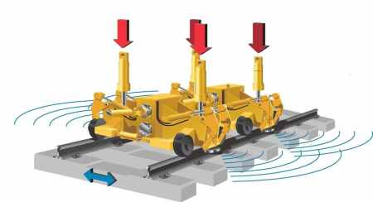
Fig 5: Dynamic Consolidation

5. Grouting and Injection
Grouting is a process whereby stabilizers, either in the form of suspension or solution are injected into subsurface soil or rock for one or more of the following applications:
- Control of ground water during construction
- Void filling to prevent excessive settlement
- Strengthening adjacent foundation soils to protect them against damage during excavation, Pile driving, etc.
- Soil Strengthening to reduce lateral support requirements
- Stabilization of loose sands against Liquefaction
- Foundation Underpinning
- Reduction of machine foundation vibrations
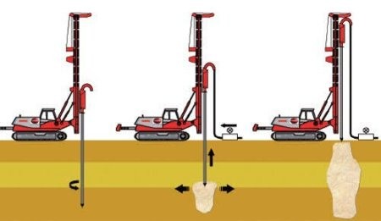
Fig 6: Soil Grouting
Grouting is done by Suspension Grouts which include grouting with Soil, Soil-cement Mixes, Cement, Lime, Displacement Grouting and by Solution Grouts using “one shot” or “two shot” systems.

6. Chemical Stabilization
Chemical Stabilization has been widely used in the form of lime, cement, fly ash and the combination of the above is widely used in soil stabilization. Chemical Stabilizations reduce permeability of the soils, improve shear strength, increase bearing capacity, decrease settlement and expedite construction. Chemical Stabilization is used for surface soils more successfully. Mixtures of soils and chemicals are mixed either mechanically in place or by batch process. Some of the chemicals used are Lime, Cement, and Fly Ash etc.

7. Soil Reinforcement
Soil Reinforcement is in the form of a weak soil reinforced by high-strength thin horizontal membranes. A large variety of materials such as rubber, aluminum and thermoplastics have been used successfully.
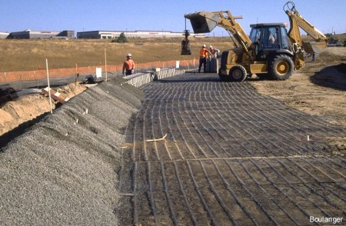
Fig 7: Fiber Reinforcement

8. Geotextiles and Geomembranes
Geotextiles are porous fabrics manufactured from synthetic materials, which are primarily petroleum products and others, such as polyester, polyethylene, polypropylene and polyvinyl chloride, nylon, fiberglass and various mixtures of these. Geotextiles are used as separators, filters, Drains, reinforcement, geomembranes etc.
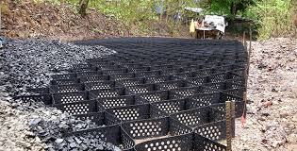
Fig 8: GeoCells
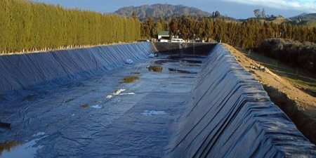
Fig 9: Geo Textile
To improve heavy clay soils, add sand and compost. Sand will improve circulation and compost will add nutrition and improve the texture. ... To improve sandy soils, the single best soil additive is compost, which will significantly improve texture, while adding nutrition and disease-preventing properties to the soil.

Part B: What are the various dewatering techniques which are generally used for ground improvement discuses briefly?
Dewatering is a process in which groundwater contained within the site’s soil is extracted, ensuring a stable foundation.
There are four methods which are generally used for dewatering to improve ground soil.
- Open dewatering: It enable one to lower the groundwater table adequately in cohesive and low permeable soils. Water pumped off directly from sumps (ditches) along the toes fo the slope of the excavation work. The section hose with strainer is merely placed in the sump and the collected water primed and discharged. This makes to install and simple to operate the open dewatering system utilize.
- Self-priming
- Vacuum assisted centrifugal pumps.
- Well point dewatering system:
- Well point dewatering system enable one to lower the groundwater table adequately for deep and lager construction sites.
- It has proven to be a very flexible system. The water form high permeable soils is pumped form well points, installed along the trench of the site.
- The well point are jetted and spaced to obtain an efficient draw done against lowest capacity.
- The well points with integral strainers are joined to transparent flexible loses, which are connected by quick release couplers to the ring main header pipeline.
- Well point dewatering is done either by gravity.
- Deep well dewatering: Deep well dewatering system enable one to lower the groundwater table to a considerable depth. A submersible pump is installed at the bottom of the well, of which the casing generally has a minimum diameter of 150 mm. The discharge pipes from the submersible pumps of a number of adjacent wells are connected to a common delivery main. The water is raised from the well by a multi-staged pump
- Sump Pumps are used in application where excess water must be pumped away from particular area. They generally sit in a basin or sump that collect this excess water this classification includes bilge and ballast pumps, Centrifugal pumps, cantilever pumps, sewage pumps, submersible sump pumps and utility pumps among others.

ANS NO 2
Part A: What do you understand about soil nailing and under which condition the soil nailing is preferable?
Soil Nailing is a technique to reinforce and strengthen ground adjacent to an excavation by installing closely spaced steel bars called “nails”, as construction proceeds from top down.
It is an effective and economical method of constructing retaining wall for excavation support, support of hill cuts, bridge abutments and high ways.
The nails are subjected to tension compression, shear and bending moments.
History of Soil Nailing:
Technique came from New Austrian Tunneling Method in 1960.
Stabilization works in underground tunnel in Europe in 1970.
The first recorded use of soil nailing in its
Modern form was in France in 1972.
The United States first used soil nailing in 1976 for the support of a 13.7 m deep foundation excavation in dense salty sands.
FAVOURABLE CONDITION OF NAILING:
Critical excavation depth of soil is about 1-2 m high vertical or nearly vertical cut.
All soil nails within a cross section are located above groundwater table.
FAVOURABLE SOILS:
Stiff to hard fine grained soils, dense to very dense granular soils with some apparent cohesion, weathered rock with no weakness planes and glacial soils etc.
UNFAVOURABLE SOILS:
Dry, poorly graded cohesion less soils, soils with cobbles and boulders, soft to very soft fine grained soils, organic soils.
ADVANTAGES:
- 1 With the right soil and site conditions, a rapid and economical means of constructing earth retention support systems and retaining walls.
- Shorter drill holes.
- Smaller diameter bars at shorter lengths.
- Retaining walls are secured laterally into the soil, eliminating piles and foundation footers.
- Grouting only once is required, saving time and labor.
- The technique is flexible, easily modified
DISADVANTAGES:
- Nail encroachment to retained ground rendering unusable underground space
- Tendency of high ground loss due to drilling technique, particularly at course grained soil
- Less suitable for course grained soil and soft clayey soil, which have short self-support time, and soils prone to creeping
- Suitable only for excavation above groundwater
CONCLUSION:
Since this process is effective in cohesive soil, broken rock, shale, or mixed face conditions it permits flexibility to conform to a variety of geometric shapes to meet specific site needs.
Due to its rather straightforward construction method and is relatively maintenance free, the method has gained popularity in India for highway and also hillside development projects. Soil nailing is an economical means of creating shoring systems and retaining walls.

Part B: Discuses the Characteristic of a grout where and why grout is required? What is compacted grout, discuss the advantages and disadvantages of grouting.
Grouting is a construction materials used to embed rebar in masonry wall, connect sections of pre-cast concrete, fill voids, and seal joints. And all of these is used for to improve the ground soil. Grout is generally composed of a mixture of water, cement, sand, often color tint and sometimes fine gravel if needed. Initially, its application confines mainly in void filling, water stopping and consolidation. Nowadays, it extends to alleviate settlement of ground caused by basement and tunnels excavation works, to strengthen ground so that it can be used as a structural member to remaining structure in solve geotechnical problems. There are some types of grouting and all of them are using for one main purpose to improve ground soil to give it stranger and stability against external load.
- Cement based grout:
- Pure cement grout:
- Bentonite cement grout:
- Grout with fillers:
- Silicate based grouts:
- Soft gel grout:
- Grout injection method:
- Drill Hole Method:
- Drill Tool Method:
- Grout pipe Method:
- Jetting method:
What is compaction grouting?
Compaction grouting involves the injection of a low slump, mortar grout to density loose, granular soils and stabilize subsurface voids or sinkholes.
Advantages:
- Suitable for rubble fills, poorly placed fills, loosened or collapsible soils, soluble rocks and liquefiable soils
- Often selected for treatment beneath existing structures because the columns do not require structural connection to the foundations
- Decrease or correct settlement
- Increase bearing capacity
- Stabilize sinkholes or reduce sinkhole potential
- Often more economic than conventional approaches such as removal and replacement, or piling
- Can be done where access is difficult and in limited space

Disadvantages:
- The one main disadvantage of this technique is that it is a bit messy and may require cleanup. However, when you work with Engineered Solutions, this is never an issue, as our team strives to leave your property looking as it did when we arrived, only with sturdier ground soils underneath

ANS NO 3:
Part A: What are the causes for which ground improvement techniques are under taken?
- Increase shear strength
- Reduce permeability
- Reduce compressibility
- Reduce liquefaction potential
- Control swelling
- Control shrinkage
- Prolongs durability.
Part B: Identity various geotechnical problem of expensive soil?
Following are few geotechnical problem
- Shear strength is a problem
- Durability
- Shrinkage is a problem
- Swelling of soil is a problem
- Liquefaction potential is a problem
- Slope
- Lose soil I mean uncompressible soil
- Permeability is a problem
- Lose soil
- Organic soil
- Salty soil

ANS NO 4
Part a: How stone column and blasting help soil to stabilize and gain bearing capacity?
Stone columns method
Stone columns are extensively used to improve the bearing capacity of poor ground and reduce the settlement of structures built on them. A stone column is one of the soil stabilization methods that is used to increase strength, decrease the compressibility of soft and loose fine graded soils, accelerate a consolidation effect and reduce the liquefaction potential of soils. They are mainly used for stabilization soft soil such as soft clays, silts and salty-sands. It is believed that this method was used first in France in 1830s. This method is in wide range of use especially in Europe since 1950s. The columns consist of compacted gravel or crushed stone arranged by a vibrator. This article presents installation methods, design and failure modes of stone columns.
Stone columns are installed using either top- or bottom-feed systems, either with or without jetted water. The top-feed method is used when a stable hole can be formed by the vibratory probe. With the dry method (top or bottom-feed), the probe is inserted into the ground and penetrates to the target depth under its own weight and compressed air jetting (Taube and Her ridge, 2002). Most widely used methods for installation of stone columns are: • Vibrio-Replacement (Wet, Top Feed Method) • Vibrio-Displacement (Dry, Top and Bottom Feed Method) the construction of stone columns is generally carried out using either a replacement or a displacement method. In the displacement or dry method, native soil is displaced laterally by a vibratory probe using compressed air. This installation method is appropriate where ground water level is low and in situ soil is firm. This method is shown in the Figure 1 and Figure 2. In the replacement or wet method, native soil is replaced by stone columns in a regular pattern where the holes are constructed using a vibratory probe accompanied by a water jet. This method is shown in the Fig. 3 (Lee and Paned, 1998)

Blasting Method
The settlement control is critical for the safety of road based on high filled embankment. The traditional construction methods have the characteristic with less soil thickness compacted at a time. There are many advantages to compact the gravel soil with blasting. The cavity in soil is formed by blasting and its fillings to form a composite foundation for the embankment. The field data show this composite foundation can meet the requirement of loading and settlement control with less construction time. In geotechnical blasting, the high temperature due to blasting will swell the material around, so its worthy to do the coupled analysis with thermal mechanics (TM) and blasting compaction in the high filled embankment. In this paper, a 3D model is built with FLAC3D to simulate a single hole to predict the range and degree of thermal propagation. Then, the thermal strains got from the model are used to estimate the displacement of surrounding soil to predict the degree of compaction and optimize the distribution of blast holes in plan.
The dynamic loading due to blasting is a complex process. The blasting load can make the volume of blast hole enlarge and the fracture of soil expanded. The gas pressure and dynamic load will be reduced with volume enlargement. Finally, the explosive gas rapidly overflows and the applied force decays to zero when fractures developed to connect together.

At the beginning of blasting, the dynamic load will increase with time until it reaches the peak intensity of blasting when the detonation gas wave propagates to the bottom of blast hole. Many researches showed that the initial peak blasting load was related to the detonation wave pressure. According to the Chapman-Bouquet model by Enrich [18] for decoupled charges, the initial explosion pressure was also related to the ratio of the blast whole diameter and the charge diameter.
Stone blasting is most effective in loose sands that contain less than 20% silt and less than 5% clay. Although blasting is quite economical, it is limited by several consideration, as it produces strong vibration that may damage nearby structures or produce significant ground movement.
Blasting is the use of buried explosives to cause the densification of loose cohesion less ground. The principal is that the blasting of explosives in a predetermined pattern causes liquefaction, followed by the expulsion of pore water and subsequent densification of the ground. Blast densification is being utilized for more than 80 years to density loose, saturated sand deposits.
The aim of this ground-improvement technique is to density and improve the engineering characteristics of loose sand deposits and thus prevent or minimize the effects of liquefaction during an earthquake. The liquefaction of loose, saturated sands due to seismically induced ground motions continues to be the major source of damage to facilities and loss of human lives after severe earthquake events.

Procedure of the blasting for ground improvement
- Series of boreholes are drilled and Pipe of 7.5 to 10 cm is driven to the required depth
- The detonator and the dynamic sticks are both enclosed in a water proof bundle and is lowered through casings
- Casing is withdrawn and a wad of paper or wood is placed against the charge of Explosive (To protect it from misfire)
- Boreholes are backfilled with sand to obtain full force of blast
- The charge is fired in definite pattern
The energy released by the explosives creates compressive radial stresses in the soil mass as the shock wave approaches and generates tensile stress as the shock wave passes .The resulting cyclic stress increases the pore pressure, and the effective stresses acting on the soil are gradually reduced. As the pore water pressure dissipates, the grain particles rearrange into a denser and more stable configuration.
Blast densification offers an economical approach, when compared with other alternatives, to density large areas since it is a relatively rapid process and heavy construction equipment is not needed, making it possible for work to be carried out in remote or difficult areas.
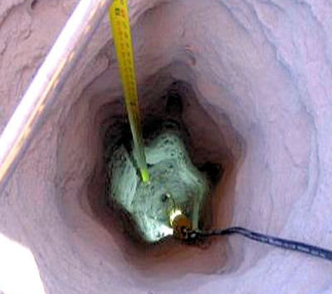
How to blast for the reason picture is applauded.
Blasting is more effective in loose sands that contain less than 20% silt and less than 5% clay. In case of partial saturated soil, the capillary action obstructs the densification tendency by preventing soil particles to come close. So this method is not useful for partial saturated soils. When deeper deposits are in question, the blasting is done in stages. Repeated shots are more effective than a single larger one.
The top surface up to 1m gets disturbed and needs surface compaction. Although blasting is quite economical, it’s limited by several considerations as it produces strong vibrations that may damage nearby structures or produce significant ground movements.

Part B: Which type of ground improvement would be used in black cotton soil and Why?
Black cotton soils are boon to agriculture but are proved to be serious threat to construction founded on it. These soils have the property of high swelling due to imbibing of water in monsoon and shrinkage due to evaporation of water in summer seasons. This swelling and shrinkage nature is attributed to the presence of mineral montmorillonite. Because of this high swelling and shrinkage nature, the structures constructed on these soils experience cracks, making it unsuitable for foundation. Hence there is a need for improving black cotton soil to suite as foundation material.

Over the past few decades, stabilization is found to be the best technique for reducing the swelling and shrinkage nature of black cotton soil. Various researchers had tried stabilizing black cotton soil using lime, cement, fly ash, rich husk ash, etc. [1–5]. Of these, lime stabilization is one of the techniques which is in use for stabilizing black cotton soil from the past few decades. Use of lime reduces the high plasticity of black cotton and makes it workable. Also reaction between lime and soil makes the soil-lime mixture more strength resistant [1]. But in recent days, the cost of lime has increased. This resulted in increase of cost of lime stabilization of soil [2]. Also in the present study, an attempt is made in stabilizing the black cotton soil with lime which turned out to be unsuitable as subcase material. Hence the need for alternative and cost-effective materials has aroused.

