Final-Term Assignment/Paper (spring -020)
Human Anatomy-II
BS Radiology Sec-A 2nd Semester)
Instructor: Dr. M.Jaffar
Name: Sahab Hussain khan
Id : 16362
Time: 6-hours (9am-3pm) Max Marks: 50

Q1. Write anterior compartment of thigh and posterior compartment of leg muscles with origin, insertion and action. (10)
Q2. Define the following (10).
- Endocrine gland
- Exocrine gland
- Thalamus
- femoral triangle
Q3. Write the Extraocular muscles. Enlist both voluntary and involuntary. (10)
Q4. Describe the arches of foot and functions of arches. (10)
Q5. Write a note on cerebrum, its lobes and functions. (10)

Question no.1
Answer :
Muscles Of Anterior Compartment Of Thigh :
Muscles:
- Femoris
- Vastus
- Sartorius
- Abductor
- Iliopsoas

Femoris :
- Quadriceps Femoris
- Rectus Femoris

Origin:
Margin of accetabullam, anterior inferior iliac spine.
Insertion :
Patella and tibial tuberocity through patellar.
Action:
Extension of knee, flexion of thigh.

VASTUS:
- Vastus lateralis
- Vastus medialis
- Vastus intermediatius

Origin:
Femur
Insertion:
Patella and tibial tuberocity through the patellar.
Action:
Extension of knee.

SARTORIUS :
It is the longest muscle of the body.
Origin:
Anterior superior iliac spine
Insertion :
Medial tibia
Action:
Flexion, abduction and lateral rotation of thigh, weak knee flexion.

Iliopsoas :
Origin:
Iliac, sacrum and lumber vertebrae.
Insertion :
Lesser trochanter
Action :
Flexion of thigh

Abductor :
- Abductor longus
- Abductor bervis
- Abductor magnus

Origin:
Inferior pelvis
Insertion :
Femur
Action:
Abduction and medial rotation

Pectines:
Origin:
Pubis
Insertion:
Lesser trochanter
Action:
Abduction and medial rotation

Gracilis:
Origin:
Pubis
Insertion :
medial of tibia
Action:
Abduction of thigh, flexion and medial rotation of leg.

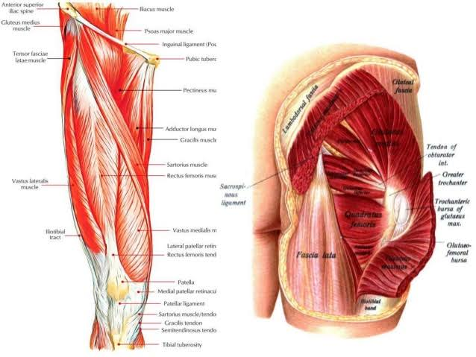

MUSCLES OF POSTERIOR COMPARTMENT OF LEG :
- Superficial posterior compartment
- Deep posterior compartment

- Superficial posterior Compartment:

- Tricep Surea( 3 head)

1. Gastrocnemius (2 head)
Origin :
Medial and lateral condyles of femur
Insertion :
Posterior calcaneus through achilis tendon
Action:
Flexion of foot at ankhle joint, and leg at knee joint. It helps in running and jumping.

2. Soleus:
Origin:
Tibia and fibula
Insertion :
Posterior calcaneus through achilis tendon
Action:
Planter flexion of foot

3. Plantaris
Origin:
Posterior femur
Insertion :
Posterior calcaneus through achilis tendon
Action:
Planter flexion of foot and weak flexion of knee.
- Deep Posterior Compartment :
Popliteus:
Origin:
Lateral condyle femur, lateral meniscus.
Insertion :
Proximal Tibia
Action:
Flexion and medial rotation of leg

Flexor Digitorum Longus :
Origin:
Tibia
Insertion :
Distal phalanges of toe, 2 to 5
Action:
Planter flexion and invert foot, and flexion of toe.

Flexor Halluas Longus:
Origin:
Fibula
Insertion :
Distal phalanges of hallum.
Action:
Planter flexion and invert foot, and flexion of toe.

Tibialis Posterior :
Origin:
Tibia, febula and interosseous membrane.
Insertion:
Tarsals and metatarsals
Action :
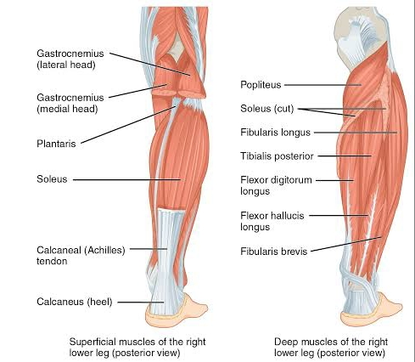
Planter flexion and invert foot.

Question no.2
(a) Endocrine Gland
Answer:
Endocrine gland:
Gland that secrete their products directly into the blood is called Endocrine Gland.
Types :
1. Pituitary gland :
It is the major endocrine gland, it is about the pea size body attached to the base of the brain. It is important in controlling growth and development.

Harmones :
Anterior lobe :
- Growth hormone (GH)
- Prolactin
- Thyroid stimulating hormone (TSH)
- Adrenocorticotrophic hormone (ACTH)
- Folical Stimulating hormone (FSH)
- Luteinizing hormone (LH)

Posterior lobe :
- Vasopressin (ADH)
- Oxytocin
Thyroid Gland :
It is an Endocrine gland in neck.
Hormones :
- Triiodothyronine(T3)
- Thyroxin (T4)
- Calcitonine

Adrenal Galnds:
There are two Adrenal glands on each kidney. they are yellowish in colour, it has two parts.
1. Outer part ( Adrenal cortex )
2. Inner part ( Adrenal medulla )

Hormones :
- Glucocorticoids
- Mineralocorticoids
- Sex hormone

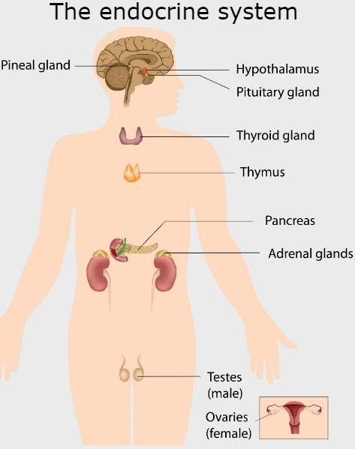

(b) Exocrine Gland
Answer:
They secreted their products onto epithelial surface through ducts
Examples:
- Sweet gland
- Salivary gland
- Mammary gland
- Cerminou
- Lacrimal
- Sebaceous
- Prostate
- Mucus

(c) Thalamus:
The brain is composed of many parts, thalamus is one of them. The thalamus is a structure in the mid of the brain . It is located between the cerebral cortex and mid brain. It is the on the top of mid brain.
Functions:

- Consciousness
- Sleep
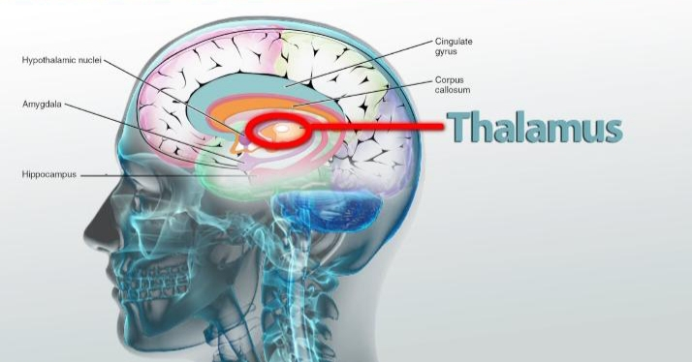
- Sensory interpretation

(d) Femoral Triangle
Answer :

Femoral triangle is an anatomical region of the upper innee human thigh. It helps in the flexion of thigh and laterally rotation. It is the depression between the muscles of thigh.
It is the passage of the main blood vessels between the pelvis and lower limb.

Question no.3
Answer :
Extraocular Muscles
They act to control the movements of the eyeballs and superior eyelid.

Voluntary Muscles:
- Superior rectus
- Inferior Rectus
- Medial rectus
- Superior oblique
- Inferior oblique
- Levator palpebrea

Involuntary Muscles :
- Superior tarsal or Muller's muscles
- Inferior tarsal muscles

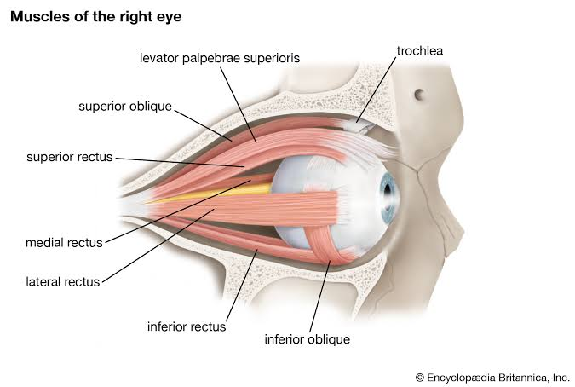

Question no.4
Answer :
Arches of Foot:
Bones of the foot are arranged to form three strong arches:
- Two longitudinal ( lateral & medial )
- One transverse

Arches are formed by the tarsal and metatarsals bones & supported by ligaments and tendons.

Functions of Arches :
Arches help the foot to support and distribute the weight of the body and provide leverage during walking.

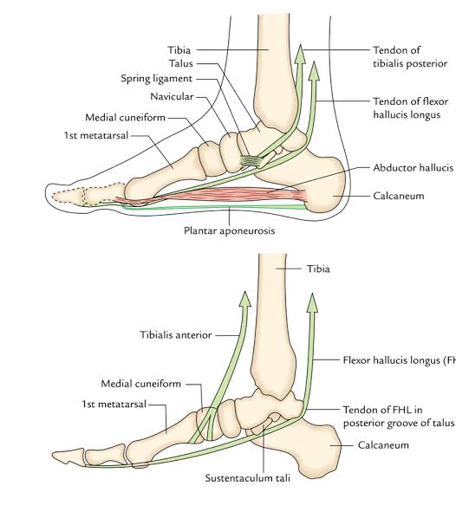

Question no.5
Answer :
Cerebrum :
- The biggest part of the brain
- Divide into two hemispheres ( left and right )
- Hemisphere connets with carpiscalosa
- Separated by fissure
- Coordinat the volantry activities.

Lobes:
Frontal Lobe :
- Most anterior part of cerebrum
- Controls motor functions e.g.
- personality of the person
- Responsible for judgment
- Responsible for social behaviour
- Controls voluntary movements ( Broca's area)

Parietal Lobe :
- Superior portion of cerebrum
- Receive sensations from skin
- Touch, pressure , temperature and pain

Occipital Lobe :
- The posterior part of cerebrum
- Visual stimulus
- Impulses receive from eyes

Temporal Lobe :
- Left and right portions of cerebrum
- Hearing system is related to this lobe
- Control of language comprehension ( Wernick's area)
- Storage and recall of memory
- There is a system called limbic system which controls the emotions

Functions Of Cerebrum :
- It controls the movement
- It helps in control of speech
- It is responsible for voluntary actions
- It helps in determining the intelligence of the person.

