NAME: IRFANULLAH AFFAN
ID 14862
SUBMITTED TO: DR AROOBA SAJJAD
SUBJECT: ANATOMAY
COURSE: NERVOUS SYSTEM
DPT 4TH SEMESTER

- Write a comprehensive note on the blood supply of brain?

The brain receives blood from two sources: the internal carotid arteries, which arise at the point in the neck where the common carotid arteries bifurcate, and the vertebral arteries (Figure 1.20). The internal carotid arteries branch to form two major cerebral arteries, the anterior and middle cerebral arteries. The right and left vertebral arteries come together at the level of the pons on the ventral surface of the brainstem to form the midline basilar artery. The basilar artery joins the blood supply from the internal carotids in an arterial ring at the base of the brain (in the vicinity of the hypothalamus and cerebral peduncles) called the circle of Willis. The posterior cerebral arteries arise at this confluence, as do two small bridging arteries, the anterior and posterior communicating arteries. Conjoining the two major sources of cerebral vascular supply via the circle of Willis presumably improves the chances of any region of the brain continuing to receive blood if one of the major arteries becomes occluded
.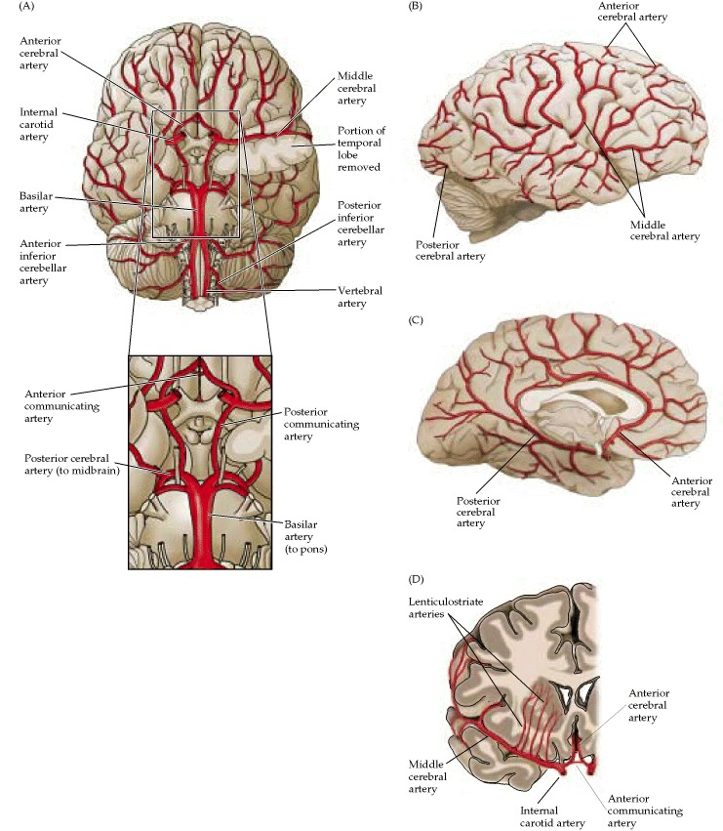
Figure 1.20
- Which type of stroke is common? Write a complete note on ischemic stroke?
Ischemic Stroke
The most common type of stroke, accounting for almost 80 percent of all strokes, is caused by a clot or other blockage within an artery leading to the brain.
Symptoms: Headache
2 Write a complete note on ischemic stroke?

Ischemic Stroke
Most strokes are this type. You get them when a fatty substance called plaque collects in your arteries and narrows them. This is called atherosclerosis, and it slows the flow of blood. As it pools, blood can clump and form clots -- and your artery gets blocked.
Besides atherosclerosis, some other things that can raise your chances of getting an ischemic stroke are:
- Atrial fibrillation
- Heart attack
- Problem with your heart's valves
- Injury to blood vessels in your neck
- Blood clotting problem
There are two main types of ischemic stroke:
Thrombotic strokes. They're caused by a blood clot that forms in an artery that supplies blood to your brain.
Embolic strokes. They happen when a clot forms somewhere else in your body and travels through the blood vessels to your brain. It gets stuck there and stops the flow of your blood.
The symptoms of an ischemic stroke depend on which parts of your brain are affected. They can include things like:
- Sudden numbness or weakness of your face, arm, or leg, often on one side of the body
- Confusion
- Problems speaking or understanding others
- Dizziness, loss of balance or coordination, or trouble walking
- Vision loss or double vision
You're more likely to have an ischemic stroke if you:
- Are over age 60
- Have high blood pressure, heart disease, high cholesterol, or diabetes
- Have an irregular heartbeat
- Smoke
- Have a family history of strokes
- What do you know about the thalamic nuclei of brain?

Introduction
The thalamus serves as the main relay station for the brain. Motor pathways, limbic pathways, and sensory pathways besides olfaction all pass through this central structure. The thalamus can divide into approximately 60 regions called nuclei. Each nucleus has unique pathways as inputs and various projections as outputs, most of which send information to the cerebral cortex.

Structure and Function
The thalamus is a paired structure located in the center of the brain. Each side can divide into three groups of thalamic nuclei: a lateral nuclear group, a medial nuclear group, and an anterior nuclear group. These three groups get split by the internal medullary lamina, a Y-shaped structure present on each side of the thalamus. There is also an area of thin, midline thalamic nuclei next to the third ventricle, and an enveloping thalamic reticular nucleus that covers each lateral thalamus.
In addition to grouping by anatomic location, the thalamic nuclei can be categorized by function as well. There are three categories [2]:
- Relay nuclei (lateral nuclear group, medial nuclear group, anterior nuclear group)
- Reticular nucleus
- Intralaminar nuclei
Relay nuclei represent the majority of the thalamus. Their projections to the cortex localize to more specific regions than the reticular and intralaminar nuclei. Relay nuclei subdivide into the three groups, as mentioned above, of lateral nuclear, medial nuclear and anterior nuclear. The most clinically relevant nuclei all fall into the lateral nuclear group. These include the ventral poster lateral, ventral poster medial, lateral geniculation, medial geniculation, and ventral lateral nuclei. The discussion of their relevance appears in detail in the section on Clinical Significance.
The reticular nucleus envelops each lateral thalamus. Lateral to it is the internal capsule. This nucleus is unique in that its projections do not go to the cortex. Its projections circle back to the thalamus itself, from which it received its inputs. Thus, the reticular nucleus serves to regulate the activity of the thalamus.
Intralaminar nuclei also send projections to the cortex. Their inputs, however, come from the basal ganglia.
Categorization of thalamic nuclei:
Relay nuclei
- Lateral nuclear group
  - Ventral posterolateral nucleus (VPL)
  - Ventral poster medial nucleus (VPM)
  - Lateral geniculation nucleus (LGN)
  - Medial geniculation nucleus (MGN)
  - Ventral lateral nucleus (VL)
  - Ventral anterior nucleus (VA)
  - Pulvinar
  - Lateral dorsal nucleus
  - Lateral posterior nucleus
  - Ventral medial nucleus
- Medial nuclear group
  - Mediodorsal nucleus (MD)
- Anterior nuclear group
  - Anterior nucleus
- Midline thalamic nuclei
  - Para ventricular
  - Parataenial
  - Interanteromedial
  - Intermediodorsal
  - Rhomboid
  - Medial ventral
Reticular nucleus
Intralaminar nuclei
- Rostral intralaminar nuclei
  - Central medial nucleus
  - Para central nucleus
  - Central lateral nucleus
- Caudal intralaminar nuclei
  - Centro median nucleus
  - Para fascicular nucleus.

- Write note on the descending tracts of spinal cord?
The descending tracts.
The descending tracts are the pathways by which motor signals are sent from the brain to lower motor neurons. The lower motor neurons then directly innervate muscles to produce movement.
The motor tracts can be functionally divided into two major groups:
- Pyramidal tracts – These tracts originate in the cerebral cortex, carrying motor fibers to the spinal cord and brain stem. They are responsible for the voluntary control of the musculature of the body and face.
- Extra pyramidal tracts – These tracts originate in the brain stem, carrying motor fibers to the spinal cord. They are responsible for the involuntary and automatic control of all musculature, such as muscle tone, balance, posture and locomotion
There are no synapses within the descending pathways. At the termination of the descending tracts, the neurons synapse with a lower motor neuron. Thus, all the neurons within the descending motor system are classed as upper motor neurons. Their cell bodies are found in the cerebral cortex or the brain stem, with their axons remaining within the CNS.
By TeachMeSeries Ltd (2020)
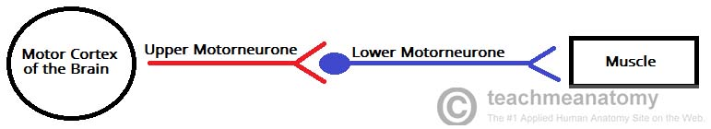
Fig 1 – Schematic of the motor nervous system. The descending tracts are represented by upper motor neurons.

Pyramidal Tracts
By TeachMeSeries Ltd (2020)
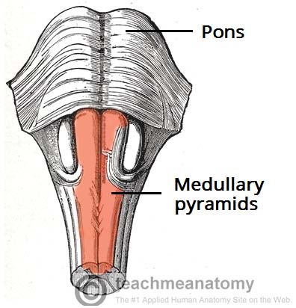
Fig 2 – The modularly pyramids
The pyramidal tracts derive their name from the modularly pyramids of the medulla oblongata, which they pass through.
These pathways are responsible for the voluntary control of the musculature of the body and face.
Functionally, these tracts can be subdivided into two:
- Corticospinal tracts – supplies the musculature of the body.
- Corticobulbar tracts – supplies the musculature of the head and neck.
We shall now discuss both pathways in further detail.

Corticospinal Tracts
The corticospinal tracts begin in the cerebral cortex, from which they receive a range of inputs:
- Primary motor cortex
- Premotor cortex
- Supplementary motor area
They also receive nerve fibers from the somatosensory area, which play a role in regulating the activity of the ascending tracts.
After originating from the cortex, the neurons converge, and descend through the internal capsule (a white matter pathway, located between the thalamus and the basal ganglia). This is clinically important, as the internal capsule is particularly susceptible to compression from hemorrhagic bleeds, known as a ‘capsular stroke‘. Such an event could cause a lesion of the descending tracts.
After the internal capsule, the neurons pass through the cur’s cerebra of the midbrain, the pons and into the medulla.
In the most inferior (caudal) part of the medulla, the tract divides into two:
The fibers within the lateral corticospinal tract decussate (cross over to the other side of the CNS). They then descend into the spinal cord, terminating in the ventral horn (at all segmental levels). From the ventral horn, the lower motor neurons go on to supply the muscles of the body.
The anterior corticospinal tract remains ipsilateral, descending into the spinal cord. They then decussate and terminate in the ventral horn of the cervical and upper thoracic segmental levels.
By TeachMeSeries Ltd (2020)
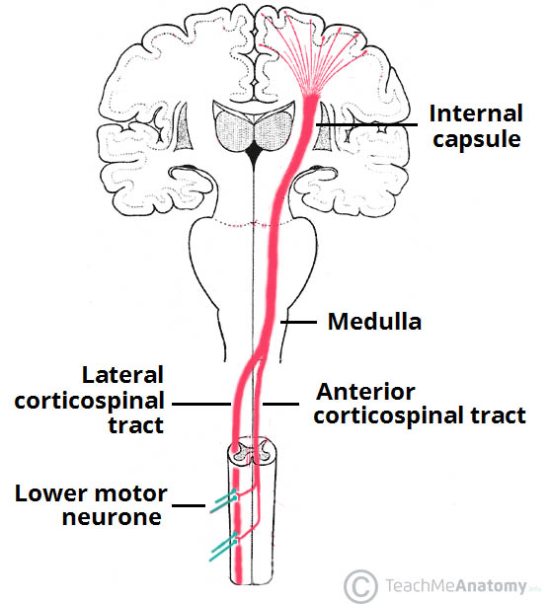
Fig 3 – The corticospinal tracts. Note the area of decussating of the lateral corticospinal tract in the medulla.

Corticobulbar Tracts
By TeachMeSeries Ltd (2020)
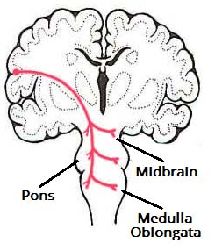
Fig 4 – Overview of the right corticobulbar tract. Note that this is a simplified diagram, ignoring the bilateral nature of these pathways.
The corticobulbar tracts arise from the lateral aspect of the primary motor cortex. They receive the same inputs as the corticospinal tracts. The fibers converge and pass through the internal capsule to the brainstem.
The neurons terminate on the motor nuclei of the cranial nerves. Here, they synapse with lower motor neurons, which carry the motor signals to the muscles of the face and neck.
Clinically, it is important to understand the organization of the corticobulbar fibers. Many of these fibers innervate the motor neurons bilaterally. For example, fibers from the left primary motor cortex act as upper motor neurons for the right and left trochlear nerves. There are a few exceptions to this rule:
- Upper motor neurons for the facial nerve (CN VII) have contra lateral innervations. This only affects the muscles in the lower quadrant of the face – below the eyes. (The reasons for this are beyond the scope of this article)
- Upper motor neurons for the hypoglossal (CN XII) nerve only provide contra lateral innervations.

Extra pyramidal Tracts
The extra pyramidal tracts originate in the brainstem, carrying motor fibers to the spinal cord. They are responsible for the involuntary and automatic control of all musculature, such as muscle tone, balance, posture and locomotion.
There are four tracts in total. The vestibulospinal and reticulospinal tracts do not decussate, providing ipsilateral innervations. The rubrospinal and tectospinal tracts do decussate, and therefore provide contra lateral innervations

Vestibulospinal Tracts
There are two vestibulospinal pathways; medial and lateral. They arise from the vestibular nuclei, which receive input from the organs of balance. The tracts convey this balance information to the spinal cord, where it remains ipsilateral.
Fibers in this pathway control balance and posture by innervating the ‘anti-gravity’ muscles (flexors of the arm, and extensors of the leg), via lower motor neurons.

Reticulospinal Tracts
The two recticulospinal tracts have differing functions:
- The medial reticulospinal tract arises from the pons. It facilitates voluntary movements, and increases muscle tone.
- The lateral reticulospinal tract arises from the medulla. It inhibits voluntary movements, and reduces muscle tone.

Rubrospinal Tracts
The rubrospinal tract originates from the red nucleus, a midbrain structure. As the fibers emerge, they decussate (cross over to the other side of the CNS), and descend into the spinal cord. Thus, they have contra lateral innervations.
Its exact function is unclear, but it is thought to play a role in the fine control of hand movements

Tectospinal Tracts
This pathway begins at the superior colliculus of the midbrain. The superior colliculus is a structure that receives input from the optic nerves. The neurons then quickly decussate, and enter the spinal cord. They terminate at the cervical levels of the spinal cord
- Write a note on the autonomic system. Differentiate between sympathetic and parasympathetic nervous system?
The Autonomic Nervous System
The autonomic nervous system controls specific body processes, such as circulation of blood, digestion, breathing, urination, heartbeat, etc. The autonomic nervous system is named so, because it works autonomously, i.e., without a person’s conscious effort.
The primary function of the autonomic nervous system is homeostasis. Apart from maintaining the body’s internal environment, it is also involved in controlling and maintaining the following life processes:
- Digestion
- Metabolism
- Urination
- Defecation
- Blood pressure
- Sexual response
- Body temperature
- Heartbeat
- Breathing rate
- Fluid balance
There are two types of autonomic nervous system:
- Sympathetic autonomic nervous system
- Parasympathetic autonomic nervous system

Difference between Sympathetic and Parasympathetic Nervous System
The sympathetic nervous system prepares the body for the “fight or flight” response during any potential danger. On the other hand, the parasympathetic nervous system inhibits the body from overworking and restores the body to a calm and composed state. The difference between the sympathetic and parasympathetic nervous system are differentiated based on the way the body responds to environmental stimuli.
The major difference between sympathetic and parasympathetic nervous system are summarized below

