I.d # 16236
Name : Ali Raza
Assignment : Discrete Structures
Instructor : Abrar ul haq

Q#1 :what is venn diagram? explain in detail the application of venn diagram.
Ans: Venn Diagram :
Defination :
A Venn diagram also called primary diagram, set diagram or logic diagram is a diagram that shows all possible logical relations between a finite collection of different sets. A Venn diagram consists of multiple overlapping closed curves, usually circles, each representing a set.

A venn diagram uses overlapping circles or other shapes to illustrate the logical relationships between two or more sets of items. Often, they serve to graphically organize things, highlighting how the items are similar and different.
Venn diagrams, also called Set diagrams or Logic diagrams, are widely used in mathematics, statistics, logic, teaching, linguistics, computer science and business. Many people first encounter them in school as they study math or logic, since Venn diagrams became part of “new math” curricula in the 1960s. These may be simple diagrams involving two or three sets of a few elements,

Types of Venn Diagram :
The most basic Venn diagrams feature two overlapping sets: ●iif your two sets don't overlap, then what you've got is a two-set Euler diagram: ●if one set completely encompasses the other, it's both a Venn diagram and a Euler diagram:
- Three Set Diagrams.
- A three set Euler diagram might include a non-overlapping set:

Venn diagram history
Venn diagrams are named after British logician John Venn. He wrote about them in an 1880 paper entitled “On the Diagrammatic and Mechanical Representation of Propositions and Reasonings” in the Philosophical Magazine and Journal of Science.

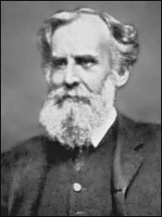
But the roots of this type of diagram go back much further, at least 600 years. In the 1200s, philosopher and logician Ramon Llull (sometimes spelled Lull) of Majorca used a similar type of diagram, wrote author M.E. Baron in a 1969 article tracing their history. She also credited German mathematician and philosopher Gottfried Wilhelm von Leibnitz with drawing similar diagrams in the late 1600s.

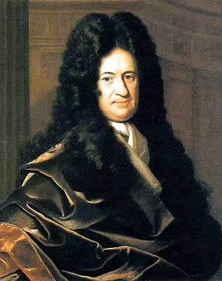
In the 1700s, Swiss mathematician Leonard Euler (pronounced Oy-ler) invented what came to be known as the Euler Diagram, the most direct forerunner of the Venn Diagram. In fact, John Venn referred to his own diagrams as Eulerian Circles, not Venn Diagrams. The term Venn Diagrams was first published by American philosopher Clarence Irving (C.I.) Lewis in his 1918 book, A Survey of Symbolic Logic.

Example Venn diagram
Say our universe is pets, and we want to compare which type of pet our family might agree on.
Set A contains my preferences: dog, bird, hamster.
Set B contains Family Member B’s preferences: dog, cat, fish.
Set C contains Family Member C’s preferences: dog, cat, turtle, snake.
The overlap, or intersection, of the three sets contains only dog. Looks like we’re getting a dog.
Of course, Venn diagrams can get a lot more involved than that, as they are used extensively in various fields.

Venn diagram purpose and benefits
- To visually organize information to see the relationship between sets of items, such as commonalities and differences. Students and professionals can use them to think through the logic behind a concept and to depict the relationships for visual communication. This purpose can range from elementary to highly advanced.
- To compare two or more choices and clearly see what they have in common versus what might distinguish them. This might be done for selecting an important product or service to buy.
- To solve complex mathematical problems. Assuming you’re a mathematician, of course.
- To compare data sets, find correlations and predict probabilities of certain occurrences.
- To reason through the logic behind statements or equations, such as the Boolean logic behind a word search involving “or” and “and” statements and how they’re grouped.
- visual communication. This purpose can range from elementary to highly advanced.
- To compare two or more choices and clearly see what they have in common versus what might distinguish them. This might be done for selecting an important product or service to buy.
- To solve complex mathematical problems. Assuming you’re a mathematician, of course.
- To compare data sets, find correlations and predict probabilities of certain occurrences.
- To reason through the logic behind statements or equations, such as the Boolean logic behind a word search involving “or” and “and” statements and how they’re grouped.

Venn diagram use cases
- Math: Venn diagrams are commonly used in school to teach basic math concepts such as sets, unions and intersections. They’re also used in advanced mathematics to solve complex problems and have been written about extensively in scholarly journals. Set theory is an entire branch of mathematics.
- Statistics and probability: Statistics experts use Venn diagrams to predict the likelihood of certain occurrences. This ties in with the field of predictive analytics. Different data sets can be compared to find degrees of commonality and differences.
- Logic: Venn diagrams are used to determine the validity of particular arguments and conclusions. In deductive reasoning, if the premises are true and the argument form is correct, then the conclusion must be true. For example, if all dogs are animals, and our pet Mojo is a dog, then Mojo has to be an animal. If we assign variables, then let’s say dogs are C, animals are A, and Mojo is B. In argument form, we say: All C are A. B is C. Therefore B is A. A related diagram in logic is called a Truth Table, which places the variables into columns to determine what is logically valid. Another related diagram is called the Randolph diagram, or R-Diagram, after mathematician John F. Randolph. It uses lines to define sets.
- Linguistics: Venn diagrams have been used to study the commonalities and differences among languages.
- Teaching reading comprehension: Teachers can use Venn diagrams to improve their students’ reading comprehension. Students can draw diagrams to compare and contrast ideas they are reading about.
- Computer science: Programmers can use Venn diagrams to visualize computer languages and hierarchies.
- Business: Venn diagrams can be used to compare and contrast products, services, processes or pretty much anything that can depicted in sets. And they’re an effective communication tool to illustrate that comparison.

Q#2: What is union ,draw membership table for union using different examples ?
Ans: Union :Deifination :
The set made by combining the elements of two sets. So the union of sets A and B is the set of elements in A, or B, or both.
The union of two sets A and B is the set of elements which are in A, in B, or in both A and B. In symbols, . For example, if A = {1, 3, 5, 7} and B = {1, 2, 4, 6, 7} then A ∪ B = {1, 2, 3, 4, 5, 6, 7}.
Example of union :
To find the union of two given sets A and B is a set which consists of all the elements of A and all the elements of B such that no element is repeated. The symbol for denoting union of sets is '∪'. For example; Let set A = {2, 4, 5, 6} and set B = {4, 6, 7, 8}
Where Are Union Used:
Union is a data type in C programming that allows different data types to be stored in the same memory locations. Union provides an efficient way of reusing the memory location, as only one of its members can be accessed at a time. A union is used almost in the same way you would declare and use a structure
Full Meaning of Union:
A union is a workers' organization which represents its members and which aims to improve things such as their working conditions and pay. ... When two or more things, for example countries or organizations, have been joined together to form one thing, you can refer to them as a union
Types of Union :
Types of Trade Unions – 4 Main Types: Craft Union, Industrial Union, General Union and Federations. Trade unions fight for workers' rights. As powerful agents of workers, they seek to extract all kinds of incentives, benefits for workers.
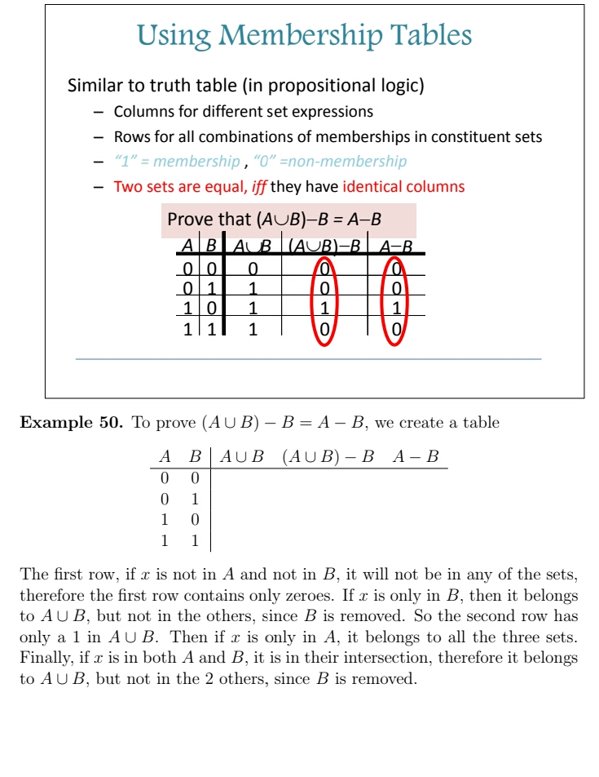
Union Job: A labor union is a group of workers who unite to improve their working conditions through collective bargaining with employers. Unions negotiate with management over work issues such as wages, benefits and safety. ... Unions represent a diverse range of employees.

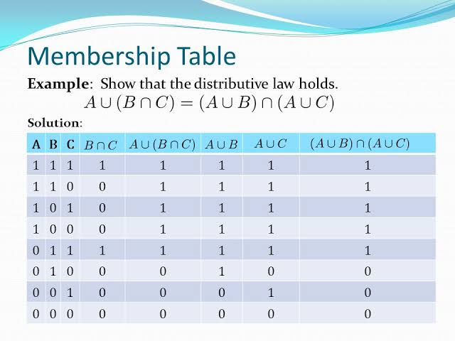

Q#3: What is Intersection , draw membership table of intersection with the help of examples ?l
Ans: Intersection :Defination:
The intersection is a subset of each set forming the intersection, i.e., A ∩ B ⊆ A and A ∩ B ⊆ B. Disjoint Sets: Two sets whose intersection is the empty set are called disjoint sets. Example: Let E = {d, a, y} and F = {n, i, g, h, t}.
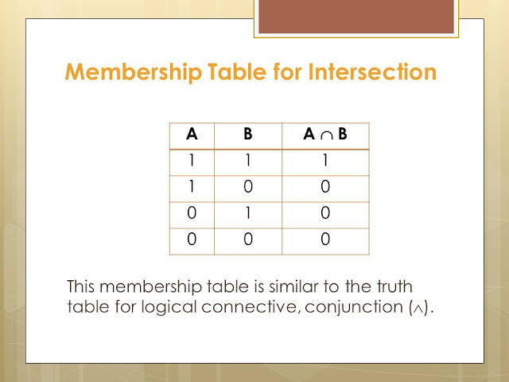

Q#4: What is difference ? Draw membership table for set differcnce using difference examples .
Ans: Difference : Defination :
The result of subtracting one number from another. How much one number differs from another. Example: The difference between 8 and 3 is 5. Subtraction
Difference is defined as the features that make one thing distinct from another or the condition of when a change is made. An example of difference is black and white
