Subject: Human Anatomy II. NAJEEB ULLLAH
15779
Instructor: Dr. Arooba.
Class: Dental Technology, 2nd semester
Section: B
MidTerm Assignment, Spring 2020. Total marks: 30.

Select the best option.

1. A muscle known for tailor master:
A. Iliacus
B. Psoas major
C. Sartorius
D. Pectineus

2. Which of the quadricep femoris muscles performs extension as well as flexion?
A. Vastus lateralis
B. Vastus medialis
C. Vastus intermedias
D. Rectus femoris

3. Which of the following muscles crosses two joints?
A. Vastus lateralis
B. Vastus medialis
C. Vastus intermedius
D. Rectus femoris
4. It is the largest and longest bone of the body:
A. Hip bone
B. Femur
C. Vertebra
D. Tibia

5. It is the union of three bones:
A. Sternum
B. Femur
C. Hip bone
D. Tibia
6. The true foot drop occurs because of:
A. Sciatic nerve
B. Common peroneal nerve
C. Tibial nerve
D. Posterior cutaneous nerve
7. Peripheral hearts are located in:
A. Thorax
B. Abdomen
C. Thigh
D. Leg
8. Which of the following structure does not take part in the formation of the knee joint?
A. Condyle of tibia
B. Head of fibula
C. Medial femoral condyle
D. Lateral femoral condyle
9. It is inserted to the quadrate tubercle:
A. Quadriceps femoris
B. Quadratus plantae
C. Quadratus femoris
D. Rectus femoris
10. How many tarsal bones are there?
A. 12
B. 14
C. 16
D. 18

Give brief answers to the following questions. Add diagrams/ picture where needed.
Each question carries 5 marks.

1. GIVE REASONS:
a) Why hip joint is more stable than shoulder joint?
b) Why flexor compartment of lower limb is directed posteriorly?
c) Why varicose veins are more common in prolonged standing working persons?

2. What do you know about the ligaments of hip joint?

3. Write a note on the movements and stability of talocrural joint.

4. Write a note on the transverse arch of the foot.

Question no 1
REASON (A)
These is because the cavity of acetabular are more deeper than shoulder
Joint also have more complexe structure are present in here
>hip joint also have one of the strongest ligament present here
>Also have more stonger and bigger muscle are present here than shoulder joint .>
>they have also limited movement than shoulder joint
>Hip joint are not easly dislocate becase one of the strongest muscle and ligament are present there . that's why hip joint are more stable thane shoulder joint
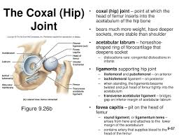

REASON (B)
On the posterior side of leg flexore compartment are present
and give the planter flexion to foot and also give flexion to leg
and also prevent the over extension of foot & leg.
If the are not present on the posterior side than no normal movement of lower leg
take place than difficult to rune easily than no flexion and no lateral rotation take place there.
The posterior compartment of the leg contains seven muscles,
organised into two layers – superficial and deep. The two layers are separated by a band of fascia.
As we know that the deep two layers separated the fascia
The posterior leg is the largest of the three compartments.Collectively, the muscles in this area plantarflex and invert the foot. They are innervated by the tibial nerve, a terminal branch of the sciatic nerve.In this diagram we should look to the attachment of muscle
actions and innervation of the muscles in the posterior compartment of the leg
Superficially
It has calf shape of posterior leg They all insert into the calcareous foot

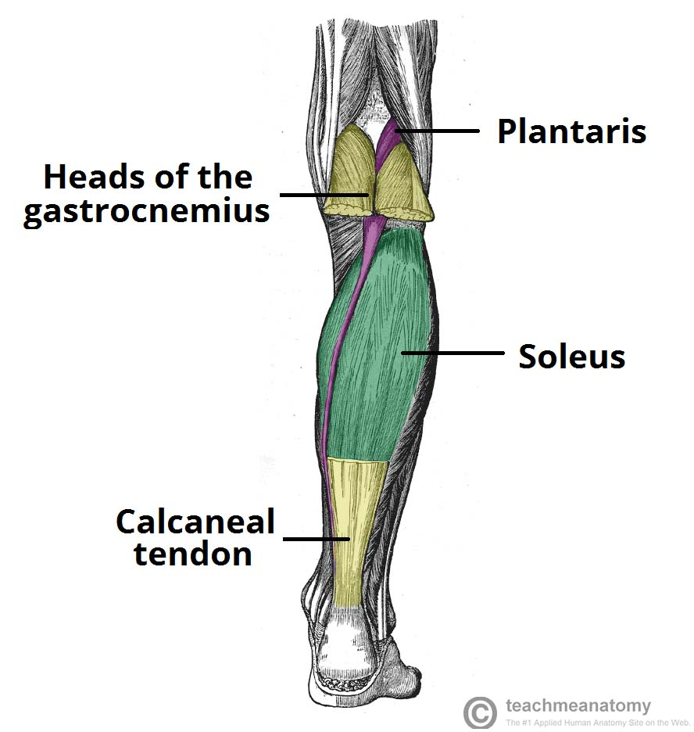

REASON (C)
Vericose veons are superficial veins and easily fell by finger
and present near to rhe skin .The are more comon seen in
prolong peeson because of over working cause the varicase vein
become enalarge and weaken there wall and increase blood pressure for the
movement of the blood toword varicose veine that's why they are more common
in prolong working person.
There are five stages of prolonged working
- Spider veins
- Varicose veins
- Leg Edma
- Skin changes
- Leg ulcers
Spider veins
The veins appearance is like spider superficially
Varicose veins
It has ropy like appearance

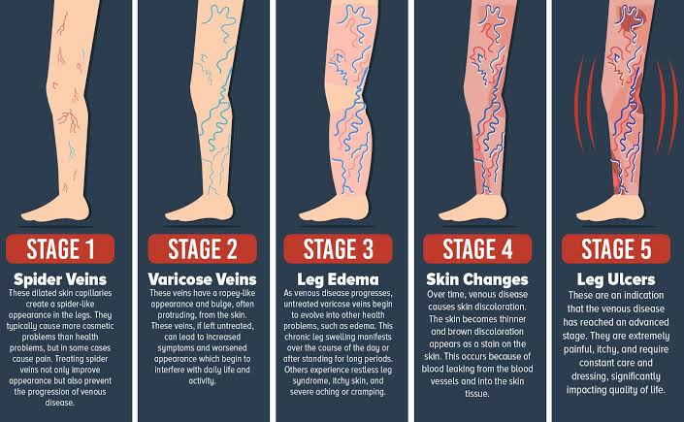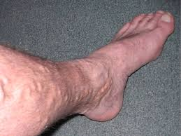

QUESTION NO: 2
Ligament of hip joint
These ligament are present on the hip joint called
ligament of hip joint

A ligament is the fibrous connective tissue that connect bone
to other bone
>It is also khnown as articular ligament because it
articulate between two bone
Types of ligament
There are two type of ligament in hip joint
1=Extra capsular ligament
Iliofemoral ligament
Are one of the strongest ligament of the body
>it structure is inverted ''Y" shaped
>base of that ligament attached with anterior inferior iliac spine.
>apex are attached lower and upper intertrocanteric line
Of femur
Function
These ligament prevent from the posterior over extension of
The thigh movement
Pubofemural ligament
>these ligament are the inferior side of hip joint
>base is attached with superior ramus of pubus
>apexe attached with lower part of intrtroantric line
"Function" it prevent the joint frome moving beyond
normal range of motion also limited external rotation of the joint
Ischiofemoral ligament
Is a bundle of very strong fiber that joint the
pelvis and femur
>shape:spiral
>attached to the body of ischium near acetabular margin
>fiber pass laterally and attached to greater trochanter
""Function: prevent excess of extention
2=Intra-capsular ligament "

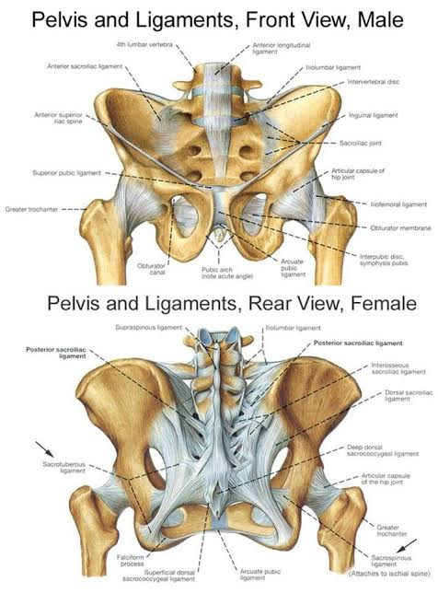

It is formed by acetabular labrum which formed bridge
Over the acetabular notch
"Function" that form foramen through which vein,artry and nerve pass and prevent inferior displacement of femure.
Ligament of head of the femure
>they are flate and triangular shape
>apex are attached with transverse ligament and one of either side of
either side of acetabular notch.
>its prevent in that joint and covered by synovial membrane.

Question no 2
Movement and stability of talocrural joint"
"Talocrural joint:
These kind of complex joint which are formed between Tibia,Fibula and Talas of the foot
>These joint are also called ankle joint
"Stability of Talocrural joint:
If we discuss the stability of the talocrural joint than we focus the type of joint and muscle and ligament and other structure
"Ligament present in Talocrural joint"
There are two ligament which give the stability to ankle joint
1=Lateral Collateral ligament:
These ligament are the set of three ligament which are present on lateral side of that joint
>They are goes through the lateral mellolus of Fibula toword the talus and calcaneus
>They resist the inversion of ankle
>These ligament give stability to ankle joint.
2=Medial Collateral ligament:
These ligament are originat frome medial melleolus and inseŗt into talas and navicular joint
>It resist to opposite movement of inversion of ankle.
Movement of talocrural joint
These type of joint hinge joint bevause of these .it give
one direction of movement like(dorsiflexion and planterflexion) in sigittal plane.

Question No 4

Definition Of Arch
Are the concave or depression surface which are formd by
Bone in the foot
Transvrs Arch
It is an arch of the bone which is formd by
three tarsal bone called Cuuneiform bone
"On the bases of there attachment of the cunieform bone"
1=Anterior:
It attached with three meta tarsal bone
2=posterior:
Its attached with Navicular bone
3=Lateral:
Attached with Cuboid bone
>head of the cunieform bone are articulate with Navicular bone
>base of the cunieform bone are articulate with
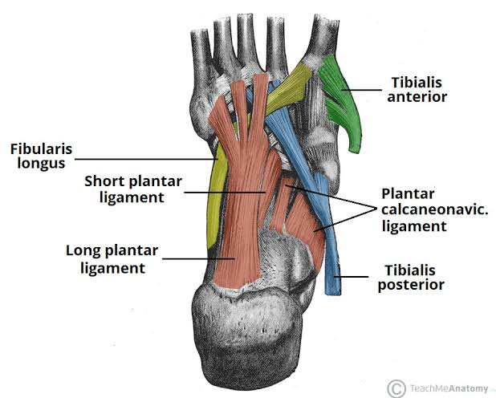

three meta tarsal bone
Ligament
Mostly there are two ligament which held the three cunieform bone
1=Planter ligament
2=Deep transverse metatarsal ligament

Those people who wear smooth shoes .
The cause inflamation due to the pus are formd here because
There maximum forsed take place on the transverse arch of foot
Function
weight bearing and balance of the movement

The end

