Lab 9: Gray to Binay Code

10.1 Aim
To Design and verify the truth table of code conversion from gray to binary code (4 bit) using basic Logic Gates
10.2 Objective:
- Design of different combinational circuits and their applications using basic logic gates.
- Creation and observation of the four-bit binary code number representation sequence
- Exercising the design of code conversion logic circuits,
- Creating the truth table of conversion functions from Gray to binary code
- Developing skills in simplification of specified logical functions
10.3 Apparatus Required:
- Prototyping board (breadboard)
- DC Power Supply 5V Battery
- Light Emitting Diode (LED)
- Digital ICs:7486: Quad 2 input XOR
- Connecting Wires

43
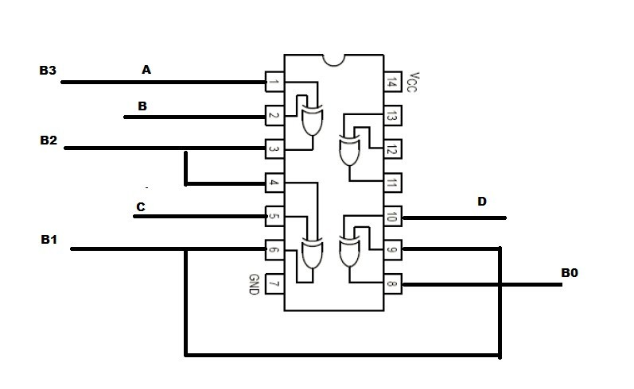
Figure 10.1: Pin Diagram of Gray to Binary code converter using 7486IC
10.4 Pin Diagram:
10.5 Theory:
Code Converters: A code converter is a circuit that makes two digital systems using different codes for the same information. It means that a code converter is a code translator from one code to the other. The code converter is used since to systems using two different codes but they need to use the same information. So the code converter is the solution. Gray-to Binary Converter: An interesting application for the exclusive-OR gate is a logic gate to change a gray number to its equivalent in binary Code. The logic circuit can be used to convert a 4-bit gray number ABCD into its binary-code equivalent, B3, B2, B1 and B0. Application: Some sensors send information in Gray code. These must be converted to binary in order to do arithmetic with it. Occasionally, it is necessary to convert back. Advantages: Higher speed or smaller code.
10.6 Procedure:
- Collect the components necessary to accomplish this experiment.
- Plug the IC chip into the breadboard.
- Connect the supply voltage and ground lines to the chips. PIN7 = Ground andPIN14 = +5V.
- Make connections as shown in the respective circuit diagram.
- Connect the inputs of the gate to the input switches of the LED.
- Connect the output of the gate to the output LEDs.
- Once all connections have been done, turn on the power switch of the breadboard

44
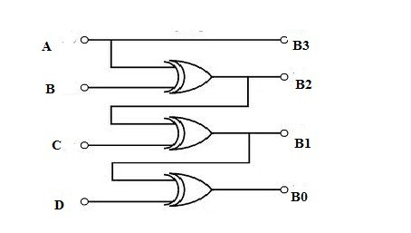
Figure 10.2: Circuit diagram of Binary to Gray Code Converter
8. Operate the switches and fill in the truth table Write "1" if LED is ON and "0" if L1 is OFF Apply the various combination of inputs according to the truth table and observe the condition of Output LEDs.
10.7 Observation Table:
: Input Variable: A B C D
Output Variable: B3 B2 B1 B0
LED ON: RED Light: Logic 1 LED OFF: Green Light: Logic 0
10.8 Calculation:
10.8.1 Kmap Simplification:
For B3
For B2
For B1
For Bo
10.8.2 Boolean Expression:
B3= B2= B1= B0=
45
Table 10.1: Add caption

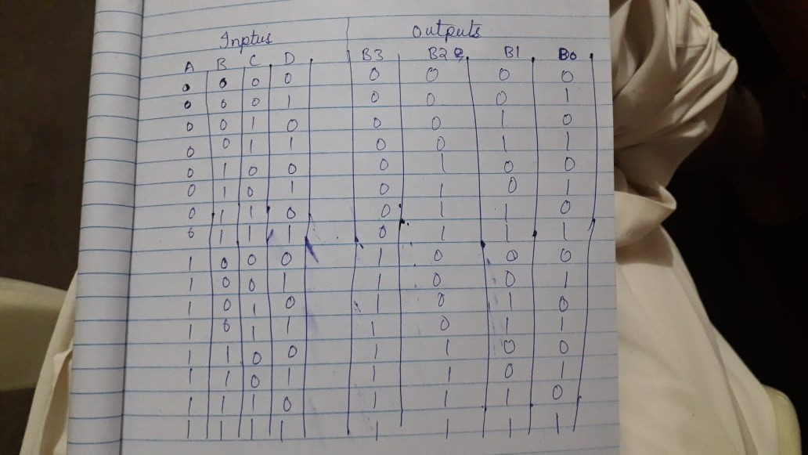

Table 10.2: Simplification for B3

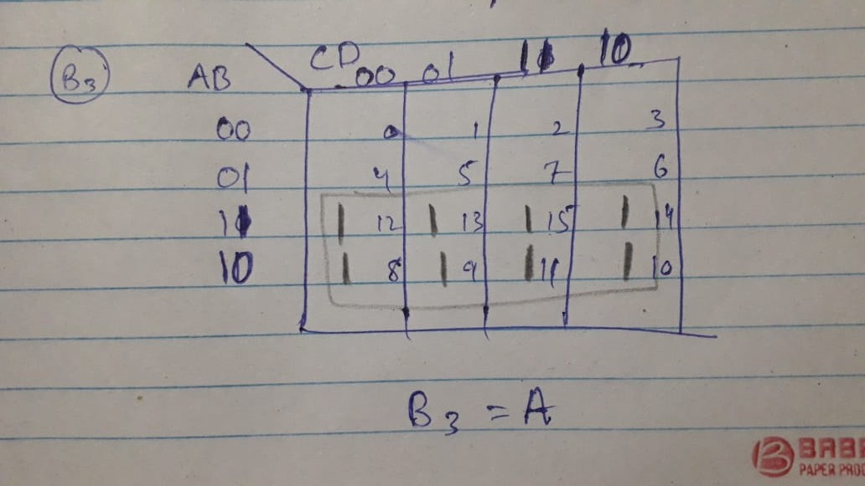

Table 10.3: Simplification for B2

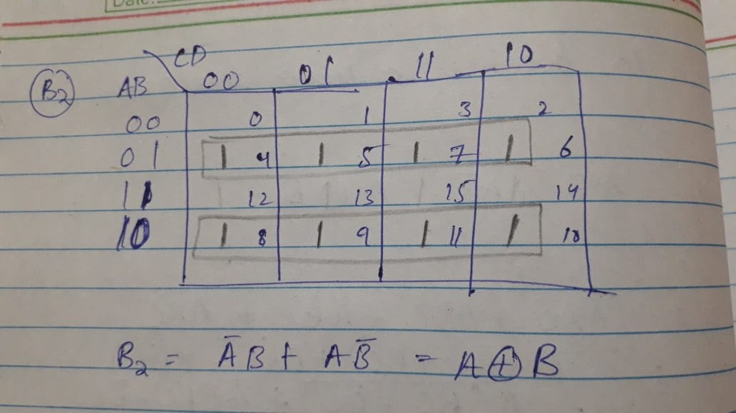
Table 10.4: Simplification for B1

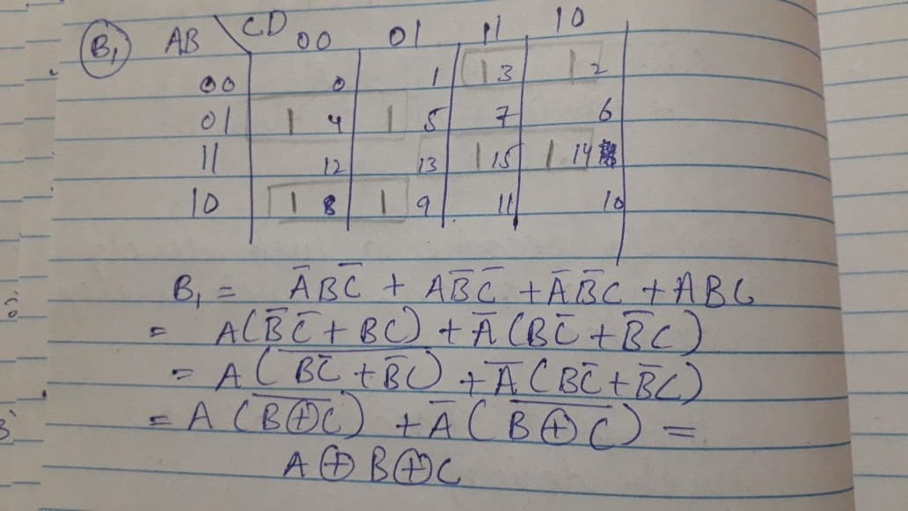
Table 10.5: Simplification for B0

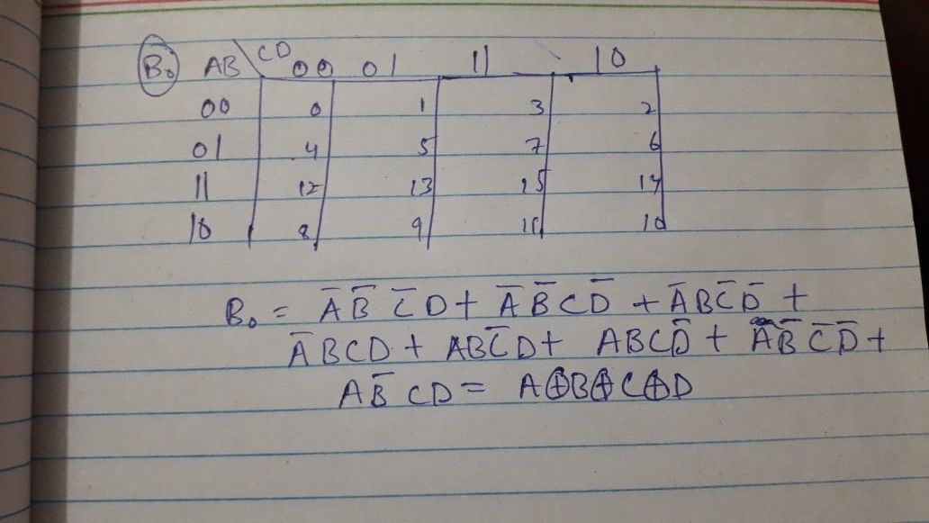

46
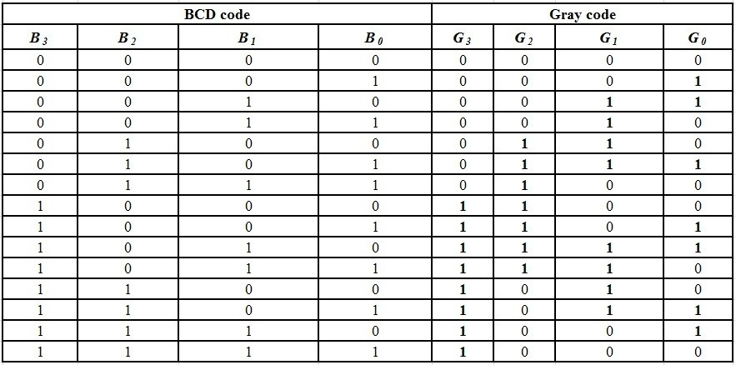
Figure 10.3: Truth table of Binary to Gray Code Converter
10.9 Results and Discussion:
The gray to binary code converter is used since two systems using two different codes but they need to use the same information. Gray to binary code converter convert correctly gray 0000 to 1111 into binary codes. The circuit diagram is very simple and only uses an 74886 IC i.e XOR gate. Unless the karnaugh map is used many gates may be used. but result of karnaugh map minimization, it can work only using XOR Gate. Gray code is a weighted ,cyclic and reflective code are used in instrumentation and acquisition system where linear or angular displacement is measured, shaft encoders, I/O devices ,A/D converters and outer peripheral devices.
10.10 Conclusion:
The function table of JK flip flop using IC 7473 has been verified.

47

