ART HISTORY MID TERM EXAM

QUESTION NUMBER 1:
FILL IN THE BLANKS:
A: Hunting
B: Pharaohs
C: Terracotta
D: Stonehenge
E: Makeup
F: Mycenaean
G: Paleolithic
H: Greek

QUESTION NUMBER 2:
TRUE AND FALSE:
A: True
B: True
C: False
D: True
E: False
F: False
G: True
H: False

QUESTION NUMBER 3:
ANSWER THE FOLLOWING QUESTIONS:
Part A:
Write details about fresco technique?
ANSWER:
FRESCO:
Naming:
The word Fresco is derived from Italian language, which means ‘fresh’.
Origin:
Fresco is an old wall painting technique, which was first introduced in West in Italy during Medieval and renaissance periods. Also, in ancient India it was used to decorate the palaces of the rulers and Ajanta caves.
Technique:
Fresco is a wall painting technique in which powdered pigments or colors are mixed in water and applied to a wet lime plaster ground. The colors then fuse with the plaster, forming a permanent waterproof surface. This technique is extremely durable.
Mostly, vibrant colors are used such as; red, blue, yellow and green. Black is also used to draw margins and white is used to form highlights.
They are applied without shading, always in solid form. On dull backgrounds the bright designs are easily identifiable even from a distance.
Materials:
Materials which are used for Fresco painting include walls, ceilings, fresco boards, color pigments, plastering tools etc.
Surface:
Mostly, walls are used as surfaces for fresco paintings.
History:
In the battle of Corinth (146 BC), the legions looted and burned the Greek city of Corinth. Due to massive destruction that era was known as ‘Dark age’. After time being when things got settled down, the Churches were painted in the form of Fresco technique, those paintings were based on ‘Christianity’. Madonna (Marry) and Jesus’s life stories were painted and illustrated on the walls of churches.
Fresco was 1st done on the walls of Ajanta caves India, then it flourished and got well known in many cultures and civilizations.
Examples:
The most famous Minoan Fresco is known worldwide.
Main Features of Minoan Fresco:
It consists of the following Frescoes;
- The Fisher Boy was excavated from a house preserved beautifully by volcanic ash.
- Three Minoan women (3500 years old artifact).
- Minoan Pottery.

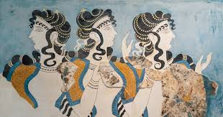
‘Three Minoan Women’
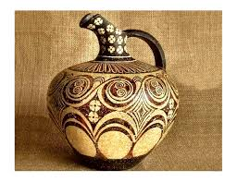
‘Minoan Pottery’
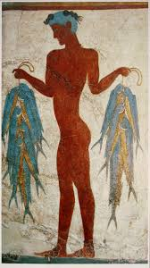
‘ Fisher Boy’
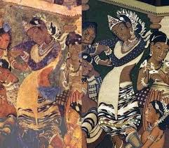
‘Ajanta Caves’

Part B:
Who were Scribes?
ANSWER:
Scribes:
A scribe is person whose work was to make copies of manuscripts before the invention of automatic printing.
In ancient times the scribe’s profession was given much importance because they played a vital role in recording the history, their work included; the copying of manuscripts and other text as well as secretarial and administrative duties such as taking of dictation keeping of business, judicial and historical records for kings, nobles, temples and cities. But now the profession has developed into public servants, journalists, accountants, bookkeepers, typists, and lawyers. In society with low literacy rates, street corner letter writers and readers may still be found providing scribe service.
Examples:
In ancient Egyptian period the hieroglyph used to signify the scribe to write and writings. The hieroglyph contains the scribe’s writing palette, a vertical case to hold writing reeds, and a leather pouch to hold the colored ink blocks, mostly black and red.
Tools used by the scribes:
Scribes usually wrote on papyrus with reed brushes dipped in ink. The ancient Egyptians made ink by grinding brightly colored minerals into powder, then mixing the powder with liquid so that it was easier to apply.

PART C:
Write the difference between obelisk and sphinx?
ANSWER:
Sphinx:
Naming:
the statue was never known as ‘the sphinx’ by the ancient Egyptians. The word Sphinx is a Greek word and came to be applied to the Egyptian sculpture at Giza, according to Verner and others through a translation of the Egyptian name Shesep-ankh which means ‘living image’.
History:
In ancient Egypt, the Sphinx was a spiritual guardian and most often depicted as a male with a pharaoh headdress as in the great Sphinx and figures of the creatures were often included in tomb and temple complexes.
It is basically a creature with the body of a lion and the head of a human, with some variations. It is a prominent mythological figure in Egyptian, Asian and Greek mythology.
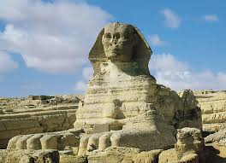

The great sphinx of Giza is the most instantly recognizable statue associated with ancient Egypt and among the most famous in the world.

OBELISK:
Naming:
Obelisk is derived from a Greek word ‘obeliskos’ which means ‘spit’.
History:
it is a tall, four sided, narrow tapering monument which ends in a pyramid like shape. Obelisk played a vital role in the religion and were prominent in the architecture of the ancient Egyptians, who placed them in pairs at the entrance of the temples. A number of ancient Egyptian obelisks are known to have survived. The unfinished obelisk is found in Aswan whereas these obelisks are now dispersed around the world, and fewer of them remain in Egypt.
The obelisk symbolized the sun God RA and during the religious reformation of ‘Akhenaten’ it was said to have been a petrified ray of the Aten, the sun disk.

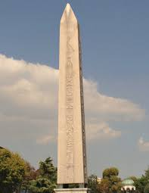

‘OBELISK’

PART C:
Which type of stencil work was introduced in history?
ANSWER:
Hand stencils, were introduced in history.
Explanation:
Hand stencils, made by blowing pigment over a hand held against a wall, are found from over 35,000 years ago in Asia and Europe, and later prehistoric dates in other continents. After that stenciling has been used as a historic painting technique on all kinds of materials. Stencils may have been used to color cloth for a very long time, the technique probably reached its peak of sophistication in ‘Katazome’ and other techniques used on silks for cloths during the Edo period in Japan. In Europe, from about 1450 they were commonly used to color old master prints printed in black and white, usually woodcuts. This was especially the case with playing-cards, which continued to be colored by stencil long after most other objects for prints were left in black and white. Stencils were used for mass publications, as the type did not have to be hand written.
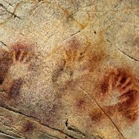
Red Ochre hands stencils in the Cave of El CASTILLO (37,300 BCE). Aurignacian culture. These markings are some of the earliest art of the Upper Paleolithic.

