Department of Computer Science
Business process Engineering
Name: Adnan Khan
Semester: 5th
ID: 14256
Recipient: Aasma Khan
NOTE: no copy/paste from lecture slides apart from figures.
Questions/Answers

Question 1(a):
Answer:
Business Processing Engineering:
A business process is in simple words a combination/blend of tasks that lead to the end goal of an organization. Within any organization there are a set of tasks that must be completed in order to achieve the final company goals these tasks/processes are known as business processes.
As we know that process is a natural continuing activity or function and business is an entity that converts raw materials into products and provides them to the customers, thus the process involved in achieving this goal of converting raw material(input) into product(output) and providing them to the customers and fulfilling their requirement is known as business process.
Process Types:
There are three main process types that we will discuss out of the many others.
- Individual Process
- Vertical Process
- Horizontal Process

Individual Process:
Individual process is the type of process within the business process where the said process is carried out by either an individual process or the process itself is individually designed making it different in characteristics from the rest of the processes.
Individual processes combine to form up vertical or horizontal processes. These individual processes or tasks are handled by single individuals within an organizations department that work on individual process/activities to meet their individually assigned goals/departmental goals.

Vertical Process:
Vertical process is the type of process where the process is contained within one functional unit or department.
The vertical process only involves individuals from a single functional unit or department i.e. in a university system processes happening within a department that only involves individuals from within the department and does not involves other departments or institutions than such a process is called vertical process. These individuals from within the organization work together in different processes to achieve organizational/departmental goals.

Horizontal Process:
Horizontal process is the type of process that is not limited to just a single department, functional unit or organization but instead spans over multiple departments, functional units and/or organizations.
Horizontal process involves individuals from different departments and these individuals from different departments then work/process together to meet the organizational goals/objectives.

Figure 1
Combination of individual processes makes up either the vertical or horizontal process. As seen in Figure 1 a single process i.e. buying a TV commercial as by itself makes up just an individual process but combined with different process within a department it results in vertical process and combination of different processes within several departments/companies results in the horizontal process.

Process Improvement Programs:
There are many process improvement programs among them five are named below.
- Six Sigma
- Lean Thinking
- Theory of Constraints
- Benchmarking
- ISO 9000 Quality Standards.

Question 1(b):
Answer:
Value Added Activities:
Value added activities are those activities that increase the benefits/worth of a product or service provided by a company/organization to its customers.
For a business value added activities are very important as they increase the business’s profitability by recognizing which activities increase profit and which do not. These activities can thus be used to strip away the non-value added activities and thus increase benefit profitability, production time and many more.

Example: For example offering a one year free maintenance/updating service on a new software purchase is a value added activity.

Non-Value Added Activities:
Non-value added activities are those activities that do not increase the worth/benefits of a product or service provided by a company and instead may be the cause to decrease or limit improvement its worth in many cases.
Thus in short words non-value added activities are activities that consumes resources but does not add value/worth to the product or service.
Example: For example there might be a process within a company that does not benefit or increase the worth of the end product but still uses resources in the company, such activities are non value added activities.

Control Activities:
Control activities like their name are activities that control risks i.e. control activities are activities that reduce the risks for a product during risk assessment process.
These are activities that help the management to ensure that risks are identified and dealt with in the risk assessment process.
Thus in simple words control activities are those activities that minimize risks, these activities are important in risk assessment process. When a risk to the company’s goal, by the assessment process than in such a case control activities are determined and implemented.
Example: Example may be that new employees are given training in company matters and employee policies upon starting in the company so as to reduce/control mistakes/risks.

Value Added Activities | Non-value added activities | Control Activities
- Used to increase worth of a product. | - Does not increase worth of a product. | - Used to control/reduce risks.
- Identifies non value added activities and strips them away. | - Wastes company resources and may cause limit end products worth. | - Controls risks that may harm the end products worth.
- Example: Providing a free package of the company’s other products for a period of time when making a new purchase. | - Example: cooking class training within a software company which may waste resources & decrease employees’ productivity. | - Example: Assessing/controlling the risk of piracy before the products launch.

Question 2:
Answer:
The old design (Figure 2) and new design (Figure 3) are given below.

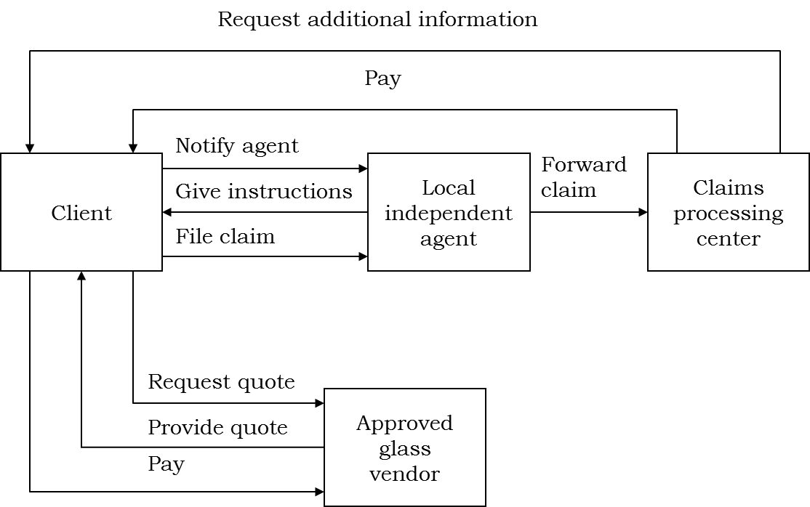
Figure 2

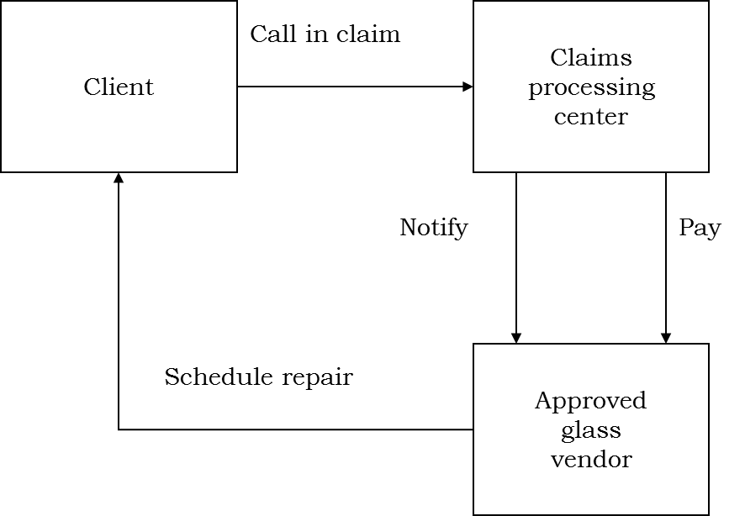

Figure 3
Following are the structural and procedural changes that occur in the new design.

Procedural Changes:
- In the previous design the claimant had to go through a local agent to file a claim and told that client has to get an estimate cost from a local glass vendor which was pretty burdensome for the client, however in the new system design the claims representative at the claim processing center will be given a new authority with which the claim representative can approve the claims without the interference of a third party member.

- The client can call in for a claim without going through the hassle of hiring a local agent.

- With the new design the clients no longer have to go through the hassle of finding estimates and glass vendors as the claims processing center itself has access to glass vendors and can find the estimate on their own giving their customers a much more relaxing and better service.

Structural Changes:

- With the new designed claim processing unit that operates 24/7 the client can contact the claims representative any time and file a claim without the need for any technicality so that any client can file a claim with ease. The clients can speak directly to the claims representative and have a one-on-one conversation with them without any interference from a third party member.
- The claims representative listens to the client’s problems and gathers data from him/her for the claim file enters the data and logs all details related to the claim on a computer and solves/answers the client’s queries.
- The new design also has the glass vendors directly in contact with the claims representative, the claims representative contacts the glass vendors finds an estimate places the order and informs the client about the vendors’ details and their contact.
- The claims information and logged details are all available via the company network system which is then sent to the vendors for calculations of price estimation. The vendors process the data and come up with a price and schedule a repair with the client directly.

Question 3(a):
Answer:

CPS Model:

The CPS model (short for Customer producer supplier model) is a useful method that is used as a means for resolving interface related problems.
The CPS model is applied to critical interfaces between the three main entities in a business i.e. the suppliers that provide the raw materials, the producers that receive the raw material from suppliers who then process it and convert it into a product and the customer who is the main recipient/target for the finished product, at every critical interface the CPS model helps in promoting coordination between all these three entities by understanding the internal and external customers.
The CPS model involves agreements and negotiations between all party members i.e. the three entities thus providing better grounds for business.

Figure 4

As you can see in figure 4 all the three parts (suppliers, producers and customers) are inter-related and perform activities/processes in a coordinated way. CPS is applied to all the critical interfaces within the figure i.e. at the input and output interfaces.
The CPS model can from these interfaces perform a coordination of processes within the three parts and involve negotiation at the input interface between producer and supplier involving the raw material and at the output interface between the customer and producer involving the end product.
In the input/output interface negotiations and agreements occur through the CPS model where producers and customers can specify their requirements which are then met by the supplier (to the producers) and the producers (to the customers).Thus the CPS model creates a chain of customers between the suppliers, producers and customers of the end product.

Question 3(b):
Answer:
The increasing change in the three C’s is when a company is driven to re-engineer their business process.
These three C’s are:
- Customer: With more and more products coming out customers are increasing becoming more and more demanding. To meet new requirements of the customers every company/organization changes their business process to stay in the market competition.
- Competition: Due to new modern technologies and many companies out there competitions in the market have now become more intense than ever before. Each organization has to offer something better than their competitors to stay in the market and meeting the increasing demands of the customers rapidly is the only way of beating the competition.
- Change:
- With time new and more advanced technology is emerging in the market that is better fast and more reliable in order to meet the increasing and fast meeting demands of the customers every company is driven to update their technology so in order to meet the increasing demands and stay in the market. And so this is when a company decides to re-engineer their business process.
- Companies constantly have pressure to improve and to design new products faster so as to keep up to date with the changing market and new trends in business.
- Every company no matter what their end product may be has to improve/change in order to survive which is why every company re-engineers its business process with new change in the three C’s.

Example: for example a company that produces good quality cold drinks sets up their product for customers at the market but does not acquire the help of any modern digital advertisement than in such a case even if the product is of a good quality it might not sell well as there is no way for the customers to know anything about the product.

The following things are what are needed to be changed in re-engineering:

Processes are changed: During re-engineering of a business process only the processes within an organization are changed so as to reduce extra costs, idle time and increase the capacity and quality of the end product.

Formal Processes: Formal processes within an organization/company are always the prime candidates for needing to be reengineered.
The formal processes involves written policies which tend to take up a lot more time resulting in consuming more time and wasting key decision moments, since these processes involve many more departments thus formal processes within several departments take a lot more time and as we know written approvals and policies take a lot of time in any organization.
Thus they are always the prime candidates for reengineering so as to improve time and efficiency.
Hence these are what a company needs to reengineer.

THE END!

