MID-TERM ASSIGNMENT # 01

Student Name: | GULDANA
Student ID Number: | 15970
Lecturer’s Name: | WAJEEHA AMIN
Date of Submission: | 14 Sep, 2020
Course Name: | MICROECONOMICS

MBA
Q1) Does a change in consumers’ tastes lead to a movement along the demand curve or a shift in the demand curve? Does a change in price lead to a movement along the demand curve or a shift in the demand curve.
Ans)
If the change in consumers tastes leads to an increase in demand consumers want to buy more of this good at every price level. A change in price leads to a movement along the demand curve. Because price is measured on the vertical axis a change in the price represents a movement along the demand curve.
The demand curve is downward sloping indicating the negative relationship between the price of a product and the quantity demanded. For normal goods, a change in price will be reflected as a move along the demand curve while a non-price change will result in a shift of the demand curve.
Changes in factors like average income and preferences can cause an entire demand curve to shift right or left. This causes a higher or lower quantity to be demanded at a given price. Ceteris paribus assumption. Demand curves relate the prices and quantities demanded assuming no other factors change.An increase in the price of a substitute-product will lead to a fall in the quantity demanded of that product and an increase in demand for the substitutes whose prices have not changed.
Regarding the tastes of the buyers for the commodity, a favorable change leads to increase in demand and unfavorable change to decrease.
Example: Increase in the popularity of physical fitness will increase the demand for jogging shoes and bicycles. As another example, the demand for cell phones rises reducing the demand for land-line phones.
Does a change in consumers tastes lead to a movement along the demand curve or a shift in the demand curve?
Regarding the tastes of the buyers for the commodity, a favorable change leads to increase in demand and unfavorable change to decrease.
Example 1: Increase in the popularity of physical fitness will increase the demand for jogging shoes and bicycles.
Example 2: the demand for cell phones rises, reducing the demand for land-line phones.
A demand curve reflects the relationship between the price of a good and the quantity demanded, ceteris paribus. So a demand curve, graphed in two dimensions, can handle only two variables: price and quantity demanded per unit time.
Example of a change in demand. A GEO company’s TV commercial showing fit young people enjoying beer and life causes sales to increase 45%

=====x=====x=====x=====x=====x=====x=====

Q2. Does a change in producers’ technology lead to a movement along the supply curve or a shift in the supply curve? Does a change in price lead to a movement along the supply curve or a shift in the supply curve.

Ans)
In addition to price, changes in other determinants of supply such as changes in the producer's technology will cause the supply curve to shift. If the change in producer's technology leads to an increase in supply, producers are able to sell more of this good at every price level.
Although a change in price of a good or service typically causes a change in quantity supplied or a movement along the supply curve for that specific good or service, it does not cause the supply curve itself to shift.
Only when quantity supplied gets affected by a change in price of that commodity, movement would happen along the supply curve. And thats because by definition supply curve is a graphical representation of quantity supplied at different price levels of a commodity.As regards to change in supply caused by factor other than price of the commodity, that would lead to a shift in supply curve.Like the case that has been mentioned in the question.
Technological change. Intuitively, I would assume a better technology use with time. And this would mean increase in production and hence increased willingness to supply at each price level by producers which would shift supply curve to the right.An inferior technology on the other hand would shift the supply curve leftwards indicating producers are willing to supply less at each price.In contrast, the supply curve represents the quantities of a good or service that will be sold at various price points during a specific period of time.
Price and quantity supplied are directly related when analyzing the supply curve. A rise in prices will result in an increase in supply, while a decrease in prices will result in a reduction in supply. Other factors that can influence the market supply of a given product or service include technological advancements and changes in pricing for things such as inventory, raw materials and labor.

=====x=====x=====x=====x=====x=====x=====

Q3)

- Draw the demand and supply curves. What is unusual about this supply curve? Why might this be true?

Price | Quantity demanded | Quantity supplied
Dh 40 | 10,000 | 8,000
80 | 8,000 | 8,000
120 | 6,000 | 8,000
160 | 4,000 | 8,000
200 | 2,000 | 8,000

Ans)
The demand curve is a downward-sloping line and supply curve is a vertical line. It is possible, if the quantity supplied is fixed at any price.

Graph
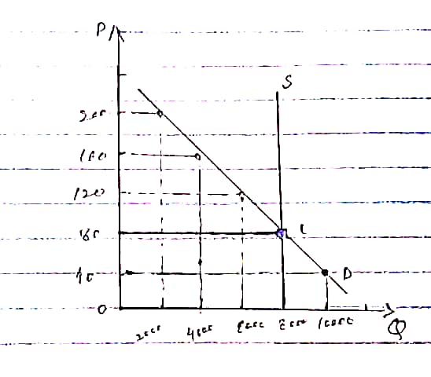

- What are the equilibrium price and quantity of tickets?

Ans)
The equilibrium price is 8 and the equilibrium quantity is 8000 tickets and the new equilibrium price is 12 and the equilibrium quantity is the same (8000 tickets)
=====x=====x=====x=====x=====x=====x=====
Q4. Choose the best answer.

1. A downward-sloping demand curve reflects …………….
a. the idea that the demand for the good in question is decreasing as time goes by.
b. the idea that there are fewer suppliers of the good as time goes by.
c. the idea that there exists a substitute for the good in question and the price of that substitute is decreasing.
d. the law of demand.

2. What will happen in the rice market if buyers are expecting higher rice prices in the near future? ……………………..
a. The demand for rice will increase.
b. The demand for rice will decrease.
c. The demand for rice will be unaffected.
d. The supply of rice will increase.

3.Two goods are complements if a decrease in the price of one good ……………
a. decreases the quantity demanded of the other good.
b. decreases the demand for the other good.
c. increases the quantity demanded of the other good.
d. increases the demand for the other good.

4. A likely example of complementary goods for most people would be…………..
a. hamburgers and hot dogs
b. lawnmowers and automobiles.
c. hamburgers and French fries.
d. Dr. Pepper and Pepsi.

5. Economists in general _________Not at all
a. do not try to explain people’s tastes, but they do try to explain what happens when tastes change.
b. believe that they must be able to explain people’s tastes in order to explain what happens when tastes change.
c. do not believe that people’s tastes determine demand and therefore they ignore the subject of tastes.
d. incorporate tastes into economic models only to the extent that tastes determine whether pairs of goods are substitutes or complements.

=====x=====x=====x=====x=====x=====x=====
x=====x=====x=====x=====x=====x
x=====x=====x=====x
x=====x
END

