NAME : JUNAID MASOOD
ID : 16718
DEGREE : B TECH CIVIL
SUBJECT: Surveying 1
SUMITTED TO : Engr Humaira
Final examination spring 2020
- Q1 ANSWER

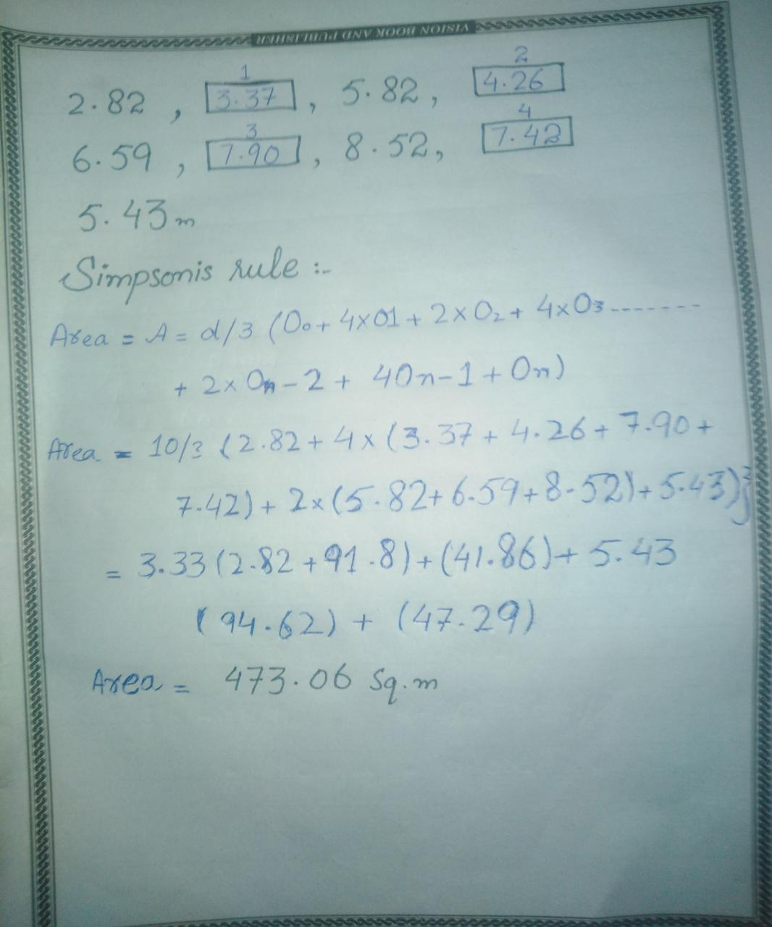

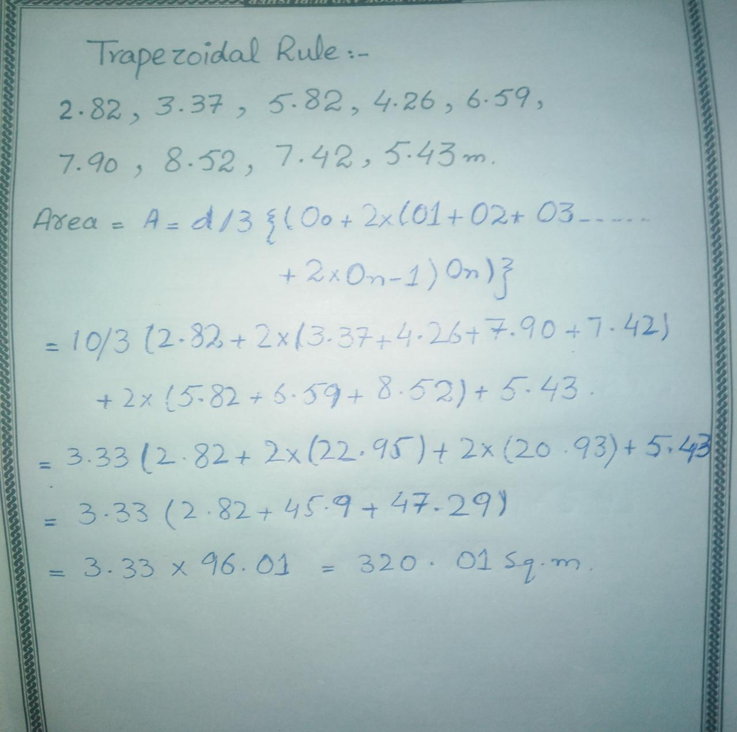

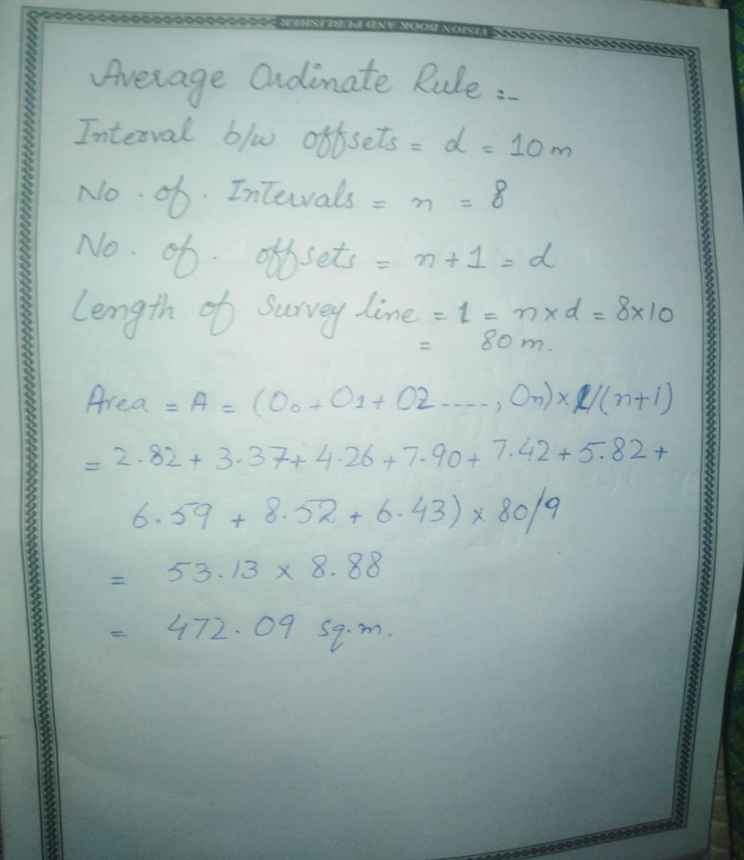

- Q2 ANSWER
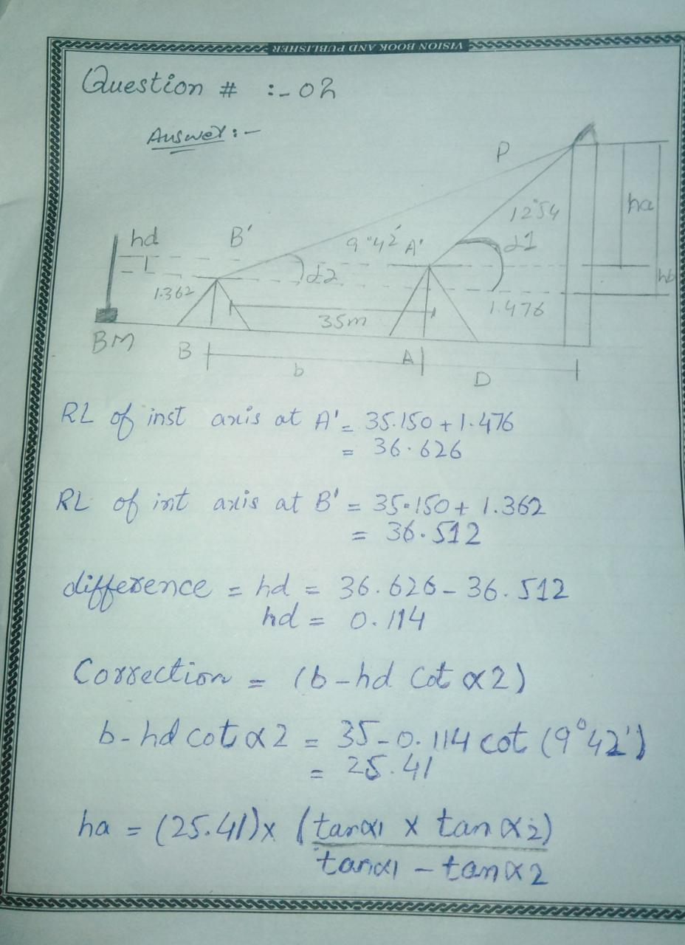

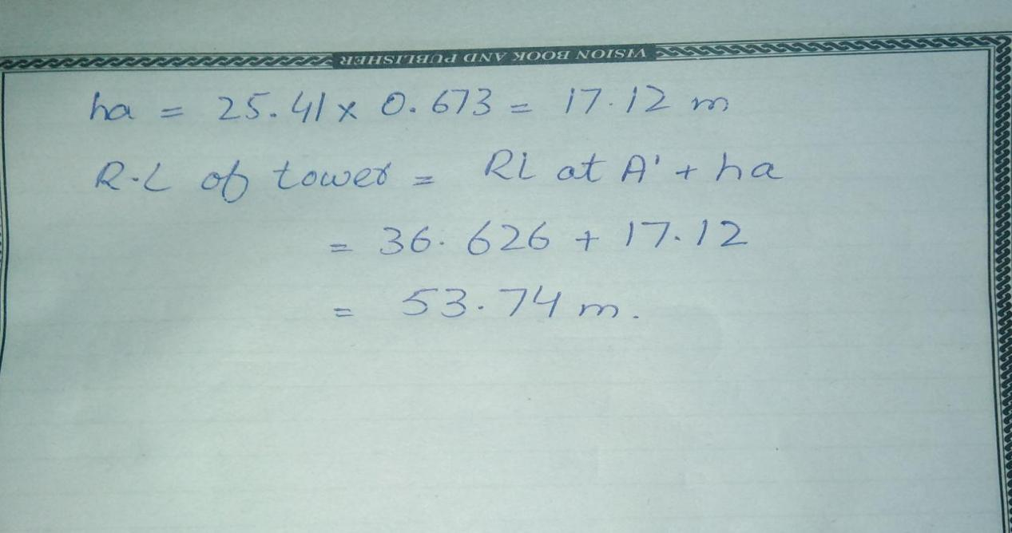

- Q3ANSWER

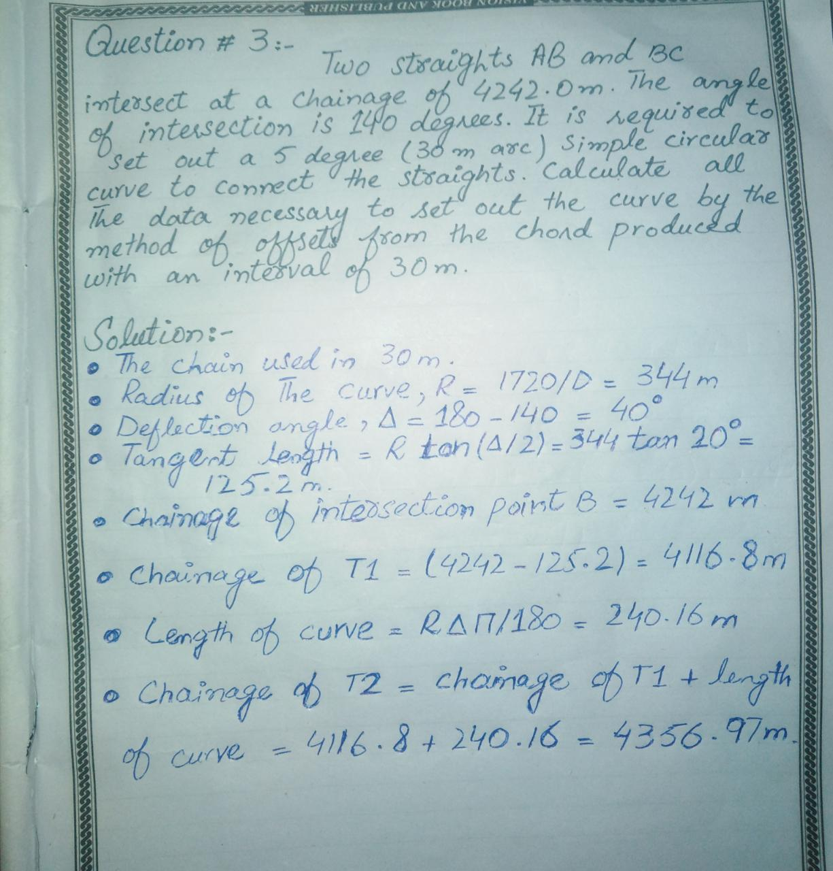

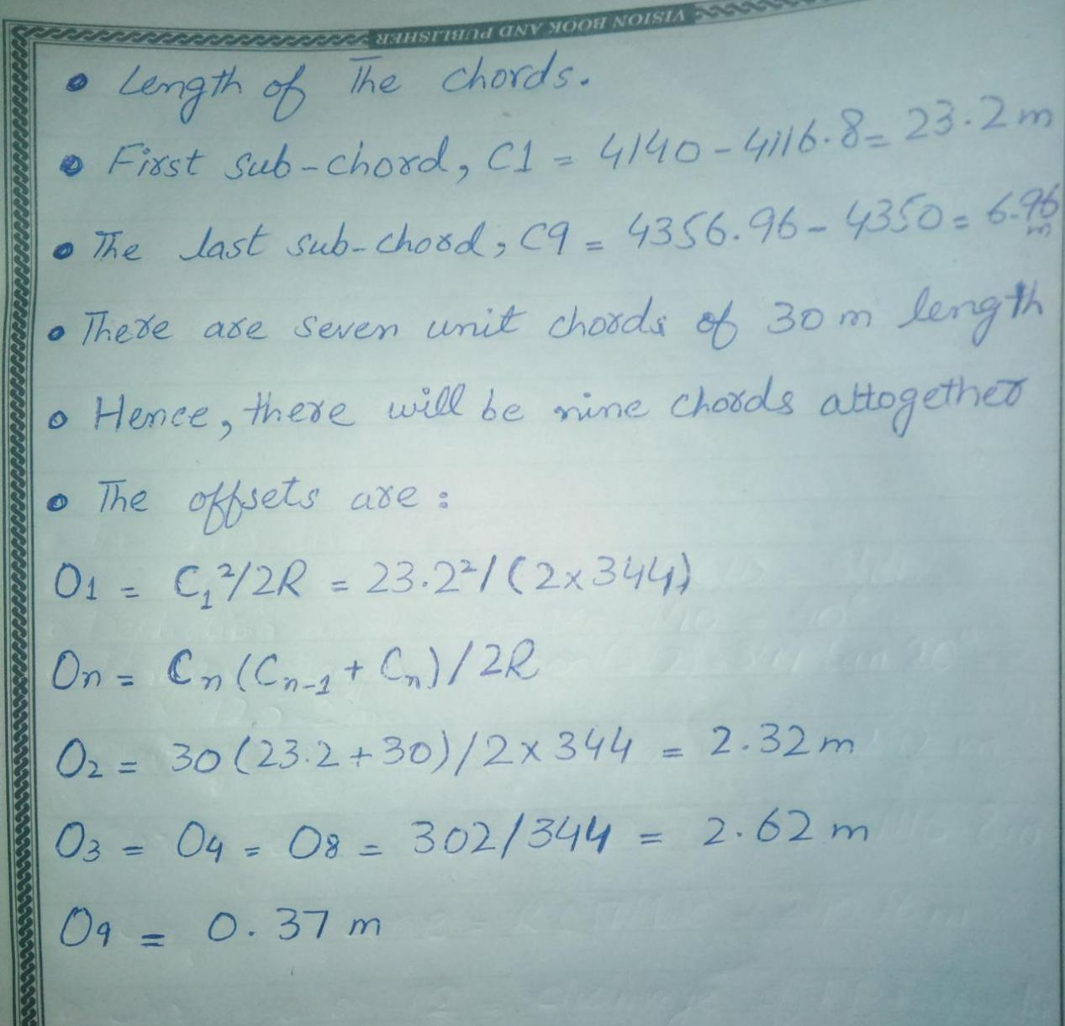

- QUESTION NO 4:

ANSWER:(I)

- objective of Hydrographic surveying:

- Measurement of tides for sea coasts I.e. construction of the sea defense work, harbors etc
- Determination of the bed depth by sounding
- For navigation
- Location of rock, sand bar, buoys, navigation lights etc.
- For location of the under water work, volume of the under water excavation etc.
- In connection with irrigation and land drainage scheme.
- Determination of direction of current in connection with
- Location of sewer out fall
- Determination of the area subjected to silt and scour
- For navigation proposes
- Measurement of quantity of water and flow of water in connection with water scheme, power scheme, flood control etc

(ii) ANSWER
- Equipment for making sounding

- (1)Sounding boat:
It should be sufficiently roomy and stable. A flat bottom boat is suitable in quiet water while round bottom boat is convenient in rough water.
A power boat (steam or motor launch) is most suitable when wind is blowing and water converts are strong.
- (2) sounding rods ( or poles)
Sounding rod are convenient is shallow and smooth water up to depth of about 4 to 6m (15 to 20 feet).
They are mode of well season tough timber and are circular in cross section of 5 cm diameter ( 2 inch)and usually 3 to 7.5 m long ( 12 to 25ft long). graduated are taken by lowering it vertically into the water until it hits the bottom and reading the graduation at the surface
- (3) lead line:
Lead lines are also called sounding lines are used for depth over about 6m(20ft). it consists of suitable length of stretch-resistance cord or other material to which a heavy lead weight 5 to 10 lb id attached.

The cord is marked with fee or meter graduation and there should be checked frequently against a steel tape, for their accuracy.
In use the weight is lowered into the water being careful to keep the cord vertical. The graduation at surface is read when the weight hits bottom.
(4)Sounding chain:

For regular sounding a brass chain is most satisfactory since its length is practically constant.
The links are welded. The brass tags are attached at 0.2m interval but leather or cloth tags are preferred as the brass tags can injure the hands of the lead man.
The chain should be tested periodically.
( 5) Sounding lead:
The weight attached to the lead line conical in shape and varies from 2.5 kg to 12.5 kg depending upon the depth of water and the strength of the water currents.
The shallow still water weight equal to 2.5 kg (5lb)
Moderate depth up to 10m (40 ft ) weight is equal to 5 kg (10lb)
Greater the depth where current are strong weight is equal to 10 kg(20 lb )
The weight is circular in cross section and length equal to 3 to 4 diameter and slightly tapers towards the top end.
(6)Sounding Machine:
It is very useful when much sounding is to be done.
The type commonly used in hand driven and consists of a paino wire carrying a 7 kg load and wound around a drum.
Two dials, the outer one indicated the depth in m or ft and on inner one is tenth of a meter
- Fathometer:
For ocean sounding on instrument known as fathometer is used.
It is electric device and measure the time required for the sound (impulses)travel to the bottom of water and back.
The travel time is converted into depth displayed in either digital or graphic for fathometer is also called echo sounder.
- Sextant:
The theodolite and other instrument used in land surveys are not used in a boat where the support is unstable. The sextant is well suited to hydro graphic work and has the added advantage of measuring angles in any plane.
It is the most precise hand instrument yet device for measuring angles.
There are two versions of the instrument:
- Nautical sextant (or sounding sextant).
- Box sextant.
- Equipment for making sounding Signals:
Shore signals are required to mark the ranges i.e, lines along which sounding are to taken and the reference points to which angular observations are to be taken from the boat.
They should be clearly visible for considerable distances. If the water is shallow, ordinary pole signal may be used but if water deep buoys are used as signals.
- Ranges:
The lines on which sounding are taken are called ranges or range
lines.
They are laid on the shore parallel to each other and at right
angles to the shore line or radiating form a prom nay natural
object when the shore line is very irregular. Each range line should be marked by means of signals erected at
2 points it, at considerable distance apart.
The spacing of range lines vary form 6m 30m (20 to 100ft)
depending upon the object of survey and the nature of the
bottom.
(iii) ANSWER
- Classification of leveling:

- Differential leveling
It is the operation of leveling determine the elevation of points some distance apart or establish B.M. the process is same as that in continuous or compound leveling.

- Check leveling
It is operation of running levels for the purpose of checking a series levels, which have been previously fixed

- Profile leveling
It is the operation in which the object is to determine the elevation of points at known distance apart along a given line, a;so called longitudinal.

- Cross -section
It is the method of leveling to determine the surface undulations or the outline of the ground transverse to the given line and on either side of it.

- Reciprocal leveling
It is the method of leveling in which the difference in elevation between two points is accurately determined by two sets of observation,when I is not possible to set up the level midway between the two points.

- Hypsometric leveling
It is the method of leveling in which the height of mountains are found by overseeing the temperature at which water boils.

- Barometric leveling
It is the method of leveling in which the altitudes of points are determined by means of a barometer. Which measures the atmospheric pressure.

- Trigonometrical leveling
It is the process of leveling in which the elevations of points are computed from vertical angles and horizontal distances measured in the field.

