NAME SAEEDA NAZ

ID 14332

SEMESTER 5TH

QUESTION NO 1

What is Class and role of object in a Class, explain in detail with the help of a Suitable program?

ANSWER NO 1

CLASS:
A class is a logical entity that determines how an object will behave and what the object will contain. In other words, it is a set of instruction to build a specific type of object. Class doesn't consume any space.
OR
Collection of objects is called class. It is a logical entity.

ROLE OF OBJECT IN CLASS:

Any entity that has state and behavior is known as an object. It can be physical or logical.
An object is an entity which consists of methods and properties to make a particular type of data useful. When you call an object, you are asking the object to invoke or execute one of its methods. An object can be a data structure, a variable or a function. It has a memory location allocated. The object is designed as class hierarchies. Objects can communicate without knowing the details of each other's data or code. The only necessary thing is the type of message accepted and the type of response returned by the objects. When an object is called the concerned class is executed and its functionality is performed then the class returns the result to the object.

EXAMPLE:

public class Dog //Class Declaration
{
String bread; //Instance Variables i.e. bread, size, age and color of dog
String size;
int age;
String color;
public string getInfo() //function for string display
{
return (“Bread is :” +bread+ “Size is :” +size+ “Age is :” +age+ “Color is :” +color);
}
}
public static void main (String[] args) // Main function
{
Dog maltese = new Dog(); //Creating object of class Dog.
maltese.bread = “Maltese”; //assigning values to the properties of dog.
maltese.size = “Small”;
malteses.age = 2;
maltese.color = “White”;
System.out.println(maltese.getInfo()); //Calling the display function along with class object.
}

OUTPUT:
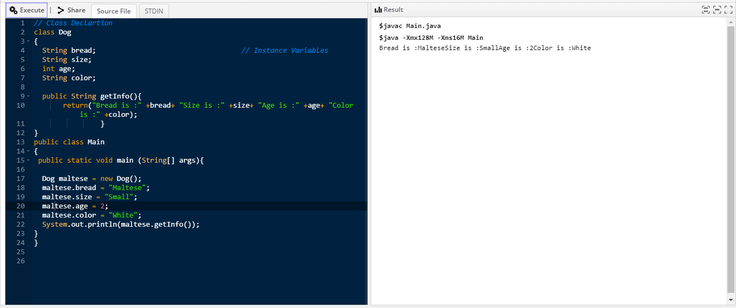

QUESTION NO 2
Write a program about table printing which takes input from the user on the basis of OOP and explain in detail.

ANSWER NO 2:

PROGRAM:

import java.util.Scanner;
class table //Created class Table
{
int c; //Initalizing integer to count 1-10.
public table(int x) //Initializing function table, passed parameter x, value taken from user.
{
System.out.println("Table of " + x);
for(c=1;c<=10;c++) //Loop to perform table calculations.
System.out.println(x + "*" + c + " = " + (x*c)); //Display each line of table.
}
}
public class Main{ //Main class
public static void main(String args[]) // Main function
{
int n; //Initializing variable to take integer from user.
System.out.println("Enter an integer to print table");
Scanner in = new Scanner(System.in); //input from user.
n = in.nextInt(); //assign user given value to integer n
table mytab = new table(n); //created object of the class and called the table function.
}
}
OUTPUT:
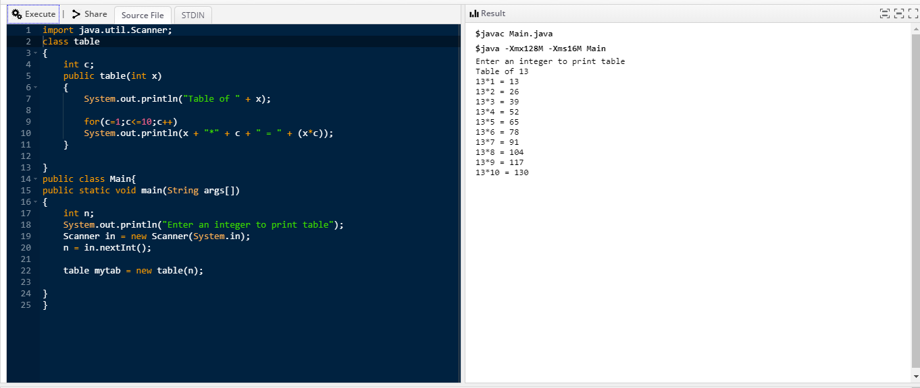

QUESTION NO 3

Write a program about any 2 cars which can calculate the performance of both of them and explain in detail.

ANSWER NO 3
PROGRAM:

class car //Class car for comparing cars performance.
{
int acc_car; /*initializing the variable of car perfom. i.e. acceleration,
fuel capacity, car break rate.*/
double fuelcap_car;
double car_break;
void perf() //Function for calculating performance of car.
{
double per;
per=acc_car/car_break; //Formula for performance.
System.out.println("Performance of the Car = " +per ); //Display Result.
}
}
public class Main { //main class
public static void main(String[] args) { // Main function
car Car1 = new car(); //creating object for 1st car.
car Car2 = new car(); //creating object for 2nd car.

Car1.acc_car = 250; //Assigning values to car1 and car2 acceleration variables.
Car2.acc_car = 340;

Car1.car_break = 9.6; //Assigning values to car1 and car2 Break variables.
Car2.car_break = 9.3;

Car1.fuelcap_car = 109; //Assigning values to car1 and car2 fuel capacity variable.
Car2.fuelcap_car = 150;
System.out.println("Car 1st Performance"); //Printing Car1 performance.
System.out.println("Accelerating Speed = " +Car1.acc_car + "km");
System.out.println("Car Break = " +Car1.car_break + "km");
System.out.println("Fuel Capacity = " +Car1.fuelcap_car + "gallons");
Car1.perf(); //Calling function performance with help of object for car1.

System.out.println("Car 2nd Performance"); //Printing Car2 performance.
System.out.println("Accelerating Speed = " +Car2.acc_car + "km");
System.out.println("Car Break = " +Car2.car_break + "km");
System.out.println("Fuel Capacity = " +Car2.fuelcap_car + "gallons");
Car2.perf(); //Calling function performance with help of object for car2.
}
}
OUTPUT:
