Assignment
Name: Sher Muhammad Khan ID # 16402
Program: BBA/MBA Assignment (Spring-2020)
Course Title: Financial Management Instructor: Sir Naveed Azeem Sb
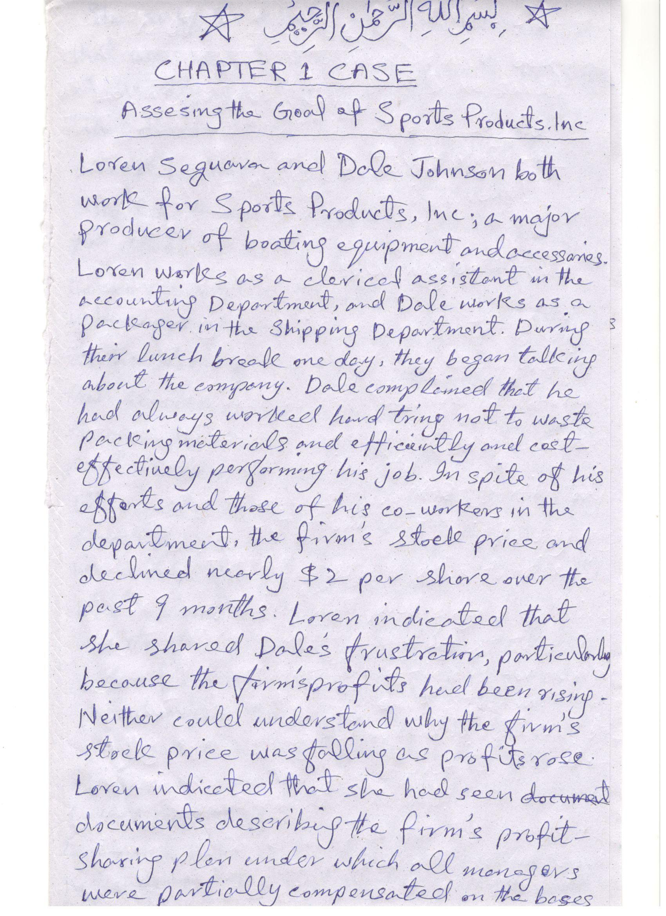
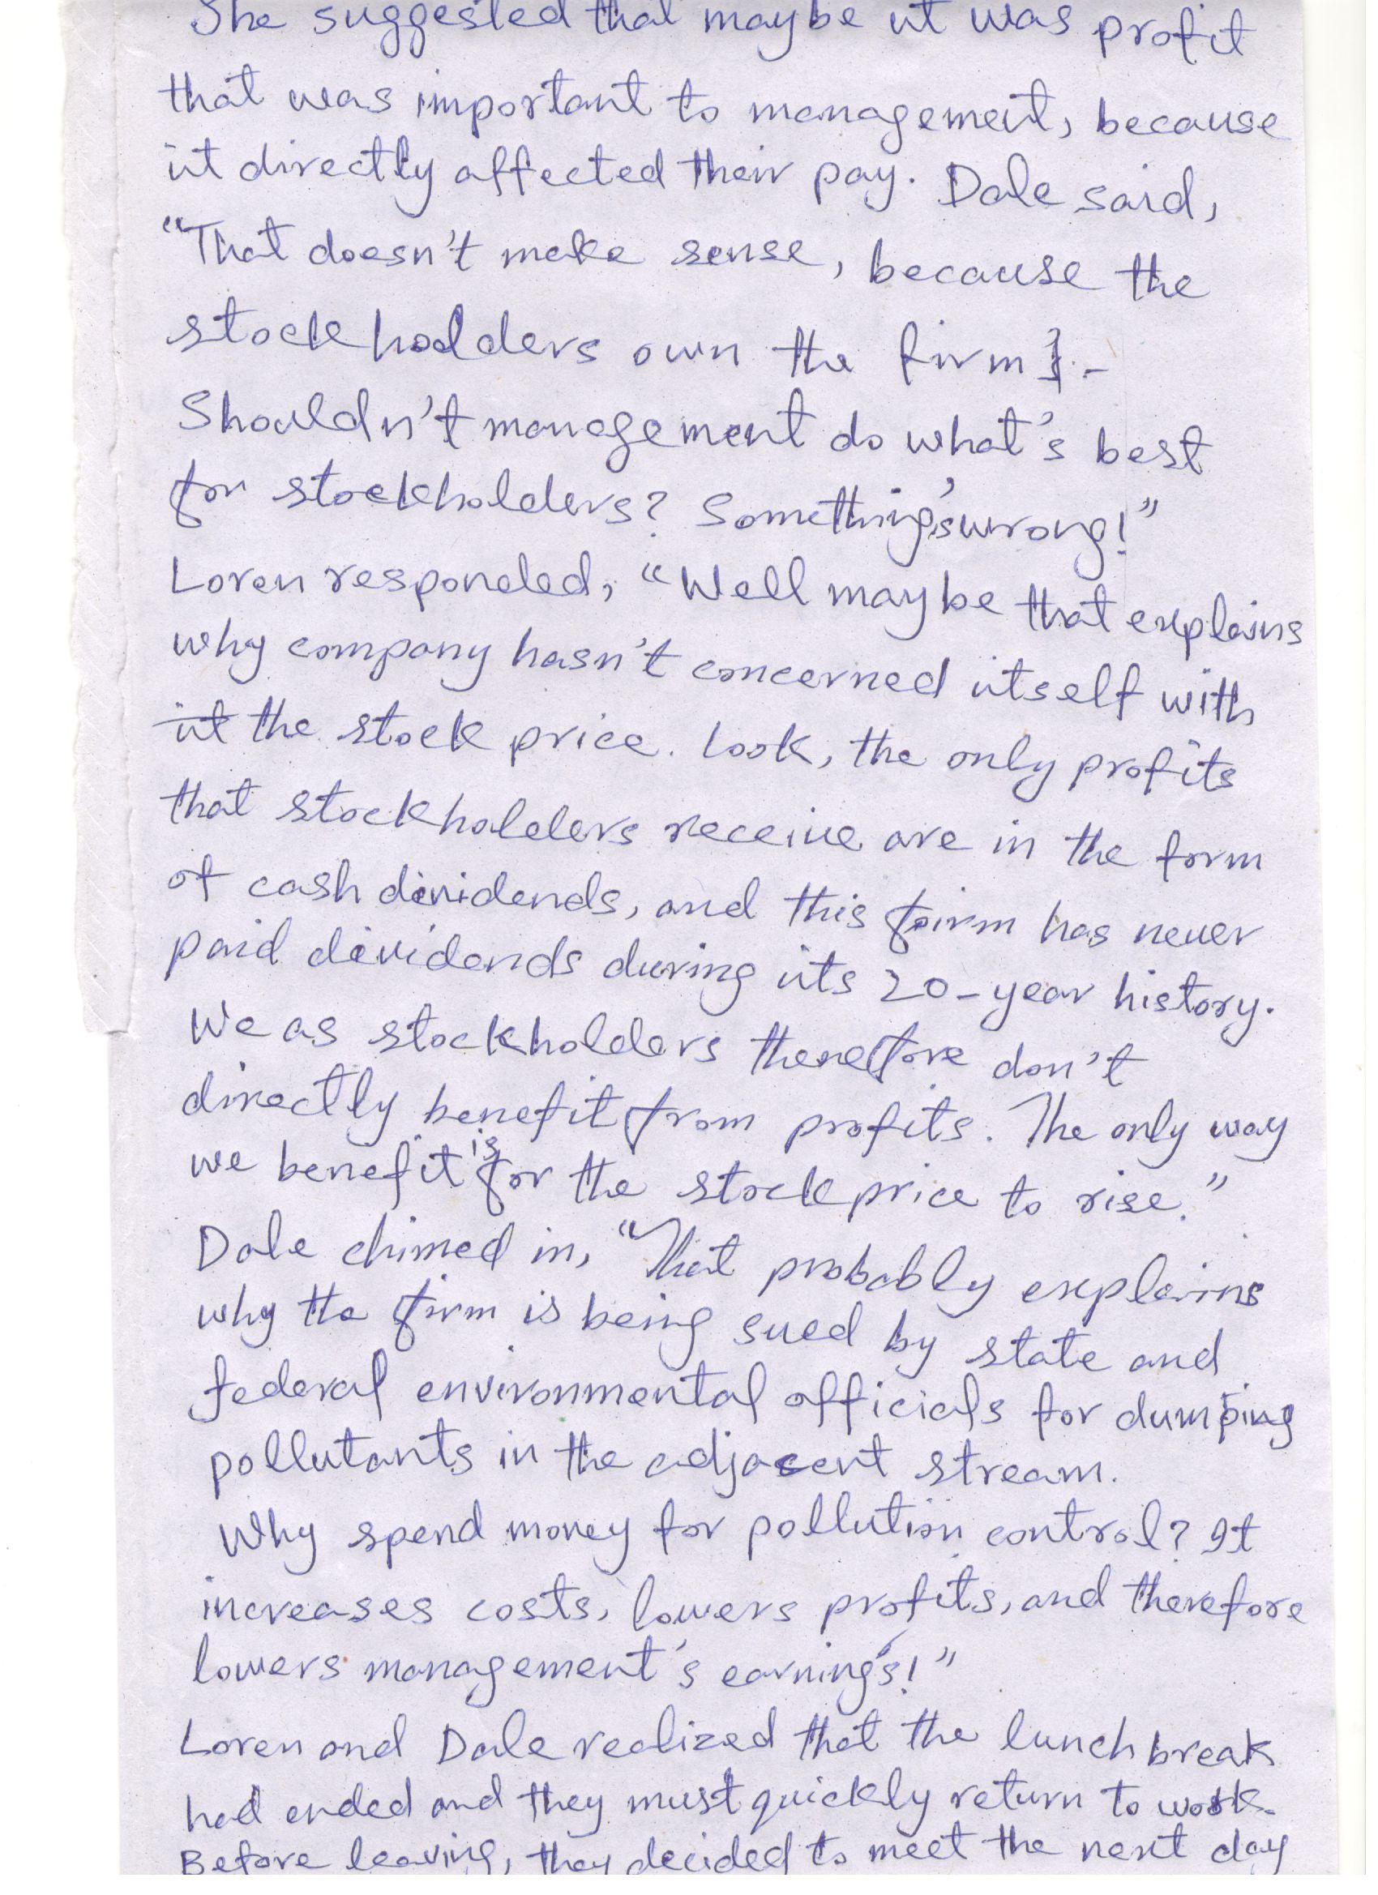

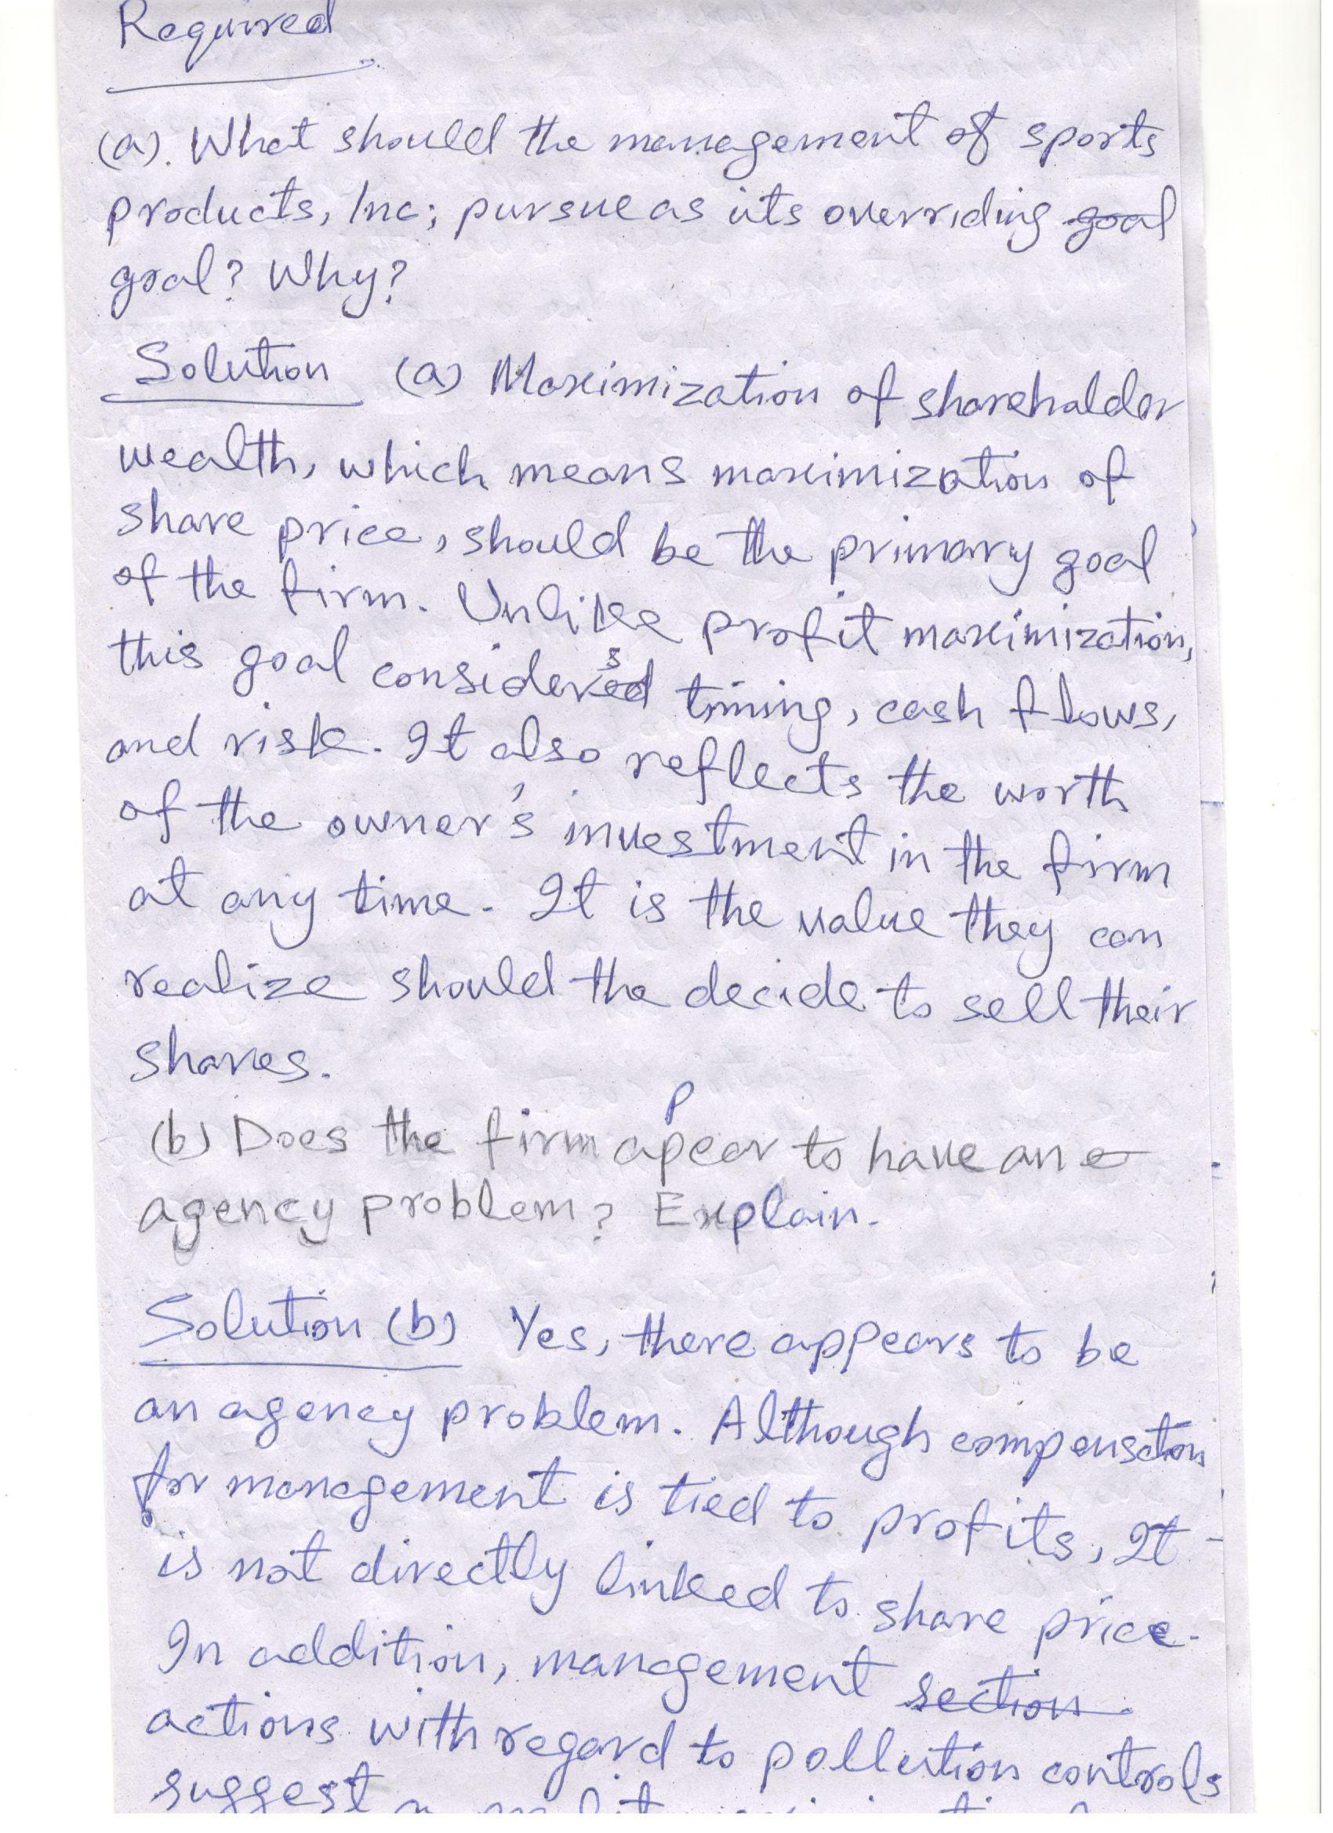

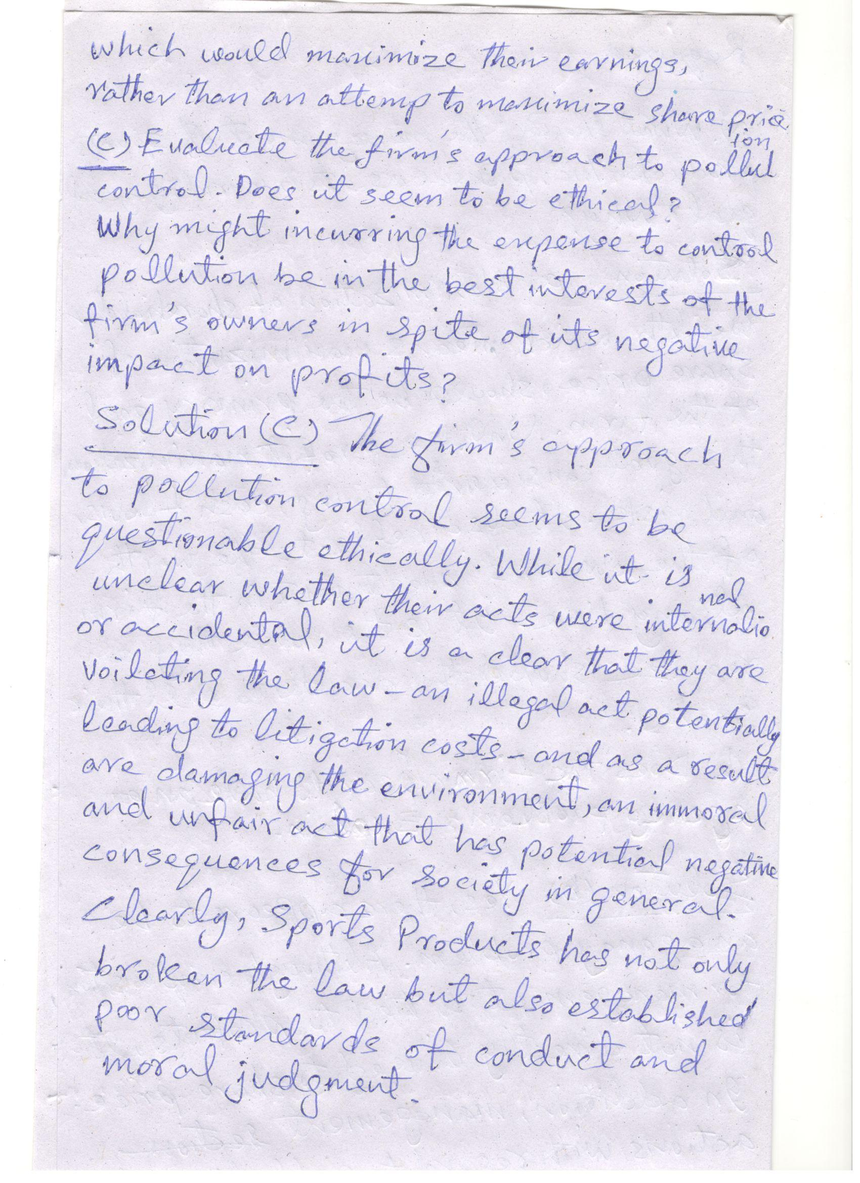

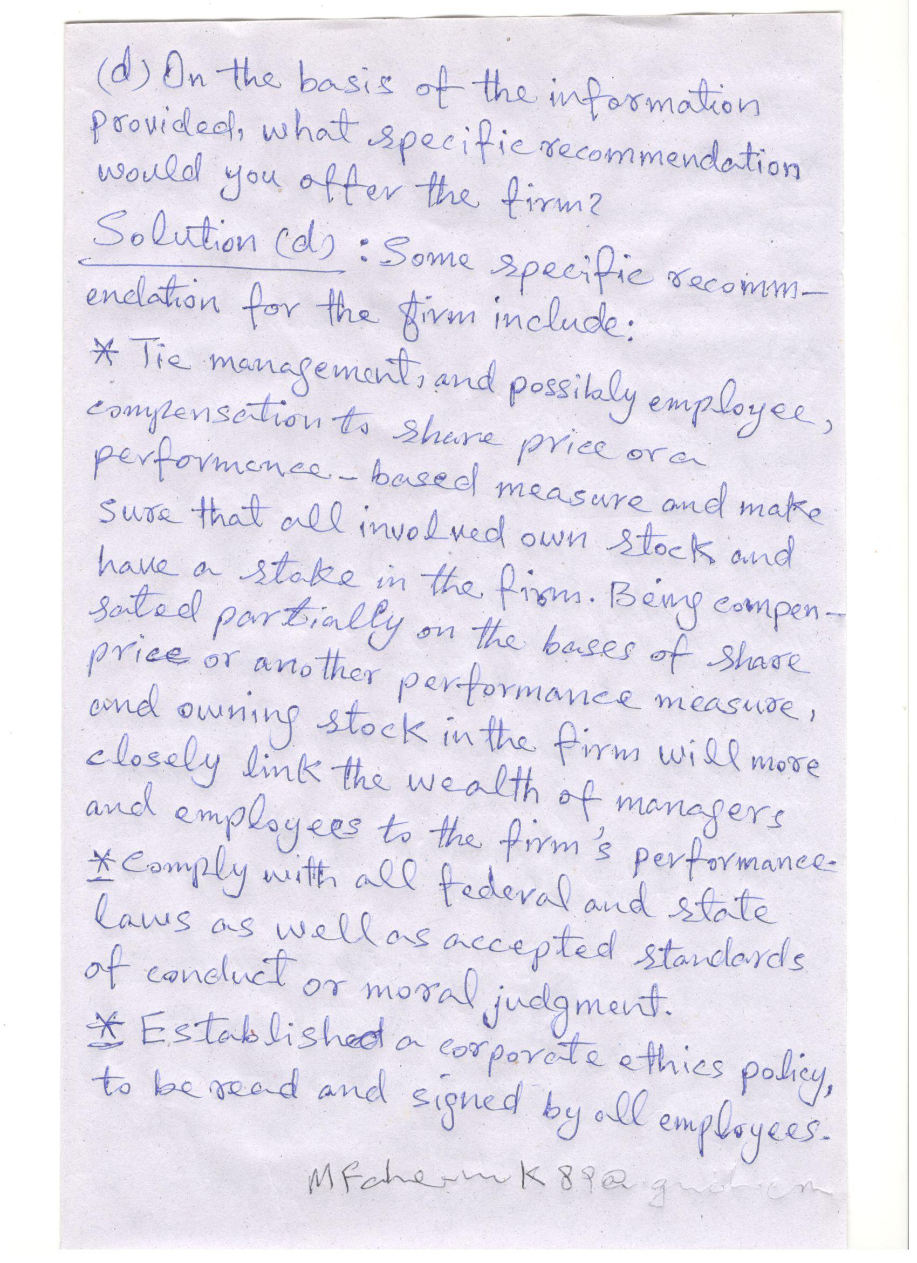

CHAPTER 2 CASE Assessing Martin Manufacturing’s
Current Financial Position
Terri Spiro, an experienced budget analyst at Martin Manufacturing Company, has been charged with assessing the firm’s financial performance
during 2003 and its financial position at year-end 2003. To complete this assignment, she gathered the firm’s 2003 financial statements, which follow. In addition, Terri obtained the firm’s ratio values for 2001 and 2002, along with the
2003 industry average ratios (also applicable to 2001 and 2002).
Martin Manufacturing Company
Income Statement
for the Year Ended December 31, 2003
Sales revenue $5,075,000
Less: Cost of goods sold 3,704:000
Gross profits $1,371,000
Less: Operating expenses
Selling expense $650,000
General and administrative expenses 416,000
Depreciation expense 152,000
Total operating expense 1,218,000
Operating profits $ 153,000
Less: Interest expense 93,000
Net profits before taxes $ 60,000
Less: Taxes (rate 40%) 24,000
Net profits after taxes $ 36,000
Less: Preferred stock dividends 3,000
Earnings available for common stockholders $ 33,000
Earnings per share (EPS) $0.33

Martin Manufacturing Company
Balance Sheets
December 31
Assets 2003 2002
Current assets
Cash $ 25,000 $ 24,100
Accounts receivable 805,556 763,900
Inventories 700,625 763,445
Total current assets $ 1,531,181 1,551,445
Gross fixed assets (at cost) $2,093,819 $1,691,707
Less: Accumulated depreciation 500,000 348,000
Net fixed assets $ 1,593,819 $ 1,343,707
Total assets $ 3,125,000 $ 2,895,152
Liabilities and Stockholders’ Equity
Current liabilities
Accounts payable $ 230,000 $ 400,500
Notes payable 311,000 370,000
Accruals 75,000 100,902
Total current liabilities $ 616,000 $ 871,402
Long-term debt $ 1,165,250 $ 700,000
Long-term debt $ 1,781,250 $ 1,571,402
Stockholders’ equity
Preferred stock (2,500 shares, $1.20 dividend) $ 50,000 $ 50,000
Common stock (100,000 shares at $4 par) 400,000 400,000
Paid-in capital in excess of par value 593,750 593,750
Retained earnings 300,000 280,000
Total stockholders’ equity $ 1,343,750 $ 1,323,750
Total liabilities and stockholders’ equity $ 3,125,000 $ 2,895,152
“The firm’s 100,000 outstanding shares of common stock closed 2003 at a price of $11.38
per share.
Martin Manufacturing Company
Historical ratios
Actual Actual Actual Industry average
Ratio 2001 2002 2003 2003
Current ratio 1.7 1.8 _____ 1.5
Quick ratio 1.0 0.9 _____ 1.2
Inventory turnover (times) 5.2 5.0 _____ 10.2
Average collection period 50 days 55 days ______ 46 days
Total asset turnover (times) 1.5 1.5 ______ 2.0
Debt ratio 45.8% 54.3% ______ 24.5%
Times interest earned ratio 2.2 1.9 ______ 2.5
Gross profit margin 27.5% 28.0% ______ 26.0%
Net profit margin 1.1% 1.0% ______ 1.2%
Return on total assets (ROA) 1.7% 1.5% ______ 2.4%
Return on common equity (ROE) 3.1% 3.3% ______ 3.2%
Price/earnings (P/E) ratio 33.5 38.7 ______ 43.4
Market/book (M/B) ratio 1.0 1.1 ______ 1.2
Required
a. Calculate the firm’s 2003 financial ratios, and then fill in the preceding table.
b. Analyze the firm’s current financial position from both a cross-sectional and
a time-series viewpoint. Break your analysis into evaluations of the firm’s
liquidity, activity, debt, profitability, and market.
c. Summarize the firm’s overall financial position on the basis of your findings
in part b.
Solution (a)
Martin Manufacturing Company is an integrative case study addressing financial analysis techniques. The company is a capital-intensive firm which has poor management of accounts receivable and inventory. The industry average inventory turnover can fluctuate from 10 to 100 depending on the market.
 |  | Ratio Calculations
 |  | Financial Ratio |  |  |  |  | 2003
 |  | Current ratio |  |  | $1,531,181 ÷ $616,000 = 2.5
 |  | Quick ratio |  |  | ($1,531,181 - $700,625) ÷ $616,000 = 1.3
 |  | Inventory turnover (times) |  |  | $3,704,000 |  | ÷ $700,625 = 5.3
 |  | Average collection period (days) |  |  | $805,556 ÷ ($5,075,000 |  |  |  |  | ÷ 360) = 57
 |  | Total asset turnover (times) |  |  | $5,075,000 |  | ÷ $3,125,000 |  |  |  | = 1.6
 |  | Debt ratio |  |  | $1,781,250 |  | ÷ $3,125,000 |  |  |  | = 57%
 |  | Times interest earned |  |  | $153,000 ÷ $93,000 = 1.6
 |  | Gross profit margin |  |  | $1,371,000 |  | ÷ $5,075,000 |  |  |  | = 27%
 |  | Net profit margin |  |  | $36,000 ÷ $5,075,000 |  |  |  | = | 0.71%
 |  | Return on total assets |  |  | $36,000 ÷ $3,125,000 |  |  |  | = | 1.2%
 |  | Return on equity |  |  | $36,000 ÷ $1,343,750 |  |  |  | = | 2.7%
 |  |  |  |  |  | Historical Ratios
 |  |  |  | Martin Manufacturing Company
 |  |  |  | Actual |  | Actual |  | Actual |  |  |  | Industry
 |  |  | Ratio | 2001 |  | 2002 |  | 2003 |  |  |  | Average
 |  |  | Current ratio | 1.7 |  | 1.8 |  | 2.5 |  |  |  | 1.5
 |  |  | Quick ratio | 1.0 |  | 0.9 |  | 1.3 |  |  |  | 1.2
 |  |  | Inventory turnover (times) | 5.2 |  | 5.0 |  | 5.3 |  |  |  | 10.2
 |  |  | Average collection period (days) 50 |  |  | 55 |  | 57 |  |  |  | 46
 |  |  | Total asset turnover (times) | 1.5 |  | 1.5 |  | 1.6 |  |  |  | 2.0
 |  |  | Debt ratio | 45.8% |  | 54.3% |  | 57% |  |  |  | 24.5%
 |  |  | Times interest earned | 2.2 |  | 1.9 |  | 1.6 |  |  |  | 2.5
 |  |  | Gross profit margin | 27.5% |  | 28.0% |  | 27.0% |  |  |  | 26.0%
 |  |  | Net profit margin | 1.1% |  | 1.0% |  | 0.71% |  |  |  | 1.2%
 |  |  | Return on total assets | 1.7% |  | 1.5% |  | 1.2% |  |  |  | 2.4%
 |  |  | Return on equity | 3.1% |  | 3.3% |  | 2.7% |  |  |  | 3.2%
 |  |  | Price/earnings ratio | 33.5 |  | 38.7 |  | 34.48 |  |  |  | 43.4
 |  |  | Market/book | 1.0 |  | 1.1 |  | 0.89 |  |  |  | 1.2
Solution (b)
Liquidity: The firm has sufficient current assets to cover current liabilities. The trend is upward and is much higher than the industry average. This is an unfavorable position, since it indicates too much inventory.

Activity: The inventory turnover is stable but much lower than the industry average. This indicates the firm is holding too much inventory. The average collection period is increasing and much higher than the industry average. These are both indicators of a problem in collecting payment.

The fixed asset turnover ratio and the total asset turnover ratios are stable but significantly lower than the industry average. This indicates that the sales volume is not sufficient for the amount of committed assets.

Debt: The debt ratio has increased and is substantially higher than the industry average. This places the company at high risk. Typically industries with heavy capital investment and higher operating risk try to minimize financial risk. Martin Manufacturing has positioned itself with both heavy operating and financial risk. The times-interest-earned ratio also indicates a potential debt service problem. The ratio is decreasing and is far below the industry average.

Profitability: The gross profit margin is stable and quite favorable when compared to the industry average. The net profit margin, however, is deteriorating and far below the industry average. When the gross profit margin is within expectations but the net profit margin is too low, high interest payments may be to blame. The high financial leverage has caused the low profitability.

Market: The market price of the firm’s common stock shows weakness relative to both earnings and book value. This result indicates a belief by the market that Martin’s ability to earn future profits faces more and increasing uncertainty as perceived by the market.
Solution (C)
Martin Manufacturing clearly has a problem with its inventory level, and sales are not at an appropriate level for its capital investment. As a consequence, the firm has acquired a substantial amount of debt which, due to the high interest payments associated with the large debt burden, is depressing profitability. These problems are being picked up by investors as shown in their weak market ratios.

CHAPTER 4 CASE Finding Jill Moran's Retirement Annuity

Sunrise Industries wishes to accumulate funds to provide a retirement annuity for its vice president of research, Jill Moran. Ms. Moran by contract will retire at the end of exactly 12 years. Upon retirement, she is entitled to receive an annual end-of-year payment of $42,000 for exactly 20 years. If she dies prior to the end of the 20-year period, the annual payments will pass to her heirs. During the 12-year “accumulation period” Sunrise wishes to fund the annuity by making equal annual end-of-year deposits into an account earning 9% interest. Once the 20-year “distribution period” begins, Sunrise plans to move the accumulated monies into an account earning a guaranteed 12% per year. At the end of the distribution period, the account balance will equal zero. Note that the first

deposit will be made at the end of year 1 and that the first distribution payment will be received at the end of year 13.
Required
a. Draw a time line depicting all of the cash flows associated with Sunrise’s view
of the retirement annuity.
b. How large a sum must Sunrise accumulate by the end of year 12 to provide
the 20-year, $42,000 annuity?
c. How large must Sunrise’s equal annual end-of-year deposits into the account
be over the 12-year accumulation period to fund fully Ms. Moran’s retirement annuity?
d. How much would Sunrise have to deposit annually during the accumulation period if it could earn 10% rather than 9% during the accumulation
period?
e. How much would Sunrise have to deposit annually during the accumulation
period if Ms. Moran’s retirement annuity were a perpetuity and all other
terms were the same as initially described?
Solution
Chapter 4 Case
Finding Jill Moran's Retirement Annuity

Chapter 4's case challenges the student to apply present and future value techniques to a real-world situation. The first step in solving this case is to determine the total amount Sunrise Industries needs to accumulate until Ms. Moran retires, remembering to take into account the interest that will be earned during the 20-year payout period. Once that is calculated, the annual amount to be deposited can be determined.
Solution (a)
Cash inflow:
Accumulation Period Cash outflow: Distribution Period

12 end-of-year deposits; 20 end-of-year payments of $42,000
Earns interest at 9% balance earns interest at 12%

|——————————|———————————————— |> 01234567891011121314151617181920212223242526272829303132
End of Year
Solution (b)
Total amount to accumulate by end of year 12
 | PV_{n} | = | PMT x (PVIFA_{i%,n})
 | PV20 | = | $42,000 x (PVIFA_{12%,20})
 | PV₂₀ | = | $42,000 x 7.469
 | PV₂₀ | = | $313,698
Calculator solution: $313,716.63

Solution (c)

 | End-of-year deposits, 9% interest: PMT = |  |  |  | FVAn
 |  |  |  |  | FVIFAi%, n
 | PMT | = | $313,698 | ÷ (FVIFA9%, 12 yrs.)
 | PMT | = | $313,698 | ÷ 20.141
 | PMT | = | $15,575.10
Calculator solution: $15,575.31
Sunrise Industries must make a $15,575.10 annual end-of-year deposit in years 1-12 in order to provide Ms. Moran a retirement annuity of $42,000 per year in years 13 to 32.

Solution (d)
End-of-year deposits, 10% interest

PMT | = | $313,698 | ÷ (FVIFA10%,12 yrs.)
PMT | = | $313,698 | ÷ 21.384
PMT | = | $14,669.75
Calculator solution: $14,669.56
Solution (e)
The corporation must make a $14,669.75 annual end-of-year deposit in years 1-12 in order to provide Ms.

Moran a retirement annuity of $42,000 per year in years 13 to 32.

Initial deposit if annuity is a perpetuity and initial deposit earns 9%:
PV
perp = PMT x (1 ÷ i)
PV
perp = $42,000 x (1 ÷ .12)
PV
perp = $42,000 x 8.333
PV
perp = $349,986
End-of-year deposit:
PMT = FVAn ⎟ (ΦςΙΦΑι%, ν)
PMT = $349,986 ÷ (FVIFA9%,12 yrs.)
PMT = $349,986 ÷ 20.141
PMT = $349,986 ÷ 20.141
Calculator solution: 17,377.04

