NAME | SANAN ALI SHAH
ID | 14450
PAPER | REGIONAL & RADIOLOGICAL ANATOMY II
DISCIPLINE | RADIOLOGY 4TH
SUBMITTED TO | SIR WAQAS

QUESTION NO 01
WRITE ABOUT THE STRUCTURE OF EYEAND WRITE THE NAMES OF FORAMINAE FOUND IN THE BASE OF THE SKULL.
ANSWER
STRUCTURE OF EYE
The eyeball is a spherical shape organ and present in a bony cavity which is known as bony orbit. This structure is responsible for the vision.
The eye is not perfectly spherical in shape. it is made up of two segment that are fused together. The eye can be divided in to two classes that are Internal and External structure. Or we can divide it into three layers.
The layers are explained below:

FIBROUS LAYER:
This layer is known as the outermost layer of the eye. Made up if Cornea and Sclera. The both structures are continuous with each other’s. the outer function is to provide support to the structures present at deeper level.

- SCLERA:
It is a white and rigid or tough sheath; which function is to protect the structure or inner parts of the eye. Sclera is the white portion of eye and is visible to the external side.

- CORNEA:
The cornea is a transparent layer which covers the iris and pupil. The function of cornea is to refract the incoming light in the eye.

VASCULAR LAYER:
This layer of eye present just beneath the fibrous layer of eye. The structures lies in this layer are listed below.
Iris.
Choroid.
Ciliary Body.

- IRIS:
Iris has a circular structure. It is a pigmented layer of tissue, that makes the colored portion of eye. The main role of iris is to control the size of pupil with respect to the light entering the eye.

- CHOROID:
It is a layer formed of connective tissue and muscles. The main role is to provide nourishment to the outer layer of retina.

- CILIARY BODY:
Made up of two components: ciliary processes and ciliary muscle. The ciliary body main role is to control the lens shape and helps in the formation of aqueous humor.
The ciliary muscles are smooth muscles fiber which are attached to the ciliary bodies.

INNER LAYER:
It is the third and inner-most layer of the eye. Comprised of a structure called RATINA.
- RATINA:
RATINA work as a light detecting part of the eye. This layer is located at the back of the eyeball. At the area all the images are formed. It is very sensitive towards the light because it has Photoreceptors cells. The function of retina is to convert the light into impulses and then it sends those signals to the brain for further processing through the optic nerve.

Now the retina is composed of two layers which are listed below.

- Neural Layer:
Also known as inner layer of retina.
it comprised of light detecting cells and photoreceptors, this portion is located posteriorly and laterally in the eyeball.

- Pigmented Layer:
Also known as outer layer of retina.
The layer is comprised of a single layer of cells. This layer relates to the choroid and provide support to the choroid in absorption of light. It helps in preventing the scatter radiations inside the eyeball.

There are also some structures in the eye which are not listed in the above layers. These structures are listed below:

ANTERIOR AND POSTERIOR CHAMBERS:
These are the two area which are filled with fluid. Their names are anterior chamber and posterior chamber.
The anterior chamber of the eye is present between the iris and cornea.
The posterior chamber is present between the ciliary processes and iris.
These chambers are filled with a fluid called aqueous humor. This fluid helps in the nourishment of the eye. And protect the eye. The production of this fluid is continuous. And it is drained through trabecular meshwork.

LENS:
The lens is present anteriorly, between the pupil and vitreous humor. Ciliary body alters the shape of the lens and can alter the refractive power of the lens.

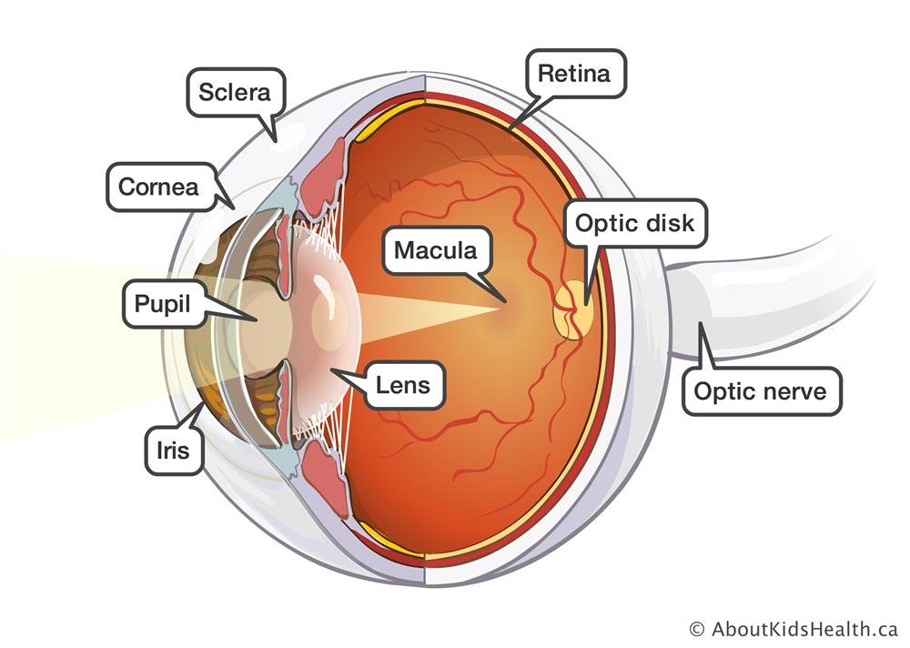

“PART B”
Names if Foramina’s found in the base of the skull:

- Optical Canal.
- Cribriform Plate.
- Jugular Foramen.
- Foramen Lacerum
- Hypoglossal Canal.
- Foramen Ovalle.
- Foramen Rotundum.
- Superior Orbital Fissure.
- Internal Acoustic Meatus.
- Foramen Caecum.
- Foramen Spinosum.
- Carotid Canal.

<------------------------------------------------------------------------------->

QUESTION NO 02
Write the Names of the muscles of the medial fascial compartment of thigh with their origin and insertion.
ANSWER
MUSCLES OF MEDIAL FASCIAL COMPARTMENT OF THIGH:
The muscles of the medial fascial compartment are listed below:

ADDUCTOR LONGUS:
It’s a flat and large muscle. This adductor longus partially covers the adductor magus and brevis. This muscle makes the medial border of femoral triangle.

ORIGIN:
It is originated from the following:
- Ramus of ischium.
- Inferior ramus of pubis

INSERTION:
It is inserted in
- Posterior surface of shaft of femur. (linea aspera)

ADDUCTOR MAGUS:
It is one of the largest muscles in the medial facial compartment. It is present posteriorly to the other muscles.

ORIGIN:
It is originated from the following:
- Ramus of ischium.
- Ischial tuberosity.
- Inferior ramus of pubis.

INSERTION:
It is inserted in
- Adductor tubercle of femur.
- Posterior surface of shaft of femur.

ADDUCTOR BRAVIS:
It’s a short muscle, which is present underneath the adductor longus muscle.
This muscle can be used to identify the aforementioned branches because it is used as an anatomical landmark.

ORIGIN:
It is originated from the following:
- Originated form Inferior ramus of pubis.

INSERTION:
It is inserted in
Posterior surface of shaft of femur (linea aspera).

GRACILIS:
This one is the most medial and superficial muscles in this compartment. It crosses at both the knee and hip joints. It is also used for the transplant into the forearm in order to replace any damaged muscle.

ORIGIN:
It is originated from the following:
- Ramus of ischium.
- Inferior ramus of pubis.

INSERTION:
It is inserted in
- Upper part of shaft of tibia on medial surface.

OBTURATOR EXTERNUS:
Obturator Externus is smaller muscles of the medial thigh, and it is present most superiorly.

ORIGIN:
It is originated from the following:
- Outer surface of obturator membrane ischial and pubic rami.

INSERTION:
It is inserted in
- Medial surface of greater trochanter.

<------------------------------------------------------------------------------->

QUESTION NO 03
What is the effect of injury of external laryngeal nerve and also write about how to test the integrity of facial nerve?
ANSWER
EFFECT INJURY TO EXTERNAL LARYNGEAL NERVE
Injury to the external laryngeal nerve can occurs due to thyroidectomy or can be occurred because of cricothyrotomy.
The injury can paralyze the cricothyroid muscle and it can make a region located just about the vocal fold’s anesthetic.
The external laryngeal nerve is located just beneath the superior laryngeal nerve and is branch of superior laryngeal nerve.
The injury to the external laryngeal nerve can affect the person voice directly. Some people may not get affected by the injury and it can be severe in some patients.
They won’t be able to change their voice pitch or will face difficulty in changing. And they may face a very reduced stamina in their speaking or voice. It can be very tragic thing if it ever happened with a category of people like public speaker and singer.

“PART B”
FACIAL NERVES
Facial Nerves are those which are branched in facial area and controls the movement or expressions of facial muscles.

FACIAL NERVES INTEGRITY
The nerves can be tested by giving some instructions to the patient.
The doctor may perform or ask the patient to do the following thinks in order to his facial nerve’s integrity.
- The doctor will be asked the patient to raise your eyebrows or crease up your forehead.
- He would be asked to open our mouth and reveal your teeth.
- By closing the eyes and keeping the eyes closed by resistance.
- Make you cheek larger. or we can say puff off your cheek.
By these means a doctor or everyone can check the integrity of their facial nerves.

<------------------------------------------------------------------------------->

QUESTION NO 04
Write about the sutures of skull also write a note on Trigeminal nerve and its branches.
ANSWER
SKULL SUTURES
Type of fibrous joints that are found in skull. These suture joints are immovable and get fused together around the age of 20.
The main sutures of the skull are sagittal, lambdoid, coronal and squamosal.
Suture are potentially weak in both adulthood and childhood. Because of that they have more clinical importance.

- CORONAL SUTURE:
It fuses the two parietal bones and frontal bone.

- SAGITTAL SUTURE:
It fuses both parietal bones.

- SQUAMOUSAL SUTURE:
Combine the parietal bone with the squamous portion of temporal bone.

- LAMBDOID SUTURE:
It fuses the two parietal bones with the occipital bone.

- METOPIC SUTURE:
Combines the two frontal bones if present.

Now here’s a point, the incomplete fused joint in neonates, they make membranous gaps between the bones of skull called fontanelle. We have two major fontanelles listed below;

Frontal Fontanelle:
It is present between the junction of the sagittal and coronal sutures.

Occipital Fontanelle:
It is present between the junction of the lambdoid and sagittal sutures.

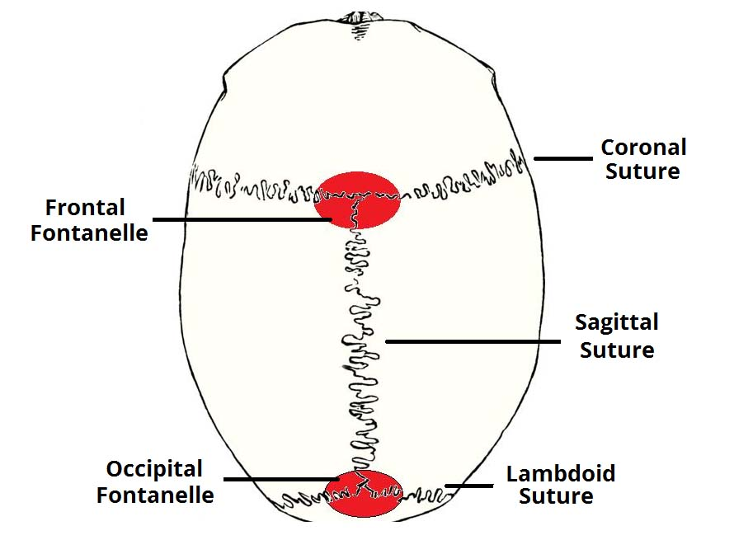

“PART B”
TRIGEMINAL NERVES
The trigeminal nerve is the most complex and largest nerve among the cranial nerves. It’s a motor nerves and is supplied to the effector for the function. This nerve contains proprioceptive fibers.
The trigeminal nerve provide sensation to the head structures, and face. It exits the head through a large sensory and small motor route.
This nerve is get originated from three sensory nuclei and one motor nucleus which is extended to the medulla.
Now at pons level, the motor nucleus makes a motor root and the sensory nucleus forms a sensory root.
In middle cranial fossa, the sensory root gets into the trigeminal ganglion. The trigeminal ganglion is present lateral to the cavernous sinus, into the temporal bone depression. That depression in the temporal bone is called trigeminal cave.
Now here, trigeminal ganglion divides into 3 nerves: ophthalmic (V1), maxillary (V2) and mandibular (V3).

OPHTHALMIC NERVE:
Ophthalmic nerve divides into 3 branches:
- Lacrimal.
- Frontal.
- Naso-ciliary.
These branches of ophthalmic nerve innervate the skin and the mucous membrane of derivatives of the frontonasal prominence derivatives:

- Dorsum of the nose.
- Upper eyelid and its conjunctiva.
- Ethmoid Sinus and Frontal Sinus.
- Scalp and Forehead.
- Cornea.

Parasympathetic Supply
Lacrimal gland:
The fibers from Post ganglionic which comes from the pterygopalatine ganglion runs along the zygomatic branch of V2 and then combines with the lacrimal branch of V1.
These fibers then provide parasympathetic innervation to the lacrimal gland.

MAXILLARY NERVE:
Maxillary nerve divides into 14 terminal branches, which provide innervation to the mucous membranes, skin and sinuses of derivatives of the maxillary prominence of the 1st pharyngeal arch:
- Lateral Nose & Nasal cavity.
- Incisor, upper molar and canine teeth.
- The associated gingiva.
- Maxillary sinus & Cheeks.
- Upper lip
- Superior palate
- Lower eyelid and its conjunctiva

Parasympathetic Supply:
Lacrimal gland:
Fibers of post ganglion from the pterygopalatine ganglion runs with the zygomatic branch of V2 and combines with the lacrimal branch of V1. These fibers provide parasympathetic innervation to the lacrimal gland.

Nasal glands:
From the nasal mucosa, the Parasympathetic fibers are also carried. Fibers of post ganglion runs along the greater palatine nerves and nasopalatine.

MANDIBULAR NERVE:
Mandibular nerve divides into four terminal branches into the infra-temporal fossa:
- Buccal nerve.
- Inferior alveolar nerve.
- Auriculotemporal nerve.
- Lingual nerve.

The branches bud off from the mandibular nerve provide innervation to the mucous membrane, skin and striated muscle derivatives of the mandibular prominence of the 1st pharyngeal arch.

Sensory supply:
Provides sensory supply to these areas.

- External Ear.
- Floor of the Oral Cavity and Mucous membranes.
- Incisor, Lower molar and canine teeth.
- The associated gingiva
- Chin.
- Lower Lip.
- Anterior 2/3 of the tongue.

Motor Supply:
Provides sensory supply to these areas.

- Tensor tympani.
- Muscles of lateral pterygoid, mastication, masseter, medial pterygoid, temporalis.
- Tensor veli palatini
- The mylohyoid muscle and Anterior belly of the digastric muscle.

Parasympathetic Supply:
Submandibular and Sublingual glands:
Fibers of post-ganglionic from the submandibular ganglion, runs along the lingual nerve to provide innervation to these glands.

Parotid gland:
Fibers of Post-ganglionic from the otic ganglion runs along the auriculotemporal branch of the V3 to provide innervation to the parotid gland.
<------------------------------------------------------------------------------->

QUESTION NO 05
Write a note on Spinal cord with reference to its anatomical position and structure also write a short note on Pharynx with enumeration to its constrictors.
ANSWER
SPINAL CORD
It’s a part pf the nervous system which is present in the spinal canal. It plays a role of conveying message between the brain and the body periphery.

SPINAL NERVES
Following are the Spinal nerves:
- Cervical (C1-C8).
- thoracic (T1-T12).
- lumbar (L1-L5).
- sacral (S1-S5).
- coccygeal (Co1).

Every spinal nerve has a posterior and anterior root. The posterior roots of the spinal nerve pass the sensory signals and have sensory ganglion attached to them. They are originated from the gray matter (posterior horns) and exit through the posterolateral sulcus of the spinal cord. The anterior roots pass motor signals, and they are originated from the gray matter (anterior horns) and then exit the spinal cord through the anterolateral sulcus.

The anterior and posterior roots combine before the intervertebral foramen, and then it forms the trunk of the spinal nerve.

STRUCTURE & POSITON OF SPINAL CORD:
It has a similar shape just like the cylinder. It is composed of white matter and grey matter. the white matter is present on its outside and the grey matter is located at the inside of the spinal cord.

As it has long length, it is divided into segment that are listed below:
- cervical Segment.
- Thoracic Segment.
- Sacral Segment.
- Coccygeal Segment.
The Spinal cord is the continuation of a part of brain stem called the medulla oblongata. It runs inferiorly and is placed inside the spinal canal.
Spinal Meninges which contain the CSF surrounds the spinal cord.
The spinal cord occupies at around two third portion of spinal canal. Spinal cord is get terminated at the 2nd lumber vertebra and then forming a structure known as conus medullaris. The end fibers which arises from the spinal cord are get bundled with each other which forms a structure called cauda equina.

ENLARGEMENT POINTS:
Two enlargement points are there on the spinal cord.
- CERVICLE ENLARGEMENT:
It is present at the C4 to T1 level proximally. It identifies the location of origin of brachial plexus.

- LUMBER ENLARGEMENT:
It is present at the T11 to L1 level distally. It identifies the location of origin of sacral plexi and lumber.

DEPRESSION ON SPINAL CORD:
Two depression are there on the surface of spinal cord.
- Anterior Median Fissure:
Present on the anterior surface. Deep Groove it is.

- Posterior Median Sulcus:
Present on the posterior surface, shallower depression it is.

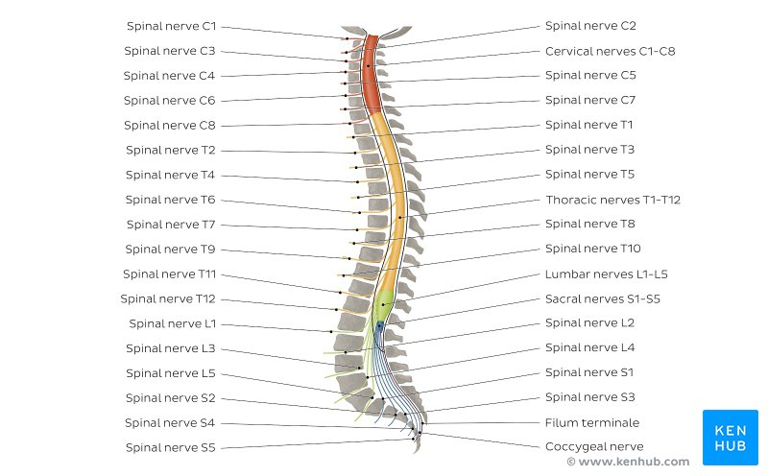

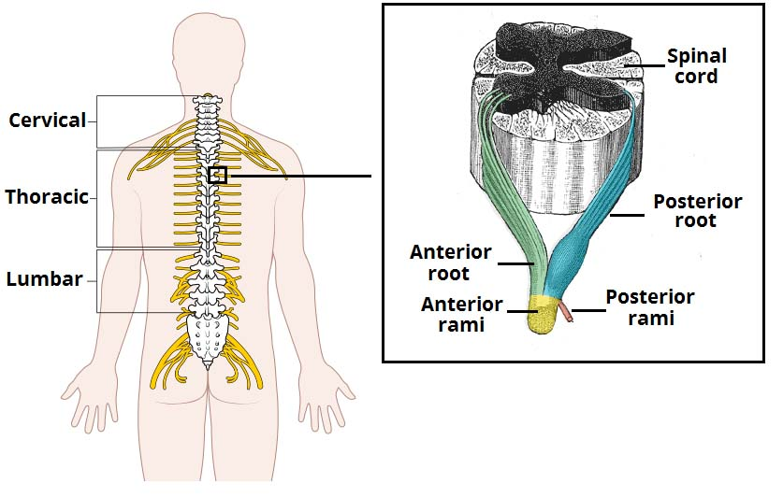

“PART B”
PHARYNX:
Definition:
Pharynx is the cavity which works as a connection between the nasal and oral cavities with the larynx and esophagus.

Involved:
It is counted in both systems namely respiratory and digestive systems. It performs specific function for both systems. which are listed below.
Respiratory System:
Performs its function while breathing, provides a pathway for the movement of air to pass from the nose and to enter the larynx.
Digestive System:
Performs its function while swallowing, provides a route for the food to travel through and enters the esophagus coming from the mouth.

Anatomy:
Length: 12.5 centimeters long in length.
Location: It runs from the posterior of nasal and oral cavities to the opening of the esophagus and larynx.

Divisions:
It is divided into the following parts.
- Nasopharynx.
- Oropharynx.
- Laryngopharynx.

PHARYNX CONSTRICTORS:
There are three pharyngeal constrictors muscles which are stacked like glass and are listed below

- SUPERIOR PHARYNX CONSTRICTORS:
- It is the uppermost pharyngeal constrictor.
- Present in the Oropharynx.
- Originates from the Pterygomandibular Ligament, medial pterygoid plate and the alveolar process of the mandible.
- Inserted posteriorly into the median pharyngeal raphe and pharyngeal tubercle of the occiput.

- MIDDLE PHARYNX CONSTRICTORS:
Present in the Laryngopharynx.
Originates from the horn of hyoid bone and Stylohyoid Ligament.
Inserted posteriorly into the pharyngeal raphe.

- INFERIOR PHARYNX CONSTRICTORS:
- Present in the Laryngopharynx.
- Horizontal fibers are there for the attachment with cricoid cartilage in its inferior compartment.
- Oblique fibers are there for the attachment with thyroid cartilage its superior compartment.





