***IQRA NATIONAL UNIVERSITY, PESHAWAR***

***DEPARTMENT OF BUSINESS ADMINISTRATION***



***Paper: STATISTICAL INFERENCE***

***Students ID: 15408***

***Subject Code:* *ASC 226***

***Program: MBA (3.5) 3rd Semester***

***Dated: 23-06-2020***

**PART-A**

**Q1: Choose the best suitable answer.**

**Answer:**

1. A
2. B
3. B
4. B
5. B
6. C
7. B
8. C

**PART-B**

**Ques No.1 (Part-A)**

**Answer:-**

**n= 500**

**x= 125**

**an approximate 75% Confidence interval for p is**

^p= x/n

^p = 125/500

**= 0.25**

**So**

^q = 1-^p

1. 0.25 = 0.75

The degree of C.I 75%

**So**

**1-α = 70%**

**α =1-0.75 = 0.25**

/2= 0.25/2=0.125

From the table value

**Z 0.125 = 1.150**

**Substituting the values in the formula we get**

^p ± z /2 √^p ^q/n

0.25 ± 1.150√0.25x0.75/500

(**0.2281,0.2719) Ans.**

**Ques NO.1: (Part-B)**

Answer:- The Z-distribution assumes that you know the population standard deviation (which is never the case).

The t-distribution in based on using the sample standard deviation as an estimate of the population standard deviation. Approximating the population standard deviation with a sample standard deviation means the sampling distribution is going to have more spread and is going to be affected by the sample size.

Hence, for any test statistics value **(t=+/-2 Vs Z=+/-2)** there will be a higher proportion outside those endpoints for the t-distribution.

However, as the sample size gets larger the t-distribution approximates the Z-distribution. For sample sizes larger than ~25, the difference between the two is usually negligible.

* **In Z test standard deviation of population is given**
* **In Z test samples size is more than 30.**
* **In T test population standard deviation is not given.**

**Difference Betweem Mean and Standard deviation**

The mean (average) of a data set is found by adding all numbers in the data set and then dividing by the number of values in the set. The median is the middle value when a data set is ordered from least to greatest. The mode is the number that occurs most often in a data set.

**Standard deviation:**-

In statistics, the standard deviation is a measure of the amount of variation or dispersion of a set of values. A low standard deviation indicates that the values tend to be close to the mean of the set, while a high standard deviation indicates that the values are spread out over a wider range

**Difference between Mean and Standard Deviation:**-

Standard deviation is basically used for the variability of data and frequently use to know the volatility of the stock. A mean is basically the average of a set of two or more number. Mean is basically the simple average of data. Standard deviation is used to measure the volatility of a stock.

**Ques No.2 (Part-A)**

**Solution:-**

n=90

xbar-= 5

σ = 1.2

Find 90% C.I

**α =1-0.90= 0.10**

/2= 0.10/2=0.05

From table value

Z 0.05 = 1.645

**Substitute the value in the formula we get**

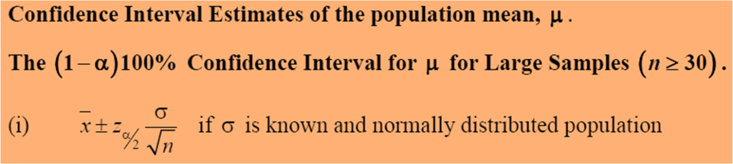

5 ± 1.645x 1.2**/**√90

5 ± 0.2081

(**4.7919, 5.2081) Ans.**

**Ques No.2 (Part-B)**

**Solution:-**

**σ = 8cm**

**E = ± 1.5**

**C.I=99%**

**n= ?**

**1-α =0.99**

**α =1-0.99 = 0.01**

/2= 0.01/2=0.005

From table value

Z 0.005 = 2.58

n = (Z/2)2 σ2

E2

n = (2.58)2 x (8)2

(1.5)2  
**n= 189.34 Ans**

Hence, 189.34 or 189 trees should be sampled with 99% C.I

**Ques No.3 (Part-A)**

**Solution:-**

**Sample Size = 21**

**Standard Deviation = 1.3**

**Find 90% C.I**

**1-α =0.90**

**α =1-0.90= 0.10**

/2= 0.10/2=0.05

1-/2=1-0.05=0.95

Now

X2 /2 at df = 21-1=20

In the table value = 31.41

X2 1-/2at df = 21-1=20

In the table value = 10.85

Putting in formula



20 (1.3)2 ≤  σ2 ≤ 20.(1.3)2

31.41 10.85

1.076 ≤ σ2 ≤ 3.115 Ans.

**Ques No.3 (Part-B)**

**Answer:-**

Chi square

**C.I 95% , df = 18**

**1-α =0.95**

**α =1-0.95= 0.05**

/2= 0.05/2=0.025

1-/2=1-0.025=0.975

Tabulated value of X2 /2 with df = 18 is (31.53)

And tabulated value of

X2 1-/2 with df = 18 is (8.23)

T-Value

**C.I 50% , df = 22**

**1-α = 50%**

**α =1-0.50 = 0.5**

/2= 0.5/2 =0.25

so

t 0.25 (22) = 0.6858

Z-Value

**C.I 70%**

**1-α = 0.70**

**α =1-0.70 = 0.30**

/2= 0.30/2 =0.15

So,

Z 0.15 = 1.036

Z-value

When z= -1.78

P (Z≤ -1.78) = 0.5 –p(-1.78≤ Z≤0)

= 0.5 - 0.462

= 0.0375 Ans.

**Ques No.4 (Part-A)**

**Answer:-** Inferential statistics is one of the two main branches of statistics.

Inferential statistics use a random sample of data taken from population to describe and make inferences about the population. Inferential statistics are valuable when examination of each member of an entire population is not convenient or possible.

There aretwo kinds of statistics:-

1. **Descriptive Statistics**
2. **Inferential Statistics**

Descriptive statistics deal with the classification and diagrammatic representation of data. While the inferential statistics deals with the decision making under uncertain situations.

The knowledge of statistical inference mostly used for business and research, because most of them based on nature of population.

Statistical inference can be describe as an art of making conclusion about any characteristics of population using sample data.

Statistical inference can be done in two main ways:-

1. **Estimation:-** Estimation can be described as the process of finding an estimate or estimate can be known as (the value of unknown parameter).
2. **Hypothesis Testing:-** Hypothesis testing can be described as an assumption/ claim about parameter, researchers has to test where sample supported or reject.

**Ques No.4 (Part-B)**

**Solution:-**

n = 10 so df=n-1 = 10-1= 9

X bar = 317.2

σ = 15.7

C.I 99% α = 1% =0.01 then

α/2 = 0.01/2 = 0.005

from table value

Z 0.005 (9) = 3.250

Now put all the values in the formula

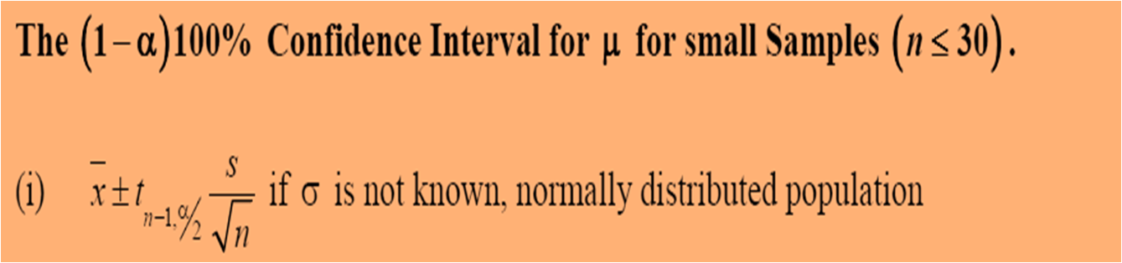

**μ=** 317.2 ± 3.250 . 15.7/√10

**=** 317.2 ± 16.14

= (333.34 , 301.0) Ans

_________________________________________________