NAME: M. ASIM KHAN
CLASS: BE(C)
SUBJECT: CONSTRUCTION MANAGMENT
SECTION: A
ID: 7708
LECTURER: DR. ENGR. ZEESHAN AHAD
ASSIGHNMENT

What Is Project Life-Cycle Explain Briefly with Diagram?

PROJECT LIFE-CYCLE
The Project Life Cycle refers to the four-step process that is followed by nearly all project managers when moving through stages of project completion. This is the standard project life cycle most people are familiar with. The Project Life Cycle provides a framework for managing any type of project within a business.
A standard project typically has the following four major phases (each with its own agenda of tasks and issues): initiation, planning, implementation, and closure. Taken together, these phases represent the path a project takes from the beginning to its end and are generally referred to as the project “life cycle.”
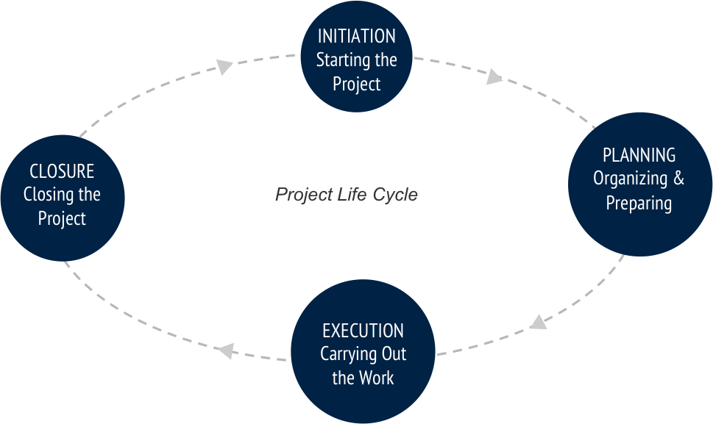
INITIATION PHASE
During the first of these phases, the initiation phase, the project objective or need is identified; this can be a business problem or opportunity. An appropriate response to the need is documented in a business case with recommended solution options. A feasibility study is conducted to investigate whether each option addresses the project objective and a final recommended solution is determined. Issues of feasibility (“can we do the project?”) and justification (“should we do the project?”) are addressed.
Once the recommended solution is approved, a project is initiated to deliver the approved solution and a project manager is appointed. The major deliverables and the participating work groups are identified, and the project team begins to take shape. Approval is then sought by the project manager to move onto the detailed planning phase.

PLANNING PHASE
The next phase, the planning phase, is where the project solution is further developed in as much detail as possible and the steps necessary to meet the project’s objective are planned. In this step, the team identifies all of the work to be done. The project’s tasks and resource requirements are identified, along with the strategy for producing them. This is also referred to as “scope management.” A project plan is created outlining the activities, tasks, dependencies, and timeframes. The project manager coordinates the preparation of a project budget by providing cost estimates for the labour, equipment, and materials costs. The budget is used to monitor and control cost expenditures during project implementation.
Once the project team has identified the work, prepared the schedule, and estimated the costs, the three fundamental components of the planning process are complete. This is an excellent time to identify and try to deal with anything that might pose a threat to the successful completion of the project. This is called risk management. In risk management, “high-threat” potential problems are identified along with the action that is to be taken on each high-threat potential problem, either to reduce the probability that the problem will occur or to reduce the impact on the project if it does occur. This is also a good time to identify all project stakeholders and establish a communication plan describing the information needed and the delivery method to be used to keep the stakeholders informed.
Finally, you will want to document a quality plan, providing quality targets, assurance, and control measures, along with an acceptance plan, listing the criteria to be met to gain customer acceptance. At this point, the project would have been planned in detail and is ready to be executed.

IMPLEMENTATION (EXECUTION) PHASE
During the third phase, the implementation phase, the project plan is put into motion and the work of the project is performed. It is important to maintain control and communicate as needed during implementation. Progress is continuously monitored and appropriate adjustments are made and recorded as variances from the original plan. In any project, a project manager spends most of the time in this step. During project implementation, people are carrying out the tasks, and progress information is being reported through regular team meetings. The project manager uses this information to maintain control over the direction of the project by comparing the progress reports with the project plan to measure the performance of the project activities and take corrective action as needed. The first course of action should always be to bring the project back on course (i.e., to return it to the original plan). If that cannot happen, the team should record variations from the original plan and record and publish modifications to the plan. Throughout this step, project sponsors and other key stakeholders should be kept informed of the project’s status according to the agreed-on frequency and format of communication. The plan should be updated and published on a regular basis.
Status reports should always emphasize the anticipated end point in terms of cost, schedule, and quality of deliverables. Each project deliverable produced should be reviewed for quality and measured against the acceptance criteria. Once all of the deliverables have been produced and the customer has accepted the final solution, the project is ready for closure.

CLOSING PHASE
During the final closure, or completion phase, the emphasis is on releasing the final deliverables to the customer, handing over project documentation to the business, terminating supplier contracts, releasing project resources, and communicating the closure of the project to all stakeholders. The last remaining step is to conduct lessons-learned studies to examine what went well and what didn’t. Through this type of analysis, the wisdom of experience is transferred back to the project organization, which will help future project teams.

Example: Project Phases on a Large Multinational Project
A U.S. construction company won a contract to design and build the first copper mine in northern Argentina. There was no existing infrastructure for either the mining industry or large construction projects in this part of South America. During the initiation phase of the project, the project manager focused on defining and finding a project leadership team with the knowledge, skills, and experience to manage a large complex project in a remote area of the globe. The project team set up three offices. One was in Chile, where large mining construction project infrastructure existed. The other two were in Argentina. One was in Buenos Aries to establish relationships and Argentinian expertise, and the second was in Catamarca—the largest town close to the mine site. With offices in place, the project start-up team began developing procedures for getting work done, acquiring the appropriate permits, and developing relationships with Chilean and Argentine partners.
During the planning phase, the project team developed an integrated project schedule that coordinated the activities of the design, procurement, and construction teams. The project controls team also developed a detailed budget that enabled the project team to track project expenditures against the expected expenses. The project design team built on the conceptual design and developed detailed drawings for use by the procurement team. The procurement team used the drawings to begin ordering equipment and materials for the construction team; develop labor projections; refine the construction schedule; and set up the construction site. Although planning is a never-ending process on a project, the planning phase focused on developing sufficient details to allow various parts of the project team to coordinate their work and allow the project management team to make priority decisions.
The implementation phase represents the work done to meet the requirements of the scope of work and fulfill the charter. During the implementation phase, the project team accomplished the work defined in the plan and made adjustments when the project factors changed. Equipment and materials were delivered to the work site, labour was hired and trained, a construction site was built, and all the construction activities, from the arrival of the first dozer to the installation of the final light switch, were accomplished.
The closeout phase included turning over the newly constructed plant to the operations team of the client. A punch list of a few remaining construction items was developed and those items completed. The office in Catamarca was closed, the office in Buenos Aries archived all the project documents, and the Chilean office was already working on the next project. The accounting books were reconciled and closed, final reports written and distributed, and the project manager started on a new project.

Define and Explain Briefly Major Types Of Construction Projects?
CONSTRUCTION PROJECTS
A project is a series of related a tasks which when they are carried in the correct order will lead to the completion of the project. Projects are temporary, generally resulting in the creation of a tangible product or outcome. This is as opposed to a programme, which is a series of interrelated projects that may be carried out repeatedly or continuously in order to support an ongoing process. For more information, see Project v programme.
A construction project, sometimes just referred to as a ‘project’, is the organized process of constructing, renovating, refurbishing, etc. a building, structure or infrastructure. The project process typically starts with an overarching requirement which is developed through the creation of a brief, feasibility studies, option studies, design, financing and construction.
Construction projects are typically one off's. That is, a project team, brief and financing are put together to produce a unique design that delivers a single project. Once the project is complete the team is disbanded and sometimes will not work together again. This can make it difficult to develop ideas or relationships, and so lessons learned are often not carried forward to the next project. The exceptions to this are repeat developers such as supermarket chains, housebuilders, and so on.
Typically, a construction project comprises many smaller projects which require a wide range of different disciplines working in collaboration. Large numbers of people are involved on a typical construction project, with the structure and composition of the project team usually changing through its duration. Projects may be coordinated by a project manager (or by a lead consultant) who is supported by professionals such as an architect, engineer, cost consultant and so on. For more information, see Project team.
This separation of project roles into different disciplines, and contractual arrangements that further separate the client, consultants, contractors and subcontractors can make construction projects adversarial. This can result in conflict, opposition, confrontation, dispute and even hostility.

TYPES OF CONSTRUCTION PROJECTS
Broadly speaking, you can separate construction project types into 3 categories:
- Private construction
- State construction
- Federal construction

1. PRIVATE CONSTRUCTION PROJECTS
- The first type of construction project is the Private Construction Project. Put simply, private projects are projects of every type that are owned, controlled or commissioned by a private party. Private parties include individuals, homeowners, corporations, other business entities, non-profit associations, privately funded schools, hospitals, publicly traded companies, etc. Anything, in other words, that is not the government.
- Private construction projects come in all different shapes and sizes, and this is when it’s useful to look at the character of the work performed to segment private construction into different subcategories. These subcategories would include:

RESIDENTIAL CONSTRUCTION
- Whenever construction work is being performed to a single-family residence or a residential facility with (usually) less than 3 or 4 units. If you are working on an apartment complex this would more likely be considered a commercial project instead of a residential project. Similarly, if you are working at a condominium, the work would be residential if upon a single unit, but if on the entire complex or the common elements, the work would more likely be considered commercial.

COMMERCIAL CONSTRUCTION
- Commercial construction is the construction of any buildings or similar structures for commercial purposes. Commercial construction includes a huge variety of projects including building restaurants, grocery stores, skyscrapers, shopping centers, sports facilities, hospitals, private schools and universities, etc.

INDUSTRIAL CONSTRUCTION
- This is a relatively small segment of the construction industry. These projects include power plants, manufacturing plants, solar wind farms, refineries, etc. While termed “industrial construction,” it is pretty interchangeable with “commercial construction.”

2. STATE CONSTRUCTION PROJECTS
- Some people get confused by the term “state” when talking about state construction projects because the term “state” can refer to projects commissioned by a county, city, municipality, government board, public school board or any other state-funded entity. The term “state construction” means, therefore, any government-funded construction that is not “federal” – which is discussed in the next section.
- State construction projects can take a variety of forms.
- They can be pretty traditional projects like the construction of a public school or government building (like a court room). These projects can also be pretty sophisticated, such as the construction of a bridge, sewer line, highways, etc.

3. FEDERAL CONSTRUCTION PROJECTS
- Federal construction projects are very similar to state projects. Just like state projects they can take on a variety of forms: very simple and traditional, and very complex. And the stuff being constructed can be pretty similar to the stuff constructed by state authority: courthouses, government buildings, flood control projects, etc.
- The difference between state and federal projects simply depends on who owns or controls the underlying project site. The difference is not which entity funds the project, because federal funds are all over state (and even private) projects. The difference is in who owns and controls the project.
- If work is done on a state courthouse using federally provided funds, it is a state project. If work is done on a federal courthouse, however, it’s a federal project. Work done on a federally funded interstate is usually a state project because the states control the highways. Work done through the US Army Corps of Engineers, however, even on state land such as the levees, is always a federal project because it is federally controlled.

