15855
MAIRA KHAN
BBA-A
MARKETING

QUESTION 1
WHAT IS SWOTANALYSIS? WHY COMPANIES USE IT? SWOTANALYSIS FOR IQRA NATIONAL UNIVERSITY?
ANSWER
SWOT ANALYSIS
A study undertaken by an organisation to identify its internal strengths and weaknesses, as well as its external opportunities and returns.
STRENTGHS
Strengths is an internal factor that shows the properties of a business that give it advantages over its competitors.
WEAKNESSES
Weakness is an internal factor that shows properties of a business at a disadvantage compared to others.
OPPORTUNITIES
Opportunity is an external factor that shows different opportunities in external environment to avail to its advantage.
THREATS
Threat is an external factor that shows the business threats in the external environment of an organisation that can cause trouble later.
-Swot analysis is a tool that is used to identify the internal strengths and weaknesses and external opportunities and threats of an organisation. This tool is used for the evaluation, which shows us the position of an organisation where it stands. Swot analysis is used by every organisation.
QUESTION2
DISCUSSNEW PRODUCT DEVELOPMENT PROCESS AND DRAW ITS MODEL?
ANSWER
Product Development Process encompasses all steps needed to take a product from concept to market availability. This includes identifying market need, researching the competitive landscape, conceptualising a solution, developing a product road map, building a minimum viable product etc.
- Idea Generation
- Idea Screening
- Concept Development And Testing
- Marketing Strategy Development
- Business Analysis
- Product Development
- Test Marketing
- Commercialisation

- IDEA GENERATION
Ideation or idea generation is the most challenging and most rewarding job. It is the long tedious, difficult task of assembling all the pertinent information, analysing the problem and searching for some verbal or visual concepts of how to communicate what need to be said. It means establishing a mental idea or picture of the advertisement, commercial or campaign.
Creativity is the ability to bring something new into existence.

- IDEA SCREENING
Setting up criteria for ideas that you are going to continue with or drop it selecting the idea that is highly agreed upon. Then have a considerate eye on the top three products that your competitors are offering and at last considering all the ideas select the most doable idea.
- CONCEPT DEVELOPMENT AND TESTING
That allows you to study your target audience problems, test your product on your potential users, build your value proposition and identify your market. Its main stages are :
- List product benefit issues it solves.
- Analyse your buyer persons.
- Conduct competitor analysis.
- Think of product main features and its value proposition.
- Create materials for investors and potential customers.

- MARKETING STRATEGY DEVELOPMENT
Involves the activities of selecting and describing one or more target markets and developing and maintaining a marketing mix that will produce mutually satisfying exchanges with target markets.
- BUSINESS ANALYSIS
Investigate situation: the business analyst takes a holistic look at the situation to uncover issues and determine the real problem.
Consider perspectives: identify all the stakeholders involved, understand and analyse their perspectives.
Analyse needs: identify improvements that can be made by gap analysis ( comparing current situation with desired situation)
Evaluate options: examine improvements, check their feasibility and applicability.
Define requirements : elicit and documents the detailed requirements changes to the business situation.
- PRODUCT DEVELOPMENT
One of the most essential step in which the production line would focus on production centre, marketing area would focus on how to promote and what new strategies should be applied to advertise product completely different from their competitors, the finance department will make a complete budget for the cost.
- TEST MARKETING
In this step the companies usually arrange then they conduct test panels after the product. After test panels and products that has been tested will provide valuable and essential problem that allows improvement that can be made last minutes.
- COMMERCIALISATION
This is the last step of product development process where the product is introduced into the market, consumers are purchasing the product advertisements during this stage will keep your products name firm.
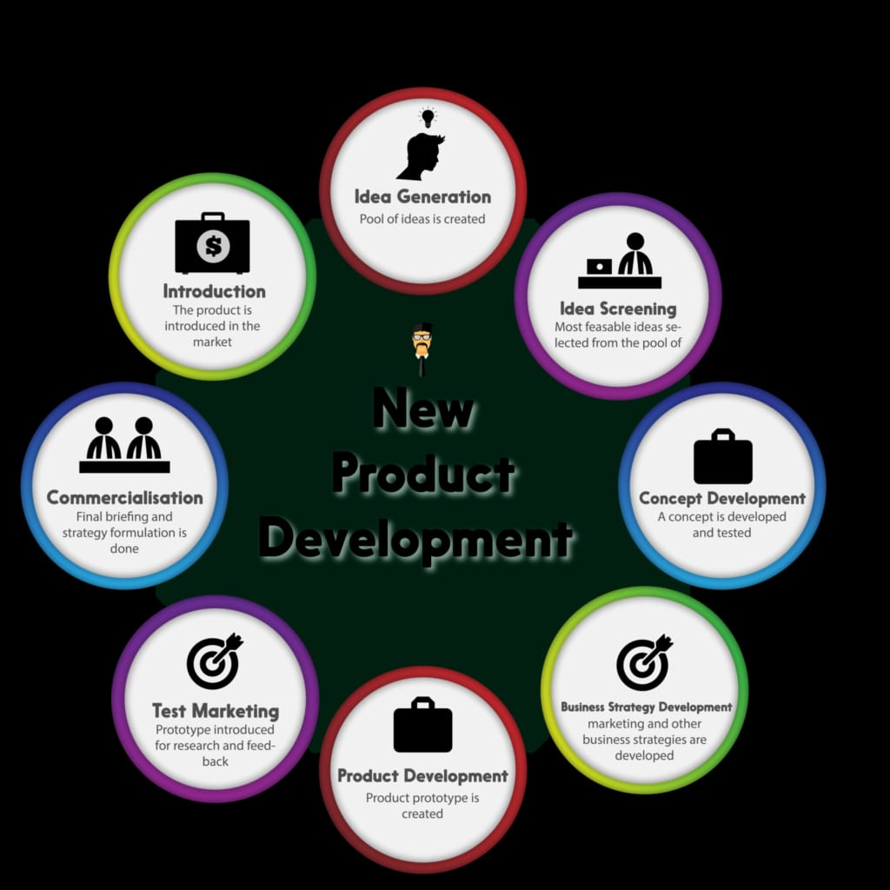
QUESTION 3
WRITE BRIEFLY ABOUT PRODUCT CYCLE. DRAW MODEL?
ANSWER
PRODUCT LIFE CYCLE
The product life cycle is a process by which the product goes through from when it is firstly introduced in the market to the stage of decline or when it is removed from the market.
Product life cycle has four major stages :
- Introduction
- Growth
- Maturity
- Decline

- INTRODUCTION
It is the first stage of a new product being released in a market. When a new product is launched in a market this is not necessary for the product to break success. Maybe it breaks success into the market or maybe it doesn’t. In introduction stage the costs are kept very high and competition is less. In this stage the company is more intended to invest in marketing and promotion of a product. It is the stage where companies get sense of what consumers want by getting responses by them in the form of feedbacks on different platforms.
- EXAMPLE
Pagers ( one-way pagers that would receive alphanumeric or voice messages)
-Developed in 1950’s.
-Used for emergency service
-Public safety
-Used by health service
-10 million pagers were active in 1996

- GROWTH
This is the second stage of a product where the product becomes popular and seeks attention of a consumer that it needs. Consumers increasingly buy the product, sales volume of a product is high, increasingly sales. In this stage the concept of a product is proven still in the second stage of product life cycle the company heavily invests in advertising and promoting the product because the competition is high, market expands. Companies mainly focus onupdating the features and improve functions. However sales volume increases that generate revenue.
- EXAMPLE
-Used by physicians pagers (paid 12 per month for service)
-combined elements with Motorola walkie-talkie.
-Adoption of emergency personal which is still popular as of July, 2016.
-Widely used in restaurants to place and order.

- MATURITY
It is the third stage of a product cycle in which the sales becomes less or slower down or sometimes it just stops. At this stage sales also starts to drop. Prices can get competitive too because of competition or less demand of a product. At this stage companies don’t advertise their products, they work on a new product, features, and improving functions of a product to
reach different markets segments. But for the product like Coca-Cola the Maturity stage is drawn out.
- EXAMPLE
-Pager widespread availability of cell phones and smartphones has almost finished the industry of pagers.

- DECLINE
This is the last stage where the companies attempts to keep a product alive in Maturity stage, but eventually sales drop due to the less demand response of consumers towards the product does not remains same. In this stage the product loses market share which causes sales to diminish. Here marketing and promotion is kept minimal at target market or loyal customers. Eventually the product will retire out of the market.
- EXAMPLE
- In late 1990’s mobile phones industry ruined the pagers industry, which was a decline stage for a pagers.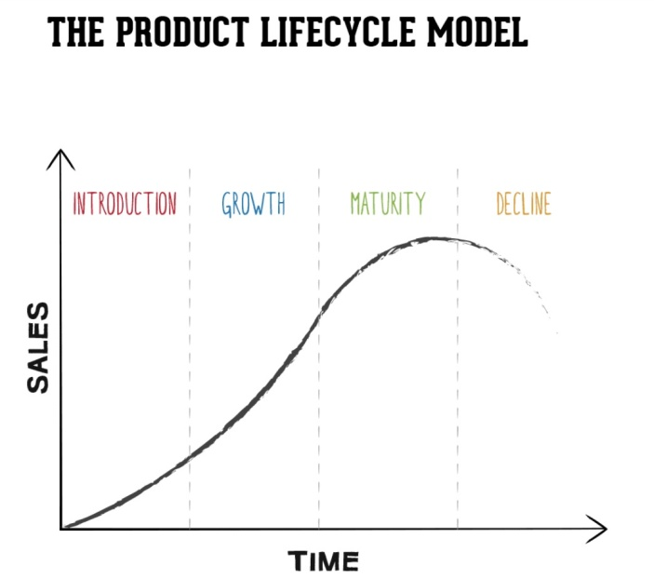

QUESTION 4
WRITE BRIEFLY ABOUT BRANDING ALONG WITH EXAMPLE?
ANSWER
BRANDING

Branding is a marketing practice in which a company creates name, symbol or design that is easily identifiable as belonging to the company.
-Branding of a product is important because it distinguishes and identifies your product from your competitors. It distinguishes your product from other products and services. Branding of products actually shows who you are as a business, it distinguishes you from your competitors, makes a quite big difference in products, which makes them identifiable.
IMPORTANCE OF BRANDING
Branding is quite essential to a business because of overall image and impact it makes on your company. – branding can change person’s perception of your brand. They start thinking differently about your brand.
RECOGNITION
Branding is very important and essential factor of business because it is how company gets recognition and consumers get to know that this brand exists. Branding drives attention of the consumer towards it. Logo is an important part of branding which plays an essential role in this whole process because logo is the face of brand. It distinguishes your organisation from your competitors.
INCREASES BUSINESS VALUE
Branding adds value to business, which is important for future business too and for a strong established brand it is more appealing investment to make its firm position in market place.
EXAMPLE
McDonald’s
KFC
H&M
CHANNEL
GENERATE NEW CUSTOMERS
Branding generates new customers, because it is the positive image of a company on consumer. Branding differentiates same products of your and your competitors. It identifies your products. A well established brand word of a mouth will be company most advertising campaign.
EMPLOYEES PRIDE AND SATISFACTION
Working for a very reputable brand improves, employee pride and satisfaction. For example having a comfortable and branded office cabin makes them satisfied and they often feels proud about it and works with enjoyment and devotion.
TRUST WITHIN MARKET PLACE
Branding causes professionalism, makes appearance well that also help build trust between the workplace, between the clients and staff. And because of positive portrayed of a company other shows interest in doing businesses too.
EXAMPLE
Logo of McDonald’s differentiate it from other brands.

