Name Ahmad Ilyas
Roll no 16188
Subject Introduction to Computer Programming
Teacher Ashraf Ali
Semester 2nd Btech (civil)
Q No 4(a); what do you mean by M-file in MATLAB?
Ans; An m-file, or script file, is a simple text file where you can place MATLAB commands. When the file is run, MATLAB reads the commands and executes them exactly as it would if you had typed each command sequentially at the MATLAB prompt. All m-file names must end with the extension '. m' (e.g. test. m).

Q No 4(b); Write a MATLAB program that reads an input temperature in degree Fahrenheit, convert it
into an absolute temperature in Kelvin.
Ans;
Sol; T (in kelvin) = (( $\frac{5}{9}$ (Tf – 32.0)) = 273.15
Boiling point of water 212 $℉$ 373.15 K.
Sublimation point of ice -110 $℉$ 194.26 K.
Matlab program must perform the following steps;
- Prompt the user to enter an input temperature in $℉.$
- Read the input temperature
- Calculate the temperature in kelvin
- Write out the result
We will use the function input input to get the temperature in $℉$and function ( fprintf )
$∞$ Script file : temp – conversion
$∞$ Purpose:
$∞$ To convert input temperature from $℉$ to
$∞$
$∞$ Record of revision
$∞$ Variables
$∞$ temp_f … Temperature in degree $℉$
$∞$ temp_k … Temperature in kelvin
$∞$ Prompt the user for the input temperature.
temp_f = Input ( Enter the temperature in $℉$ : ‘ ) ;
$∞$ convert to kelvin.
Temp_k = ( 5/9 ) * ( temp_f -32) + 273.15;
$∞$ Write out the result.
Fprintf ( $∞$6.2f degree fehrenheit = $∞$ 6.2f kelvin./ n’ … temp_f , temp_k) ;
To test the complete program, we will run it with the known input values ginen previously.
- Temp_ conversion
Enter the temp in $℉$ : 212
212.00 $℉$ =373.15 kelvin
- Temp_conversion
Enter the temp in $℉$ : -110
-110.00 $℉$ = 194.26 kelvin
………………………………………………………………………………………………………………………….
………………………………………………………………………………………………………………………….
Q No 1(a); what are the Basic Plots and Graphs of MATLAB?
Ans; Basic Plots and Graphs of MATLAB.
Following table describes basic plots and graphs.

- box - Axis border
- errorbar - Plots error bars along curve
- hold - Retains current graph while adding new graphs
- line - Creates line object
- LineSpec (Line Specification) - Syntax of Line Specification String
- loglog - Log to log scale plot
- plot - 2-D line plot
- plot3 - 3-D line plot
- plotyy - 2-D line plots with y-axis on both left and right side
- polar - Polar coordinate plot
- semilogx - Semilogarithmic plot
- semilogy - Semilogarithmic plot
- subplot - Creates axis in tiled positions
- xlim - Sets or queries x-axis limits
- ylim - Sets or queries y-axis limits
- zlim - Sets or queries z-axis limits

Q No 1(b); Plot the function;
y(x)=sin(x) For 0≤x≤6
y(x)=2sin(x)e^{-0.2x} For 0≤x≤15
Ans; Sol,
X = linspace(0 : 6 : 15);
$\%$ Create y
Y=x . * cos(x). * sin(x);
$\%$ Plot the function
Plot(x, y ,`b-`, Linewidth, 2);
Grid on;
Xlabel (X , fontsize, 15);
Ylabel (Y, Fontsize, 15);
Title (Y = X. * cos(x). * sin(x), Fontsize, 15);
Axis equal;
$\%$ Make a black line at the x and y axis
Line (x lim, (0 , 0), Linewidth, 2);
Line (0 , 0), y lim, linewidth, 2);
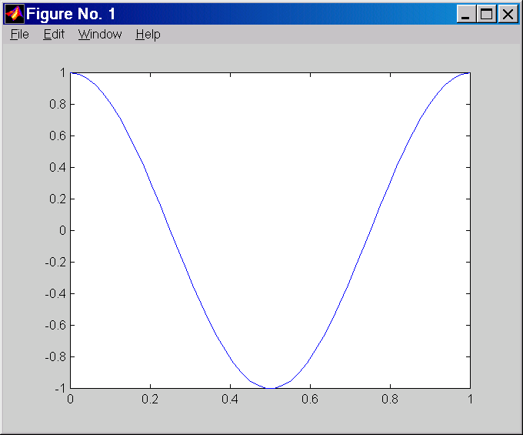
……………………………………………………………………………………………………………
……………………………………………………………………………………………………………
Q No 3 (a); ) what are the memory Management Functions in MATLAB?
Ans; Memory Management Functions in MATLAB ;
1. clear - Removes variables from memory.
2. pack - Saves the existing variables to disk, and then reloads them contiguously.
3. save - Selectively persists variables to disk.
4. load - Reloads a data file saved with the save function.
5. quit - Exits MATLAB and returns all allocated memory to the system
When a MEX function returns control to MATLAB, it returns the results of its computations in the output arguments—the mxArrays contained in the left-side arguments plhs. These arrays must have a temporary scope, so do not pass arrays created with the mexMakeArrayPersistent function in plhs. MATLAB destroys any mxArray created by the MEX function that is not in plhs. MATLAB also frees any memory that was allocated in the MEX function using the mxCalloc, mxMalloc, or mxRealloc functions.

Q No 3(b); Write a MATLAB function to calculate the distance between two points (x₁, y₁) and (x₂,y₂) in Cartesian coordinate system.
Ans; Sol;
D = sqrt (x(p1)-x(p2))^2+(y(p1)-y(p2))^2);
>> plot (x1,y1,'sk',x2,y2,'r--')
>> legend ('7 Data Points','629 Data Points', 'Location', 'NorthEast')
>> title ('Some Sine Curves!')
>> xlabel ('x')
>> ylabel ('sin(x)')
>> grid on
>> axis tight
………………………………………………………………………………………………………………………..
………………………………………………………………………………………………………………………..
Q No 2; Plot the function; f(x)=sin2x and its derivative d/dx sin2x on same graph.
Ans;
Find the f(x)=sin2x and the derivative of sin2x =?
d/dx sin (2x) = cos (2x) = 2 cos 2x
sin(2x) = 2 sin(x) * cos(x)
(2 cos x) cos x + 2 sin x (-sin^2x) = 2 cos ^2x – 2 sin^2x
Now ploting the value;
X = 0 : pi / 100 : 2x pi ;
Y1 = sin (2 * x)
Y2 = 2x cos (2 * x)
Plot (x , y1 , ‘K’ , x , y2 , ‘b’ ..’);
Title (‘plot of f(x) = sin (2x) and its derivative ‘);
Xlabel (‘x’);
Ylabel (‘y’);
Legend (‘f(x)’ , ‘d/dx f/x’ , ‘t1’);
Grid on;
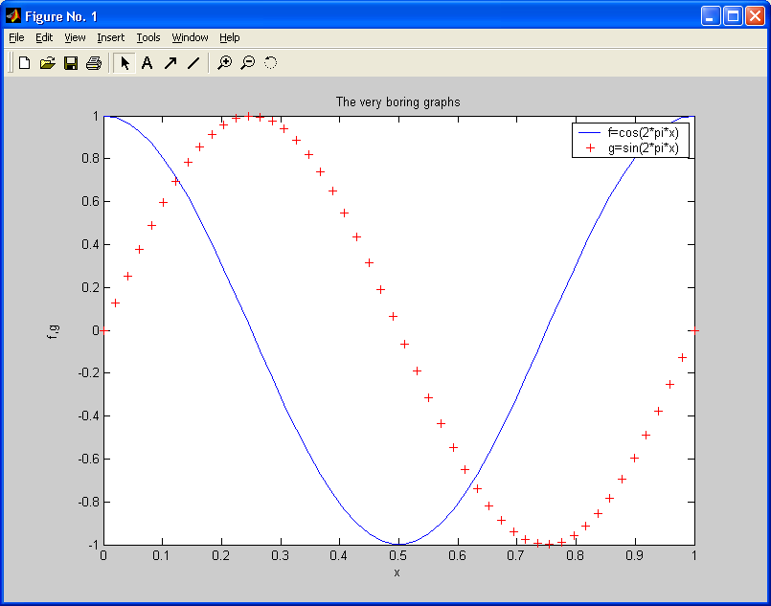
……………………………………………………………………………………………………………
…………………………………………………………………………………………………………..
Q No 5; Write a MATLAB program to evaluate the equation y(x) =$x^{2}$-3x+2 for all values of x between -1 and 3,in steps of 0.1 using for loop. Plot the resulting function using a 3-point thick dashed red line.]
Ans; Generate a plot fot the function of y(x) = x^2 – 3x +2
Sol;
Y(x) = x^2 -3x +2
x = 0 : 1 : 3
y = x , ^2 – 3, * x + 2;
plot ( x,y )
title ( plot of x , ^2 – 3, * x + 2);
xlabel ( ‘x’ );
ylabel ( ‘y’ );
grid on;




