NAME : JUNAID MASOOD
ID : 16718
DEGREE : B-TECH (CIVIL)
SUBJECT: INTRODUCTION TO COMPUTER PROGRAMMING
TEACHER NAME: Instructor: Engr. SYED ASHRAF ALI
MID TERM EXAMINATION
Q 1 (A) Design an algorithm and draw a flowchart that will read the two sides a Rectangle and calculate its area?
(A) ANSAWAR:-
ALGORRITHM AND FLOWCHAT:
START

Input the width (w) and length (L) of a Rectangle,
INPUT WxL
Calculate the area (A) by multiply L with W,
Print A
A-LxW
Algorithm Input No 1...Input W, L
Step No 2...A-LxW
Print A
Step No 3...Print
STOP

Q1 (B) Name different types of errors which can occur during the execution of a program?
(B) ANSAWAR:-

- There are three kind of errors: During the execution of a program, the errors that may occur are
- SYNTAX ERRORS: Errors occur when our program contains grammatical errors.
- RUN TIME ERRORS: These errors occur while the program is running.
- LOGICAL ERREORS: Errors such as calculation mistakes etc.

Q2(A) Design an algorithm that reads two values, determines the largest value and prints the
largest value with an identifying message.

ANSWER:- 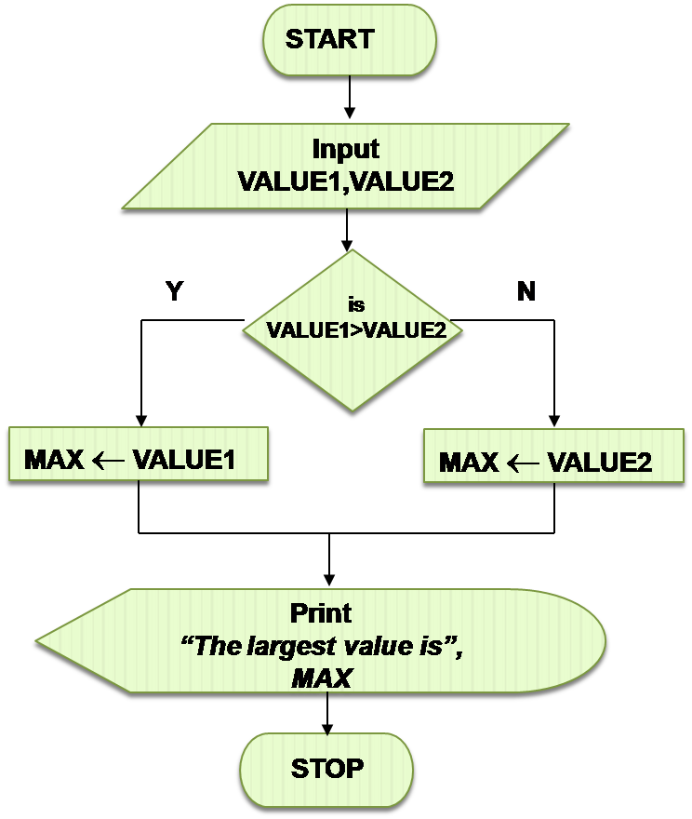

Input variable 1 and variable 2,
Check if variable1> variable2,
Store variable 1 in another variable ‘MAX’.
Else
Store variable2 in another variable ‘MAX’
Print MAX.
Algorithm:
Step 1: input VALUE 1, VALUE2
Step 2: if (VALUE1> VALUE2) them MAX VALUE1
Else
MAX VALUE 2
Step 3 Print ‘‘the largest value is’’, MAX.

Q2 (B) What do you understand by the term “Maintain and update the Program”.
ANSWER:-
- Software maintenance is a part of software Development life cycle. Its main purpose is to modify and update software application after delivery to correct faults and to improve performance. Software is a model of the real world. When the real world changes, the software requires alteration wherever possible.
- Software maintenance is a vast activity which includes optimization, errors correction, and deletion of discarded feature and enhancement of existing features. Since these changes are necessary, a mechanism must be created for estimation, controlling and making modification. The essential part of software maintenance requires preparation of an accurate plan during the development cycle. Typically maintenance take up about 40-80% of the project cost usually closer to the higher pole hence a focus on maintenance definitely help keep costs down

Q3 Differentiate between the following.
ANSWER
- Bug & Debug

  - As verbs the difference between debug and bug is that debug is (computer science) to search for and eliminate malfunctioning element or errors in something, especially a computer program or machinery while bug is (informal / transitive) to annoy

- (B) Syntex error & Logical error
  - The difference between a syntax errors and logical error is that the syntax error occurs due to an error in the syntax of a sequence of characters or tokens that is intended to be written in a particular programming language while logical error is an error that occurs due to the fault in the program.

- (C) Compiler & Assembler
  - If we talk about the main difference, then the main difference between assembler and compiler is that compiler takes the source code and translates it into the assembler takes the assembler code generated by the compiler and translates it into the machine code

- (D) System Software & Application Software
  - System software is used for operating computer hardware. Application software used by user to perform specific task. System software is installed on the computer when operating system is installed. Application software is installed according to user’s requirements.

- (E) Low level language & High level language

- Both high level language and low level language are programming languages types. The main difference between high level language and low level language is that, programmers can easily understand or interpret or compiler the high level language in comparison of machine. One the other hand, machine can easily understand the low level language in comparison of human beings.
- Examples of high level language are C, C++ java, python, etc.
THE END

