Kashmir issue
Until 1947, modern-day India, Pakistan and Bangladesh were part of British India. Yet it was not as simple a matter as the transfer of power from the British to the Indians. There was a fly in the ointment. The British had propped up a number of princely states ruled by local monarchies that acted as their loyal clients.
When the British decided to leave, the future of these states came into question. Both India and Pakistan wanted to absorb these vestigial states into their territories. The populations of most princely states were in favor of joining either India or Pakistan. The rulers themselves had three options. They could either join India, Pakistan or declare independence.
The princes were known for their opulence, decadence and misrule. Besides, many saw them as traitors who had been rewarded for betraying their countrymen to the British. So, in the post-independence environment, there was little chance of these princely states retaining independence. Without the teat of the British Empire to suckle from, they were simply not in a position to survive.
Embed from Getty Images
Most people forget that these princely states were a big deal in 1947. First, there were an ungodly 565 of them. Second, they comprised 40% of the Indian subcontinent. Third, about 23% of the population of this region lived in these states. Integrating them into two newly independent countries was a matter of paramount importance to the political leadership of India and Pakistan.
Jammu and Kashmir was one of these princely states. In the dying days of the short-lived Sikh Empire, the Dogra Rajput generals of Jammu conquered many small Himalayan states such as Kashmir Valley, Gilgit, Baltistan and Ladakh. They even tried to conquer Tibet but were beaten back. When the British beat the Sikhs, they sold Jammu and Kashmir to Gulab Singh Jamwal, a Dogra general of their rivals. Jamwal abandoned his Sikh masters and cast his lot with the rising British East India Company. This enabled him and his successors to rule the second largest princely state in the Indian subcontinent.
In 1947, Hari Singh, Jamwal’s successor and the last Dogra king, wanted independence. However, he was effete, ineffectual and debauched. As a Hindu king ruling over a majority Muslim population, his power base was slipping. As in much of India, communal tension broke out in Jammu and Kashmir. This excited emotions in Pakistan.
Ideologically, many in Pakistan saw Kashmir as an integral part of a new Muslim nation. On the night of October 21-22, the Pakistanis sent tribal militia and soldiers in civilian clothing to annex the state. Sheikh Abdullah, the most important Kashmiri leader and a friend of Jawaharlal Nehru, opposed the Pakistani incursion. So did the ruler Singh. In panic, he signed the Instrument of Accession, ceding Jammu and Kashmir to India. Indian troops arrived by air and pushed Pakistani forces out until Nehru took the matter to the United Nations.
In 1948, the former princely state of Jammu and Kashmir was divided between India and Pakistan. Pakistan controls part of Kashmir, Gilgit and Baltistan. India holds much of Kashmir, Jammu and Ladakh. India lost territory to China after a disastrous war in 1962 and Pakistan ceded territory to the Middle Kingdom in 1963.
Since 1989, Kashmir has suffered from insurgency after the 1987 elections were reportedly rigged by New Delhi. Since then, many Kashmiris have called for independence. India has blamed Pakistan for stirring up trouble. Pakistan has blamed India for oppressing Kashmiris just as Israelis persecute Palestinians. Tensions have frequently run high. Casualties on the militarized Line of Control are a regular occurrence. Full-scale conflict between India and Pakistan has broken out in 1947, 1965, 1971, 1985 and 1998.
2 Women empowerment and Islam
Before the advent of Islam in Arabia, the position of the fair sex was appalling. Girls were sometimes killed as soon as they were born. The infant girls were buried alive. A man could marry and abandon or divorce a woman any number of times. The number of wives was unlimited. Islam emancipated woman in all respects. Provisions for empowerment of women in the Islamic system of life:
1. Freedom. Girls are as free to receive education as boys are. “It is obligatory for every man and woman to receive education.” Education and training in etiquette is the best gift of parents to children. A girl cannot be married off to anybody without her consent. As man has liberty to divorce; a woman is also allowed to take “khula” (divorce) if she dislikes her husband who is cruel, unjust or impotent. A widow or a divorcee is allowed to re-marry if she wishes. In Islam it is preferred that women remain at home to look after the family and train children. Still if no male guardian lives with her or if he is ill or his income is insufficient, she may go out to earn but in hijab. During the time of Prophet Muhammad (peace be upon him), there were women traders and there were instances when women participated in wars to supply water or to nurse the wounded. At present thousands of Muslim women in hijab work in hospitals, banks, schools, colleges and many other congenial working places.
2. Equality. There is no gender disparity in Islam. “And whoever does righteous good deeds — male or female — and is a true believer in the Oneness of Allah, such will enter Paradise and not the least injustice, even to the size of a Naqira (speck on the back of a date-stone), will be done to them.” (Qur’an, 4:124) Man is the head of the family. Critics of Islam quote this out of context. This position of man is to safeguard and strengthen the institution of the family.
3. Security: The security of woman in Islam is very important. She is not inferior to a male. “The person to whom a daughter is born and he does not ... mete out preferential treatment to boys, Allah will reward him with heaven.” (Hadith i.e. saying of the Prophet). Parents are motivated to nurture girls. The responsibility to provide bread and meat to girls and women lies with the male guardian. “You should feed her when you eat, and clothe her when you yourself put on clothes. And in case of temporary boycott due to strained relations, it should be limited to the four walls of your house.”
4. Economic empowerment. Women receive money in the form of bride price (mehr). She gets bread and meat from either father or husband. She has a lawful share in property. “For men is a share of what the parents and close relatives leave, and for women is a share of what the parents and close relatives leave, be it little or much — a legal share.” (Qur’an, 4:7)
5. Dignity: In contrast to the Christian idea that woman is the source of evil and she opened the door to Satan, Islam believes that Satan simultaneously seduced both Adam and Eve. The mother’s place is higher than the father’s. Heaven lies under the mother’s feet. Woman is the ruler/queen of her husband’s establishment. The veil is only a protective device to shield her from mischievous staring eyes.

Pakistani female life history and her struggle.
In the shadows of the more prominent figures like Fatima Jinnah, Begum Shahnawaz, Salma Tassaduque Hussain, Begum Liaqat Ali Khan and Fatima Sughra, there were countless women who dedicated their lives to the Pakistan movement. Theirs was a parallel story of courage and labour, a voice that invigorated the struggle but was unheard when the deafening roar of 'Pakistan Zindabad' rang out.

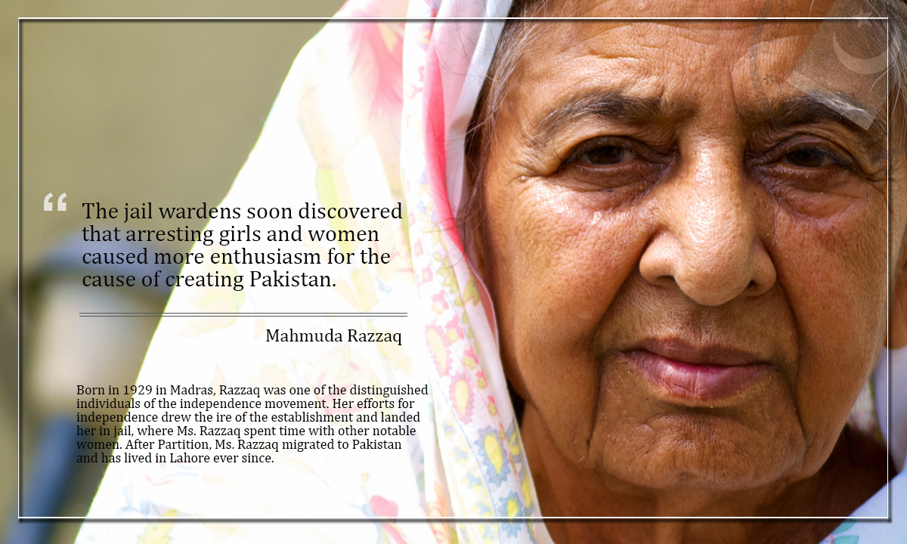

3 Experience of democracy
in Pakistan
Pakistanis have yearned for democracy for the last 68 years. Most of their struggles had been for the survival of democracy. They successfully reclaimedtheir right to be governed democratically by defeating four usurpers in uniform and by frustrating many more carefully orchestrated conspiracies. The risk of reversal is still there but the journey to realise democratic dreams continues.
The narrative of democracy in Pakistan reminds me of a childhood story, ‘Blind Men and the Elephant’. The elite view it as a share in the economic cake including loot and plunder. The poor regard it as an agency for patron-client relationship and then there is the mufassil and modern middle class that has read somewhere that democracy is about equality, inclusion, justice and rule of law — concerns deliberately avoided by the elite and the poor. Critics of Pakistani democracy promote numerous unexploded myths.
Pakistan has spent more time under highly centralised presidential dispensations at the cost of its federal diversity. The odd experience of One Unit (1955-1970) cost the nation its federal unity. The Dominion status after Independence imported the centralised federal system embedded in the Indian Act of 1935. Pakistan has had pure parliamentary governance for only 34 per cent of its national life, spanning 24,488 days till August 31, 2014. Therefore, denial of federal-parliamentary democracy is the real problem.

Pakistan has experienced high constitutional mortality. The single product – Pakistan – had been operated through multiple user manuals — the Constitutions of 1956, 1962 and 1973 and a series of Provisional Constitutional and Legal Framework Orders. Resultantly, the product has crashed on many occasions.
Whenever there is martial law, fundamental rights are suspended. The dictators do get a set of obedient judges through Provisional Constitutional Orders and puppet parliaments like the Majlis-e-Shura. But we, the people, don’t even remain citizens as our rights are suspended. The total life of the Constitution of 1973 is 14,992 days (41 years). Practically it has been operational for only less than 20 per cent at different stages. So who actually denied our rights?.
So what is the way out? Address the civil-military disequilibrium and negotiate peace with neighbours. Pakistanis also need a compulsory vaccine of ‘democratic civic education’ and a series of crash courses in democracy, constitutionalism, due process and democratic conflict resolution to transform our heated political culture into a delivering democracy. Only then will we be out of the thick woods and be able to see the real dawn of democracy that cares and caters to the socio-economic needs of its citizens.

4 Period of any dictator in Pakistan

The Pervez Musharraf government
As chief executive, Musharraf arrogated virtual total power to himself. The general cited the substantial turmoil in the country and noted that institutions had been systematically destroyed, that the economy was in a state of near collapse, and that only the most drastic measures could even begin to improve the national condition. Musharraf said Pakistan was at a critical crossroads and that the Sharif government had even planned to split and weaken the armed forces. Noting that he could not save both the country and the constitution at the same time, Musharraf chose to sacrifice the latter for the former. Nonetheless, the constitution had not been abrogated—merely held in “abeyance” until better times again allowed for its reinstatement. Careful to point out that martial law had not been imposed, he nevertheless insisted the country could not afford to perpetuate the old politics.
A Chief Executive Secretariat was hurriedly assembled in the waning days of 1999, and by mid-2000 that temporary edifice had undergone restructuring in order to give more administrative powers to the new regime. Ranking military officers assumed the most important positions in the government, and all civilian members of the secretariat had to pass scrutiny by army officers. The massive induction of serving military officers in the secretariat also was aimed at providing Musharraf with the same command and discipline structure found in the Pakistan army. The major dilemma facing Pakistan’s new rulers, however, was their lack of experience in civil affairs. Moreover, on-the-job training in the day-to-day life of the country quickly caused strains within the services.
Nawaz Sharif was arrested, charged and tried for high crimes, and, after being found guilty, sentenced to a long prison term. However, under international pressure he subsequently was released and sent into exile (Saudi Arabia), with the understanding that he would remain out of the country for 10 years.

Relations with the United States, consolidation of Musharraf’s rule, and meetings with India
The actions of Pakistan’s generals were coldly received by many in the outside world. Washington was quick to criticize the coup leaders, and Clinton signaled his disfavour by altering his March 2000 South Asian itinerary so as to spend only a few hours in Pakistan while stopping in India and Bangladesh for longer visits. However, the strain in U.S.-Pakistan relations was caused by a wide array of issues: Pakistan’s sustained political instability, its repeated failure at constructing civil society, the impediments to a resolution of the Kashmir question, and—most significantly—what seemed to be the country’s nuclear arms race with India.
As was the case in previous military governments, Musharraf’s announced intent was to return Pakistan to civilian rule as soon as feasible. The chief executive’s plan to achieve this goal was similar in certain aspects to that put forward by Ayub Khan a generation earlier. Civilian rule had fragmented, and a return to full civilian control would first require the establishment of local democracy—hearkening back to Ayub Khan’s “basic democracies”—a system devoid of competitive political parties. However, like the generals before him, Musharraf chose in June 2001 to consolidate his power by forcing the retirement of President Rafique Tarar, dispensing with the title of chief executive, and making himself president. The general also effectively became head of government, since the position of prime minister had been vacant since Sharif’s ouster.
In July, as president, Musharraf traveled to Agra, India, where he met with Indian Prime Minister Atal Bihari Vajpayee to discuss regional security and, importantly, the status of Kashmir. No real progress was made, but the meeting set the stage for subsequent summit meetings between Musharraf and his Indian counterparts. The president appeared to be slipping into a role that promised a period of reflection on how to reconstruct the country’s domestic and foreign policy, but that all was changed within two months by the new reality created by the September 11 attacks on the United States
The End
Name; Shakil Ahmed
ID; 14271
Subject; Pakistan study
Assignment no ; 2
Submited to; Mam benish

