GIS/RS Application to Civil Engineering
Submitted by:
Arqam Habib
ID: 7702
Section: A
Submitted to:
Engr. Syed Hamza Mustafa

IQRA NATIONAL UNIVERSITY PESHAWAR
Residential Area in Islamabad (Sector F, G and H)

By Arqam Habib

IQRA NATIONAL UNIVERSITY PESHAWAR

Introduction:
Islamabad is the capital city of Pakistan, and is federally administered as part of the Islamabad Capital Territory. Islamabad is the ninth largest city in Pakistan. Built as a planned city in the 1960s to replace Karachi as Pakistan's capital, Islamabad is noted for its high standards of living, safety and abundant greenery. The city's master-plan, designed by Greek architect Constantinos Apostolou Doxiadis, divides the city into eight zones, including administrative, diplomatic enclave, residential areas, educational sectors, industrial sectors, commercial areas, and rural and green areas.
Islamabad is divided in different residential sectors some of them are F-Sector, G-Sector and H-Sector. The F and G series contains the most developed sectors. F series contains sectors F-5 to F-17. G sectors are numbered G-5 through G-17. Some important places include the Jinnah Convention Centre and Serena Hotel in G-5, the Red Mosque in G-6, the Pakistan Institute of Medical Sciences, the largest medical complex in the capital, located in G-8, and the Karachi Company shopping canter in G-9. The H sectors are numbered H-8 through H-17. The H sectors are mostly dedicated to educational and health institutions. National University of Sciences and Technology covers a major portion of sector H-12.

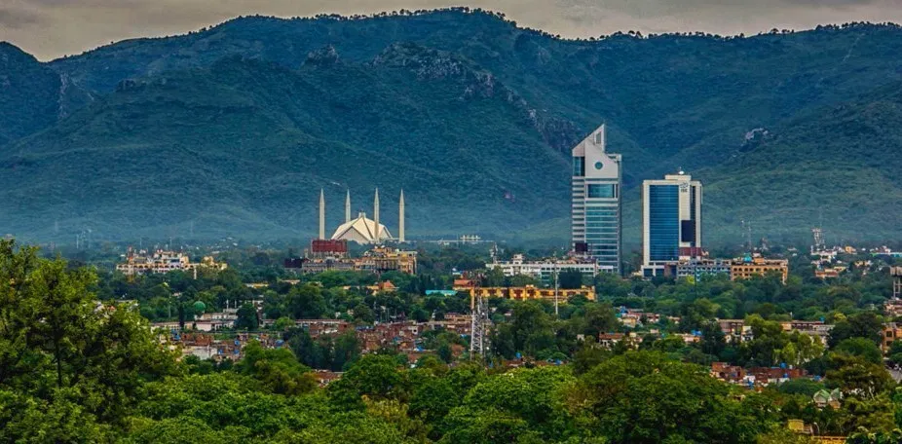
Figure 1 Islamabad

Problem Statement:
We are living in a modern life of 21st century which required well education, good environment and proper facilities for life style. But unluckily such facilities of modern life style are not properly available in backward areas of Pakistan. In such backward area peace, well education, good environment and lifestyle facilities are very rare. Hence people want to live in a condition where every facility of life is available.

Objective:
Our project's goal and objective are to identify a location using QGIS for residential area in Islamabad (Sector-F, Sector-G, and Sector-H) where one could have all the life facilities and on the following criteria;
- Road with a range of 50m to residential area.
- Police with a range of 1000 m to residential area.
- Market with a range of 50 m to residential area.
- School with a range of 400 m to residential area.
- Masjid with a range of 30 m to residential area.
- Hospital with a range of 1500 m to residential area.

Literature Review:
The first step toward the project was to conduct a literature review. The literature review consisted of evaluating research on popular problems and their solutions contained elsewhere, as a result of which a methodology was applied to achieve the goal of the project.

Methodology:
The methods followed for achieving the project's goal is shown in the figure below;

Figure 5 Methodology of the project

Data Collection:
Data was obtained from OpenStreetMap.
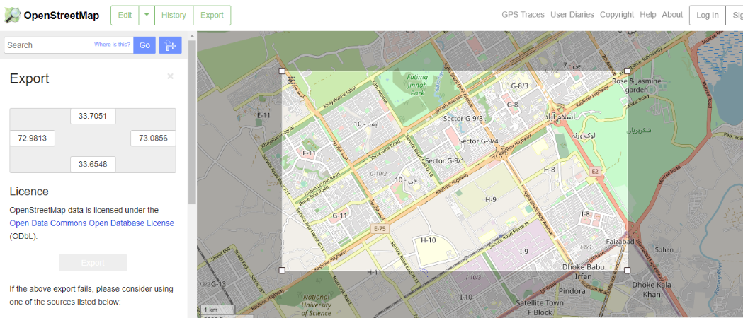
figure 5. 1 OpenStreetMap

Data Processing and Integration:
The data processing and integration consists of following steps;
- Installation of data into QGIS
- Converting of layers to 34S files
- Buffering of layers
- Intersection of layers

Installation of data into QGIS:
First, in the form of shapefiles, we put the OpenStreetMap data in QGIS. We hold the data of roads, schools, hospitals, Market, Police and masjids in the installed data as can be seen in figure;
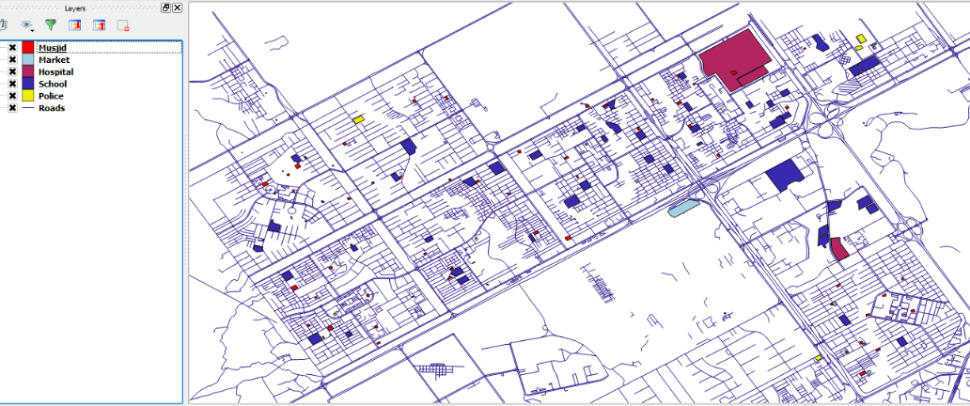
figure 5. 2 Installed data in QGIS

Converting of layers to 34S files:
For proper buffering, layers are then converted to 34S file;
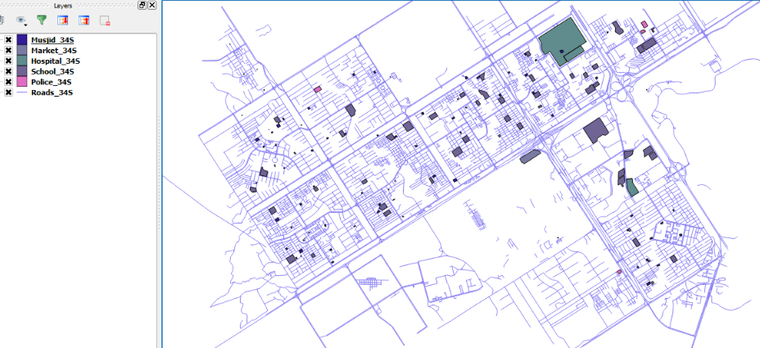
figure 5. 3 34S files

Buffering of layers:
After transforming the layers into 34S files, one by one we buffer the layers as;

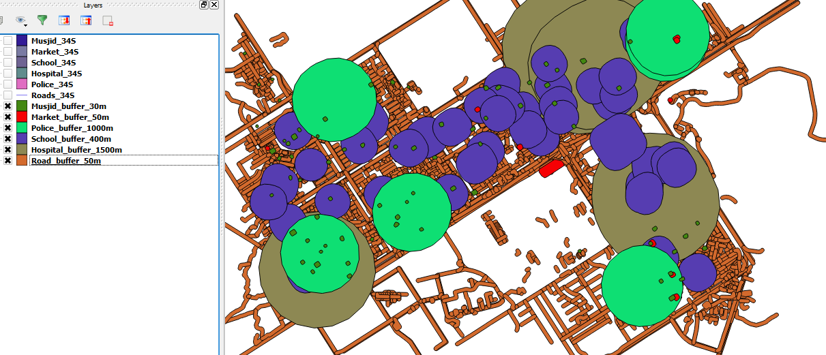
figure 5. 4 Buffered layers

Intersection of layers:
After the buffer layers are intersecting, we get the location according to the conditions shown in figure;

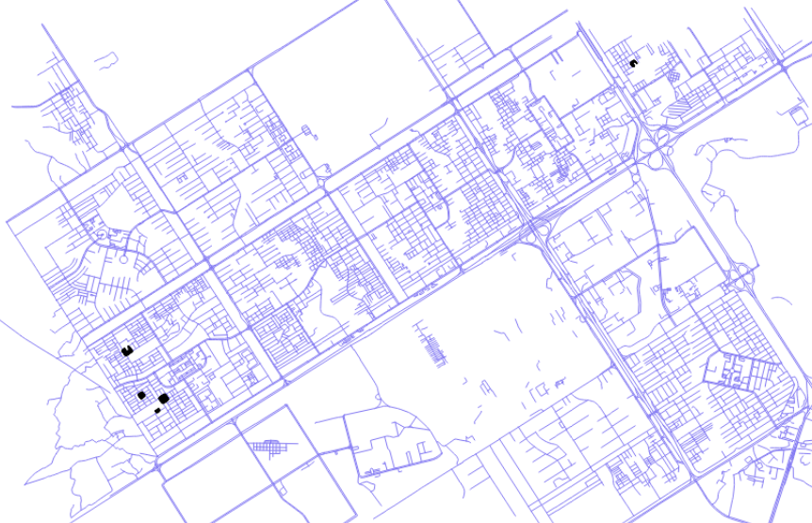
figure 5. 5 Intersection of layers

Data Output and Results:
The location for residential area according to mentioned condition is obtained in Sector G-11 and G-7 using techniques of QGIS.

Final Solution:

Location in G7:
The location according to the condition mentioned in objective are available in Street-19, Gali-20 and Gali-21.
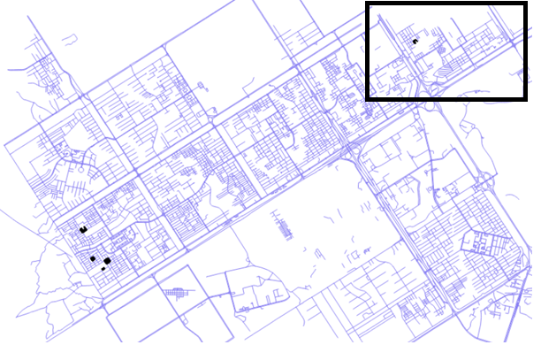
Figure 5. 6 Location in G7

Location in G11:
The location according to the condition mentioned in objective are available in Street-58, 70A, 69, 40, 58, 72, 73, 41, 42, 14, 21, 27, 18, 22, 20, 25, 8, 157, 158, 11, 166, 175, 174, 72, 173, 171, 7 and 10.
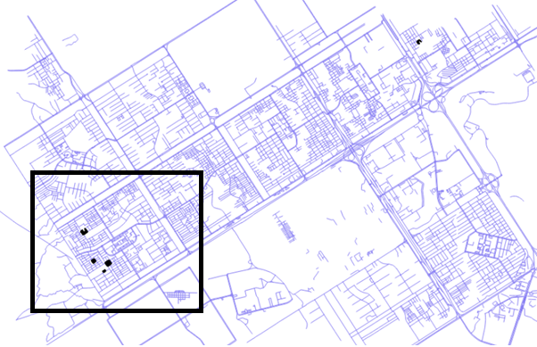
Figure 5. 7 Location in G11

