TSS
Name: Hikmat Ullah
ID: 13813
Program: BS – Telecommunications & Networks

Q.1A Determine the following equivalents:
27dBm=? dBW
36dBW= ? Watts
34dBm=? dBW

Solution:
- 27dBm=? dBW

Given P(dBW) = P(dBM) – 3 = 27 – 30 = 3dBW

- 36dBW=? Watts

P(dBW) = P(1W) – 3 = 36 – 30 = 6W

- 34dBm=? dBW

P(dBW) = P(dBm) – 3 = 34 – 30 = - 3dBW

B) A microwave transmitter has an output of 500 mW. What is its output in dBW? A combining network has two inputs: +29 dBm and +6 dBm. It has an insertion loss of 3 dB. What is the combined output in dBm?

1mw=0-001w=-30dBw
500mw=16.66 1w=-499.8dBw
Given..+29dBm and +6dBm
Insertion loss 3dB
To find output in dBm?
P(m
w)=1mw.10 p(dBm)10
P(mw)=1mw.10${29}^{10}$
P(mw)=0.1mw+290=+60
P(mw)=290.1dBm+60 dBm
230.1dm/3dm
=76.7dBm

Q.2A) In a traditional TDM system, four devices A, B, C, & D are transmitting data at the rates L, L, L, & 2L kbps, respectively. What must be the minimum transmission rate of output stream of the multiplexor? If the TDM frame size is ‘M’ k-bytes, then with the help of a diagram show a generic technique to keep the frames synchronized between multiplexor and demultiplexor. Draw the format of an ISDN multiplexed frame.

TDM
- The Sampled PAM waveform for must of form
- During the off period the channel can be used to transmit sample of other waveform
- The concept of interfacing samples from several signals into a single waveform is called TDM

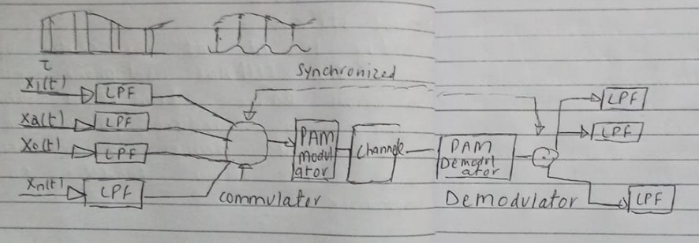

B) Describe Statistical TDM. How DWDM is different from WDM? Explain working of DWDM.

Statistical TDM:

Statistical Time Division Multiplexing (STDM) is a form of communication link sharing, which is almost identical to dynamic bandwidth allocation (DBA) in STDM, a communication channel is split into a random range of variable bit rate data streams or digital channels.

Difference between DWDM & WDM:

The difference between DWDM & WDM is one of degree only DWDM spaces the wavelengths more closely than WDM and therefore DWDM has greater overall capacity. The full capacity is not precisely known and probably has not been reached.

Working of DWDM:

DWDM is an optical technology used to increase bandwidth over existing Fiber Optic backbones. DWDM works by combining and transmitting multiple signals simultaneously at different wavelengths on the same Fiber.

C) What is PBX? What is its function? Draw PBX Architecture Diagram. What is an IP PBX & it differs from a normal PBX. Discuss the different services that can be provided by a PBX and an IP PBX.

PBX means Private Branch Exchange which is a private telephone network used within a company or organization, The users of PBX phone system can communicate internally and externally using different communication channels like voice over ip VOIP.

Function of PBX:

A PBX is a switch station for telephone systems it consist of mainly of several branches of telephone system and it switches connection to and from them, thereby linking phone lines.

PBX Architecture:

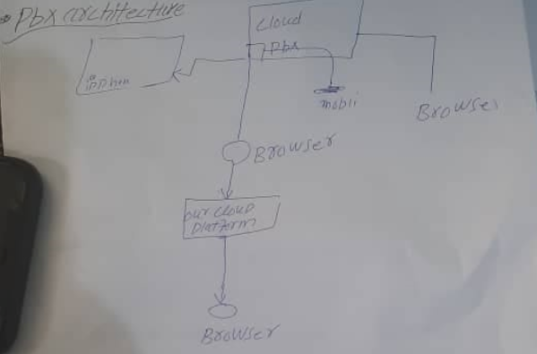

IP PBX:

Also known as a PBX, Unified Communication System or Business Phone System, a PBX acts as the central switching system for phone calls within a business, IP PBX system handle internal traffic between stations and act as the gatekeeper.

Difference between Normal and IP PBX:

The difference between PBX and IP PBX is the way they connect users, a PBX system is essentially a small telephone network that uses standard telephone lines for incoming and outgoing calls.

The different services provided by a PBX and IP PBX:

PBX: Communicate internally and externally within a company or organization using different communication channels like Voice over IP (VoiP), ISDN or Analog.

IP PBX: Switches call between VoiP users on local line while allowing all user to share a line.

Q.3A) Elaborate at least three speech coding schemes. What advantages nonlinear encoding has over linear coding? How nonlinear encoding is implemented in practical systems?

Three Speech Coding Schemes are:

. Waveform Coders:
PCM, ADPCM

. Vocoders:
Synthesized voice, LPC

. Hybrid Coders:
Linear waveform approximation with synthesized voice, CELP

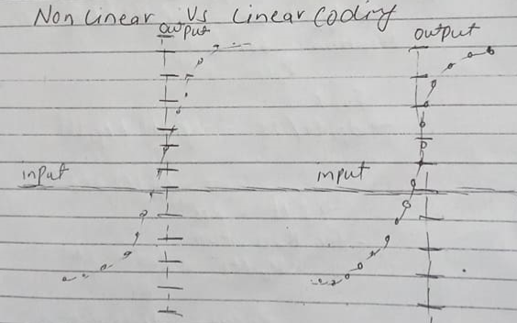

Linear Coding: Relatively easy to analyze and regenerate all amplitudes that have equal distortion.

Non Linear Coding: Closely follow human voice characteristics, high amplitude signal have more distortion.

B) A Mobile Station (MS) is in idle mode and wants to originate a call, however it doesn’t have a physical channel for communication with the base station. How communication takes place between MS and the base station?

Mobile station equipment such as cell phone sim card etc. and software needed from communication with a GSM network. The four main components of GSM station are terminal
Equipment in any devices connected to the mobile station which offers services to user such as mobile phone and mobile devices.
Base station....
- Relay located at the center of any cellular Telephone system
- A sort range which connect a cordless phone or other wireless devices to a central hub and allow connecting to a network

Q3C ) Explain in detail Incoming Traffic and Services time characterization.

µk=0 li all k
Ʌu=Ʌ li all k
The system begins with the zero meters
Pk(0) =$\begin{matrix}1 & k=0 \\ 0 & k≠0\end{matrix}$

Dp(t)/ dt = - p(t) + µ1p1 (t)
Dp (t)dt = -Ap(t)
Dp(t)dt= Ʌp(t)
Dpk (t )dt =Ʌpk (t) +Ʌpk -1(t)
Solution for p0(t)

p. (t) =$e^{-xt}$
For k=1
dp1 (trdt=-Ʌp1 (t) +Ʌ0 (t)
=t-Ʌp1(t)+ Ʌe-Ʌt
For k > 0,t>0
Pk(t)=( Ʌ+)k/k1e-kt
Poison distribution

