NAME : SANGEEN KHAN
ID : 16098
SECTION : A
SUBMITTED TO ; ALINA MUSHTAQ
2ND SEMESTER
CIVIL ENGINEERING.
- QUESTION :
Isalmic architecture of Turkey ( Seljuk architecture )
- ANSWER :
- If we talk about the countries which are rich and famous in architecture , Turkey is the one in them .
- Eastern and western architecture can be seen in Turkey architecture.
- By combining different architecture styles has resulted in an expansive architectural experience for the country Turkey .
- American architectural influence can be clearly seen in turkey architecture.
- Turkey is among the countries that offer a wide range of architectural diversity.
- GREAT SELJUK EMPIRE ARCHITECTURE:
- Seljuk architectural elements can be found around a large area stretching from central asia to the Persian gulf.
- The basic area of Seljuk is TURKMENISTAN.
- Earthquake destroy most of these building and only few were left .
- The most significant alteration was the conversation of the mosque plan into four_iwan plan mosque .Another mosque type introduced at this time was the containing of a DOMED space with three open sides.
- The architecture of this period was also characterized by memorial tombs, structure with DOMED ROOFS. 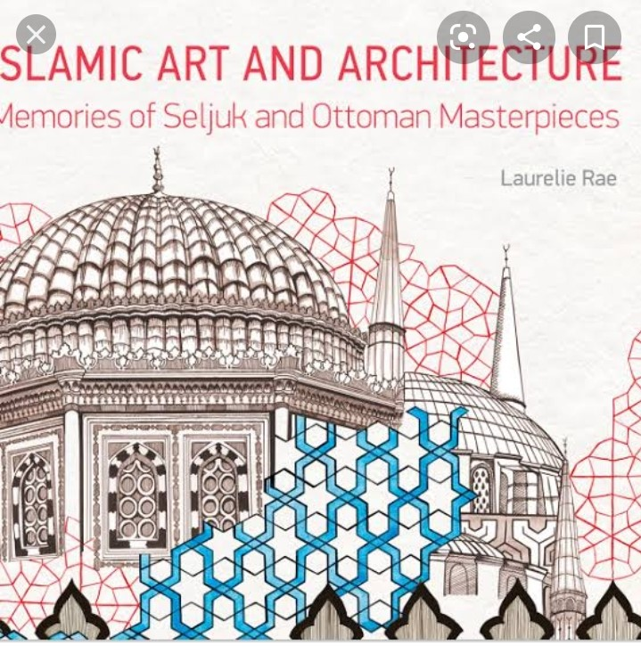
- SOME EXAMPLES OF SELJUK ARCHITECTURE INClUDE :
- Tomb of Ahmad Sanjar.
- Kharraqan tower.
- ANATOLIAN SELUK ARECHITECTURE :
- The greatest numbers of monuments are in Anatolia.
- The Seljuks of Rum built monumental stone building of simple design. There is also a DOOR DECORTION and WALL DECORTION.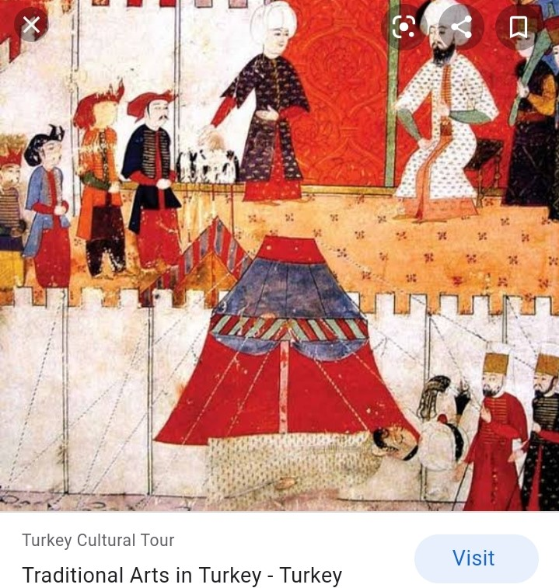
- About a hundred of structures were built during the Anatolian Seljuks period, are particularly remarkable.
- Seljuk influenced by American architecture.
- As such Anatolian architecture represents some of the most famous and impressive construction in entire history of Islamic architecture.
- The use of stones in Anatolia is the biggest difference with the Seljuk building in Iran , which are made of bricks.
- BUILDING TYPES IN THE SELJUK EMPIRE :
- Mosques( complex mosque )
- Medreses (building for higher education in the science )
- Hospitals (which could also be combined with medical school )
- Bridges .
- Tomb towers.
- Palaces.
- Civil construction and urban infrastructure.
- Military construction (city walls ).
- SELJUK TURKISH ARCHITECTURE :
- The Seljuk Turks settled in Anatolia ( now a days Turkey ).
- They arrived from the central Asia by the way of Iran where they learn the architecture of Persian and also new styles.
- When they came to Turkey ( Seljuk) they leran new tradition in turkey they mixed all the architecture and give shape to the unique and beautiful architecture , which became the famous architecture through out the world.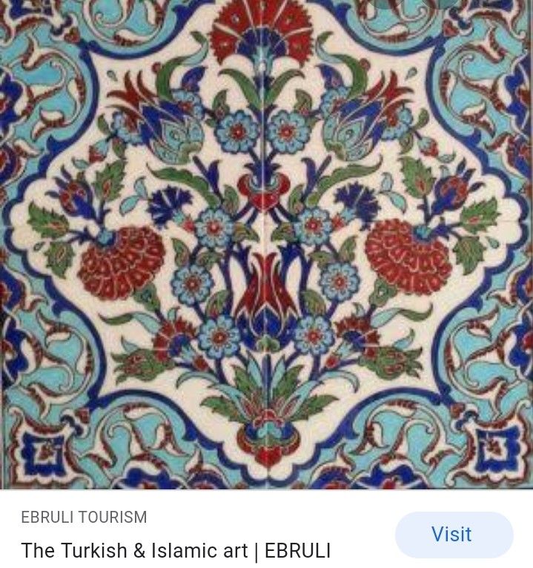
- THE ESSENCE OF SELJUK STYLE :
- The Seljuks of Rum built monumental stone building of simple design and harmonious proportion , for the most part severely plain, with decoration around the walls and doorways.
- Most of the Anatolian Seljuk work is with stone, bricks.
- Architects in the Seljuk Sultanate of Rum often decided the court must be cover with protect against the colder snowier winter of the Anatolian plateau.
- WHERE TO SEE SELJUK BUILDINGS :
- Konya is the best place to see architecture and other great Seljuk cities _ Alana , Erzurum and sivas have good examples.
- Most of the Seljuk work can be seen in the most of cities of ANATOLIA epically in central and eastern Anatolia.
- Most of the buildings are made in ANATOLIA in 1200s to encourage trade throughout the empire.
- The most important and famous of the Seljuk empire is their architecture.
- A large number of Seljuk buildings still stand in Turkey today, and is consider the most famous and beautiful monuments ever built in Islamic hands.
- These monuments were considered of the most expansive quilty.
- Most the decoration is done by the stones which gives very attractive look.
- The Seljuk built most of mosques, educational and other institution which are still alive in Turkey.
- The most of the buildings in Turkey were considering the most outstanding buildings in the history.
- FEATURES OG SELJUK ARCHITECTURE :
- Seljuk decoration is most of done by the stones and colorful ceramic.
- Most of the walls is covered with HUMAN and ANIMALS picture.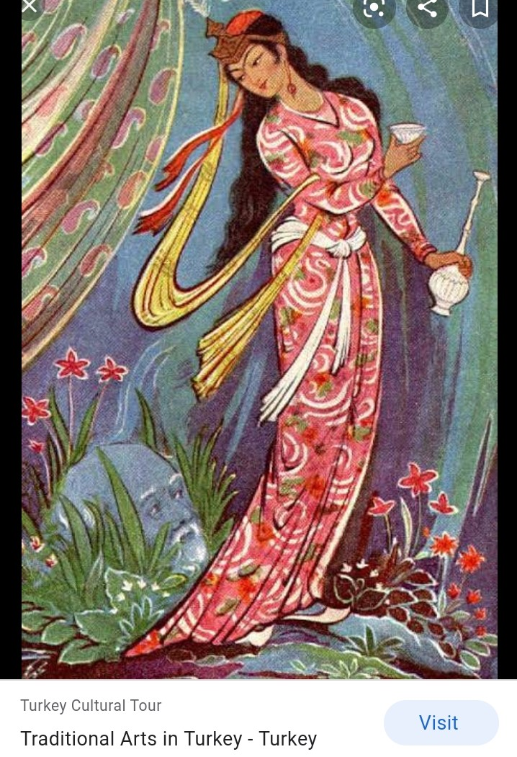
- An important element used in Seljuk building constriction is the IWAN.
- Most of the building middle is in shape of domed and the domed is covered with tiles .
- The walls of buildings is covered by most of shone and lime stone.
- SOME OF THE BUILDING TYPES BUILD BY ANATOLIA SELJUKS :
- MOSQUES :
- Most of the buildings that are build in Turkey by Seljuk were MOSQUES.
- By the first time in history MOSQUES were build in Turkey by Seljuks
- When the Seljuks arrived in Turkey in the 13 century , they constructed mosques with wooden columns.
- Muslims _Turks built these kinds of mosques for the first time in Muslim history.
- In mosques most of the pillars were of wooden pillars instead of stone piers.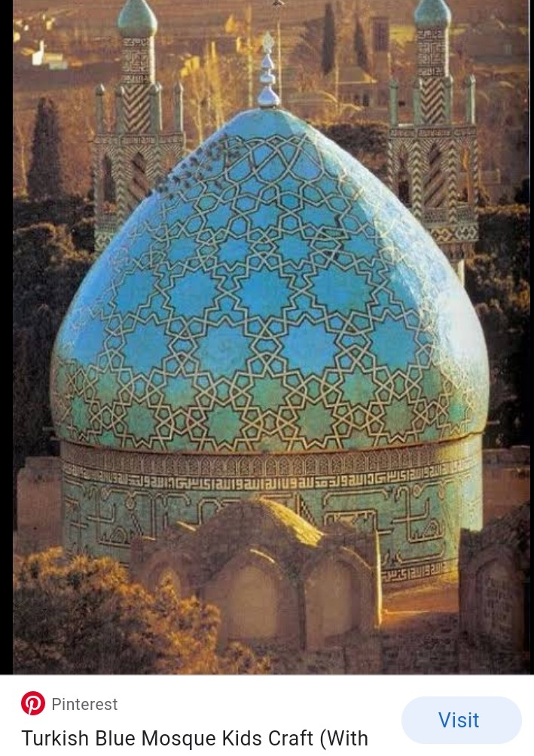
- MADRESES:
- Madreses were educational buildings which were build with either open or closed domed included 1-4 iwan.
- The iwan were build for lecture halls and study spaces.
- HOSPITALS :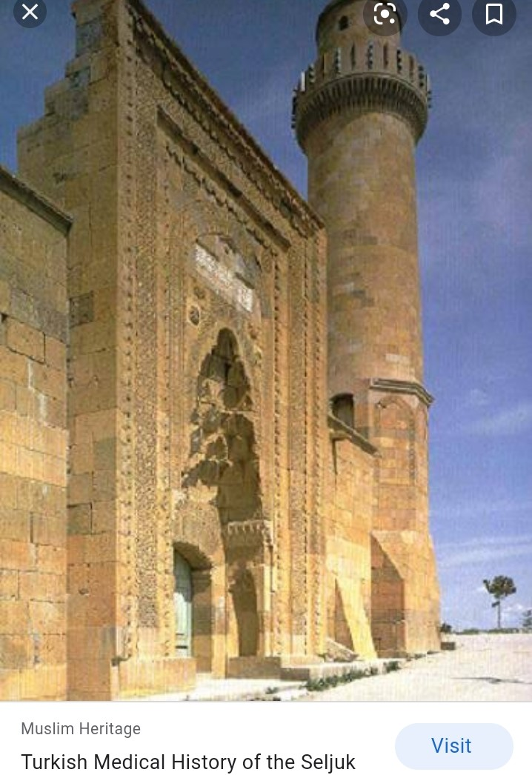
- These buildings were build for health care for its citizens.
- These hospitals were free of cost for all the citizens.
- The wealth for these hospitals were paid by the wealthy persons.
- The Seljuks were paid more attention to the needy and poor people.
- PALACES:
- As there were mosques , medreses their were also Seljuk palaces .
- These palaces were build with stones and bricks.
- These palaces were decorated by the geometric tiles.
- These palaces were most of two storeys palaces.
_________________________-
The end

