IQRA NATIONAL UNIVERSITY MID TERM ASSIGNMENT PAPER.
ID: 16099 SECTION: A. INSTRUCTOR: MADAM ALINA BABAR.
SEMESTER SPRING FALL 2020. MODULE: 2ND SEMESTER.
SUBJECT: INTODUCTION TO ARHITECTURE AND TOWN PLANNING.

Note:
Attempt All Questions. Each question carry 10 Marks.

Q1: Take any building from internet, put its picture in Microsoft Word and explain its positive and negative points according to the principles of design. What could be done to make the building more attractive? Answer must be at least 200 words.
ANS:
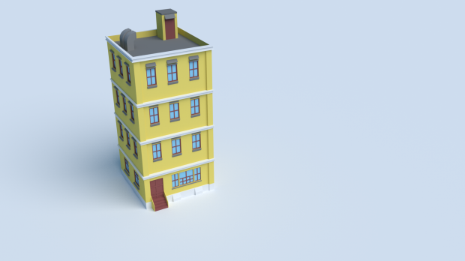

Following are the positive and negative points of the building shown in the picture according to the principle of design.

POSITIVE POINTS:
- BALANCE: The shown building in the above sketch is symmetrical and well balanced from all directions and the load is equally distributed on all columns which indicates the positive part of the building.
- PATTERN: The building also posseses the same pattern in the windows and also in the column.
- REPETITION: The repetition can be noticed in the building which is also a positive point. The windows and the columns are repeated which makes the building look beautiful.
- RYTHEM: The building also have rhythmic properties as you can see in the building floor 1st, 2nd and 3rd.
- UNITY: The building also have unity its all structured elements are working together to form this building.
- SCALE: The structure and elements of the buildings are all according to the scale and objects are well placed.

NEGATIVE POINTS:
- EMPHASIS: The building does not possess any unique property which can catch a human eye which makes the building look beautiful.
- CONTRAST: There is no contrast in the building which is the main negative point in the building, contrast can make the building look beautiful.
- VARIETY: There is no variety in the building which can easily be seen in the above sketch, there is no contrast which means not much variety is used.

Steps can be taken to attract the building which will make the building beautiful and can attract human eyes, if we put any emphasis on any side of the building which can easily attract human eyes plus if there were variety of colours with a combination of dark-light the building would look more gorgeous.

2ND QUESTION ON NEXT PAGE.

Q2: Design and sketch an ideal single storey house on the site shown below. The design should be free hand and can be drawn on graph paper. If a graph paper is not available then make a grid of 5’x5’ on a separate white A4 size paper. The house should be naturally ventilated and have natural lighting. Also, it should be free of noise. The site is located in Peshawar. Label or explain the Plan neatly.
Site Problems:
- Open drainage in direction of summer winds which is a major source of bad smell
- Noise from west side and Winter winds from north-east side
- Existing 2 storey building on south side blocking some solar radiations.

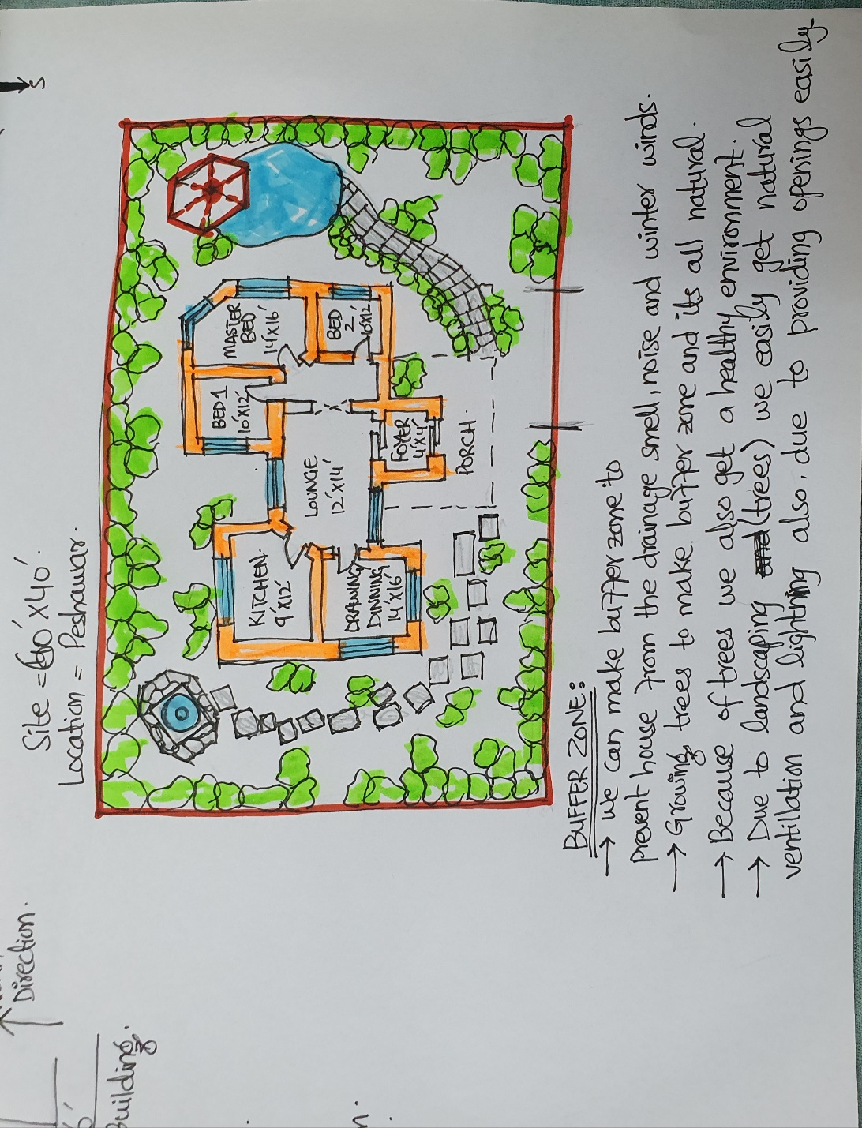

Q3: Select a site at the place where you live. Do Micro site analysis of Site and make its sketch on another A4 paper and write about it in detail. You can take your own lawn as a site for analysis or any other site in the neighborhood. Additionally, make a solar path diagram for your area on a separate piece of paper to find the exact sun angles for both winter and summer. Watch videos on YouTube to understand and make Solar Path diagram. Use these sun angles to make a rough sketch of a room. Show window height, type of fixed sun shade used, angle and height of shade as well as its depth and width by keeping sun angles in mind. The purpose for the sketch is to show how winter sun is allowed and summer sun is blocked.
ANS:
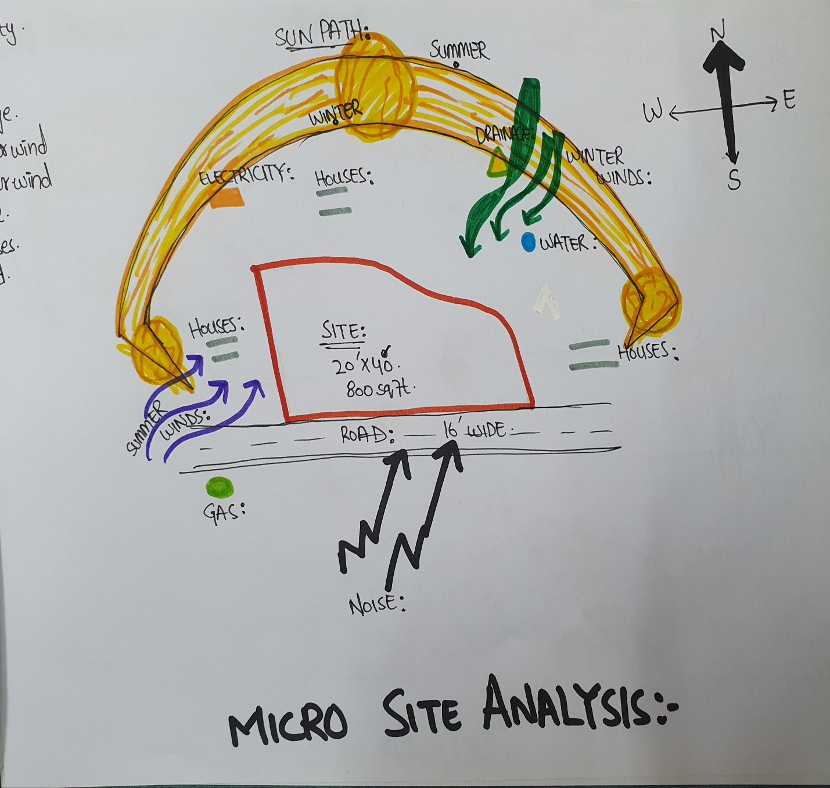
SUN PATH and SUN ANGLES picture is on another page..
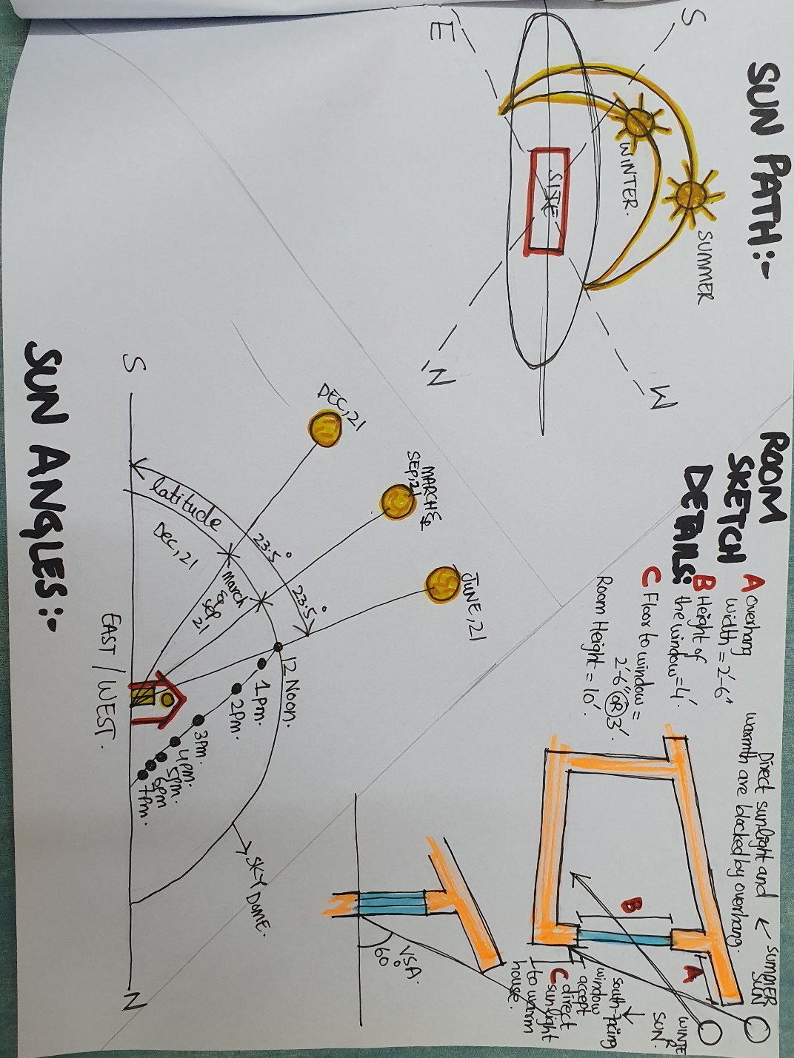

THE END.

