VIVA ASSIGNMENT
DEPARMENT OF SOFTWERE ENGINEERING

NAME: JIBRAN KHAN
ID NO: 16107
SEMESTER: 2nd
COURSE TITLE : PROGRAMMING
COURSE INSTRUCTOR: SIR AYUB

Q.No.01:
Answer:
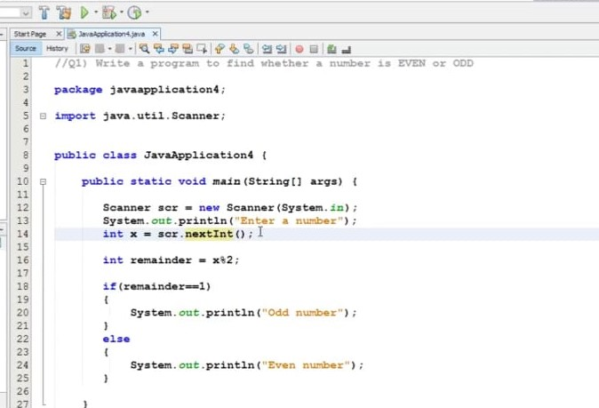

Explanation:
In this program we would tell that how to print the even and odd numbers. We know that class is the collection of objects. Else and if else are used in this program. We also know that the public is an access modifier. We write the statement in the system.out.println because we that the println is a method of java. io. PrintStream. This method is overloaded to print message to output destination, which is typically a console or file. the System class belongs to java.lang package. So after that we will click on the run option and the compiler will show us the even and odd numbers.

Q.No.02:
Answer:

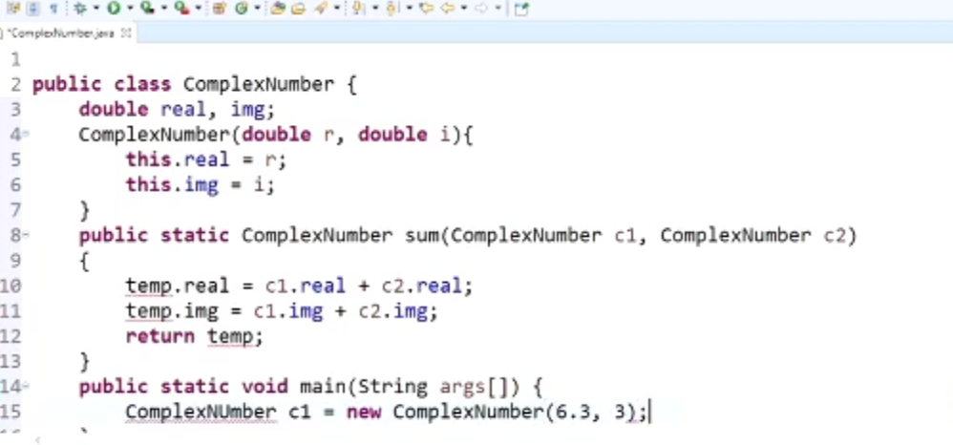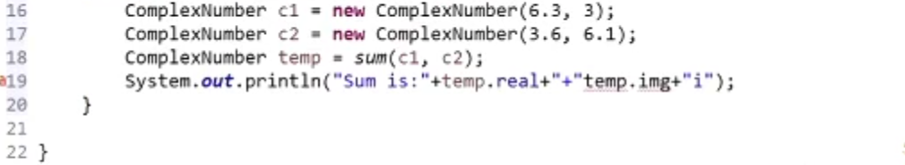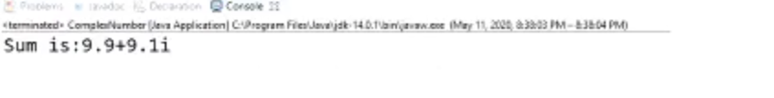

Explanation:
In this program I am going to add two complex numbers. We know that the complex numbers have two parts – real part and imaginary part. When adding complex numbers we add real parts together and imaginary parts together. Public and double access modifiers are used in the program. So in this program we add two complex numbers C1 and C2.Hence in system.out.println , the println is a method of java. io. PrintStream. This method is overloaded to print message to output destination, which is typically a console or file. the System class belongs to java.lang package. Whenever we run the program, then the compiler will show us the result.

Q.No.03:
Answer:
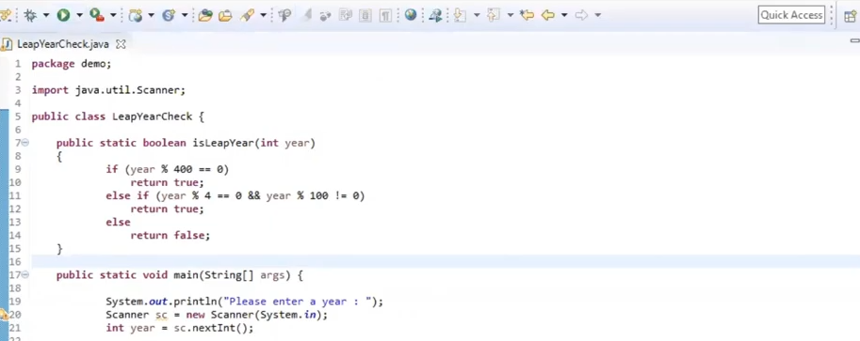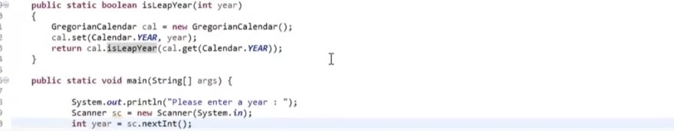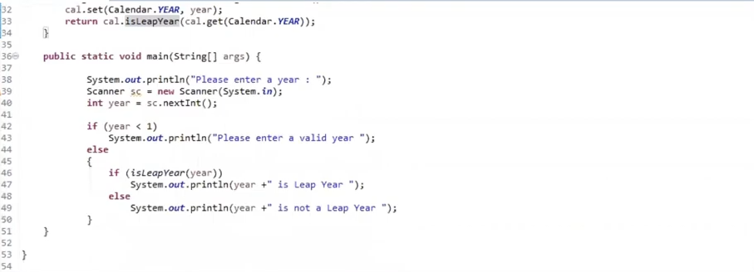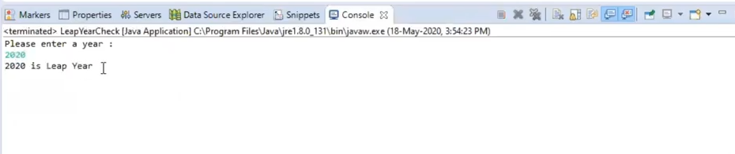

Explanation:
In this program we will check that which year is a leap year. So first the keyword public static void main is the means by which you create a main method within the Java application. It's the core method of the program and calls all others. It can't return values and accepts parameters for complex command-line processing. Else and if else are used in this program. Use if to specify a block of code to be executed, if a specified condition is true. Use else if to specify a new condition to test, if the first condition is false. In system.out.println, the println is a method of java. io. PrintStream. This method is overloaded to print message to output destination, which is typically a console or file. the System class belongs to java.lang package. So if we click on the run option, then the compiler will show us the result.

Q.No.04:
Answer: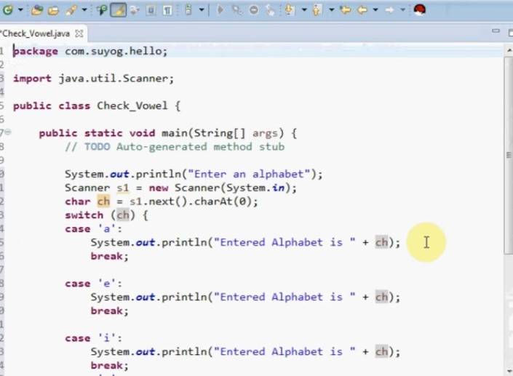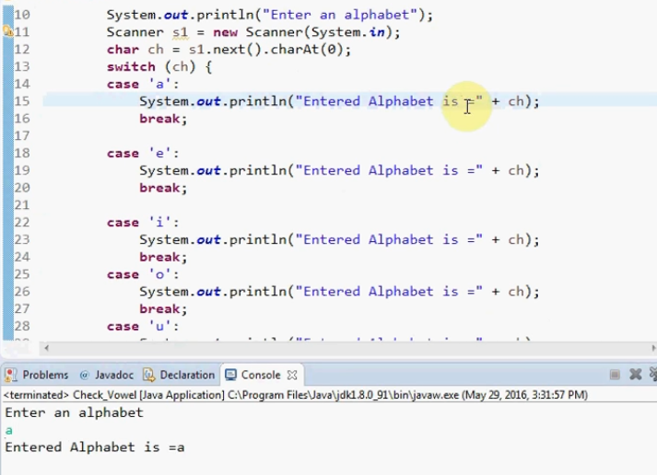

Explanation:
In this program we are taken the value from the user. Public access modifier is used in the program. We will check that either it is vowel or not. We also know that a, e , i , o , u are vowels. So the keyword public static void main is the means by which you create a main method within the Java application. It's the core method of the program and calls all others. It can't return values and accepts parameters for complex command-line processing. We input all the statements in the system.out.println just for showing us the result in the compilar. So if we click on the run option then the compilar will show us the result that which one is vowel or not.

Q.No.05:
Answer:
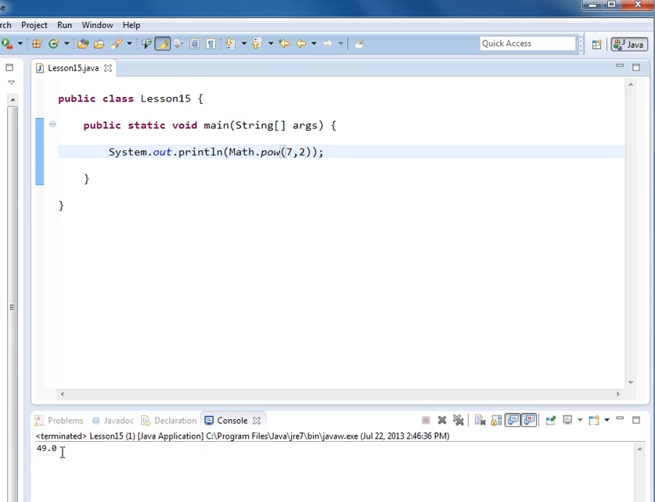

Explanation:
In this program the power of a number is used in java. The keyword public static void main is the means by which you create a main method within the Java application. It's the core method of the program and calls all others. It can't return values and accepts parameters for complex command-line processing. The println is a method of java. io. PrintStream. This method is overloaded to print message to output destination, which is typically a console or file. the System class belongs to java.lang package. At the last if we run the program, then the compilar will show us the result.

THE END…

