DPT 2nd Semester (section A)

Course Title: Biomechanics-I Instructor: Ahmed Hayat
Assignment for VIVA
NAME BAHAR ALI
ID 16063
DEPARTMENT DPT 2ND
SECTION A
SUBJECT BIOMECHANICS
LABEL ANY 15 MUSCLES IN THE PICTURE.
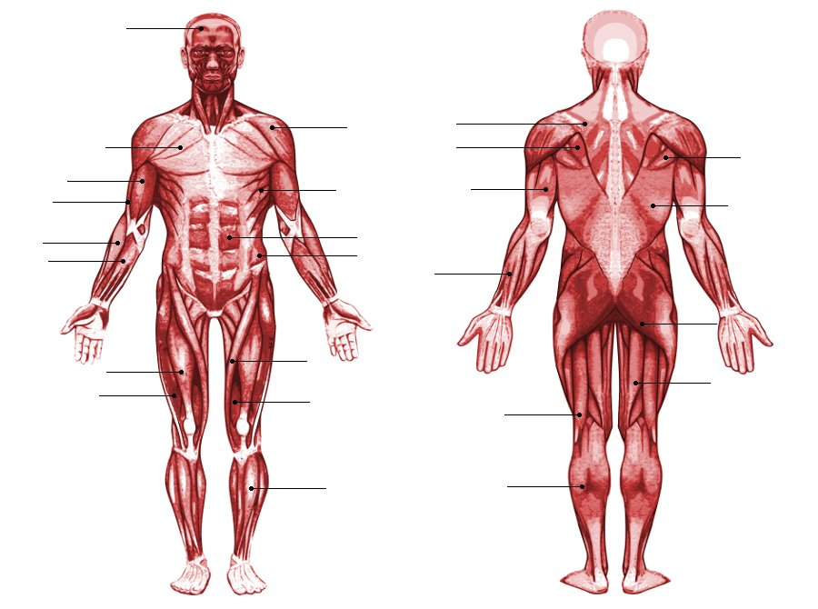
15
14
13
12
11
10
9
8
7
6
5
4
3
2
1
- TERES MAJOR
- BRACHIALIS
- CORACHOBRACHIALIS
- BRACHIORADIALIS
- FLEXOR CARPI RADIALIS
- RECTUS FEMORIS
- VASTUS LATERALIS
- DELTOID
- SERRATUS ANTERIOR
- RECTUS ABDOMINUS
- INTERNAL OBLIQUE
- SARTORIUS
- GRACILIS
- TIBIALIS ANTERIOR
- TERES MAJOR

