Subject: Econometrics
Sessional Assignment
Uploading Date 1 May 2020
Due Date: 1 June 2020

Task 1: Select a research topic related with your degree specialization. The results should be empirically tested for supporting or refuting your claim hypothesis. The report should be written in Ms word document. The 18% plagiarism in the report will be allowed. The data file should also be submitted along with the report. For analysis the Eviews or SPSS software should be use.
The report should contain:
- Research topic
- Research questions
- Research objectives
- Research hypothesis
- Problem statement
- 2-pages latest Literature review
- Econometric modelling
- Empirical analysis
- Interpretation
- 1-page conclusion
- 1-page policy recommendations

TOPIC : THE EFFECTS OF INFLATION ON GDP GROWTH OF PAKISTAN

Introduction:
Pakistan has gained independent status in 1947 and after seventy three years the economic conditions have not improved substantially and comparatively to other developing nations the GDP (Gross domestic Product)growth is not in proportion to the other developing nations of similar stature to Pakistan. There can be many reasons behind the stagnant economic environment and the decrease in per capita income of citizens of the country. A prominent reason is that of Inflation that has resulted in an increase in commodity prices especially in the last decade. This report will aim to examine the relationship of inflation to the GDP of Pakistan and conclude if deterioration in this economic indicator is because of rapid inflation experienced by Pakistan. In order to address the research in consideration the following questions have been designed and best directed towards addressing the topic in consideration. They are:
Research Questions:
- Does an increase in inflation affect the Gross domestic Product and its growth?
Objectives of the research :
Primarily there are three core objectives which are intended to be achieved through this effort.
- To find if the constant increase in inflation has any relationship with the worsening of the GDP thus leading to the deteriorating economic conditions of Pakistan.
- Possible remedial steps that can be implemented by the Central bank(State Bank) and regulating authorities of enterprise and the central government for to curb inflation.
- Should it be the Policy objective of the establishment of the country to prioritize controlling inflation.

Problem statement :

Recently the past two years have experienced the highest increase in prices at an average of 8.50% in April 2020.Which is alarming when future economic growth and all indicators are taken into consideration. Being one of the highest population density countries, Pakistan has to focus on fixing this increasing issue before the country is plummeted in severe poverty as has been the case of many undeveloped nation in the past. The following chart is prepared by the Pakistan bureau of statistics showing the statistics of GDP for Pakistan showing the growth rate at 1.9 %, which is the lowest in south Asia .

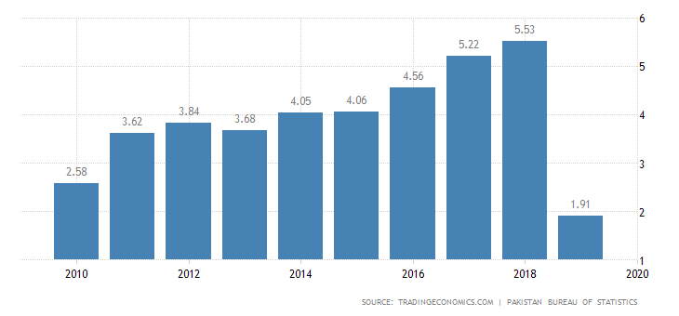
The other following chart presents the inflation data for Pakistan also prepared by Pakistan Bureau of statistics. Values have been averaging at a rate of 10% throughout recent time, which is far greater than the GDP growth, signalling that recessionary trends are settling in the country and deficits will be growing in future. In order to protect prosperity and future viability , regulating authorities as well as the common people must have knowledge of the effects of inflation not only on the economic conditions but also societal condition leading to possible civil unrest, crime surge and internal instability. Once the structure of a country is weak it is prone to outside interference and foreign powers are most interest in destabilization. Therefor the importance of addressing inflationary pressures cannot be undermined and ignored if a state is to be preserved and developed.
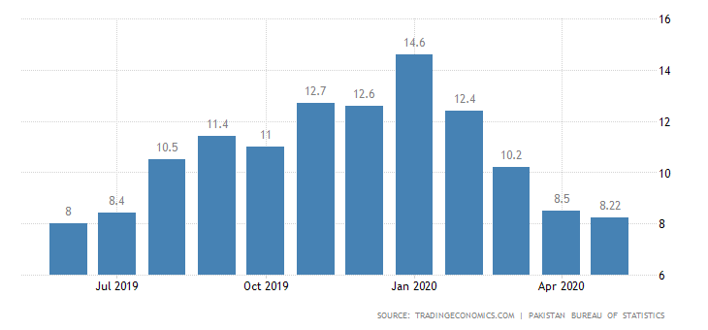

Research Hypothesis:
The following hypotheses have been formulated for the statistic test that is performed and these are as following:

H1: The increase in inflation is a reason for worsening of GDP growth in Pakistan
Ho: The increase in inflation has no effect on the worsening of the GDP(Gross domestic product ) of Pakistan .

Literature review:
Barro (1995) explores the relationship between inflation an economic growth by conducting a research of 100 countries which is fairly large sample , and the data is of the time frame from 1960 to 1990 . His empirical analysis concluded that for a 10 % increase in inflation a year can reduce the real GDP and per capita income by 0.2% – 0.3% per year . A trend which if kept continued can severely diminish economic progress and civil well being. The relationship between economic growth and inflation is negative and there is reason to consider from the data that high long term inflation reduces economic growth. A fact that is also intended to be uncovered by the research as well.
Sarel (1995) mentions that before the 1970s inflation rates were modest in most countries throughout the world and after that began to increase. Therefor most empirical studies conducted before the 1970s show that economic growth and inflation go hand in hand. But these studies have decreased in relevance with time.
Malik and chawodhury (2001) examine the short run as well as the long run dynamics of this relationship and the rearch work was based on the data of four countries Banglades, Pakistan, India and Sri Lanks.this data was retrieve form the internation monetary fund (IMF) International financial statistics(IFS). Two motivating results wre uncovered during this work , firstly that the relationship between inflation and economic growth is positive and statistically significant for all four countries. Econdl the sensitivity of economic growth to changes in inflation is lower that that of the sensitivity of inflation to economic growth.
Khan and Senhadji (2001) conducted analysis of the growth rate of industrialised countries. The authors re-examine the issue of the existence of “Threshold” effects in relationship between inflation and growth, using econometric techniques initially developed by Chan and Tsay (1998) and Hansen (1999, 2000). They used the data set for 140 countries from 1960 to 1998. Their findings strongly suggested the existence of threshold beyond which inflation exerts a negative effect on growth. Inflation level below the threshold level has no effect on the growth, while inflation rates above the threshold have a significant negative effect on growth.

Munir and masor (2005) investigate the non linear relationship between inflation rate and economic growth for the countr of malasis in the tie period from 1970 to 2005 . the estimates thresh hold or limit recognised from the economic model was at 3.89 % inflation . above this threshold inflation had significant effects on growth and retarded economic growth below this point however the raltionship was positive.
Further Sergi (2009) investigation revealed that growth and inflation interaction for industrialized countries in the time period of 2001 to 2008 also had similar results. In that an inflation level of 8% and above slow the economy and damages growth for present year as well as forthcoming ears , which makes it difficult to recover from inflationary pressures Therefor the increase should not be more than 8% inflation rise to prevent recession and ensure that the state maintains its viability.
Conclusively stating that literature already available on the topic has similar and varying results. Those results being that economy has a direct relationship with inflation. That relationship being negative or inverse for the fact of the matter and empirical analysis reveal that a constant rise can deteriorate recover from recession. In the present and modern day scenarios the world is globally competitive and markets are filled with competition . Technological innovation have caused economies to be connected and benefit from trade but as well be able to compete. In such a globalized setting the state which has weak economic policies and direction will face incalculable losses and be threatened for its survival. Inflation being one of the foremost challenged faced, has to be targeted for a thriving economy. Otherwise limited resources especially in the case of Pakistan are directed towards unimportant matters and have no positive results

Econometric modelling :
The following results were displayed by the analysis conducted on SPSS software.

