Name : Muez Ullah
Department : B.s (Rad) section B
Student I’D : 15707

Subject: Human Anatomy II
Instructor: Dr. Arooba.
Section: B
June 22nd, 2020. Total marks: 50
Attempt the following questions. Add diagrams where needed.
Each carries 10 marks.

- What are the major features of intracranial fossae of the skull?
ANS : The floor of the cranial cavity is divided into three distinct depressions. They are known as
*Anterior cranial fossa
*middle cranial fossa
*posterior cranial fossa.
Each FOSSA accommodates a different part of the brain. The anterior cranial fossa is the most shallow and superior of the three cranial fossae. It lies superiorly over the nasal and orbital cavities. The fossa accommodates the anteroinferior portions of the frontal lobes of the brain
Borders:
The anterior cranial fossa consists of three bones: the frontal bone, ethmoid bone and sphenoid bone.
It is bounded as follows:
Anteriorly and laterally it is bounded by the inner surface of the frontal bone.
Posteriorly and medially it is bounded by the limbus of the sphenoid bone. The limbus is a bony ridge that forms the anterior border of the prechiasmatic sulcus
Posteriorly and laterally it is bounded by the lesser wings of the sphenoid bone
The floor consists of the frontal bone, ethmoid bone and the anterior aspects of the body and lesser wings of the sphenoid bone
Contents:
There are several bony landmarks present in the anterior cranial fossa.
The frontal bone is marked in the midline by a body ridge, known as the frontal crest. It projects upwards, and acts as a site of attachment for the falx cerebri
In the midline of the ethmoid bone, the crista galli is situated. This is an upwards projection of bone, which acts as another point of attachment for the falx cerebri.
On either side of the crista galli is the cribriform plate which supports the olfactory bulb and has numerous foramina that transmit vessels and nerves.
The anterior aspect of the sphenoid bone lies within the anterior cranial fossa. From the central body, the lesser wings arise. The rounded ends of the lesser wings are known as the anterior clinoid processes.
the sphenoid bone also separate the anterior and middle cranial fossae
.
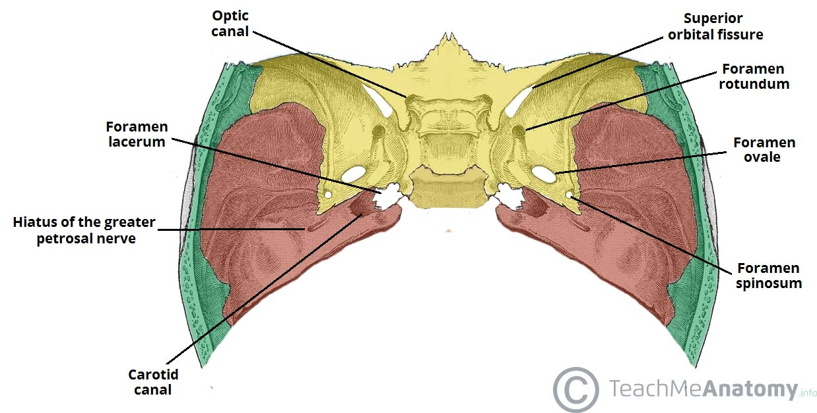
- Write note on the cranial nerves.

ANS: What are cranial nerves?
Your cranial nerves are pairs of nerves that connect your brain to different parts of your head, neck, and trunk. There are 12 of them, each named for their function or structure.
Each nerve also has a corresponding Roman numeral between I and XII. This is based off their location from front to back. For example, your olfactory nerve is closest to the front of your head, so it’s designated as I.
Their functions are usually categorized as being either sensory or motor. Sensory nerves are involved with your senses, such as smell, hearing, and touch. Motor nerves control the movement and function of muscles or glands.
12 cranial nerves and how they function.
Nerves and functions.

I. Olfactory nerve
The olfactory nerve transmits sensory information to your brain regarding smells that you encounter.

II. Optic nerve
The optic nerve is the sensory nerve that involves vision.
When light enters your eye, it comes into contact with special receptors in your retina called rods and cones. Rods are found in large numbers and are highly sensitive to light. They’re more specialized for black and white or night vision.
Cones are present in smaller numbers. They have a lower light sensitivity than rods and are more involved with color vision.

III. Oculomotor nerve
The oculomotor nerve has two different motor functions: muscle function and pupil response.
- Muscle function. Your oculomotor nerve provides motor function to four of the six muscles around your eyes. These muscles help your eyes move and focus on objects.
- Pupil response. It also helps to control the size of your pupil as it responds to light.

IV. Trochlear nerve
The trochlear nerve controls your superior oblique muscle. This is the muscle that’s responsible for downward, outward, and inward eye movements.
It emerges from the back part of your midbrain. Like your oculomotor nerve, it moves forward until it reaches your eye sockets, where it stimulates the superior oblique muscle.

V. Trigeminal nerve
The trigeminal nerve is the largest of your cranial nerves and has both sensory and motor functions.
The trigeminal nerve has three divisions, which are:
- Opthemic
- Maxillary.
- Mandibular.
The trigeminal nerve originates from a group of nuclei — which is a collection of nerve cells — in the midbrain and medulla regions of your brainstem. Eventually, these nuclei form a separate sensory root and motor root.

VI. Abducens nerve
The abducens nerve controls another muscle that’s associated with eye movement, called the lateral rectus muscle. This muscle is involved in outward eye movement. For example, you would use it to look the back side

VII. Facial nerve
The facial nerve provides both sensory and motor functions, including:
- moving muscles used for facial expressions as well as some muscles in your jaw
- providing a sense of taste for most of your tongue
- supplying glands in your head or neck area, such as salivary glands and tear-producing glands
- communicating sensations from the outer parts of your ear

VIII. Vestibulocochlear nerve

Your vestibulocochlear nerve has sensory functions involving hearing and balance. It consists of two parts, the cochlear portion and vestibular portion:
- Cochlear portion. Specialized cells within your ear detect vibrations from sound based off of the sound’s loudness and pitch. This generates nerve impulses that are transmitted to the cochlear nerve.
- Vestibular portion. Another set of special cells in this portion can track both linear and rotational movements of your head. This information is transmitted to the vestibular nerve and used to adjust your balance and equilibrium.

IX. Glossopharyngeal nerve
The glossopharyngeal nerve has both motor and sensory functions, including
- providing a sense of taste for the back part of your tongue
in a part of your brainstem called the medulla oblongata. It eventually extends into your neck and throat region.

X. Vagus nerve
The Vagus nerve is a very diverse nerve. It has both sensory and motor functions, including:
- communicating sensation information from your ear canal and parts of your throat
- sending sensory information from organs in your chest and trunk, such as your heart and intestines
- allowing motor control of muscles in your throat
- stimulating the muscles of organs in your chest and trunk, including those that move food through your digestive tract (peristalsis)

Out of all of the cranial nerves, the vagus nerve has the longest pathway. It extends from your head all the way into your abdomen. It originates in the part of your brainstem called the medulla.

XI. Accessory nerve
Your accessory nerve is a motor nerve that controls the muscles in your neck. These muscles allow you to rotate, flex, and extend your neck and shoulders.
It’s divided into two parts: spinal and cranial. The spinal portion originates in the upper part of your spinal cord. The cranial part starts in your medulla oblongata.
XII. Hypoglossal nerve
Your hypoglossal nerve is the 12th cranial nerve which is responsible for the movement of most of the muscles in your tongue. It starts in the medulla oblongata and moves down into the jaw, where it reaches the tongue.

- Write note on the salient features of norma frontalis and norma occipitalis of skull.?
ANS: Norma frontalis . The outline of the skull viewed from the front. Synonym:
* anterior Norma;
* Norma facialis
Norma occipitalis is convex upwards and on each side, and is flattened below.
1. Posterior parts of the parietal bones, above.
2. Upper part of the squamous part of the occipital bone below.
3. Mastoid part of the temporal bone, on each side.

SUTURES
1. The lambdoid suture lies between the occipital bone and the two parietal bones. Sutural bones are common along this suture.
2. The occipitomastoid suture lies between the occipital bone and the mastoid part of the temporal bone.
3. The parietomastoid suture lies between the parietal bone and the mastoid part of the temporal bone.
4. The posterior part of the sagittal suture is also seen.
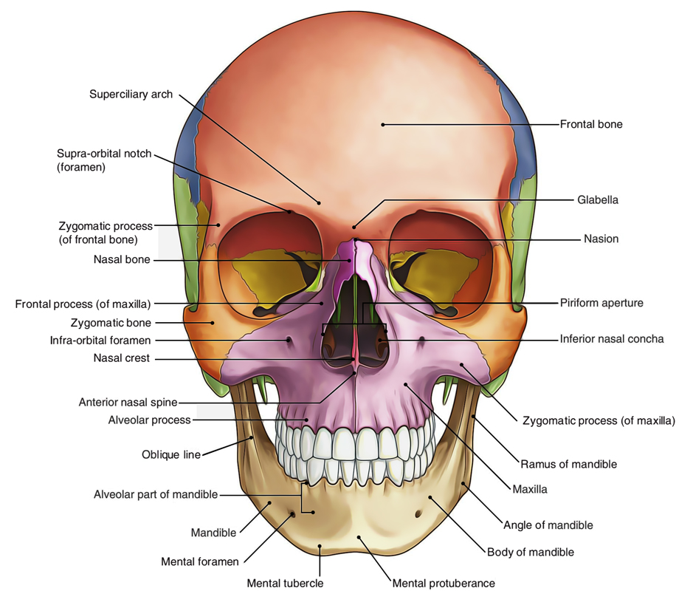

- What do you know about the muscles of hip and knee?

ANS: Muscles of the hip
Hip joint is the one of the most fracible joint in the entire human body the many muscles of the hip provide movement and strength and stability to the hip joint and the bone of hip and thigh these muscle can be group best upon their location and function. Most modern anatomists define 17 of these muscles, although some addiction muscles may sometimes be considered. These are often divided into four groups. According to their orientation around the hip joint. Then gluteal groups, the lateral rotator group. The adductor group, and the iliopsoas group.

Gluteal group.

The gluteal muscles include the gluteal maximus. Gluteus Medius, gluteul minimums and tasciae late. They cover the lateral surface of the ilium the gluteus maximus. Which forms most of the muscle of the buttocks.

Adductor group.

The adductor brevis, adductor longus adductor mangus, pectineus and the graciles make up the adductor group.

Iliopsoas group:
The illacus and psoas major comprise the iliopsoas group the major is a large muscle that runs from the bodies and disc of the l1to l5 vertebrae.

Lateral rotator group:

This group consist of the externus and internus obturators. The piriformis the superior and inferior or below the acetabulum of the ilium and insert on near the greater trochanter of the femur.
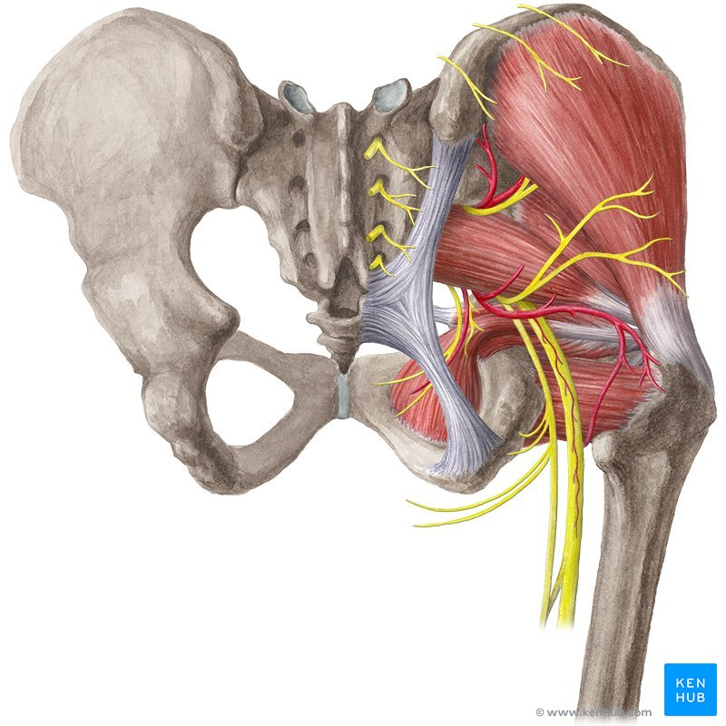
Knee muscles.:

Our knee muscles are responsible for initiating and controlling movement of the knee and the kneecap.
They also work with with the various buttock, thigh and calf muscles to help control the hip and the foot.
When we think about knee muscles the ones that usually springs to mind are the quadriceps found at the back and the thigh , and the hamstrings found at the back at back of the thigh but there are other muscle around the knee that are just as important.
The hamstring and the quadriceps work to gather one contracting ( against ) while the other relaxes to allow the knee that work with the quads and the hamstrings that are just as important to help protect the knee, most notably the glutes and calf muscles.
Knee muscles net to have both good strength and the flexibility any tightness or weakness in the muscles around knee makes prone to a whole host of knee problem.
Here we look at each of the muscles of the knee the work, what can go wrong and how to prevent knee muscle injuries.
1: quadriceps.
The quadriceps are found on the front of the thigh from the hip to the knee and are the main muscles.

Action: the main actions is to straighten the knee, but they also help bend the hip.

Hamstrings:
Location: hamstring are found on the back of the thigh from the hip to the knee
ACTION:
There main action is to bend the knee but they also help to extend the hip.
Other muscles.:
1: popliteus
2: calf muscles.
3: gluteal muscles.
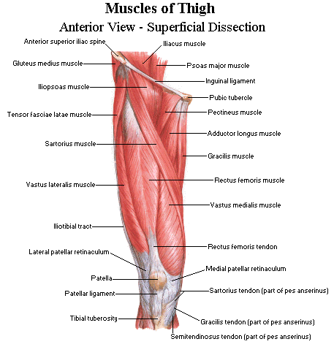

- Write a comprehensive note on the femoral triangle. ?
ANS: femoral triangle is a hollow area in the anterior thigh. Many large neurovascular structures pass through this area and can be accessed relatively easily. Thus, it is an area of both anatomical and clinical importance. Borders
As this area is a triangle, it has
*three borders:

Superior border – Formed by the inguinal ligament, a ligament that runs from the anterior superior iliac spine to the pubic tubercle.
Lateral border – Formed by the medial border of the sartorius muscle.
Medial border – Formed by the medial border of the adductor longus muscle.
The rest of this muscle forms part of the floor of the triangle.

Anteriorly , the roof of the femoral triangle is formed by the fascia lata.
Posteriorly , the base of the femoral triangle is formed by the pectineus, iliopsoas and adductor longus muscles.
The inguinal ligament acts as a flexor retinaculum, supporting the contents of the femoral triangle during flexion at the hip.
Contents
The femoral triangle contains some of the major neurovascular structures of the lower limb. Its contents lateral to medial are:
Femoral nerve – Innervates the anterior compartment of the thigh, and provides sensory branches for the leg and foot.
Femoral artery – Responsible for the majority of the arterial supply to the lower limb.
Femoral vein – The great saphenous vein drains into the femoral vein within the triangle.
Femoral canal – A structure which contains deep lymph nodes and vessels.The femoral artery, vein and canal are contained within a fascial compartment – known as the femoral sheath .
