Subject Islamic studies instructor: Mr. Saad Haider
Final term Assignment 50 Marks
Department AHS Second Semester

Answer the following questions.
NAME IJAZ UL HAQ
I.D 15825
SECTION A
DEPARTMENT

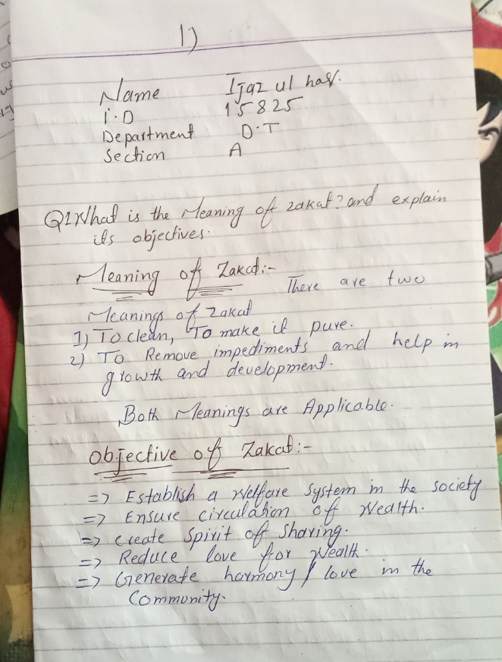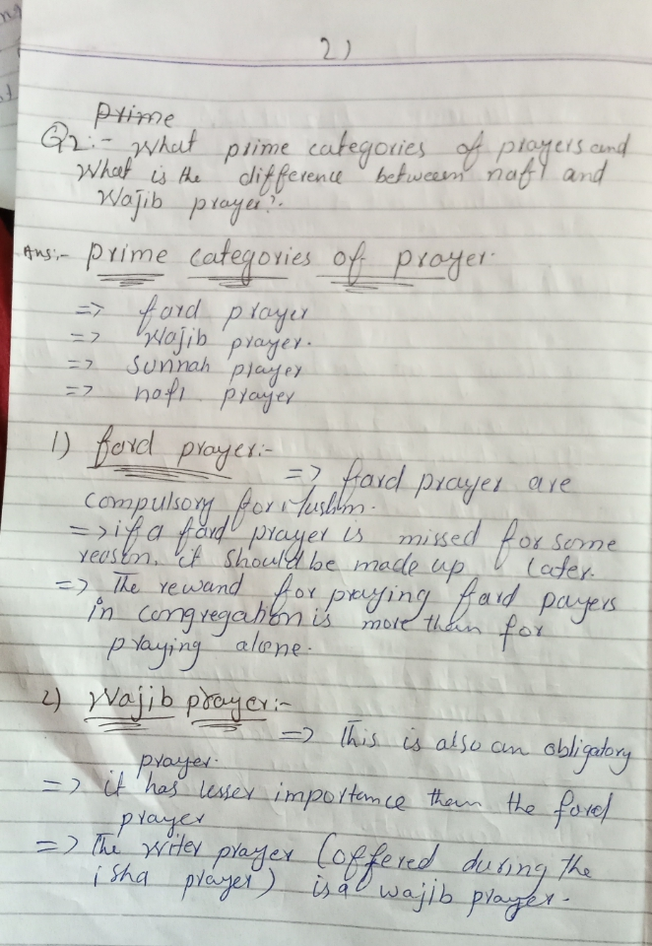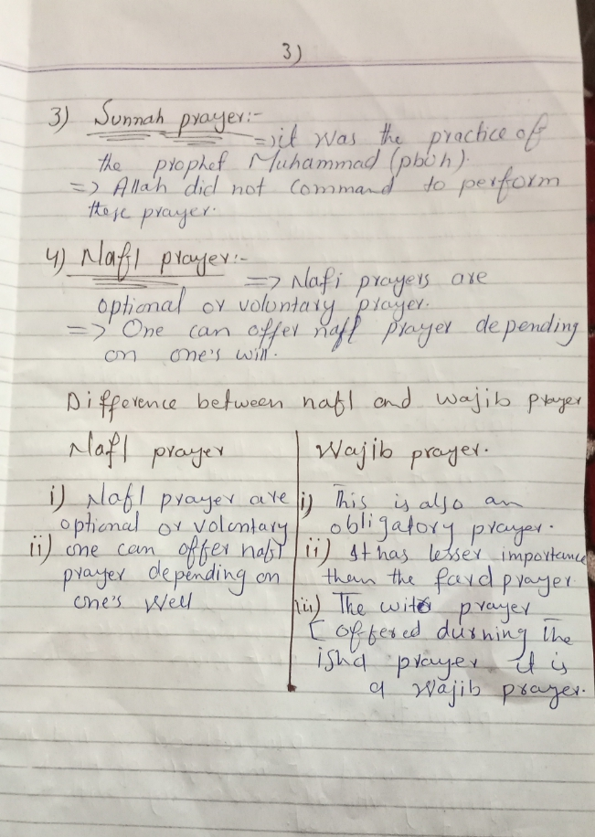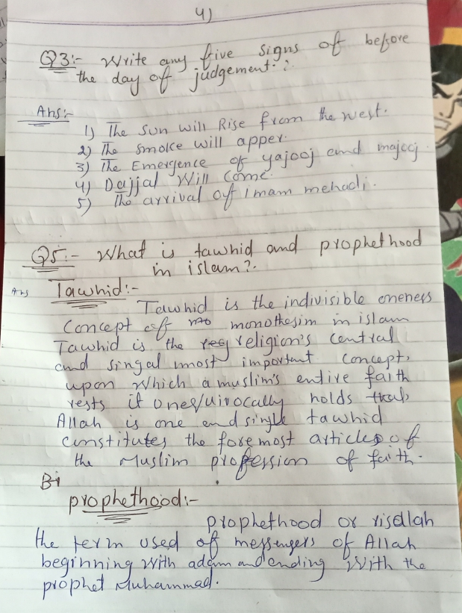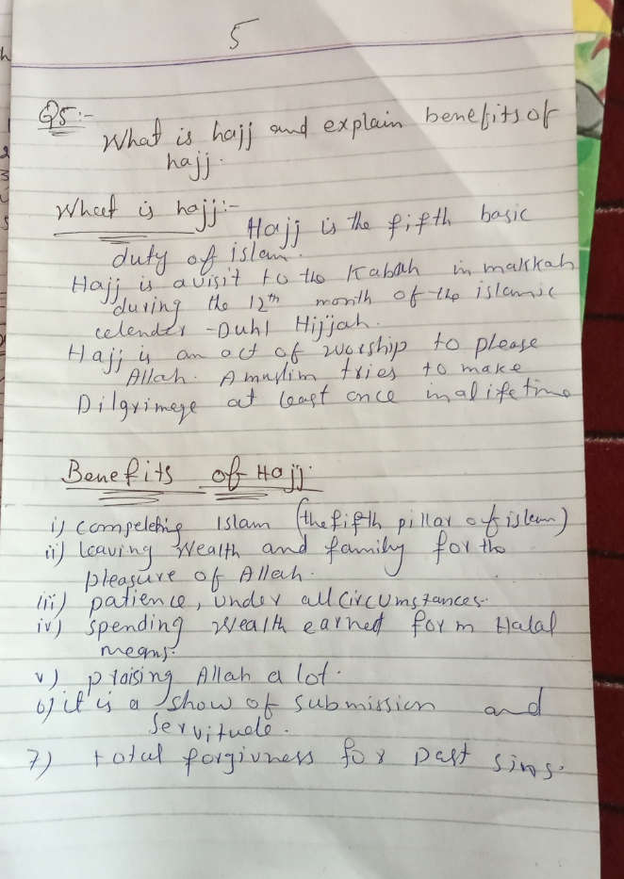Q3. write any five signs of before the day of judgememnt.
Q4.what is hajj and explain benefits of hajj.
Q5, what is tawhid and prophethood in islam?

