KIRAN BADSHAH
DPT 2 SMESTER
29 June 2020
Sociology paper
Submit to : sir shehzad
Id#16483

- What is the role of “SOCIAL DETERMINANTS OF HEALTH” in current condition of Covid-19? Explain with examples. (15 marks)
Answer:

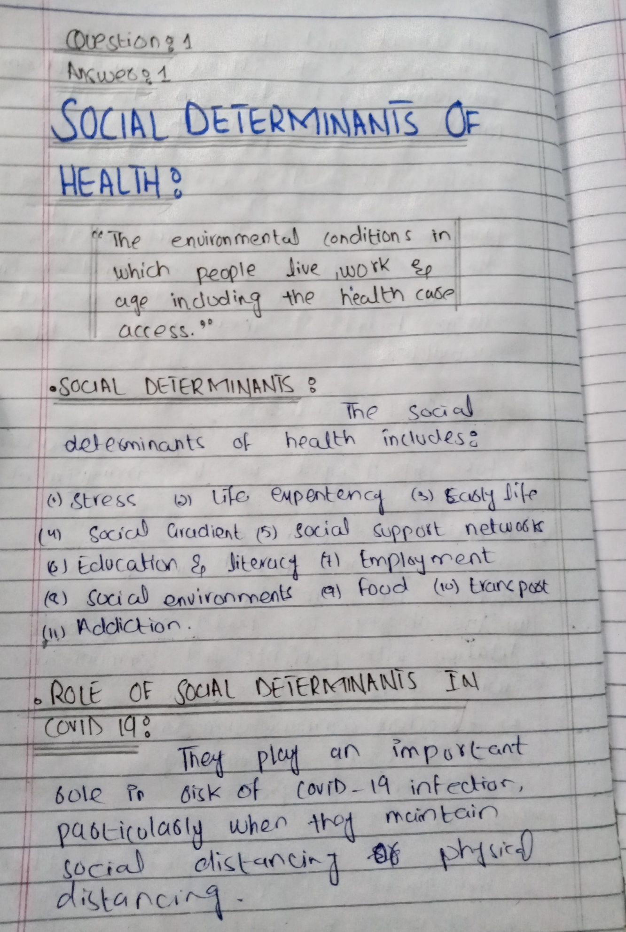
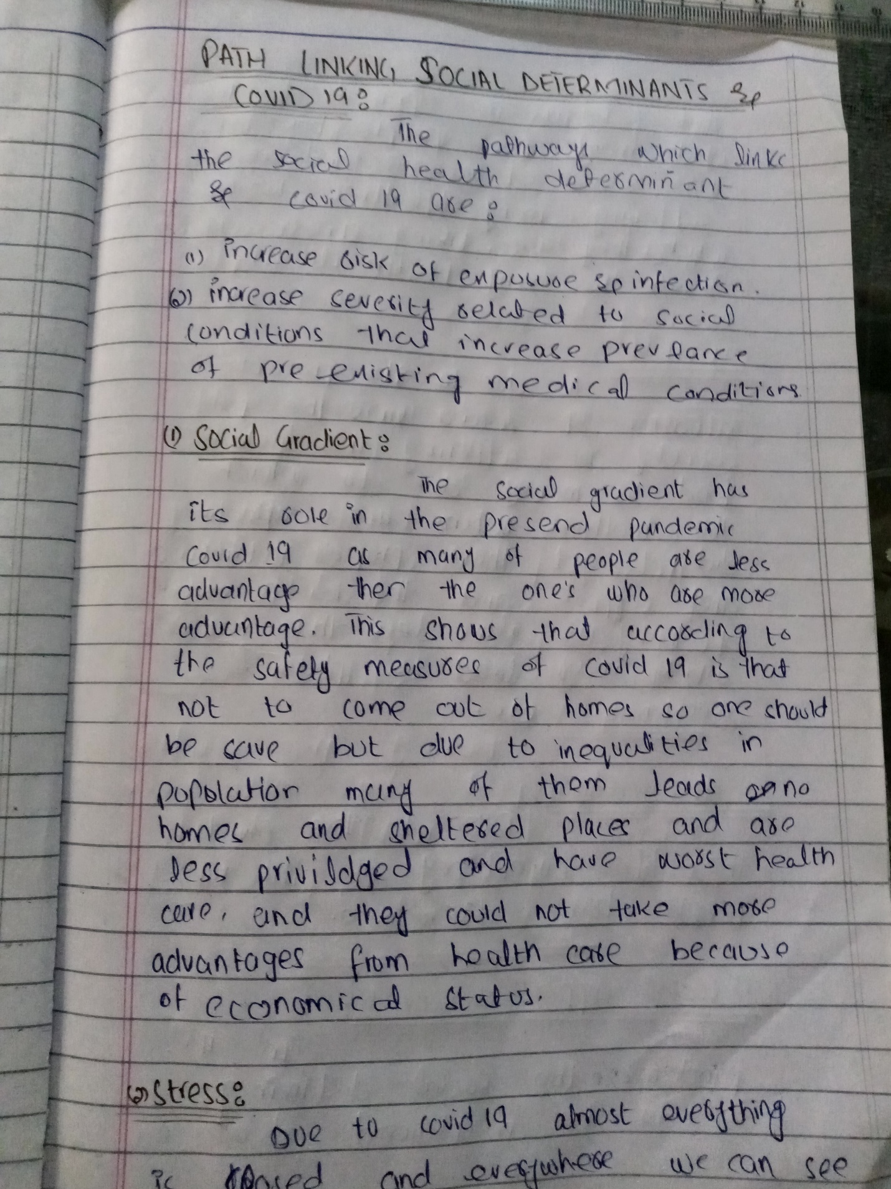
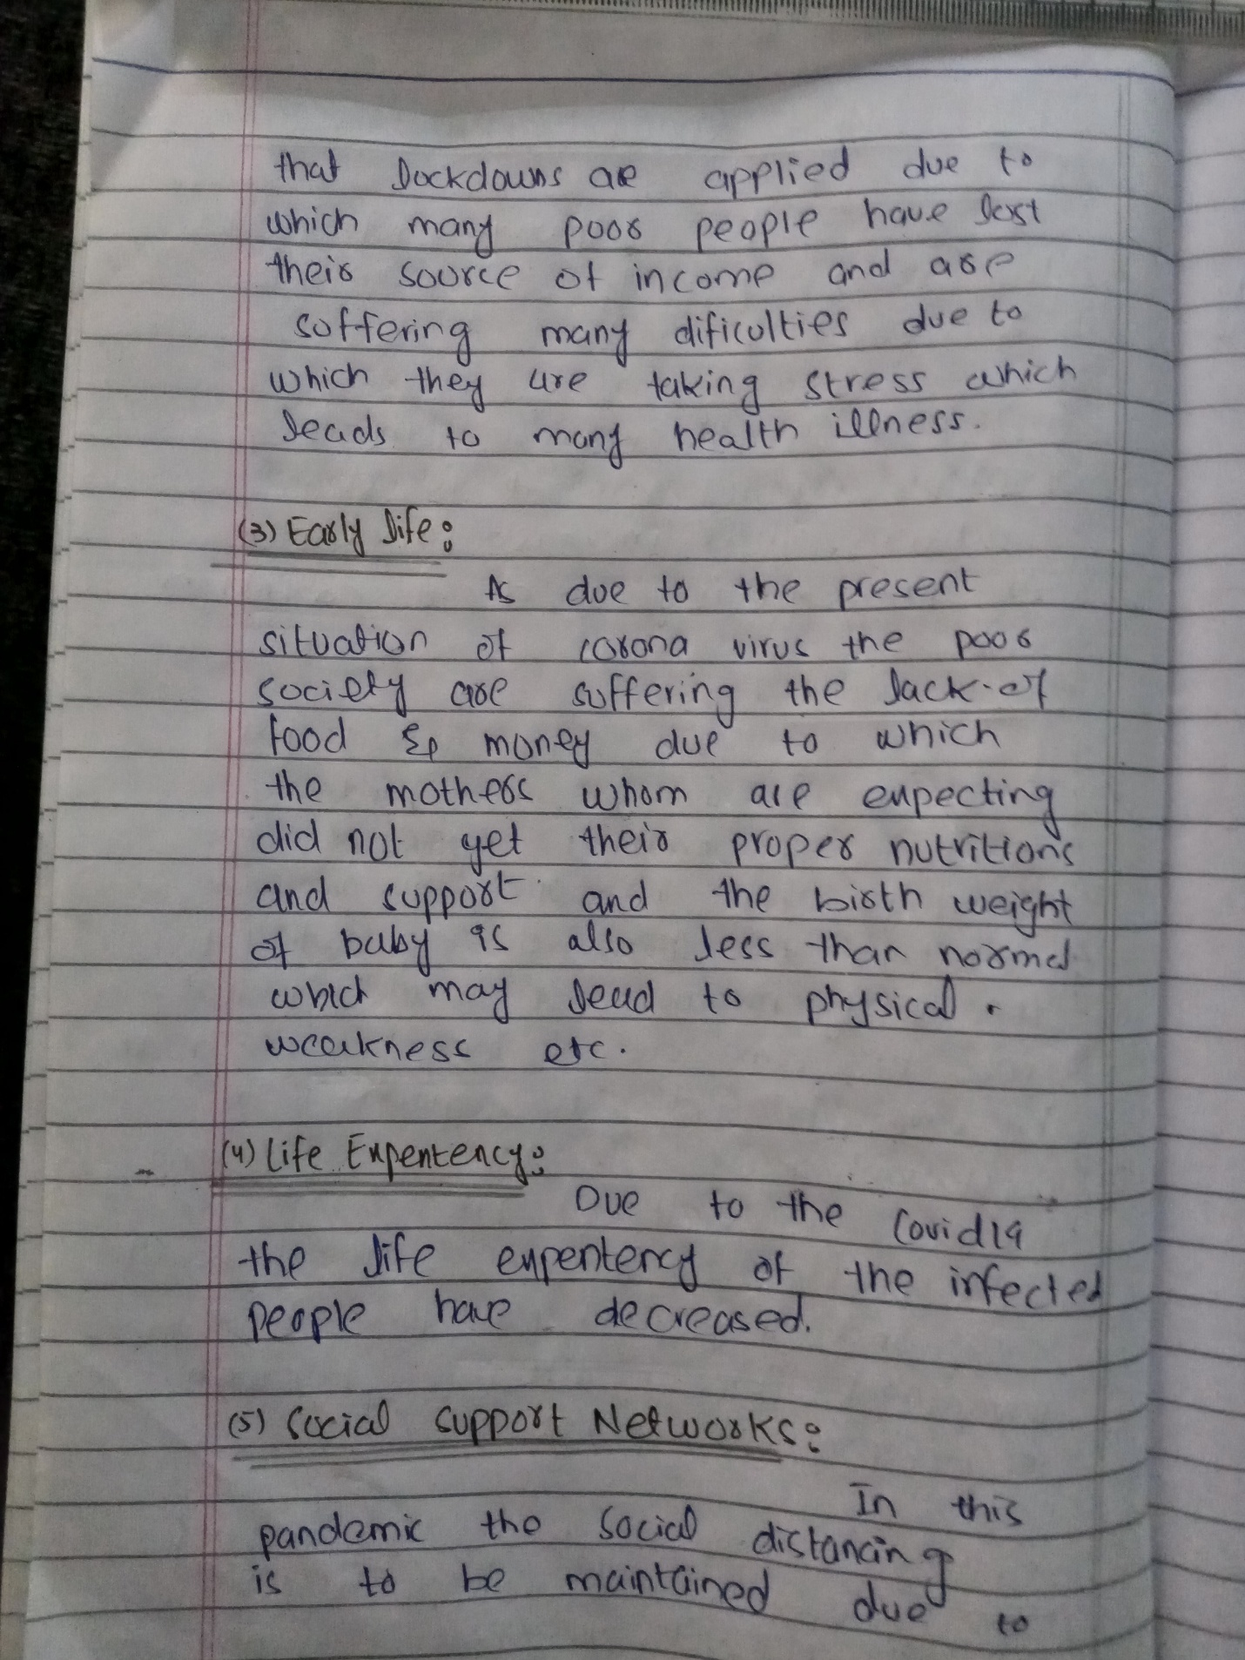
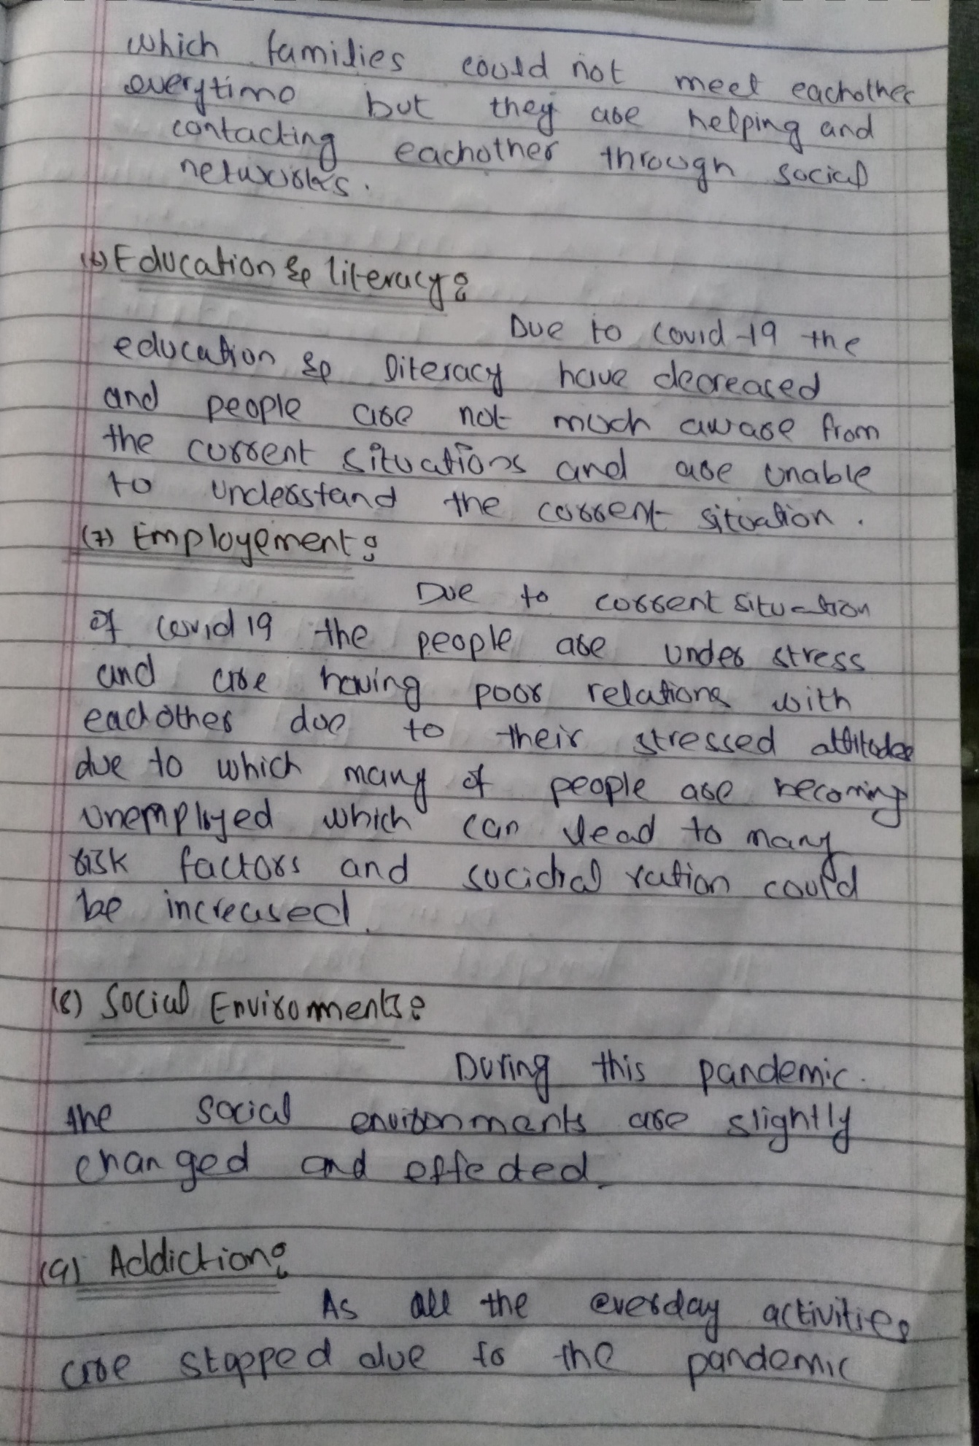
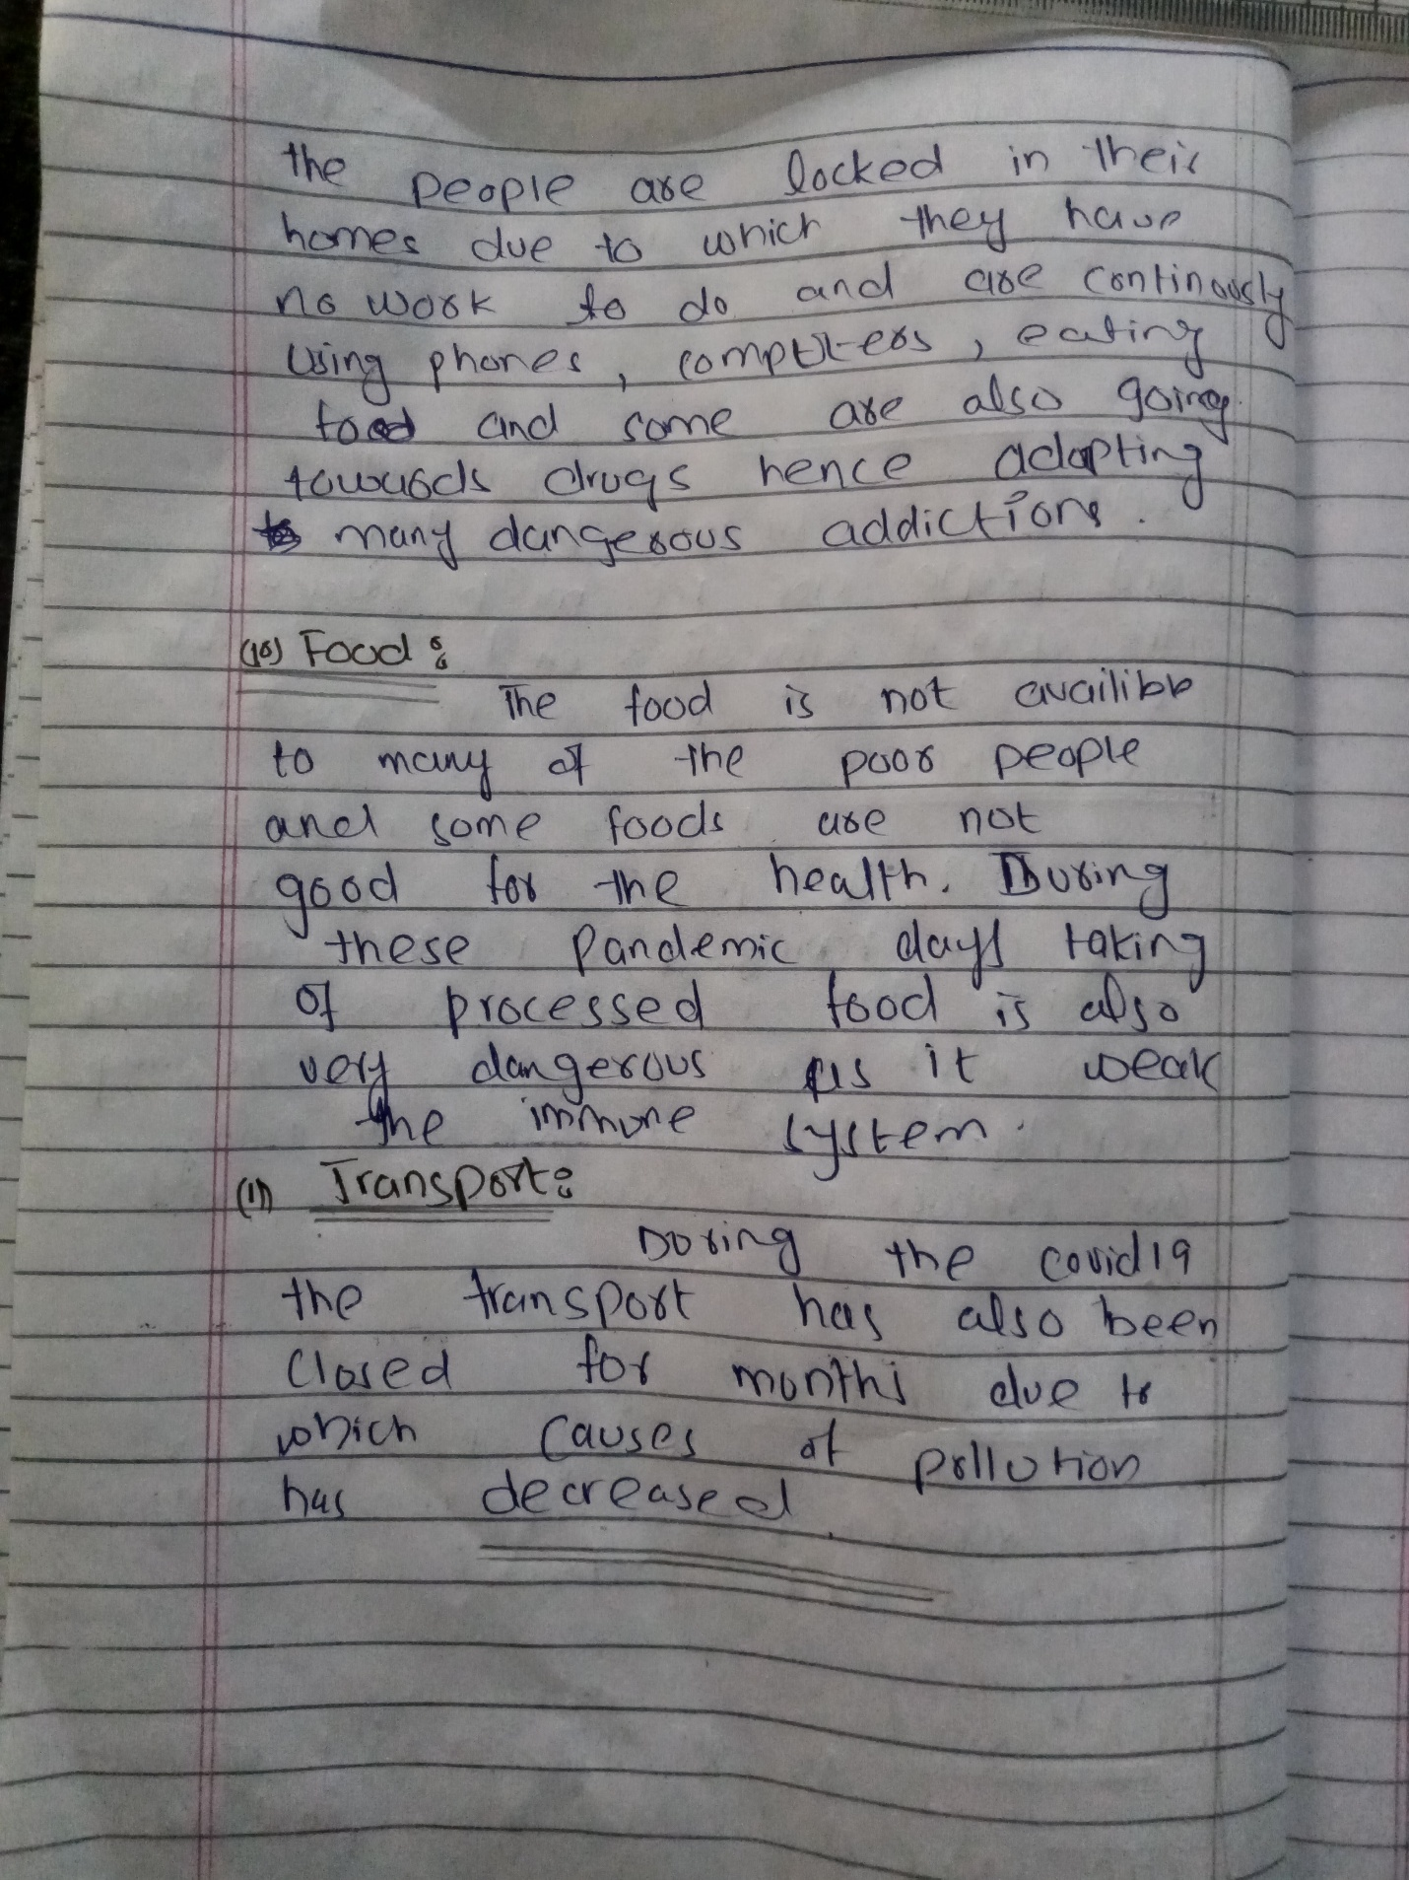
- In your opinion, “SELF-MEDICATION” is a good practice or not? In both cases, justify your answer with proper explanation and examples. (15 marks)
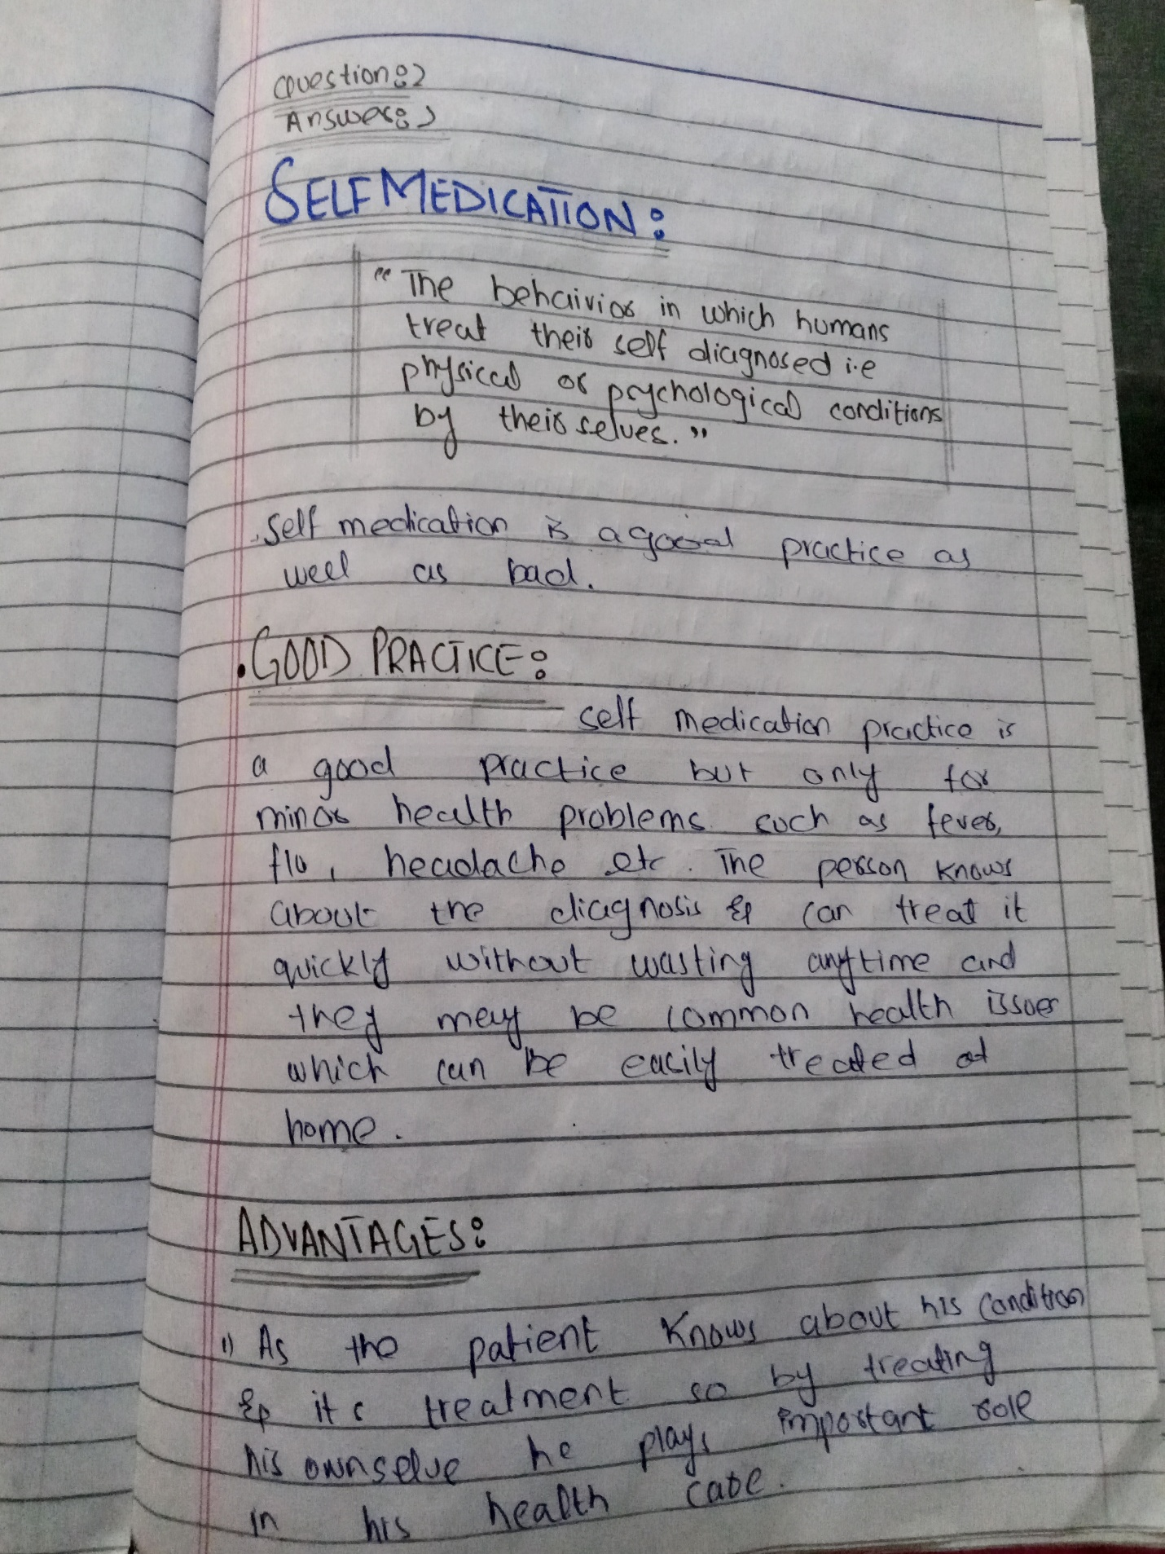
Answer:
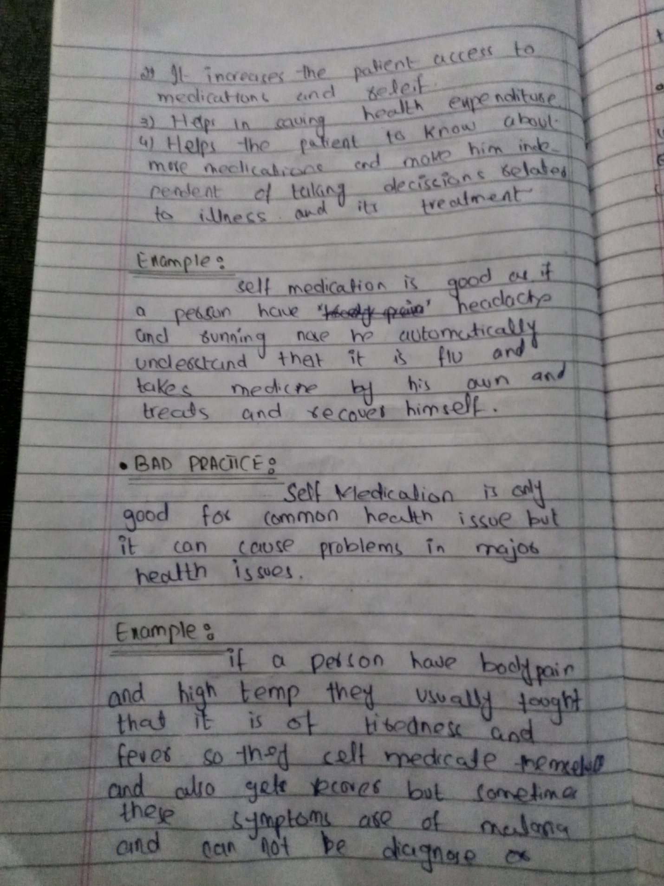
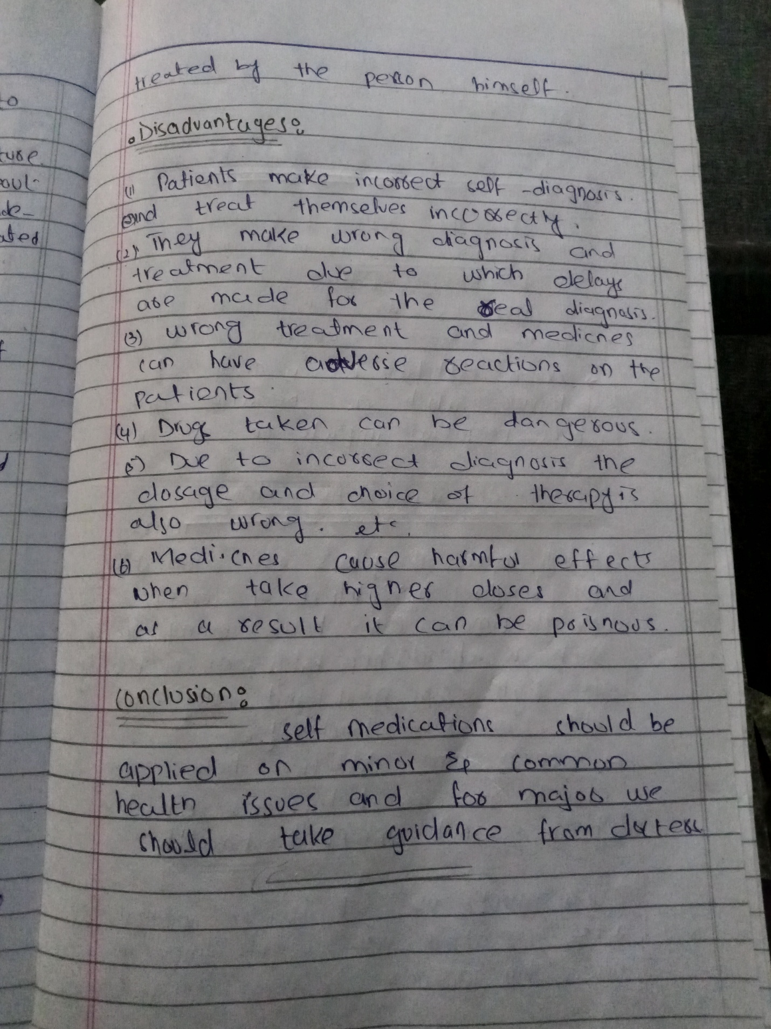
- How “SCREEN TIME ADDICTION” affects our mental health? Explain in detail. (10 marks)
Answer:
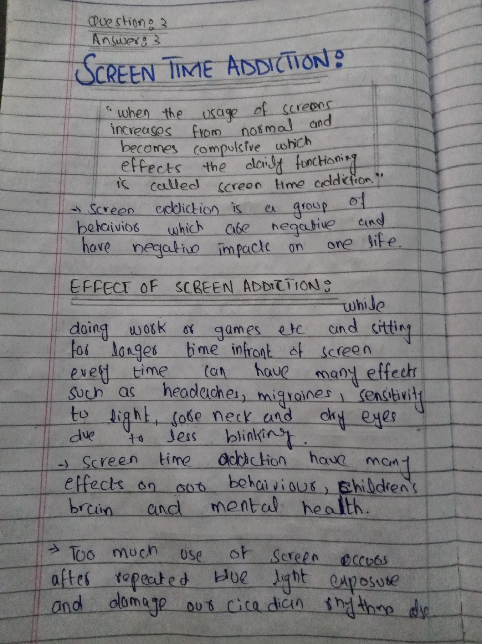
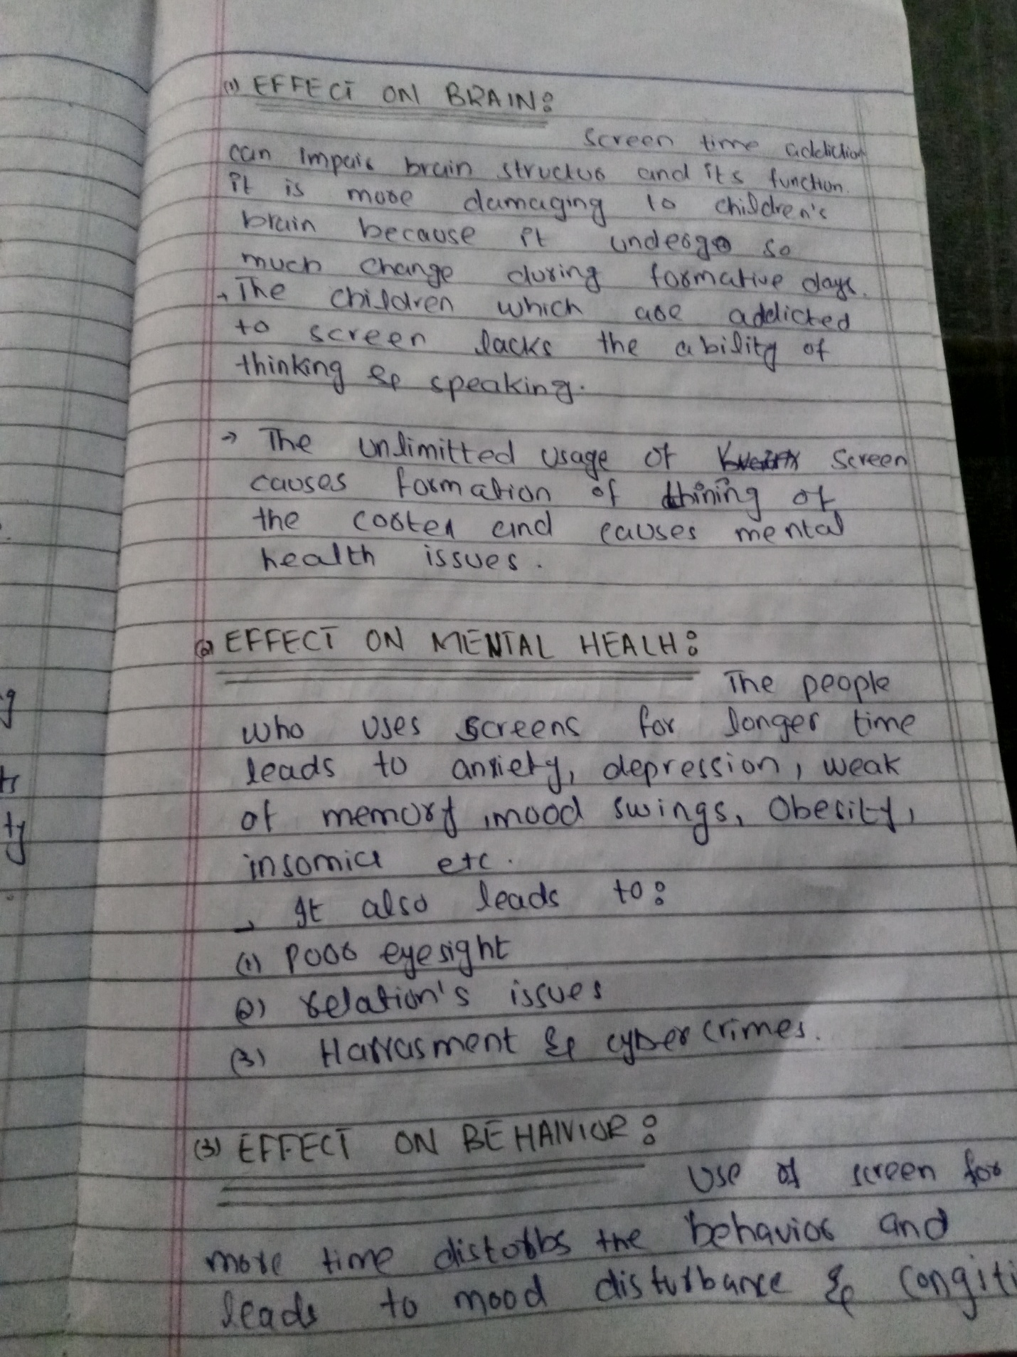
- Describe the role of PHYSIOTHERAPIST in the management of patients? (10 marks)
Answer:
