NAME AFTAB SHEHZAD

ID 16138

SECTION A

SUBJECT ARCHITECTURE

CIVIL ENGINEERING DEPARTMENT

SEMESTER 2ND

INTERNATIONAL STYLE

INTRODUCTION
International style could be a major style of architecture.
In architecture, the term "International Style" describes a kind of design that developed mainly in (Germany, Holland and France) during the 1920s, before spreading to America within the 1930s, where it became the dominant tendency in American architecture during the center decades of the 20th century.
Hitchcock and Johnson's exhibition catalog identified three principles of the style: volume of space (as opposition mass and solidity), regularity, and suppleness.
The International Style may be discover to buildings designed by alittle group of modernists, of which the main figures includes Ludwig Mies van der Rohe, Jacobus Oud , architect, Richard Neutra and Philip Johnson.
The International Style grew out of three phenomena that challenge architects within the late 19th century:
(1) Architects’ increasing dissapointment with the continued use in elaborate wide buildings of a combination of decorative elements from different architectural periods and designs that bore little or no importance the building’s functions,
(2) The economical creation of huge numbers of office buildings and other commercials, residential, and civic structures that served a rapidly industrializing society, and
(3) the event of recent building technologies centering on the utilization of iron and steel, concrete, and glass.
Technology was an important factor; the new availability of cheap, mass-produced iron and steel and also the discovery within the 1890s of these materials’ benefit as primary structural members it provides the old traditions of masonry (brick and stone) construction. The new use of steel-reinforced concrete as secondary support elements (floors, etc.) and of glass as sheathing for the exteriors of buildings completed the technology needed for current building, and designers set about incorporating that technology into an architecture that openly recognized its new technical foundation.
The International Style was thus formed under the rule that modern buildings’ form and arrival should naturally grow out of and express the ability of their materials and structural engineering. A harmony between beautiful function and technology would thus be established in a very strict and disciplined new architecture.
LOCATION
An International style , art form that developed in Europe and therefore the us. it developed first mainly in France, Germany and Holland.
The term "International Style" was coined in 1932 by an eponymous exposition of European architects at the Museum of recent Art in ny curated by Henry-Russell Hitchcock and Philip Johnson to explain an ethos of construction purely in terms of materials and space, with virtually no relevance the sociopolitical dimension, as had been highly emphasized in Europe. This differentiated the International Style between its understandings in Europe versus within the USA in Western architecture during the center decades of the 20th century.
TIMELINE
It starts from the 19th century till the 20th century…that developed in Europe and the United States in the 1920s and ’30s and became the dominant tendency in Western architecture during the middle decades of the 20th century and ended in the 20th century.
Materials
Materials that are used in these buildings, reinforced concrete, steel, iron, concrete and glass, steel, and concrete for greater strength..
The normal characteristics of International Style buildings include rectilinear forms; plane surfaces that are completely empty applied ornamentation and open, even fluid, interior spaces. reinforced by its use of modern materials, including glass for the show , steel for exterior support, and concrete for interior supports and floors. the foremost common characteristics of International Style buildings are rectilinear forms; light, taut plane surfaces that are completely stripped of applied ornamentation and decoration; open interior spaces; and a visually weightless quality produce by the employment of cantilever construction.

POPULAR BUILDINGS
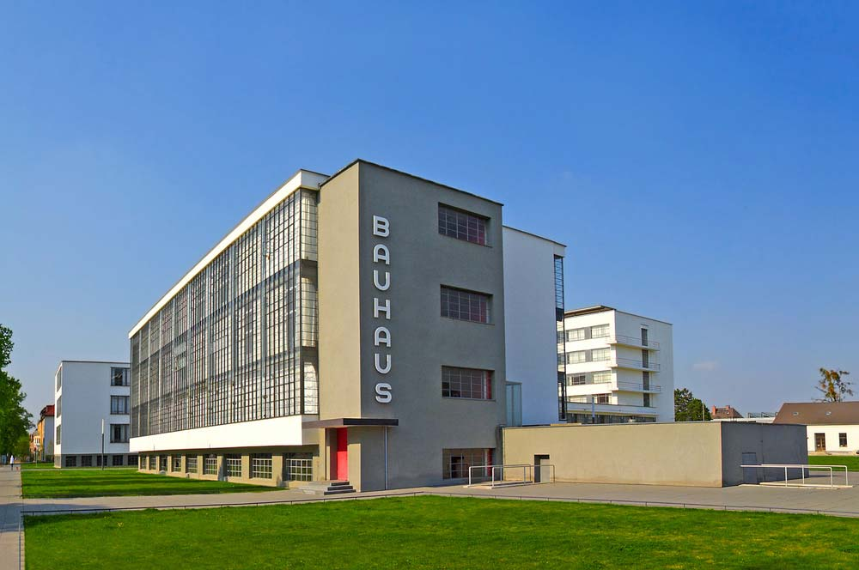
(1925 -1926)
Bauhaus, Dessau, Germany
Designer : Walter Gropius
Home to the state-supported school for the applied arts, the Bauhaus was founded in Weimar in 1919 by Walter Gropius, but moved to Dessau in 1925 when political conditions in the latter became more favorable to its liberal educational climate Gropius designed the school's new permanent home together with the school residences nearby that very same year.
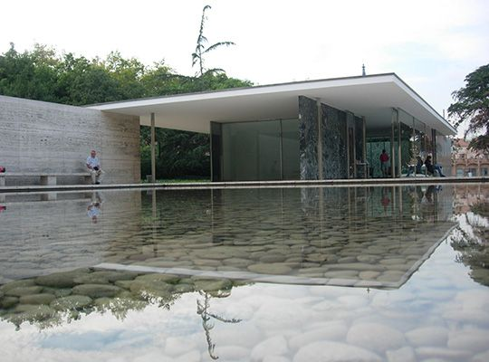
(1929)
German Pavilion, Barcelona, Spain
Designer : Ludwig Mies van der and Lily Reich
“Mies and Lilly Reich” together designed the German Pavilion for the (1929) World's Fair in Barcelona - a structure which now ranks among the foremost important temporary structures ever built, particularly for a global exposition. Destroy after the fair, it absolutely was reconstructed in 1986 using the initial plans, now within the collection of the Museum of modern Art in ny. It constitutes Mies' most succinct statement within the reduction of a building to the minimal requirements to define space: one or two of columns elevated on a platform juxtaposed with unbalanced opaque and transparent wall planes, supporting a flat roof. 1929-32.
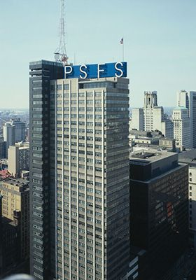

1929-32
Philadelphia Savings Fund Society (PSFS) Building, USA
Designer : William Lescaze and George Howe
The PSFS Building was the only important structure to come back back from the temporary partnership of Howe & Lescaze, but it gave both men architectural eternal ife. The invention of the Lescaze,who was born in Switzerland, who had immigrated to the USA in 1920 and kept in tune throughout the last decade with progressive European architectural currents, the PSFS Building was the first International Style skyscraper to be inbuilt the USA, the birthplace of the building type. it absolutely was also the first tall building within the country to be air-conditioned, a necessity when it opened in humid central Philadelphia on August 1st, 1932..

MODERN ARCHITECTURE
INTRODUCTION
Modern Architecture is Architecture that emerged within the 1920s in Europe and also the u. s.. It began as a response by Architects to rapid technological advances and greater urbanization of society at the turn of the century. it's the very dominant style which came during the 19th century. It symbolized the perfect Public Virtues of democracy, liberty and reason. it's the Architecture of straightforward forms (rectangles) enclosed with flat opaque (solid) or transparent (glass) walls. •Modern Architecture is taken into account progressive(forward looking) instead of regressive(backwards looking). Modern Architecture expresses volume, balance, and elimination of ornaments modern styles and ideas, in contrast, took root more quickly in commercial, industrial, and residential Architecture. Sydney house St. Louis Brasilia CN Tower.
ARCHITECTS OF MODERN ARCHITECTURE
ARCHITECTURE Notable architects important to the history and development of the modernist movement include 1.Le Corbusier (2).Ludwig Mies van der Rohe( 3).Walter Gropius( 4).Frank Lloyd Wright (5).Louis Sullivan 6.C.R. Mackintosh (7).Edwin Lute’s (8).Antonio Gaudi Barcelona Pavilion by Ludwig Saddam Hussein Gymnasium by architect Tel Aviv-by Walter Gropius Wainwright Building by Louis Henri Sullivan.

TECHNOLOGIES
As the 20th century began modern architects believed it had been necessary to make an architecture that expressed the spirit of a long lived and would exceed the styles, materials, and technologies of earlier architecture Crystal Palace by Sir designer Skyscraper HSBC urban CRYSTAL PALACE in London. Skyscrapers- a modern building center Headquarters .By 1920s there was an increasingly wide understanding that building forms must be determined by their functions and materials if they were to understand beauty in contemporary terms.

TIMELINE
It appear within the half of the 20th century and have become dominant after warfare II until the 1980s, when it had been gradually replaced because the principal style for institutional and company buildings by postmodern architecture. Modernism first appear within the early 20th century, and by the 1920s, the important figures of the movement (Charles Edouard Jeanneret, Walter Gropius, and Ludwig Mies van der Rohe) had established their reputations.
LOCATION
(1920 - 1950)
Modernism in architecture grew from The Bauhaus, a German architecture and style school established in 1919 by architect together with(“ Mies, Marcel Bruer, Wasily Kandinsky, and Paul Kle)”. The Father of recent Architecture Mies Born in Germany on March 27th 1886, Ludwig Mies van der Rohe is widely considered one among the pioneers of recent architecture, accelerating after the war shift from classical ideologies of architectural design and construction methods.

MATERIALS
- BRICKS
- STEEL
- CONCRETE
- GLASS
- ALUMINUM
- NATURAL STONE
- WOOD
- CERAMIC HOLLOW TILES AND CONCRETE BLOCKS.

FORM OF THE BUILDING
Its form is different from other architectural styles , for instance these variety of building looks beautiful and having greater strength .Aluminum and glass works give these buildings more beauty and it's beautiful, these building have a novel styles during which different materials are used .Wood works in its interior and plenty of more.
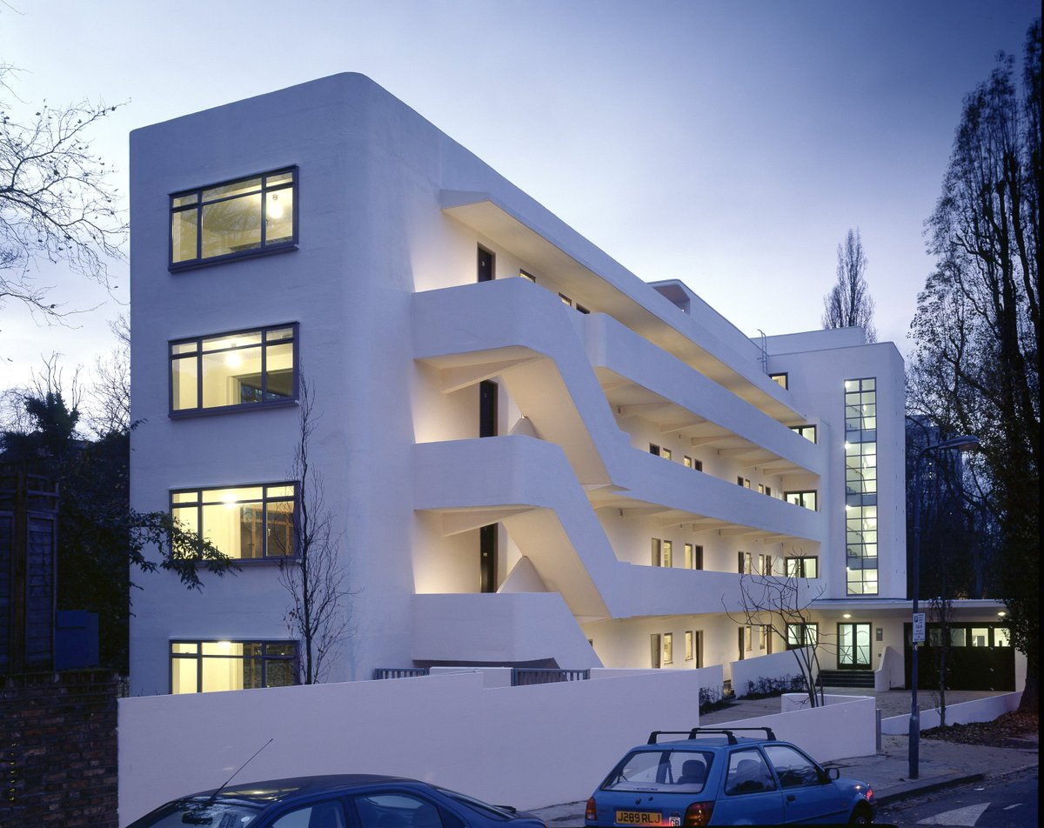

(1934)
"Isokon Building in London (Wells Coates, London, UK)"
The residential building, which continues to be in fritter away to the current day, consists of 32 apartments; 24 of which are studio apartments and eight are single-bedroom apartments. The building also includes staff rooms and an oversized garage. The apartments had small kitchens because there was a joint kitchen at the disposal of the residents. they may freely use it to arrange food. There were, also, other services like laundry and shoe polishing , Architects who are specialized in renovating apartments, refurbished the building in 2003. The refurbishment resulted in establishing a communal gallery within the garage to inform the people the history of the building. The concrete residential block is listed as a Grade I-building and is one in all the key architectural landmarks within the british capital.

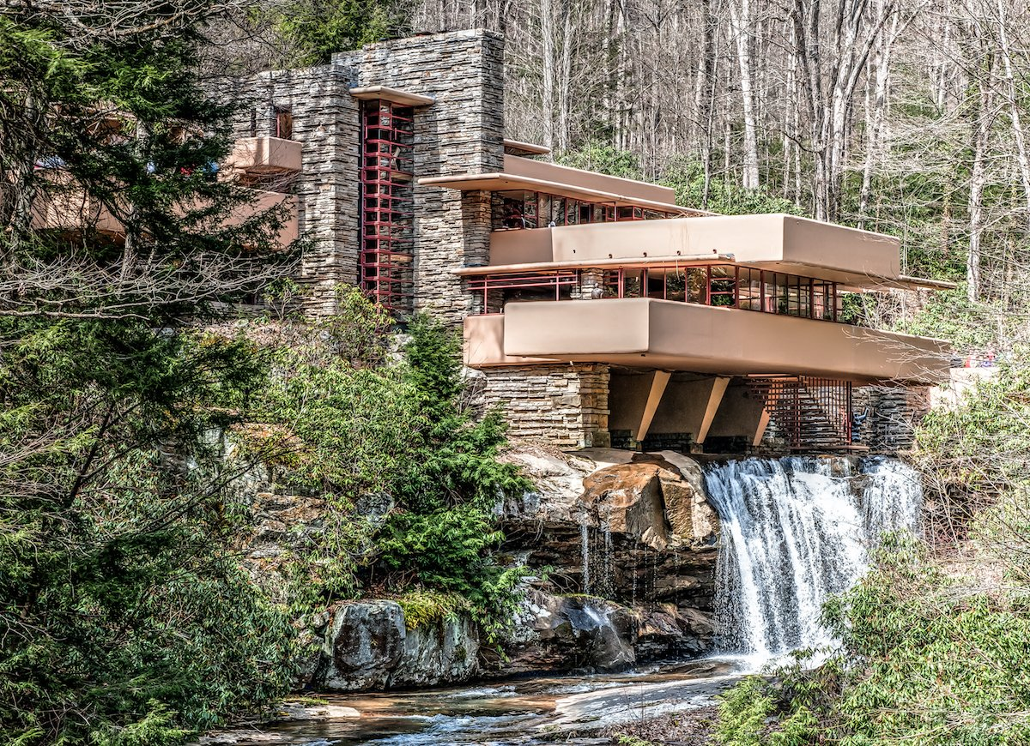
The Fallingwater house "Frank Lloyd Wright", Mill Run, Pensylvania, USA, 1935
The design of the house was encouraged by Japanese architecture which is famous for using cantilevers. The house, that was ideally include into the natural landscape, was created as a weekend break for the Kaufman family. The house’s condition began to degenerate quickly after construction that Mr. Kaufman called it the ‘seven-buckets building’, relating the leaky roof. Moreover, the cantilevered terraces began to fall off due to the shortage of proper reinforcement. The house underwent renovate several times and was converted into a museum in 2002.
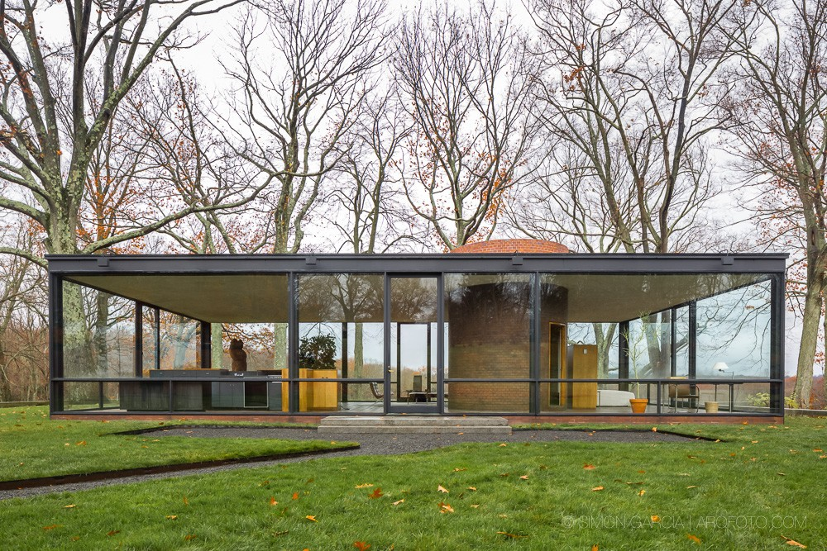
(1949)
"Glass House (Philip Johnson, New Canaan, Connecticut, USA)"
Philip Johnson built that house to his own. His design was least and utilized the reflection/transparency features of glass. He also experimented with dimensions and geometric shapes which made the house one amongst the sign of the world and an icon within the world of recent architecture. The home was made mainly of glass and steel. However, it also suffered from the ‘leaky roof’ issue rather like the Fallingwater house, which made Johnson describe it, jokingly, thanks to the ’four-bucket house’.

THE END

