IQRA NATIONAL UNIVERSITY PESHAWAR

DEPARTMENT OF CIVIL ENGINEERING
SUBJECT: FLUID MECHANICS II NAME: ABDUL BASIT
ID: 7776 SECTION: C
Q.NO (01) Part A ANSWER
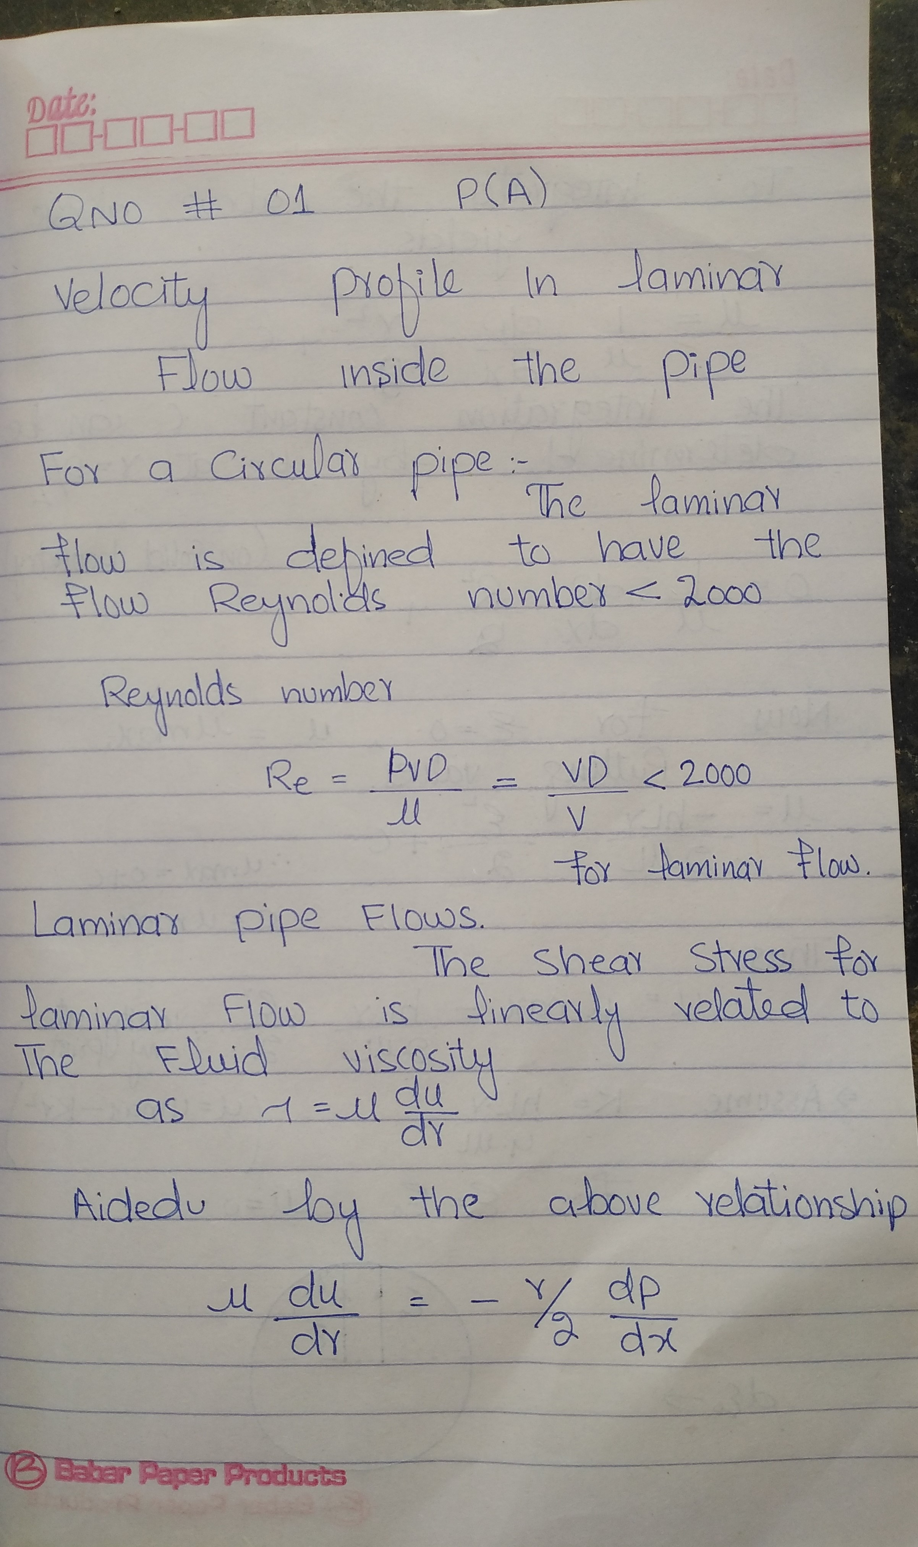

. =====================Q.NO 01 PART A END=====================

Q.NO (01) Part B

ANSWER
CRITICAL REYNOLDS NUMBER
A critical Reynolds number is determined as a limit where the laminar flow changes to turbulent flow. If the calculated NRe is greater than the critical Reynolds number NRec, the flow regime is turbulent; otherwise the flow regime is laminar.
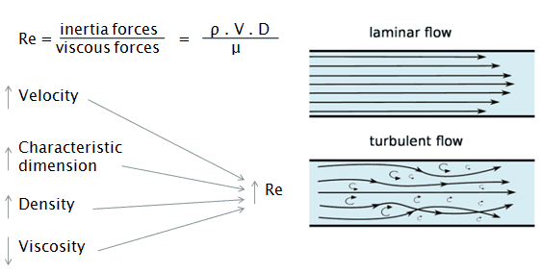Critical Reynolds number is the number which decides whether flow is laminar or turbulent.

For example in external flows over a flat plate critical Reynolds number is 5*10^5, and Reynolds number below it the flow would be Laminar and above the critical Reynolds number Flow would be Turbulent.
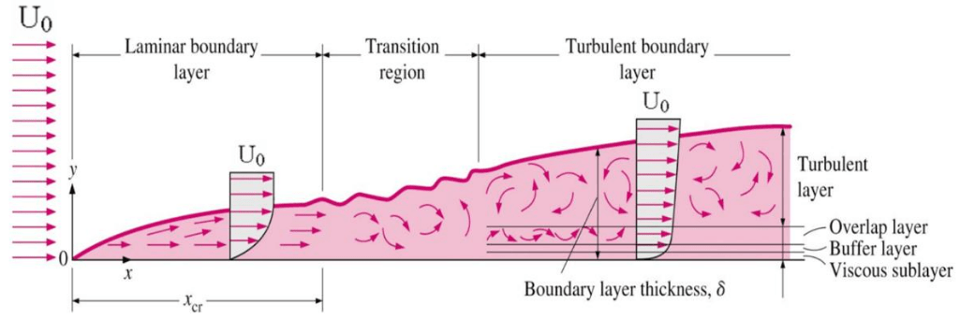

In case of internal flow, if Reynolds number is below 2000 (Critical Reynolds Number) flow would be Laminar and if it is above 4000 flow would be treated as Turbulent, region from Reynolds number 2000 - 4000 is Transition.
N rec = 3470- 1370n
Where n is Power Law fluid index
.
=====================Q.NO 01 PART B END===================

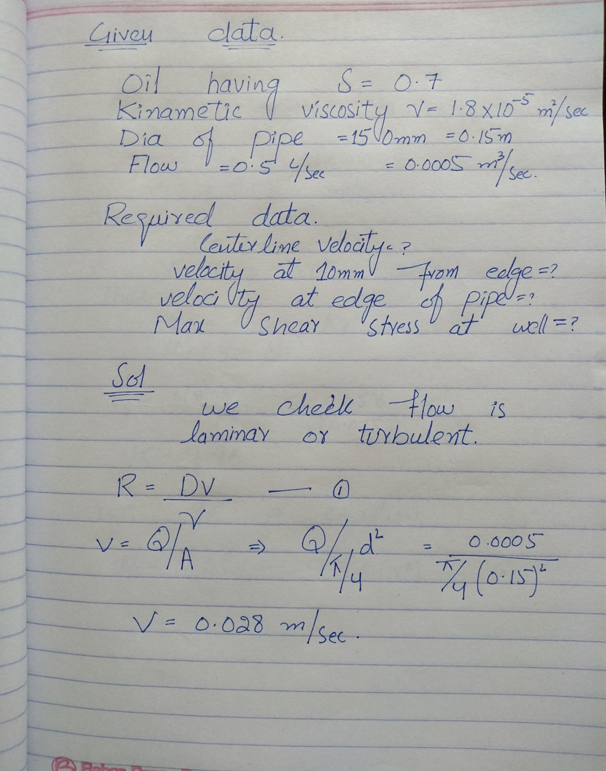
Q.NO (02) ANSWER

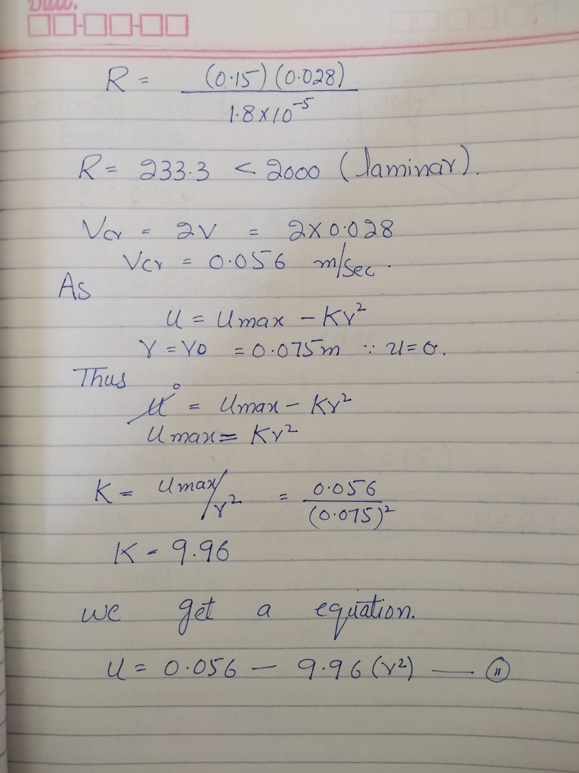

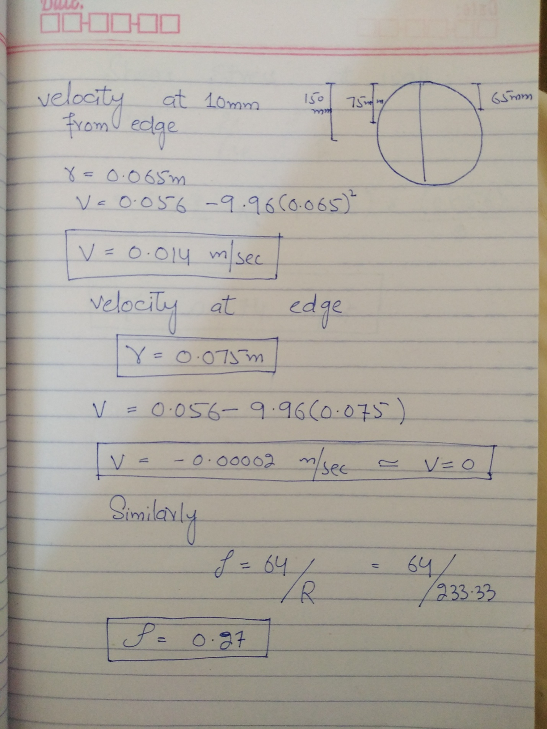

=====================Q.NO 02 END===================

