+NAME RABIA IFTIKHAR
ID 14961
CONTEMPORARY ADVERTISING
SIR SUNILCHANDAR
DATE 24 /6/2020

3 Questions:
Q 1: Make a print add 50 words
Product; Candy, Comb, Milk, Butter, Sharbat and Trouser.
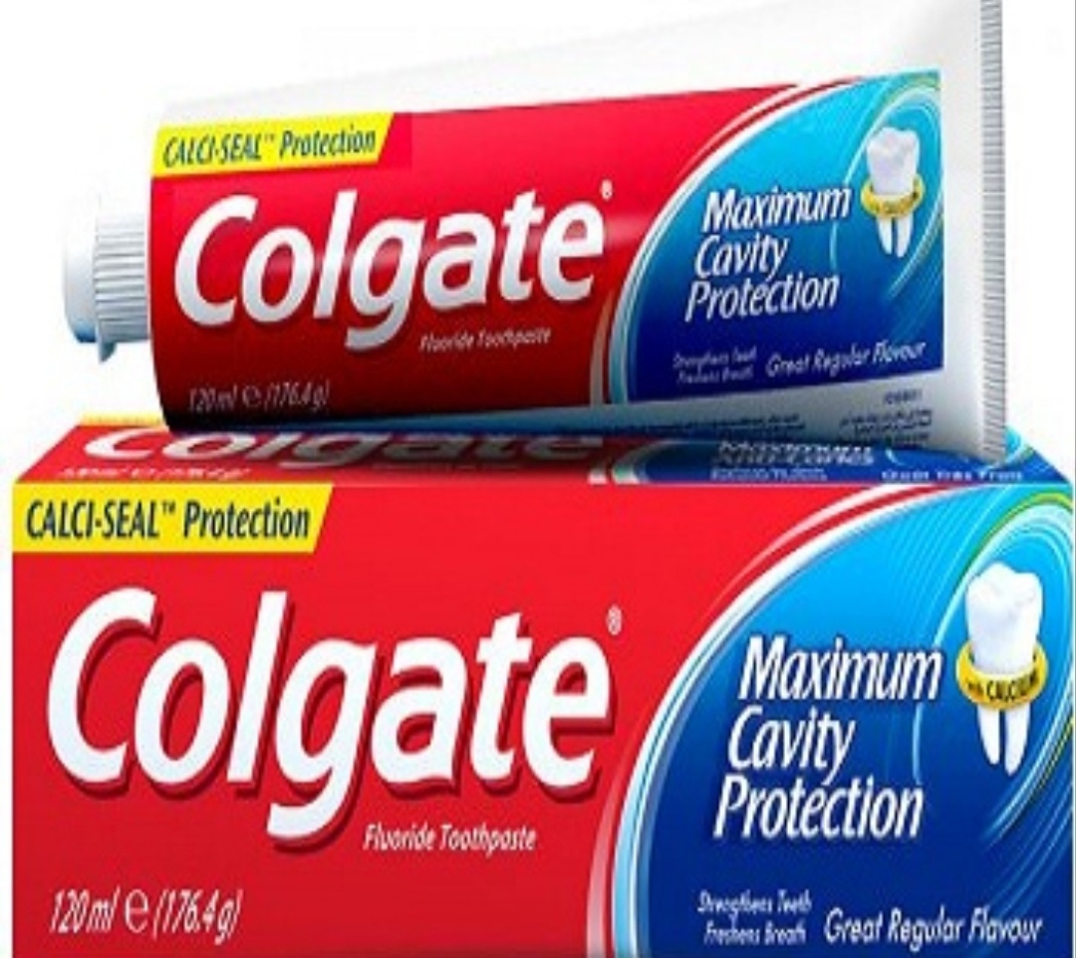
In 1806 William Colgate introduced starch, soap and candle. In 1857 William Colgate died and the company was reorgament as Colgate and company. The management of Samuel Colgate his son.
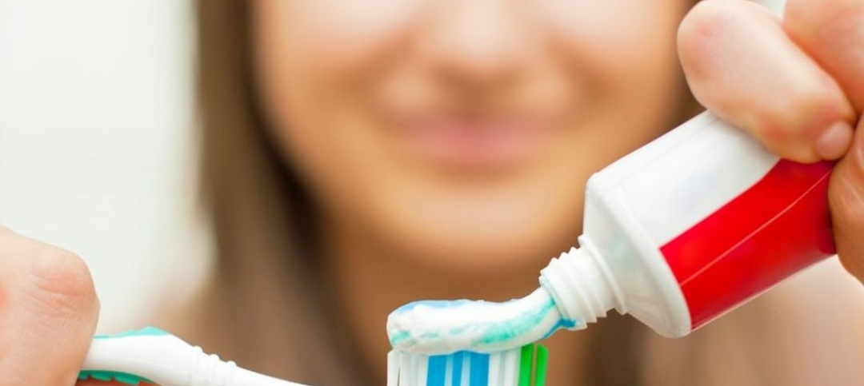
AWARD ACHIEVEMENT: Colgate has been ranked as India most trusted Brand across all categories for four consecutive years from 2003 and 2007. 51% market share in toothpaste segment. 48% market share in the toothpowder market.
They try to position some innovative toothpaste with a brand name other than Colgate but under umbrella of Colgate-Palmolive. Urban population they would come up with the product suiting to young generation.
- They launch special toothbrushes for different age groups.
- They launch a toothpaste and brush for kids and age group.
PRICE:
Based on competitors price. Packaging would be customized on the basic price points.
PROMOTION:
They positioning Colgate dental white crème and toothpowder toward rich segment.
The Colgate Company used Slogan was “It clean your breath while it clean your teeth.”
Dental Cream contained Gordon formula that helped protect teeth.Gardol was trademark for ingredient Sodium Lauroyl Sarcosinate.
All around Decay Protection buy 200g plus 100g tube with a Colgate Extra clean toothbrush in a family value pack for Rs 82.

QUESTION 3
PLAN advertising campaign for universities keeping in mind the pandemic scenario.

