Subject: Human Anatomy II
Class: Radiology, 2nd semester
Section: B
Instructor: Dr. Arooba.
Name Salman
ID 15746
MidTerm Assignment, spring 2020. Marks 30.

Select the best option.

1. A metatarsal bone has the following basic parts:
A. Head, shaft, and tail
B. Head, shaft, and base
C. Head, neck, tubercle, and base
D. Head, neck, tubercle, and tail
2. Sustentaculum tali is located on______ of calcaneum.
A. Medial surface
B. Lateral surface
C. Anterior surface
D. Superior surface
3. Circumduction is the combination of?
A. Flexion, extension, medial rotation, and lateral rotation
B. Flexion, extension, abduction, and adduction
C. Abduction, adduction, medial rotation, and lateral rotation
D. Extension, adduction, medial rotation, and lateral rotation

4. It looks like inverted Y shaped:
A. Iliofemoral ligament
B. Pubofemoral ligament
C. Ischiofemoral ligament
D. Plantar aponeurosis
5. The increase in neck angle with the shaft of the femur is called:
A. Coxa valga
B. Coxa vara
C. Coxa benda
D. Coxa increase
6. The floor of the acetabulum is non-articular called:
A. Acetabular fossa
B. Acetabular margin
C. Acetabular notch
D. Capsule
7. The tubercle separating the tendons of peroneus longus and peroneus brevis is:
A. Anterior tubercle
B. Posterior tubercle
C. Medial tubercle
D. Peroneal tubercle
8. The symphysis pubis is:
A. Primary cartilaginous joint
B. Secondary cartilaginous joint
C. Synovial joint
D. Fibrous joint
9. Which bone does not part in the formation of the knee joint?
A. Femur
B. Tibia
C. Fibula
D. Patella
10. Regarding tibia:
A. Anterior border is subcutaneous
B. Lateral border is subcutaneous
C. Medial border is subcutaneous
D. Medial surface is subcutaneous

Give brief answers to the following questions. Add diagrams/ pictures where needed.
Each question carries 5 marks.

- Describe the arches of foot. Name the factors responsible for the maintenance of these arches.

1 ans; Arches of the foot

Longitudinal arch of foot (Arcus pedis longitudinalis)
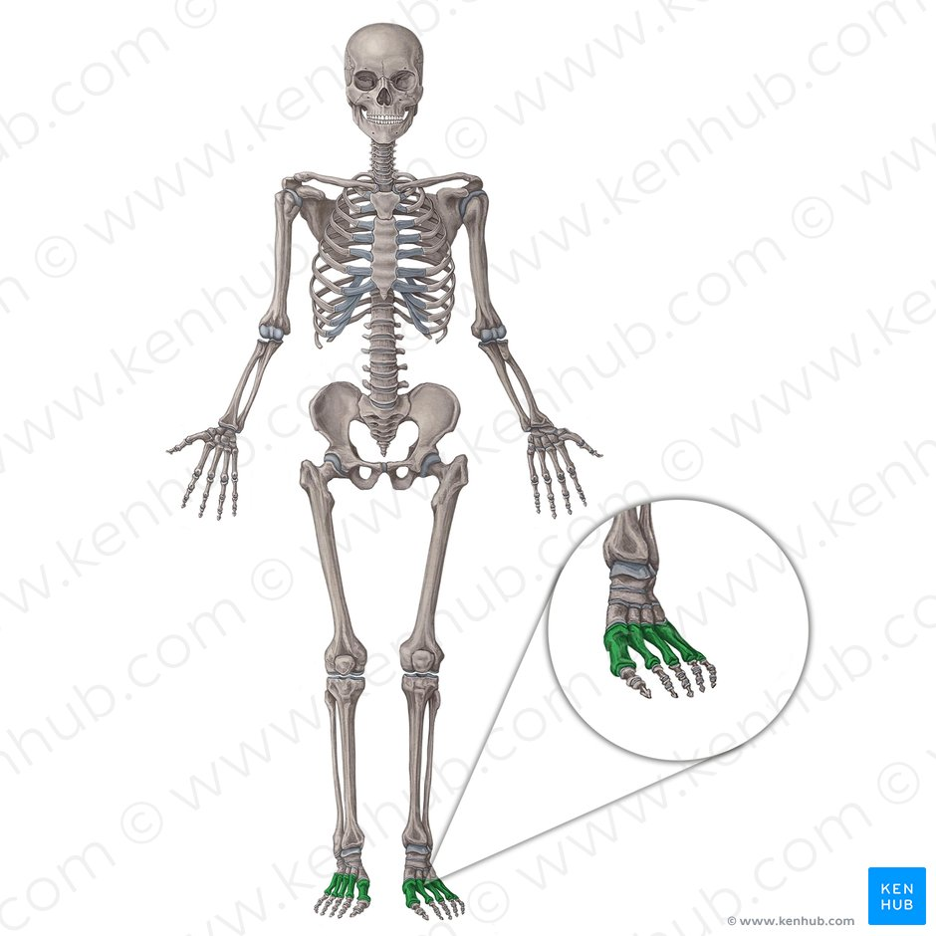
The foot is the region of the body distal to theleg and consists of 28 bones. These bones are arranged into longitudinal and transverse arches with the support of various muscles and ligaments. There are three arches in the foot, which are referred to as:
- Medial longitudinal arch
- Lateral longitudinal arch
- Transverse arch
These arches have an important role in standing, walking and running.
Key facts about the arches of the foot
Medial longitudinal arch | Bones: metatarsals 1-3, sesamoid bones, cuneiform bones, navicular, talus and calcaneus bones  Ligaments: plantar aponeurosis, spring ligament, talocalcaneal ligament, deltoid ligament  Muscles: flexor hallucis longus, flexor digitorum longus, abductor hallucis, flexor digitorum brevis, tibialis posterior
Lateral longitudinal arch | Bones: calcaneus, cuboit, metatarsals 4-5  Ligaments: plantar aponeurosis, plantar ligaments  Muscles: fibularis longus, abductor digiti minimi, lateral half of flexor digitorum brevis, fibularis brevis, fibularis tertius
Transverse arch | Bones: metatarsals 1-5, cuboid and cuneiform bones  Ligaments: ligaments of intercuneiform joints  Muscles: fibularis longus, tibialis posterior
Functions of the foot arches | Weight bearing, shock absorption, propulsion
Clinical relations | Pes planus, pes cavus
This article will discuss the anatomical structure and function of these arches, followed by any relevant clinical pathology.
Contents
- Medial longitudinal arch
  - Bones
  - Ligaments
  - Muscles
- Lateral longitudinal arch
  - Bones
  - Soft tissues
- Transverse arch
  - Bones
  - Soft tissues
- Function of the arches
  - Weight bearing
  - Movement
- Clinical notes
  - Pes planus
  - Pes cavus
- Related diagrams and images
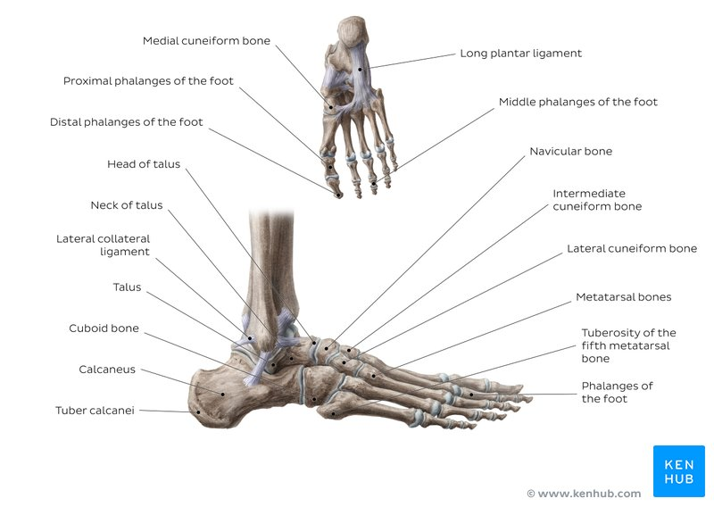
Bones and ligaments of the foot (overview)

Medial longitudinal arch

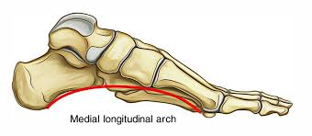
The medial longitudinal arch is higher than its lateral counterpart and is visible between the heel of the foot proximally and the medial three metatarsophalangeal joints distally.

Bones
The bones participating in the formation of the arch are the following:
- the medial three metatarsals up to their heads
- the sesamoid bones
- the three cuneiforms
- the navicular
- talus
- calcaneus
The arch consists of two pillars. The anterior pillar consists of the medial threemetatarsal heads whilst the tuberosity of the calcaneus forms the posterior pillar.

Ligaments
The supporting ligaments provide more stability than the bones of the arch. One of these ligamentous structures, the plantar aponeurosis, acts as a supporting beam between the two pillars. Another important structure, the spring ligament, supports the head of the talus. The talocalcaneal ligament and the anterior fibres of thedeltoid ligament also provide stability for this arch.

Muscles
Muscles in the foot also help support the medial longitudinal arch. These include:
- flexor hallucis longus
- flexor digitorum longus
- abductor hallucis
- flexor digitorum brevis muscles
- tibialis posterior, which is the most important muscle in the maintenance of the arch as damage to its tendon results in collapse of the arch.
The tibialis posterior and anterior muscles help to raise the medial border of the arch whilst the flexor hallucis longus acts as a bowstring.

Lateral longitudinal arch

Bones
The less prominent lateral longitudinal arch is formed by the following:

Calcaneus
calcaneus
- the cuboid
- the fourth and fifth metatarsals
Like its medial counterpart, the lateral arch consists of two pillars, which help support the arch. The anterior pillar consists of the fourth and fifth metatarsal heads whilst the calcaneus forms the posterior pillar. The main contributor to stabilisation of the arch is the fibularis longus tendon.

Soft tissues
Ligaments also have an important role in the stabilisation of this arch and include the plantar aponeurosis and the long and short plantar ligaments, which act as bowstrings beneath the arch. Other muscles and tendons, apart from the fibularis longus tendon, which contribute to the maintenance of this arch, include:
- lateral two tendons of flexor digitorum longus assisted by flexor accessorius
- abductor digiti minimi
- lateral half of flexor digitorum brevis
- fibularis brevis
- fibularis tertius

Transverse arch

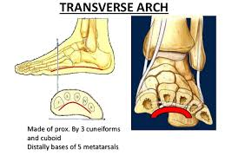

Bones
The transverse arch runs in a coronal plane and consists of the following:

the five metatarsal bases
- the cuboid
- the cuneiform bones
The intermediate and lateral cuneiforms are wedge shaped which aids in maintenance of the arch. The medial and lateral longitudinal arches act as pillars for the transverse arch.

Soft tissues
The important ligaments of this arch are the ligaments between the cuneiforms and bases of the five metatarsal bones.
The curvature of the arch is mainly maintained by the fibularis longus tendon, assisted by the tibialis posterior tendon, which both cross under the sole of the foot. The deep transverse ligaments, the transverse head of adductor longus and the fibularis longus tendon, also help to stabilise this arch.

Function of the arches

Weight bearing
The arches of the foot have an important role in weight bearing. During standing, the weight of the body is distributed throughout the bones in the foot by the arches. The weight is transmitted from the tibia to the talus, before being transmitted posteriorly to the calcaneus. It is also transmitted anteriorly to the navicular, cuneiforms and metatarsals. The lateral longitudinal arch is mostly involved in transmitting this weight and makes more contact with the ground than the medial one.

Movement
The medial longitudinal arch also has an important role in shock absorption andpropulsion during walking, running and jumping. The arch acts like a springboard, as its anterior pillar is the point of take-off during these activities. The process of walking is referred to as the gait cycle and this consists of two phases: a stance phase and a swing phase. During the stance phase, the forefoot pronates which flattens the medial longitudinal arch and the transverse arch. During the swing phase, the hind foot supinates which causes the medial longitudinal arch to elevate. This high arch acts as a rigid lever for propulsion.

- Mention the attachments, nerve supply and actions of the muscle largely responsible for the prominence of buttocks. Which site is safe for the intramuscular injection in this region?
ANS 2; The gluteal muscles are a group of threemuscles which make up the buttocks: thegluteus maximus, gluteus medius and gluteus minimus. The three muscles originate from theilium and sacrum and insert on the femur. The functions of the muscles include extension,abduction, external rotation, and internal rotation of the hip joint
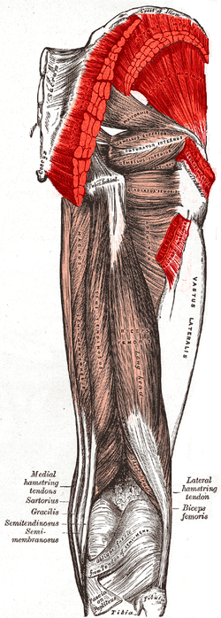

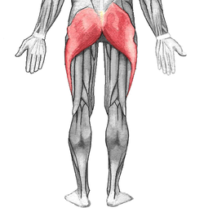

Structure
The gluteus maximus is the largest and mostsuperficial of the three gluteal muscles. It makes up a large portion of the shape and appearance of the hips. It is a narrow and thick fleshy mass of a quadrilateral shape, and forms the prominence of the nates. The gluteus medius is a broad, thick, radiating muscle, situated on the outer surface of the pelvis. It lies profound to the gluteus maximus and its posterior third is covered by the gluteus maximus, its anterior two-thirds by the gluteal aponeurosis, which separates it from the superficial fascia and integument. The gluteus minimus is the smallest of the three gluteal muscles and is situated immediately beneath the gluteus medius.
The bulk of the gluteal muscle mass contributes only partially to shape of the buttocks. The other major contributing factor is that of thepanniculus adiposus of the buttocks, which is very well developed in this area, and gives the buttock its characteristic rounded shape. The gluteal muscle bulk and tone can be improved with exercise. However, it is predominantly the disposition of the overlying panniculus adiposus which may cause sagging in this region of the body. Exercise in general (not only of the gluteal muscles but of the body in general) which can contribute to fat loss can lead to reduction of mass in subcutaneal fat storage locations on the body which includes the panniculus, so for leaner and more active individuals, the glutes will more predominantly contribute to the shape than someone less active with a fattier composition. The degree of body fat stored in various locations such as the panniculus is dictated by genetic and hormonal profiles.

Gluteus maximus

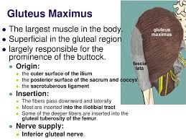
The gluteus maximus arises from the posterior gluteal line of the inner upper ilium, and the rough portion of bone including the crest, immediately above and behind it; from the posterior surface of the lower part of the sacrum and the side of the coccyx; from the aponeurosis of the erector spinae (lumbodorsal fascia), the sacrotuberous ligament, and the fascia covering the gluteus medius. The fibers are directed obliquely downward and lateralward; The muscle has two insertions: Those forming the upper and larger portion of the muscle, together with the superficial fibers of the lower portion, end in a thick tendinous lamina, which passes across the greater trochanter, and inserts into the iliotibial band of the fascia lata; and the deeper fibers of the lower portion of the muscle are inserted into the gluteal tuberositybetween the vastus lateralis and adductor magnus. Its action is to extend and to laterally rotate the hip, and also to extend the trunk.^{[citation needed]}

Gluteus medius

The gluteus medius muscle originates on the outer surface of the ilium between the iliac crestand the posterior gluteal line above, and the anterior gluteal line below; the gluteus medius also originates from the gluteal aponeurosis that covers its outer surface. The fibers of the muscle converge into a strong flattened tendon that inserts on the lateral surface of thegreater trochanter. More specifically, the muscle's tendon inserts into an oblique ridge that runs downward and forward on the lateral surface of the greater trochanter.

Gluteus minimus

The gluteus minimus is fan-shaped, arising from the outer surface of the ilium, between the anterior and inferior gluteal lines, and behind, from the margin of the greater sciatic notch. The fibers converge to the deep surface of a radiated aponeurosis, and this ends in a tendon which is inserted into an impression on the anterior border of the greater trochanter, and gives an expansion to the capsule of the hip joint.

Function
The functions of muscles includes extension, abduction, lateral(external) rotation and medial (internal) rotation of the hip joint. The gluteus maximus also supports the extended kneethrough the iliotibial tract.

Nerve supply
The inferior gluteal nerve is the main motor neuron that innervates the gluteus maximusmuscle. It is responsible for the movement of the gluteus maximus in activities requiring the hip to extend the thigh, such as climbing stairs. Injury to this nerve is rare but often occurs as a complication of posterior approach to the hip during hip replacement. When damaged, one would develop gluteus maximus lurch, which is agait abnormality which causes the individual to 'lurch' backwards to compensate lack in hip extension.
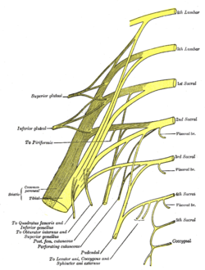

Anatomy
The largest muscle of the posterior hip, gluteus maximus, is innervated by the inferior gluteal nerve.^{[1]} It branches out and then enters the deep surface of the gluteus maximus, the principal extensor of the thigh, and supplies it.

Origin
The muscle is supplied by the inferior gluteal nerve which arises from the dorsal branches of the ventral rami of the fifth (L5), the first (S1)and second (S2) sacral nerves.^{[2]}
The lumbosacral trunk, which is made up of L5 and a small branch of L4, effectively connects the lumbar and sacral plexuses.] The lower branches of the L4 and the L5 nerves enter the sacral plexus.
The sacral plexus is formed by the lumbosacral trunk, the first to third sacral ventral rami, and part of the fourth, the remainder of the last joining the coccygeal plexus. The sacral plexus is formed in the pelvis in front of the piriformis muscle.
The sacral plexus is formed anterior to the piriformis muscle and gives rise to the sciatic nerve, the superior and inferior gluteal nerves, and the pudendal and posterior femoral cutaneous nerves.^{[3]}
However, most of the sacral plexus nerves are scarcely recognizable, because they leave the pelvis through the greater sciatic foramen. From the pelvis, the anterior primary branches of the nerves entering the plexus (the first sacral nerve being a particularly large one) and a mass of nerves on the piriformis can be recognized

Blood Supply and Lymphatics
The gluteus maximus receives vascular supply by both the inferior and superior gluteal artery. These vessels enter the gluteus maximus at the center of the muscle. The inferior gluteal artery proceeds to descend along the greater trochanter of the femur. It accompanies the descent of the sciatic nerve, which proves to be critical as rupture of the inferior gluteal artery can cause gluteal compartment syndrome and sciatic nerve palsy.The artery supplies the superficial skin and anastomoses with the perforating arteries of the lower limb. The inferior gluteal artery is also susceptible to pseudoaneurysm formation following intramuscular injection.

Nerves
The innervation of the gluteus maximus muscle is from the inferior gluteal nerve. The inferior gluteal nerve originates from the ventral rami of L5, S1, and S2. Classically, the inferior gluteal nerve was thought not to provide cutaneous innervation. However, the recent literature describes findings of cutaneous branches of the nerve which might contribute toward gluteal pain during lumbar disk herniation. Surgeons must also be aware of this nerve as injury might result in compression ulcers and various pain syndromes.
Intramuscular injection
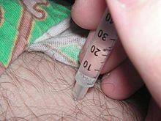
, often abbreviated IM, is the injection of a substance directly into muscle. Inmedicine, it is one of several methods for parenteral administration of medications (see route of administration). Muscles have larger and more numerous blood vessels than subcutaneous tissue; intramuscular injections usually have faster rates of absorption than subcutaneous or intradermal injections.The volume of injection is limited to 2-5milliliters, depending on injection site.

Uses

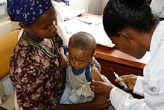
Examples of medications that are sometimes administered intramuscularly are:
- Atropine
- Haloperidol (Haldol)
- Aripiprazole (Abilify)
- Paliperidone (Invega)
- Chlorpromazine (Thorazine)
- Lorazepam (Ativan)
- Fulvestrant (Faslodex)
- Codeine
- Morphine
- Methotrexate
- Metoclopramide
- Magnesium sulfate
- Olanzapine
- Streptomycin
- Diazepam
- Prednisone
- Penicillin
- Interferon beta-1a
- Sex hormones, such as testosterone, estradiol valerate, and medroxyprogesterone acetate (as Depo Provera)
- Dimercaprol
- Ketamine
- Leuprorelin
- Naloxone
- Quinine, in its gluconate form
- Vitamin B12, as cyanocobalamin, hydroxocobalamin or methylcobalamin
- Risperidone

Vaccines are often administered as IM injections.
In addition, some vaccines are administered intramuscularly:
- Gardasil
- Hepatitis A vaccine
- Rabies vaccine
- Influenza vaccines based on inactivated viruses are commonly administered intramuscularly (although there is active research being conducted as to the best route of administration).
Platelet-rich plasma injections can be administered intramuscularly.
Certain substances (e.g. ketamine) are injected intramuscularly for recreational purposes.

Injection sites
Possible sites for IM injection include: deltoid, dorsogluteal, rectus femoris, vastus lateralisand ventrogluteal muscles. Sites that are bruised, tender, red, swollen, inflamed or scarred are avoided.

Deltoid muscle

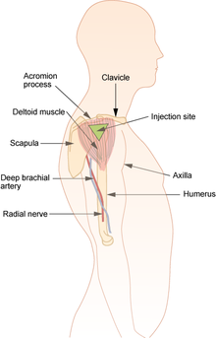

Diagram showing the deltoid site for intramuscular injection
The deltoid muscle site (upper arm) is recommended for use with injections of small volume, usually equal or less than 2 ml, including vaccinations.This site is not recommended for repeated injections; due to its small area, it is difficult to rotate the injection site.To locate the site, palpate the lower edge of theacromion process. Inject in the upside down triangle that forms with its base at the acromion process and its midpoint in line with the axilla.

Ventrogluteal site

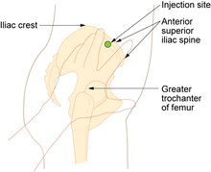

Ventrogluteal site and rectus femoris sites for intramuscular injection
Theventroglutealsite (hip) is recommended for injections requiring a larger volume to be administered, greater than 1 ml, and for medications known to be irritating, viscous or oily. It is also given for narcotic, antibiotic, sedative and anti-emeticmedications.To locate the ventrogluteal site, place the palm of your hand over the greater trochanter, with the fingers facing the patient's head. The right hand is used for the left hip and left hand is used for the right hip. Place the index finger on the anterior superior iliac spine and run the middle finger back along the iliac crest. The injection is given in the center of the triangle that is formed.

Vastus lateralis muscle
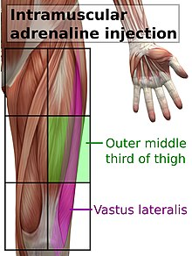

Vastus lateralis site for intramuscular injection
The vastus lateralis site is recommended for infants less than 7 months old and those unable to walk, with loss of muscular tone.] To locate the site, divide the front thigh into thirds vertically and horizontally to make nine squares and inject in the outer middle square.
It is also recommended for epinephrine autoinjectors, in such cases in the middle of the outer side of the thigh, corresponding to the location of the vastus lateralis muscle.

Dorsogluteal site
The dorsogluteal (buttock) site is not recommended for use in any patient population due to its location near major blood vessels and nerves, as well as having inconsistent depth of adipose tissue, with very few injections in this area injected to the correct depth to administer as a true intramuscular injection. Use of this site is associated with skin and tissue trauma, muscle fibrosis andcontracture, haematoma, nerve palsy and paralysis, as well as infectious processes such asabscess and gangrene. Despite the goal of healthcare in many countries to follow evidence based practices, this site is commonly preferred by healthcare professionals against research recommendation, often due to a lack of knowledge surrounding alternative sites for injection. The injection site is located by dividing the buttock into four with a plus (+) shaped cross, and administering the injection in the upper outer quadrant. This is the only intramuscular injection site for which research recommends aspiration (drawing back) of the syringe prior to injection, due to higher likelihood of accidental intravenous administration in this area. However, aspiration is not recommended by the Centers for Disease Control and Prevention, considering it outdated.

- How greater and lesser sciatic foramina formed and enlist the structures passing through them
ANS 3: These are two foramina of the gluteal region, which provide a path for entrance and exit of structures to and from pelvis.

Greater sciatic foramen

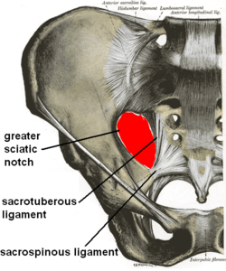
Greater sciatic foramen
The greater sciatic foramen is an opening (foramen) in the posterior human pelvis. It is formed by the sacrotuberous and sacrospinous ligaments. The piriformis muscle passes through the foramen and occupies most of its volume. The greater sciatic foramen is wider in women than in men.

Structure
It is bounded as follows:
- anterolaterally by the greater sciatic notch of the ilium
- posteromedially by the sacrotuberous ligament
- inferiorly by the sacrospinous ligament and the ischial spine
- superiorly by the anterior sacroiliac ligament

Function
The piriformis, which exits the pelvis through the foramen, occupies most of its volume.
The following structures also exit the pelvis through the greater sciatic foramen:
Location | Name | Vessels | Nerves
Above the Piriformis | suprapiriform foramen^{[1]} | superior gluteal vessels | superior gluteal nerve
Below the Piriformis | infrapiriform foramen^{[1]} | inferior gluteal vessels  internal pudendal vessels | inferior gluteal nerve  pudendal nerve  sciatic nerve  posterior femoral cutaneous nerve  Nerve to obturator internus  Nerve to quadratus femoris
The foramen contains:^{[2]}
- 7 nerves:
  - Sciatic Nerve:
  - Superior Gluteal Nerve
  - Inferior Gluteal Nerve
  - Pudendal Nerve
  - Posterior Femoral Cutaneous Nerve
  - Nerve to Quadratus Femoris
  - Nerve to Obturator Internus
- 3 Vessel Sets:
  - Superior Gluteal Artery & Vein
  - Inferior Gluteal Artery & Vein
  - Internal Pudendal Artery & Vein
- 1 Muscle:
  - Piriformis
  - 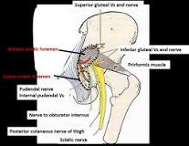

  - 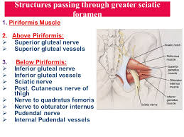

Lesser sciatic foramen

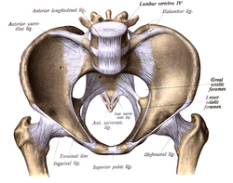

Lesser sciatic foramen
The lesser sciatic foramen is an opening (foramen) between the pelvis and the back of the thigh. The foramen is formed by thesacrotuberous ligament which runs between thesacrum and the ischial tuberosity and thesacrospinous ligament which runs between the sacrum and the ischial spine.

Structure
The lesser sciatic foramen has the following boundaries:
- Anterior: the tuberosity of the ischium
- Superior: the spine of the ischium and sacrospinous ligament
- Posterior: the sacrotuberous ligament
Alternatively, the foramen can be defined by the boundaries of the lesser sciatic notch and the two ligaments.

Function
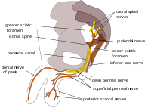
Pudendal nerve and its course through the lesser sciatic foramen.
The following pass through the foramen:
- the tendon of the Obturator internus
- internal pudendal vessels
- pudendal nerve
- nerve to the obturator internus

- What are hamstring muscles? Give their origin, insertion, nerve supply and action.

ANS 4; Hamstring Muscles
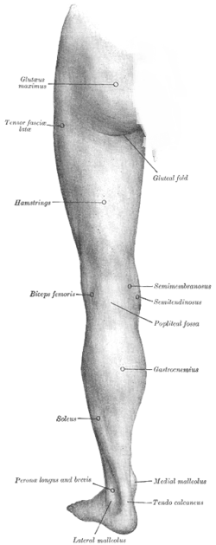
In human anatomy, a hamstring is any one of the three posterior thigh musclesin between the hip and the knee (from medial to lateral: semimembranosus, semitendinosus andbiceps femoris). The hamstrings are quite susceptible to injury.
In quadrupeds, the hamstring is the single largetendon found behind the knee or comparable area.

Criteria
The common criteria of any hamstring muscles are:
- Muscles should originate from ischial tuberosity.
- Muscles should be inserted over the knee joint, in the tibia or in the fibula.
- Muscles will be innervated by the tibial branch of the sciatic nerve.
- Muscle will participate in flexion of theknee joint and extension of the hip joint.
Those muscles which fulfill all of the four criteria are called true hamstrings.
The adductor magnus reaches only up to the adductor tubercle of the femur, but it is included amongst the hamstrings because the tibial collateral ligament of the knee joint morphologically is the degenerated tendon of this muscle. The ligament is attached to medialepicondyle, two millimeters from the adductor tubercle.

Structure
The three muscles of the posterior thigh (semitendinosus, semimembranosus, biceps femoris long & short head) flex (bend) the knee, while all but the short head of biceps femoris extend(straighten) the hip. The three 'true' hamstrings cross both the hip and the knee joint and are therefore involved in knee flexion and hip extension. The short head of the biceps femoris crosses only one joint (knee) and is therefore not involved in hip extension. With its divergent origin and innervation it is sometimes excluded from the 'hamstring' characterization
Muscle | Origin | Insertion | Nerve
semitendinosus | ischial tuberosity | medial surface of tibia | tibial part ofsciatic
semimembranosus | ischial tuberosity | medial tibial condyle | lateral side of the head of the fibula | tibial part ofsciatic
biceps femoris - short head | linea aspera andlateral supracondylar line of femur | lateral side of the head of the fibula (common tendon with the long head) | common peroneal
A portion of the adductor magnus is sometimes considered a part of the hamstrings.
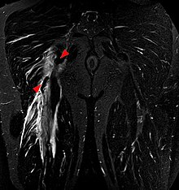
Tear of the hamstrings muscles at the ischial tuberosity seen on MRI (coronal STIR). The arrowheads indicate the tuber and the retracted tendon stump. Significant bleeding around and into the muscles.

Function
The hamstrings cross and act upon two joints – the hip and the knee – and as such are termed biarticular muscles.
Semitendinosus and semimembranosus extend the hip when the trunk is fixed; they also flex the knee and medially (inwardly) rotate the lower leg when the knee is bent.
The long head of the biceps femoris extends the hip, as when beginning to walk; both short and long heads flex the knee and laterally (outwardly) rotate the lower leg when the knee is bent.
The hamstrings play a crucial role in many daily activities such as walking, running, jumping, and controlling some movement in the gluteus. In walking, they are most important as anantagonist to the quadriceps in the deceleration of knee extension.
