NAME :Liaqat Ali
ID :14942
BS DT
DATE :26 /6/2020
4TH SEMISTER
PAPER :General pharmacology
QUESTION NO :01
ANSWER NO :01
PART A
(1)TYPE 1 DIABETES MELLITUS
- A form of chronic hyperglycemia caused by immunologic destruction of pancreatic beta cells

(2) TYPE 2 DIABETES MELLITUS
A form of chronic hyperglycemia initially caused by resistance to insulin ; often progresses to insulin deficiency.

PART B
There is two insulin delivery device one is pen and other is syringe.My opinion is syringe is more effective insulin delivary device because I belong to village , syringe is simple 1ml syringe therefore any one understand unit .
Syringe are cost effective and widely available , pen are expensive and not available any where.but but insulin pen is less pain and syringe is more painfull.

QUESTION NO :05
ANSWER NO :05
PART A
RIGHT HEART FAILURE
In right heart failure ,the right atrium and ventricle are unable to handle blood returning from the systemic circulation .This caused fluid to accumulate in the peripheral tissue and ankle edema and and organ congestion (liver , spleen ) are typically manifestations.
LEFT HEART FAILURE
The left atrium and ventricle are unable to adequately handle the blood returning from lungs .This causes pressure to build up in the pulmonary veins, and fluid accumulates in the lungs .Consequently , left heart failure is associated with pulmonary edema.

PART B
PHARMACOTHERAPY OF HEART FAILURE
Basic goals is congestive heart failure is to improve the heart pumping ability
Strateges
- Increase cardic contractile performance and produce what is referred to as a positive inotropic effect.”inotropic” refer to the force of muscular contraction ; the primary drugs used to exert a positive inotropic effect of the cardiac glycosides
- Decrease workload through an effect on the heart of peripheral vasculature , or by controlling fluid volume , are recognized as benefical in congestive heart failure .angiotensin converting enzyme inhibitors , beta blockers ,diuretics , and vasodilators

QUESTION NO :03
ANSWER NO :03
PART (B)
STABLE ANGINA
The most common (90 persent )
- It chestpain caused by temporary inadequacy of blood flow to the myocardium ,the underlying cause is usually occlusion of the coronary arteries by atherosclerosis
- Usually lasts 1-15 minutes and is provoked by exercise , stress , extreme cold or heart heavy meals , alcohol , or smoking.
- Rx : promptly relived by rest or nitroglycerin ( a vasodilator).

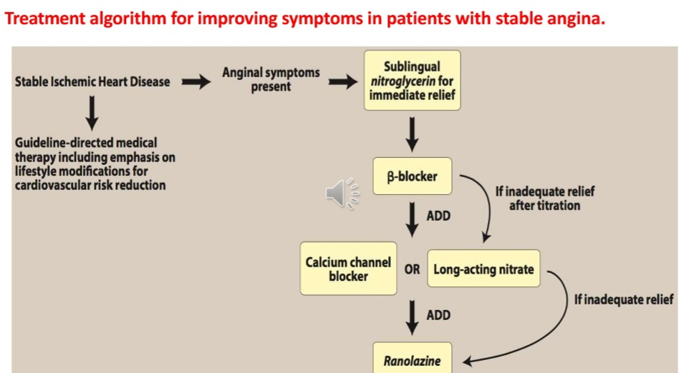

PART (A)
ORGANIC NITRATES
ORGANIC nitrates and (nitritis) are simple nitric and nitrous acid asters of alcohols. They differ in their volatility ; for example ,isosorbide dinitrate is solid at room temperature ,nitroglycerin is only moderately volatile , whereas amyl nitrates is extremely volatile .these compounds caused a rapid reduction in mycocardial oxygen demand followed by rapid relief of symptoms. They are effective in stable and unstable angina as well as prinzmetal’s or variant angina pectoris
EFFECT OF ORGANIC NITRATE IN ANGINA PACTORIS
- At therspeutic doses , nitro –glycerin has to major effects .first, it caused dilation of the large veins, resulting in pooling of blood in the veins.This diminishes preload (venous return to the heart ) . Seconds nitroglycerin, dilates the coronary vasculature ,providing increased blood supply to the heart muscle .Nitroglycerin causes a decrease in myocardial oxygen consumption because of decrease cardiac work.
ADVERSE EFFECT OF ORGANIC NITRATES IN ANGINA PACTORIS
- The most common adverse effect of nitroglycerin ,as well as the other nitrates ,is headache.Thirty to sixty parcent of patients reciving intermittent nitrate therapy with long – acting agents develop headaches. High doses of organic nitrates can also caused postural hypotension ,facial flushing , and tachycardia.

QUESTION NO : 02
ANSWER NO :02
PART (B)
THROMBOLYTIC AGENTS
Mcchanism of action
Plasmin is an endogenious fibrinolytics enzyme that degrades clots by splitings fibrin into fragments .The thrombolitics enzyme catalyze the conversion of the inactive precursor , plasminogen ,to plasmin .
- TISSUE PLASMINOGEN ACTIVATOR =T-PA is an enzyme that directly converts plasminogen to plasmin.It has little activity unless it is bound to fibrin , which is theory , should make it selective for the plasminogen that has already bounded to fibrin (ie , in a clot )and should in less danger of widespread production of plasmin and spontaneous bleeding.
- STREPTOKINASE = Streptokinase is obtained from bacterial caltures. Although not itself an enzyme ,streptokinase forms a complex with endogenous plasminogen ; the plasminogen in this complex undergoes a comformational changes that allows it to rapidly convert free plasminogen into plasmin.
SPECIFIC AGENTS FOR THROMBOLYTICS
Alteplase , recombanint (activase) anistreplase (eminase)streptokinase (streptase)Urokinase (abbokinase)
ADVERSE EFFECTS
Hemorrage is the major adverse effect associated with thrombolytic agents.
Fever and an allergic reaction (itching ,nausea headache ,other symptoms).

PART A
ROLE OF VITAMIN K IN BLOOD CLOTING
Role of vitamin K in the synthesis of vitamin K –dependent clotting (2,7,9,and 10).
Vitamin k catalyzes the reaction necessary for completion of clotting factor synthesis , but it is oxidized in the process to vitamin k epoxide.
Regeneration of vitamin k occurs via vitamin k epoxide reductase.
Oral anticoagulants such as warfarin (Coumadin)block the regeneration to vitamin k , thus halting the further synthesis of the vitamin k dependent factors.
DRUGS USED IN BLEEDING DISORDERS OR DRUGS THAT FACILITATES CLOTTING
Inadequate blood clotting can result from with vitamin k deficiency ,genetically determined errors of clotting factors synthesis(eg, hemophilla) a variety of drug – induced condition and thrombocytopenia .treatment involve administration os vitamin k preformed clotting factors ,or antiplasmin drugs.
VITAMIN K
Deficiency of vitamin k , a fat – soluble vitamin ,is most common in order persons with abnormalities of fat absorption and in newborns , who are at risk of bleeding due to oral or parenteral phytonadione (vitamin k1) .
ANTIPLASMIN AGENTS
Antiplasmin agents are valuable for the prevention or management of acute bleeding episodes in patients with hemophilia and others with a high risk of bleeding disorders.aminocaporic acid and tranexamic acid are orally active agents that inhibits fibrinolysis by inhibiting plasminogen activation.
CLOTTING FACTORS AND DESMORPRESSIN
The most important agents used to treat hemophilia are fresh plasma and purified human blood clotting factors espicallyrecombinant DNA technology.
The vasorpressin v2 receptor agonist desmorpressin acetate increase the plasma concentration of von willibrand factorand factor 8. It is used to prepare with mild hemophilia A or won willbrand disease for elective surgery.

QUSTION NO ;04
ANSWER NO : 04
PART A
DIFFERENTIATION BETWEEN PRIMARY AND SECONDRY HYPERTENSION
Although hypertension may occurs secondry to other disease processes, more than 90 percent of patients have essential hypertension a disorder of unknown origin affecting the blood pressure –regulating mechanisms .A family history of hypertension increase the likelihood that an individual will develop hypertension disease . Essential hypertension occurs four times more frequently among blacks than among whites , and it occur more often among middle- aged males than among middle – aged females .Enviromental factor such as a stressful lifestyle, high dietary intake of sodium , obesity , and smoking all further predispose an individual to the occurrence of hypertension .summarizes the drugs used to treat hypertension [note:Nonsteroidalanti –inflammatory drugs(NSAID)Interfere with the hypertensive action of many antihypertensives.

PART B
EFFECT OF RENIN ON HYPERTENSION
The kidney provides for the long –term control of blood pressure by altering the blood volume.Baroreceptors in the kidney respond to reduced arterial pressure (and to sympathetic atimulation of beta adrenoceptors0 by releasing the enzyme renin. This peptidase converts angiotensinogen to angiotensin 1, which is in turn converted to angiotensin 2 in the presence of angiotensin converting enzyme antiotensin 2 in the body’s most response of the automatic ,nervous system and the renin –angiotensin- aldosterone system to a decrease in the blood.
Protent circulating vasoconstrictor , causing an increase in the blood pressure. Furthermore , angiotensin 2 stimulates aldosterone secretion ,leading to increased renal sodium resorption and an increase in blood volume ,which contributes to a further increase in the blood pressure.

PART C
ANTIHYPERTENSIVE DRUGS
- BUMENTANIDE
- FUROSEMIDE
- Hydrochlorothizide
- Spironoiactone
- Triamterene
BETA BLOCKERS
- Atenolol
- Labetalol
- Metoprolol
- Propranolol
- Timolol
ACE INHIBITORS
- BENAZEPRIL
- CAPTOPRIL
- Enalapril
- Fosinopril
- Lisinopril
- Moexipril
- Quinapril
- Ramipril
ANGIOTENSIN 2 ANTAGONIST
- LOSARTAN
CA ++ CHANNEL BLOCKERS
- Amiodipine
- Diltiazem
- Feiodipine
- Laradipine
- Nicardipine
- Nifedifine
- Verapamil
ALPHA BLOCKER
- Doxazosin
- Prazosin
- Terazosin
OTHER
- Clonidine
- Diazoxide
- Hydralazine
- Alpha methyldopa
- Minoxidil
- Sodium nitroprusside

