Iqra National University Peshawar

Name usman ali
ID 16963
Programed B.Tech Civil ii Semester
Subject Mechanics of Material.
Submitted to Engr Marvan Raza
Exam Final Term
__________________________________________________________________________

Q no 1 Ans =

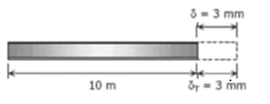

$$∝ -11.7 Km \left(MC°\right)and 250 Gpa$$
Temp = 25cº
$$δT=3mm at temprature$$
$$δT= ∝L\left(∆T\right) formula$$
$$=\left(∆T=Tf-T1\right) put in formula formula$$
$$δT= ∝L\left(Tf-Ti\right)$$
3 = (11.7 x ${10}^{-6}) (10000)(Tf-25°)$
3 = (117000 x ${10}^{-6})(Tf-25°)$
$$\frac{δ}{0.117}= \frac{0.117}{0.117} \left(TF-25\right)$$
= $Tf-25°$ = 25.641
= Tf = 50.641
$$σ= δT$$
$$\frac{δ}{T}= ∝\left(∆T\right) formula$$
$$δ= ∝E\left(∆T\right)$$
$$δ=(11.7 x {10}^{-6})(250 x 10G)( \left(50.641\right)-25°)$$
$$δ=\left(11.7 x {10}^{-6}\right)250 x10G \left(250641\right)$$
$$δ=\left(11.7 x {10}^{6} x 25\right)\left(25.641\right)$$
$$δ=7499.9925 x {10}^{3 }Pa$$

Q no 3 =
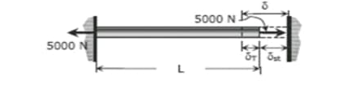
Ans No 3 =
Given data = External Diameter = 600 mm
Internal Diameter = 300mm
Twisting Moment = 60 kn-m
Span = 5 m
G =0.8 x ${10}^{3} N/{mm}^{2}$
$$θ= ?$$
Sol = Douter 600 x ${10}^{-3}=0.06$
Dinner = 300 x ${10}^{-3}$ = 0.03
Formula $\frac{T}{R} = \frac{Gθ}{I}$ T = Toque R = Radius G = Modula’s OF readies
I = Inertia $θ =Angle of Teisting$
R = $\frac{D}{2 }= \frac{600}{2}=300m$
60 x ${10}^{3}= \frac{π}{16} x T x \frac{{600}^{4 }-{300}^{4}}{400}$
T = $\frac{60000}{π 1265625}$
T = 15.2 $N/{mm}^{2}$
Now putting the value

$$\frac{5.2 x {10}^{3}}{300mm}= \frac{0.8 x {10}^{3}θ}{5}$$

$$θ=\frac{5.2 x {10}^{3} x 5}{300 x{10}^{-3} 0.8 x {10}^{\begin{aligned}3 \\ \end{aligned}}}$$

$$θ= \frac{\left(5.2\right)x(5)}{\left(0.3\right)X (0.8)}$$
$$θ=108.3°$$

Q no 5 = Find Shear force and bending moment diagram of given beam?
Ans =
Sol =
$\sum{MA}$ =0
180 x 3 +RC (13) – 40 (15) = 0
-540 + 13RC – 600 = 0
RC = 87.69 KN
EFY = 0
RA + RC = 180+40
RA =220 -87.69
RA= 132.31 KN (diagram of question no 5 is given below)
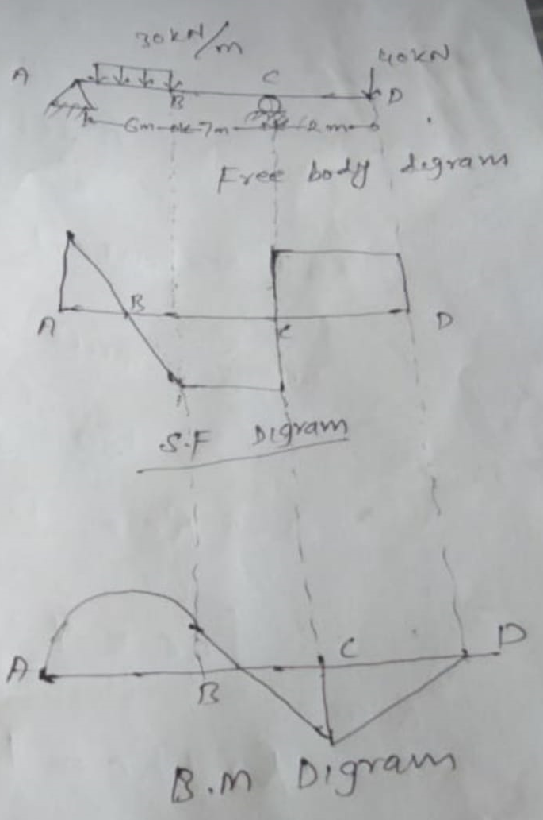

Q no 2 =
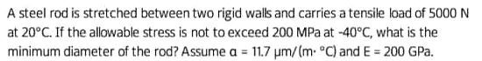
Ans Q no 2 =
Sol = $∆ T= -40c°-20c°$
$∆T= -60°$
Stress is not exceed 200mpa
Dmin =? $∝ =11.7 \left(μm / m. c°\right)$
E = 200 Gpa
P = 5000 N
Formula p = -$πr^{2 }E α (∆T)$
$$\sqrt{\frac{P}{-πE x (∆T)}}= \sqrt{r^{2}}$$
r = $\sqrt{\frac{P}{-πE x (∆T)}}$

$\frac{D}{2}= \sqrt{\frac{-P}{∆E x ∆T}}$ = 2 $\sqrt{\frac{-P}{∆E x ∆T}}$

D = 2 $\sqrt{\frac{-P}{∆E x ∆T}}$
D = 2 $\sqrt{\frac{+5000}{3.14 x 200 x {10}^{3} x 11.7 x\left(+60\right)}}$
D = 1.1134 x ${10}^{-5}$
D = 11.134 x ${10}^{3}μm$

Q no 4 =
Q no Ans =
Given Data = Length = 30 fit
E = 31000 ksi
I = 1540
Area = 160 ${in}^{2}$
To find critical buckling load = per
Per =?
Slenderness Ratio = $λ$

Critical buckling load
Formula Per = $π^{2} EIL^{2}$

Per = ${\left(3.14\right)}^{2}\left(31000\right)\left(1540\right)\left(30\right)$
Per = $1.4 x {10}^{10}$

Now I find Slenderness Ratio = $λ$
Formula $λ= \frac{L }{R }$ = $\frac{L}{\sqrt{\frac{I}{r}}}$
$λ= \frac{30 }{3.1 }$ = $\frac{30}{\sqrt{\frac{1540}{160 }}}$ = 9.67 Ans

