Name: Rehan ullah
ID: 15929
Department: BS (Radiology) Second Semester
Section: B
Assignment: Human Physiology
Submitted To: Mam Kousar Shah Jehan

Q No: 1
Ans: Cardiovascular system:
The cardiovascular system can be through of as the transport system of the body. This system has three main components; the heart, the blood vessel and the blood itself. The heart is the system’s pump and the blood vessels are like the delivery routes. Blood can be through of as a fluid which contains the oxygen and nutrients the body needs and carries the wastes which need to be removed. The following information describes the structure and function of the heart and the cardiovascular system as a whole.
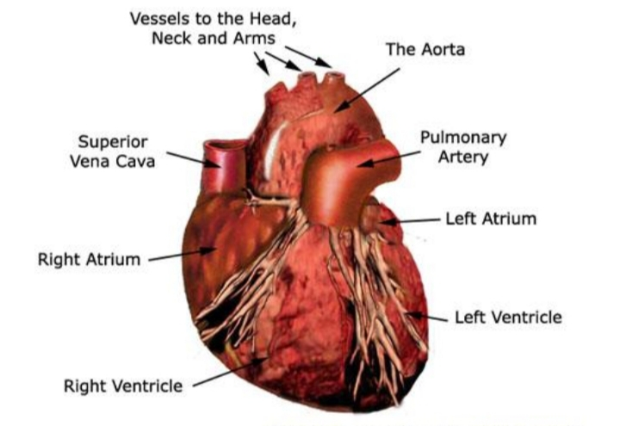
Structure and function of the heart:

Function and location of the heart:
The heart’s job is to pump blood around the body. The heart is located in between the two lungs. It lies left of the middle of the chest.

Structure of the heart:
The heart is a muscle about the size of a fist and is roughly cone-shaped. It is about 12cm long, 9cm across the broadest point and about 6cm thick. The pericardium is a fibrous covering which wraps around the whole heart. It holds the heart in place but allows it to move as it beats. The wall of the heart itself is made up of a special type of muscle called cardiac muscle.
Chambers of the heart:
The heart has two sides, the right side and the left side. The heart has four chambers. The left and right side each have two chambers, a top chamber and a bottom chamber. The two top chambers are known as the left and right atria (singular: atrium). The atria receive blood from different sources. The left atrium receives blood from the lungs the right atrium receives blood from the rest of the body. The bottom two chambers are known as the left and right ventricles. The ventricles pump blood out to different parts of the body. The right ventricle pump bloods to the lungs while the left ventricle pump out blood to the rest of the body. The ventricles have much thicker walls than the atria which allow them to perform more work by pumping out blood to the whole body.

Blood Vessels:
Blood vessels are tubes which carry blood. Veins are blood vessels which carry blood from the body back to the heart. Arteries are blood vessels which carry blood from the heart to the body. There are also microscopic blood vessels which connect arteries and veins together called capillaries. There are a few main blood vessels which connect to different chambers of the heart. The aorta is the largest artery in our body. The left ventricle pumps blood into the aorta which then carries it to the rest of the body though smaller arteries. The pulmonary trunk is the large artery which the right venteries which pumps into. It splits into pulmonary arteries which take the blood to the lung. The pulmonary veins take blood from the lungs the left atrium. All the other veins in our body drain into inferior vena cava (IVC). Or the superior vena cava (SVC). These two large veins then take the blood from the rest of the body into the right atrium.

Valves:
Valves are fibrous flaps of tissue found between the hearts the chambers and in the blood vessels. They are rather like gates which prevent blood from flowing in a number of places. Valves between the atria and ventricles are the known as the right and left atriventricular valves, otherwise known as the tricuspid and mitral valves respectively. Valves between the ventricles and the great arteries are known as the semi lunar valves. The aortic valve is found at the base of the aorta, while the pulmonary valve is found the base of the pulmonary trunk. There are also many valves found in veins throughout the body. However, there are no valves found in any of the other arteries besides the aorta and pulmonary trunk.

Q No: 2
Ans: HIGH BLOOD PRESSURE:
WARNING SIGNS
- Chest pains
- Confusion
- Headaches
- Ear noise or Buzzing
- Irregular Heartbeat
- Nosebleeds
- Tiredness
- Vision changes

LOW BLOOD PRESSUER:
WARNING SIGNS:
- Dizziness or lightheadedness
- Cold, Clammy, Pala skin
- Fainting (called syncope)
- Rapid, Shallow Breathing
- Dehydration and unusual Thirst
- Fatigue
- Blurred vision
- Depression
- Nausea
- Lack of concentration

Q No: 3
Ans: Treatment of high and low blood pressure
- Use more salt. Experts usually recommend limiting salt in your diet because sodium can raise blood pressure, sometime dramatically.
- Drink more water. Fluids increase blood volume and help prevent dehydration, both of which are important in treating hypotension.
- Wear compression stockings
- Medications

Some ways to help control blood pressure:
- Eat a heart-healthy diet that includes potassium and fiber
- Drink plenty of water
- Exercise regularly
- Don’t smoke
- Limit alcohol consumption to one drink a day for women, two a day for men
- Limit salt consumption to less than 1,500 mg per day
- Try to avoid stress
- Maintain a healthy body weight

THE END
THANK YOU

