IQRA NATIONAL UNIVERSITY
DEPARTMENT OF ELECTRICAL ENGINEERING
MID TERM PAPER
DIRECT ENERGY CONVERSION

NAME: MUHAMMAD WASEEM
I.D: 13422
SEMESTER: LAST
INSTRUCTOR: ENGR.SHAYAN TARIQ JAN

Q.No.1 What will be the advantage of Solar Photo Voltaic and Fuels Cell technologies for Peshawar which will be the better option to power a 10 KW load. Explain your answer based on its pros & cons, users, applications, availability and market. Back your reasons with valid data, facts and figures.

Now a days solar energy and fuel cell technology are widely used in order to meet the energy requirement. The uses of these technologies are encouraged because of increasing demand of the energy. Soon we will meet the challenges of energy crises. The global energy demand rises 2 to 3 times in 2050. So because of these issues independent power projects are used.
Let we talk about the solar energy. Solar energy is a type of direct energy conversion in which electricity is produced by the light that hitting the solar panel. On the other hand fuel cell is the type of direct energy conversion in which electricity is produced by a chemical reaction.
Let’s compare these two technologies according to their advantages, disadvantages, market availability and some other aspects.
Advantages of Solar Energy:
- Solar energy does not need any kind of fuel.
- It has low maintenance cost.
- It does not produce any kind of pollution as compared to diesel power plant and gasoline power plants.
- It is reliable.
Disadvantages of Solar Energy:
- It has high initial cost.
- Less efficiency 20 - 25%
- Placement requires large space.
Advantages of Fuel Cells:
- The efficiency of fuel cell is high (ranges from 50 – 70%)
- Noiseless
- Eco-friendly
- Requires less space

Disadvantages of Fuel Cell:
- This technology is not fully developed.
- This technology is expensive
- Refueling problem
- Low service life.
We see that there are different advantages and disadvantages of both the technologies. We are talking about Peshawar, so let’s see the market availability of both the technologies.
Market Availability of Solar System and Fuel Cell:
As we know that solar energy now are widely used to meet the energy requirement. This technology includes solar panels, batteries and inverters, and charge controllers which are easily available from the market. On the other hand, fuel cell technology is not fully developed yet and are not easily available in the market
Applications of Solar Energy:
- Used as small power station.
- Used for water heating purpose.
- Used for lightning on the roads.
- Used for water pumping.
Applications of Fuel Cell:
- Used for domestic power.
- Used in vehicles.
- Used as central power station.
Conclusion:
We see that there are different advantages, disadvantages, market availability and applications of both the technologies. Now, if we talk about Peshawar the solar energy technology is the best option for power generation because we know that this technology is easily available in the market, and their installation is also very simple and requires not any kind of refueling. Although the efficiency of this technology is low but still it is a good option. There maintenance is also very easy. On the other hand if we talk about fuel cell technology, it is also a good option because it has greater efficiency than that of solar energy technology but there refueling is still a major issue and in this area this technology is not fully developed yet. This technology requires hydrogen for chemical reaction, and we know that the storage of hydrogen and its transportation is also very difficult. The service life of the fuel cell is also very low as compared to solar energy.
So to power the 10KW of load in Peshawar, we think that solar energy is the best option.

Q.No.2) For Peshawar, based on its average climate conditions what techniques will you apply to a PV cell to reduce the effects of climate on the cells performance, reduce losses and increase efficiency. Back your reasons with valid data, facts and figures.

Let we first talk about the average climate condition of Peshawar.
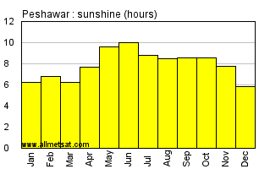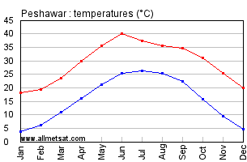

The figure shows the average climate condition of Peshawar. So, from the figure we see that there are more sunshine hours. So the generation of solar power is suitable for this area. But we know that the generation of power through solar cells is effected by various climate conditions.
There are some techniques that are applied to reduce the effects of climate on the solar cells performance, reduce losses and increase efficiency.
Methods to Reduce Climate Effects:
The performance of the solar cells is effected by different conditions which includes less efficiency of solar cell in high temperature, accumulation of dust on solar panel, partial shading, birds droppings or fouling and water drops on solar panel
- Effect of High Temperature on Performance of Solar Panel:
As we that the manufacturer provide some data on the back side of the solar panel. There is a term used which is described as temperature coefficient denoted by Pmax. This value is given in negative percentage, shows the impact of weather on solar panel. Solar panels are tested at 25 degree C. The temperature coefficient changes the efficiency of solar panel as the temperature goes 1 degree up or down. For example, if the temperature coefficient of solar panel is -0.4%, then at every 1 degree C rise, panel power is reduced by 0.4%. This means on hot day, when the temperature of panel reaches 45 – 50 degree, the temperature coefficient with -0.4% will result in reduction of 8 – 10% of power. The panel works more efficiently in sunny winter morning.
Method that Reduce the Effects of High Temperature:
Place a solar panel few inches above the roof in order to provide the free flow of air (ventilation) to solar panel. It is also possible to provide some additional ventilation or fan to the solar panel, which allows the movement of air around the solar panel.
- Accumulation of Dust on Solar Panel:
As the accumulation of dust on solar panel affect the efficiency of solar panel and reduce the output power. The percentage of efficiency that is affected by the accumulation of dust is 10 – 14% and that of power reduction is 8 – 12 %.
So this is necessary that, solar cell should be cleaned regularly or 2 to 3 times in a week, in order to improve efficiency of solar panel.
- Efficiency Reduction Due to Birds Droppings or Fouling:
The efficiency of solar panel is also reduced about 6 – 8% by the birds fouling. Therefore it is necessary to clean the panel in order to get high efficiency and increase output power.
- Less Efficiency Due to Water Drops:
The water drops affect the efficiency of solar panel by 4 – 6%. Water drops can decrease the temperature of the solar panel which affects the generation, as the water provides cooling characteristics to the solar panel. So it is also necessary to remove the water drops from panel surface.
- Less Efficiency Due to Shaded Area:
If the solar panel is installed at the shaded area or there is a shade of tree on the solar panel, this affects the efficiency of solar panel. So, it is important to install it in a suitable area.

Q.No.3) Fuel Cells have many types based on temperature, electrolyte and fuel. What would be the best option and the worst option among the types of fuel cell for providing power to Iqra National University (Take the last 3 digits of your student ID to be the average load KW of INU) located in Peshawar. Explain your choices based on the pros & cons, applications, availability and market. Back your reasons with valid data, facts and figures.

As we know that fuel cell is a device that generates electrical energy by a electrochemical reaction. Electricity is produced in this process by the combination of hydrogen and oxygen. The by-product of this process is water and heat. There are different types of fuel cell including polymer electrolyte membrane fuel cell (PEMFC), alkaline fuel cell (AFC), phosphoric acid fuel cell (PAFC), molten carbonate fuel cell (MCFC), solid oxide fuel cell (SOFC), each having their own characteristics.
Let we first check the characteristics of different types of fuel cells to decide which one is the best option.
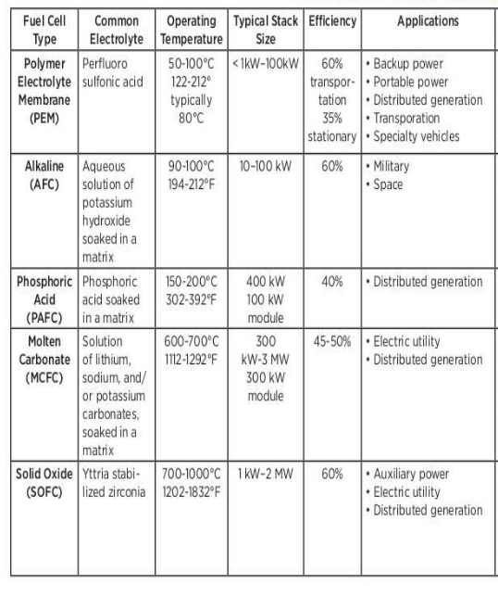
From the table we see that there are different types of fuel cells each having its own power capacity, operating temperature and electrical efficiency.
Now we choose the best option among these types of fuel cells for providing power to INU.
First I take the last 3 digits of my student I.D. as average load of INU i.e. (I.D: 13422). So, 422 KW is the average load of INU. Now, we decide the best option from the table.
As we see polymer electrolyte membrane fuel cell (PEMFC) has a good efficiency of 60% which is a good one but if we talk about the power capacity, the power capacity of PEMFC is between 1KW – 100KW, which is less according to our need. As we need 422 KW, so this is the worst option.
Now we talk about alkaline fuel cell (AFC). The alkaline fuel cell has good efficiency of 60%, but the power capacity of this fuel cell is also less, so this is also a worst option.
Phosphoric acid fuel cell (PAFC) has less efficiency so this type is also not suitable. Now consider molten carbonate fuel cell (MCFC), the efficiency of MCFC is about 50% and there power capacity is from 300KW to 3MW, so it is better option than the other types. But we talk about the better option among all of these types so this type is also not selected.
Now in solid oxide fuel cell (SOFC) we see that the efficiency range is 60% and the power capacity is from 1KW to 2MW, so this is the best option among all of these types of fuel cell.
So, Solid oxide fuel cell (SOFC) is the best option to provide power to INU.

