IQRA NATIONAL UNIVERSITY
DEPARTMENT OF ALLIED HEALTH SCIENCES
Final-Term Examination
DPT 2nd Semester
Course Title: Human Physiology II Instructor: Dr Sara Naeem
Time: 6 Hours Max Marks:50
Name: Bilal Haider
Id: 15953
Parograme; Dpt
Semister: 2nd final term
Section: A
Subject: physiology
Teacher: Dr sara

Question no (2)
Pulmonary edema:
It is often caused by congestive heart failure.when the heart is not able to pump efficiently, blood can back up into the veins that take blood through the lungs. AS the pressure in these blood vessels increases fluids is pushed into the air space alveoli in the lungs.
Muscles of inspiration:
.muscles of normal tidal inspiration.
.Diaphragm
.External intercostal
.Accessory muscles of inspiration.
.sternocleidomastoid
.scales
.serratus anterior
.pectoralis major and minor
Muscles of expiration:
.internal intercostal
.abdominal muscles include
.abdominal section
.transversus abdominis
.internal oblique
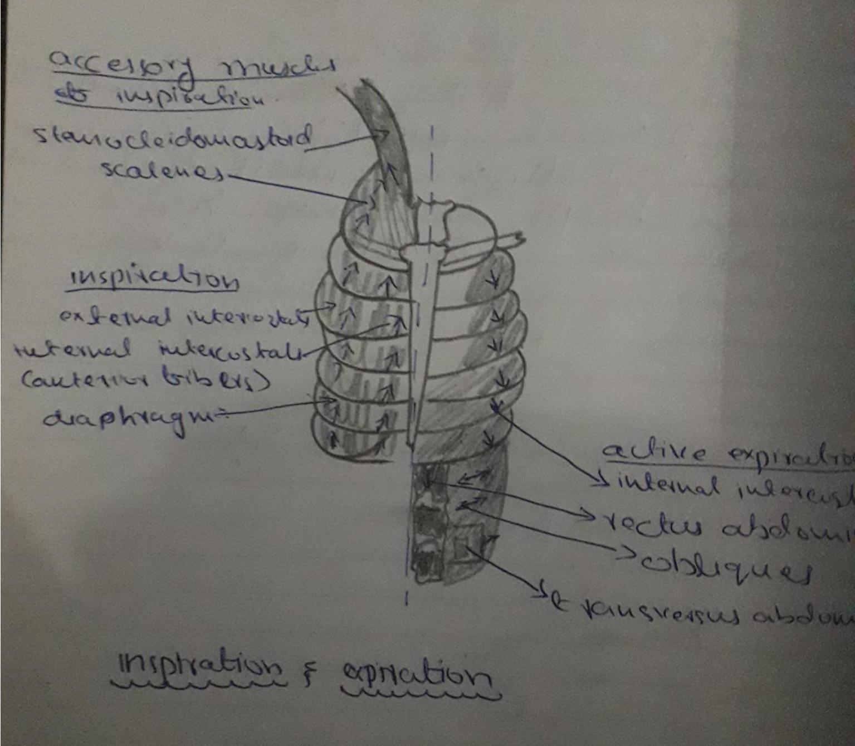
Question no( 4)
Respiratory muscles:
The muscles of inspiration are those muscles that contribute to inhalation and exhalation by aiding in the expansion and contraction of the thoracic cavity . The diaphragm and to a lesser extent the intercostal muscles drive respiration during quiet breathing.
.Factors that effect diffusion of a gases across the membrane:
Thus the factors that determines how rapidly a gas will pass through the membrane are
.the thickness of the membrane
.the surface area of the membrane
.the diffusion coefficient of the gas in the substance of the membrane
.the partial pressure difference of the gas between the two sides of the membrane.
Question no( 1)
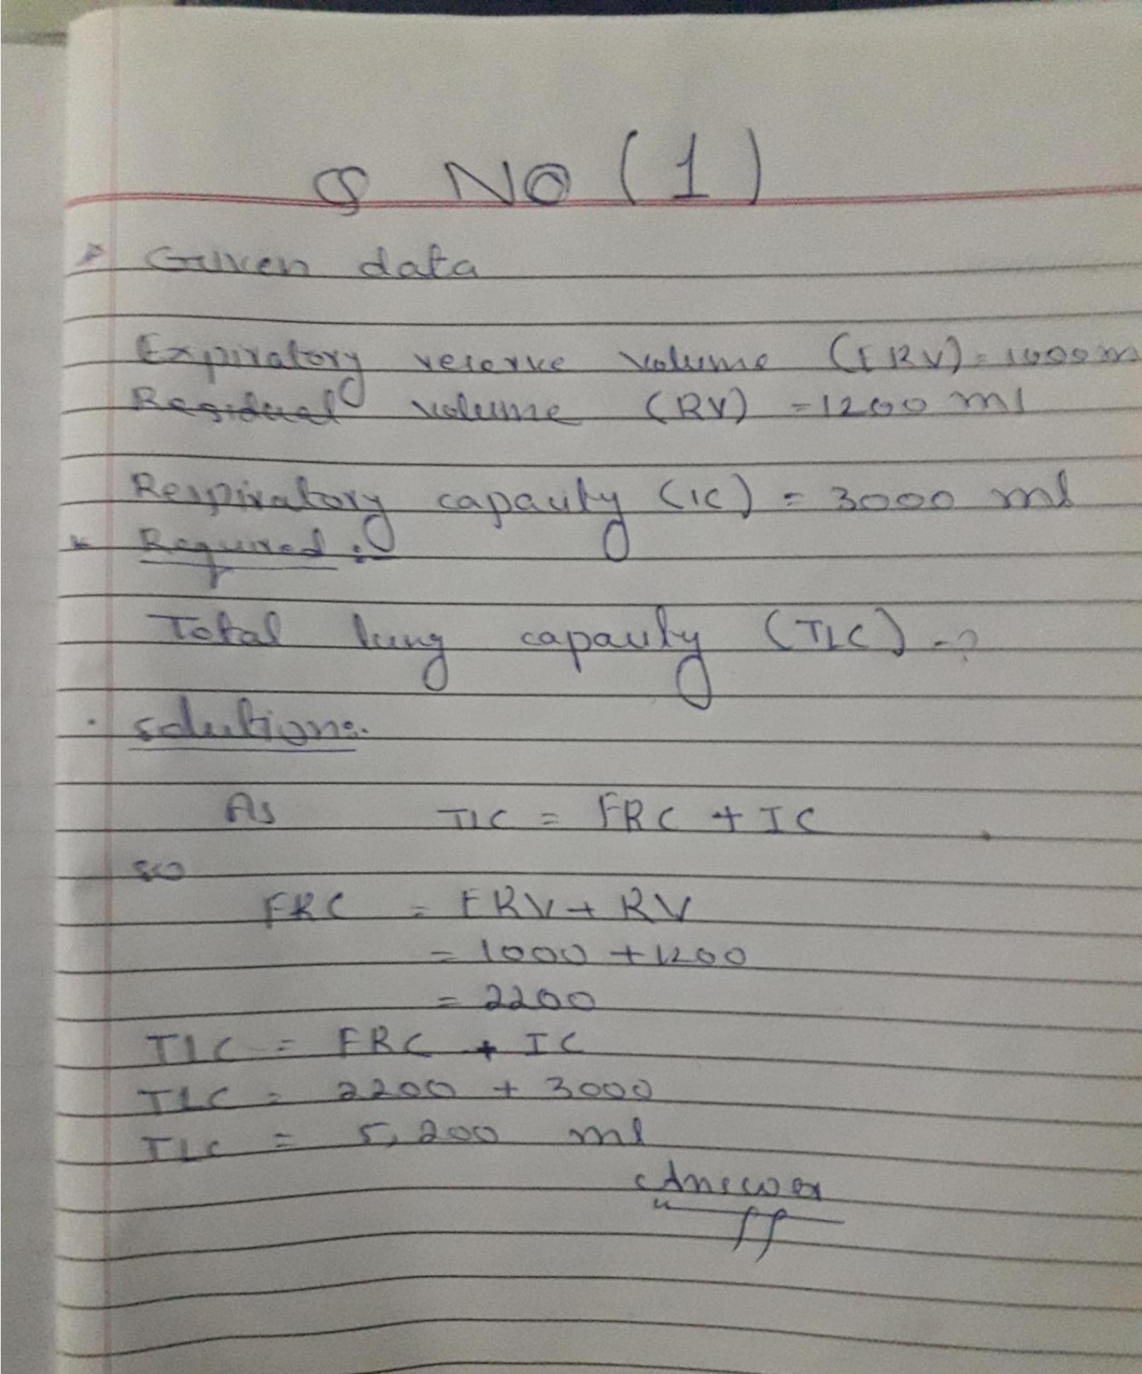
Question no( 3)
Blood Types (Groups)
Blood Type A - If the red blood cell has only "A" molecules on it.
Blood Type B - If the red blood cell has only "B" molecules on it.
Blood Type AB - If the red blood cell has a mixture of both "A" and "B" molecules.
Blood Type O - If the red blood cell has neither "A" or "B" molecule.
ABO Blood Types:
Blood types are determined and named by the existence of two different antigens present on the surface of red blood cells; A antigens and B antigens. These antigens, which can be sugars or proteins, are essentialy markers attached to red blood cell membranes that let the body's immune system know which type of blood is natural to the body and which should be destroyed. For example, someone with A antigens would not be able to receive B antigen blood, as the immune system would attack what it sees as "incompatible" blood. The immune system responds to blood types through the use of antibodies produced by the blood. These antibodies are made to counter antigens of the opposite type - ie: anti-A antibodies attack B antigens and anti-B antibodies attack A antigens. The main blood types are:

Type A: This type contains A antigens and produces anti-B antibodies.

Type B: This type contains B antigens and produces anti-A antibodies.
Universal acceptor:
Type AB: This type contains both A and B antigens. As such, type AB blood will attack neither type A nor type B blood because it accepts both antigens as being natural to the body. This means AB blood is able to accept any type of blood during transfusions, making it a universal acceptor.
Universal donor:
Type O: This type contains no antigens. This means that O blood will not react with antibodies produced by other blood types, making it a universally accepted blood type for transfusions, also called a universal donor.
Question no( 5)
Dead space.
Dead space comprises of those areas of respiratory tract where gases are present but do not take part in gas exchange.
TYPES OF DEAD SPACES
.anstomical dead space
.physiological dead space
=Anatomical dead space
It is the volume of all spaces of respiratory systems besides the gas exchange area.
=Physiological dead space
Sometimes some of the alveoli are nonfunctioal.when alveolar dead space is included in total measurement of dead space this is then called physiological dead space.
.clinical manifestations of pulmonary effusion:
.shortness of breathing
.Dry cough
.pain
.feeling of chest heaviness or tightness
.inability to lie flat
.inability to exercise
.generally feeling unwell

