DPTIV
Biochemistry Final term
Name: Babar Ali ID: 15036
Marks 50
Attempt the following questions each carries equal marks
- Write brief note on steroidhormone?
Steroid Hormones: A steroid Hormones is a steroid that acts as a hormones. Steroid Hormones can be grouped into two classes
Corticosteroids Typically made in the adrenal cortex.
Sex steroid typically made in the gonads or placenta with in those two classes are five types according to the receptor to which they bind Glucocorticoid and mineralocorticoid and androgen, estrogen,and progestogen vitamin D derivative are a sixth closely related Hormones system with homologous receptor. They have some of the characteristics of true steroid as a receptorligands.
Steroid Hormones help control metabolism inflammation, immune, salt and water balance development of sexual characteristics and the ability to withstand illness's and injury. The term steroid describe both hormones produce by the body and artificially produced medication that duplicate the action for the naturally occurring steroid.

Synthesis:
The natural steroid Hormones are generally synthesized from cholesterol in the gonads and adrenal glands. These forms of hormones are lipids they can pass through the cell membrane and as they are fat soluble and then bind to steroid Hormones receptor which may be nuclear or cytosolic depending on the steroid Hormones to bring about changes with in the cell.

Synthetic Steroid and sterols;
A variety of synthetic Steroid and sterols have also been contrived most are steroids but some non Steroidal molecules can interact with the steroid receptor because of a similar of shape. Some synthetic Steroid are weaker or stronger than the natural steroid whose receptor they activate.

Example of steroids hormones;
- Glucocorticoid, alclometasone, Prednisone, dexamethasone , triamcinolone, cortisone
- Mineralocorticoid,fludrocortisone
- VitaminD
- Androgen: oxadrolone, oxabolone, testosterone,nandrolone.
- Oestrogen
- Progestins.

Transport:
Steroid hormones are transported through the blood by being bound to Carrier proteins serum proteins that bind them and increase the hormones solubility in water some example are sex hormones binding globulin andalbumin.
Steroid can effect cells when they do not bound by serum proteins.

What is deamination andtransamination?
Deamination is the removal of an amino group from a molecule. Enzymes that catalyze this reaction are called deaminases . In the human body , deamination takes place primarily in the liver , however it can also occur in thekidney.
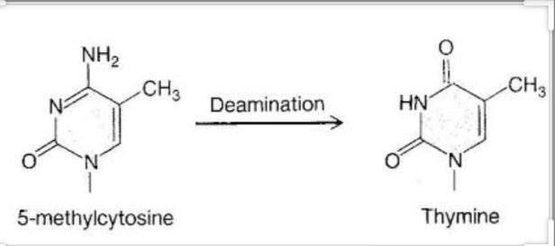

Transamination : a chemical reaction that transfer an amino group to a ketoacid to form new amino acid. This pathway is responsible for the deamination of most amino acids. This is one of the major degradation pathway which convert essential amino acids to non-essential amino acids.
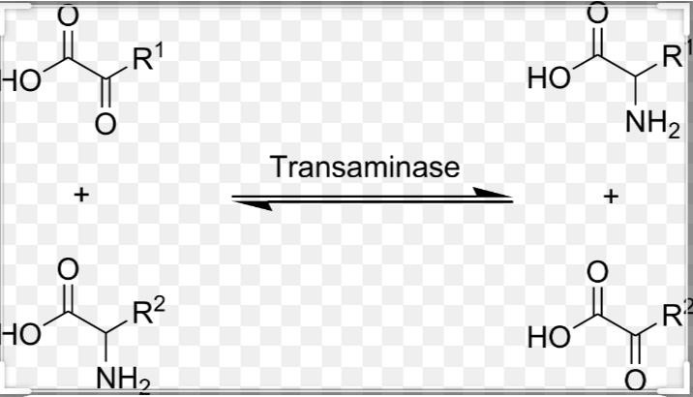

Write down the metabolism ofprotein?
Protein metabolism donates the various biochemical processes responsible for the synthesis of proteins and amino acids(anabolism) and the breakdown of proteins by catabolism.

The steps of the protein synthesis includes
  - Transcription
  - Translation
  - Post translationmechanism
RNA polymerase transcribes a coding region of the DNA in a cell producing a sequence of RNA , specifically messenger RNA (mRNA) . This mRHNA sequence contains codons: 3 nucleotide long segments that code for a specific amino acid. Ribosomes translate the codons to their respective amino acid. In humans non essential amino acids are synthesized from intermediates in major metabolic pathway such as citric acid cycle . Essential amino acids must be consumed and are made in other organisms. The amino acids are joined by peptide bonds making a polypeptide chain . This polypeptide chain then goes through post translation modification and is sometimes joined with other polypeptide chains to form a fully functionalprotein.

Dietary proteins are first broken down to individual amino acids by various enzymes and hydrochloric acid present in the gastrointestinal track . These amino acids are further broken down to a-keto acids which can be recycled in the body for generation of energy and production of glucose or fat or other amino acids. Proteins can be broken down by enzymes known as peptidases or can break down as a result of denaturation protein can denature in environmental conditions the protein is not made for.

Explain briefly translation of DNA ineukaryotes? Translation Of DNA inEukaryotes;
Itis the process in which the protein is synthesized from the information contained in a molecule of messenger RNA (mRNA).

Translation Process;
In a eukaryotic cell, the translation occurs in the cytoplasm. Translation involves three major steps
1. INITIATION 2. ELONGATION 3. TERMINATION

1:INITIATION;

The initiation of translation in eukaryotes is complex, involving at least 10 eukaryotic initiation factors (eIFs) & divided into 4 steps:
- Ribosomaldissociation.
- Formation of 43S preinitiationcomplex.
- Formation of 48S initiationcomplex.
- Formation of 80S initiationcomplex.

a . Ribosomal Dissociation
The 80S ribosome dissociates to form 40S & 60S subunits. Two initiating factors namely elF-3 & elF-1A bind to the newly formed 40S subunit & thereby block its reassociation with 60Ssubunit.

Formation Of 43S PreinitiationComplex
A ternary complex containing met-tRNA′ & elF-2 bound to GTP attaches to 40S ribosomal subunit to form 43S preinitiation complex. The presence of elF-3 & elF-1A stabilizes this complex.

Formation Of 48S InitiationComplex
The binding of mRNA to 43S preinitiation complex results in the formation of 48S initiation complex through the intermediate 43S initiation complex. elF-4F complex is formed by the association of elF-4G, elF-4A with elF-4E. The elF- 4F (referred to as cap binding protein) binds to the cap ofmRNA.
9. Then elF-4A & elF-4B bind to mRNA & reduce its complex structure. This mRNA is then transferred to 43S complex. For the appropriate association of 43S preinitiation complex with mRNA, energy has to be supplied by ATP. The ribosomal initiation complex scans the mRNA for the identification of appropriate initiation codon. 5'-AUG is the initiationcodon.

Formation Of 80S InitiationComplex
48S initiation complex binds to 60S ribosomal subunit to form 80S initiation complex. The binding involves the hydrolysis of GTP (bound to elF- 2). This step is facilitated by the involvement of elF-5. As the 80S complex is formed, the initiation factors bound to 48S initiation complex are released &recycled.

2 . ELONGATION :

Ribosomes elongate the polypeptide chain by a sequential addition of amino acids. The amino acid sequence is determined by the order of the codons in the specific mRNA. Elongation, a cyclic process involving certain elongation factors (EFs). Elongation may be divided into threesteps.
- Binding of Aminoacyl t-RNA toA-site.
- Peptide bondformation.
- Translocation.

Binding of Aminoacyl t-RNA to A-site
The 80S initiation complex contains met tRNA′ in the P- site & A-site is free. Another Aminoacyl-tRNA is placed in the A-site. This requires proper codon recognition on the mRNA & involvement of elongation factor 1a (EF-1a) & supply of energy by GTP. The Aminoacyl-tRNA is placed in the A-site, EF-1a & GDP are recycled to bring anotherAminoacyl-tRNA.

Peptide bondformation

The enzyme Peptidyl transferase catalyzes the formation of peptide bond. The activity of this enzyme lies on 28S RNA of 60S ribosomal subunit. It is therefore the rRNA (and not protein) referred to as ribozyme that catalyzes peptide bond formation. Net result of peptide bond formation is the attachment of the growing peptide chain to the tRNA in theA-site.

Translocation

The ribosome moves to the next codon of the mRNA (towards 3'-end). This process called translocation, involves the movement of growing peptide chain from A-site to P-site. Translocation requires EF-2 & GTP. GTP gets hydrolyzed and supplies energy to move mRNA. EF-2 & GTP complex recycles for translocation. About six amino acids per second are incorporated during the course of elongation of translation in eukaryotes.

3. TERMINATION;
One of the stop or termination signals (UAA, UAG and UGA) terminates the growing polypeptide. When the ribosome encounters a stop codon, - there is no tRNA available to bind to the A site of the ribosome, - instead a release factor binds to it. In eukaryotes, a single release factor- eukaryotic release factor 1 (eRF1)-recognizes all three stop codons, and eRF3 stimulates the termination events. once the release factor binds, the ribosome unit falls apart, - releasing the large and small subunits, - the tRNA carrying the polypeptide is also released, freeing up the polypeptide product. Ribosome recycling occurs in eukaryotes.

Write down clinical significance ofcholesterol?
Significance: Cholesterol , triglycerides and high density lipoproteins are important constituent of the lipid fraction of the human body . cholesterol is an unsaturated alcohol of the steroid family of compounds . It is essential for the normal function of all animal cells and is fundamental element of their cell membranes. It is also a precursor of various critical substances such as adrenal and gonadal steroid hormones and bile acid . Triglycerides are fatty acid esters of glycerol and represent the main lipid computer of dietary fat and fat depots of animals
Cholesterol and triglyceride , being nonpolar lipid substances , need to be transported in the plasma associated with various lipoproteins particles . plasma lipoprotein are separated by hydrated density , electrophoretic of coronary atherosclerosis in persons falling in the 75Th to 90Th percentiles . according to this last statement , cholesterol level bellow 200 mg/dl are classified as “ desirable blood cholesterol ” those 200 to 239 mg/dl as “borderline –high blood cholesterol ” and those 240 mg/dl and above as “ high blood cholesterol”
Mobility size and their relative content of cholesterol , triglycerides and proteins into five major classes:
  - Chylomicrons
  - Very low density lipoproteins(VLDL)
  - Intermediate density lipoproteins(IDL)
  - Low density lipoproteins(LDL)
  - High density lipoproteins(HDL)
Since the levels of plasma lipids have bell shaped distribution in the general population the definition of either a high or a low value of these substances has remained an arbitrary statistical decision. High value have been traditionally considered as those in the 90Th and 95Th percentiles , low values were considered to be those below the 5th percentile . The NIH Consensus Conference has recently revised the value concerning cholesterol , however , in view of clear evidence of an increasedrisk.

