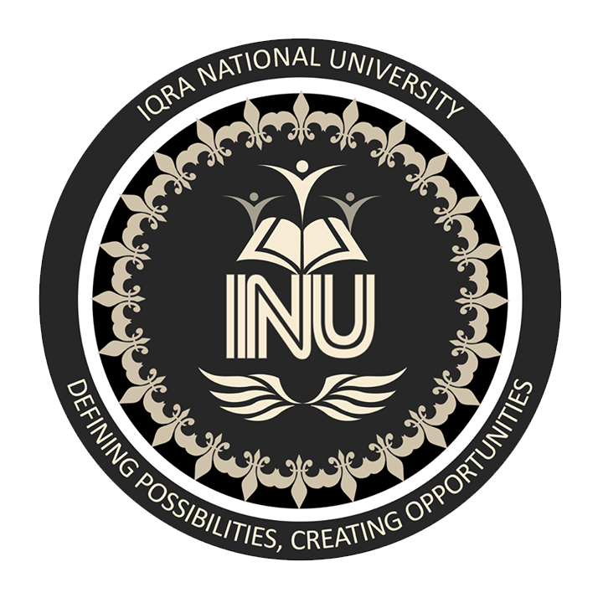

IQRA NATIONAL UNIVERSITY
INSTRACTOR mam benish
NAME zain ullah khan
STUDENT ID 16547
DEPARTMENT BS(CS)
SEMESTER ii
ASSIGNMENT sessional

QNO 1= A critical Analysis of Pakistan’s Foreign policy post 9/11.

ANS

Introduction =>
No country today can think of a life independent of other nations. Every country has to develop relations with other countries so as to meet its requirements in economical, industrial and technological fields. It is this necessary for every country to formulate a sound foreign policy.
Pakistan is an important third country, in its development stage. It also has formulated his foreign policy keeping in mind its geography, politics and economics.

Definition of foreign policy
“Relation between sovereign states. It is a reflection of domestic politics and an interaction among sovereign states. It indicates the principles and preferences on which a country want to establish relations with another country.”

Pakistan foreign policy in light of Quaid-e-Azam’s Words
The father of nation, Quaid-e-Azam defined foreign policy towards other countries of the World in 1948, as follows:
“Our foreign policy is one of friendliness and good-will towards all the nations of the world. We do not cherish aggressive design against any country or nation. We believe in the policy of honesty and fair play in national and international dealings and are prepared to make our utmost contribution to the promotion of peace and prosperity among the nations of the World. Pakistan will never be found lacking in extending its material and moral support to the oppressed and suppressed peoples of the world and in upholding the principles of the UNC (United Nations Charter).”

Basic goals of Pakistan’s Foreign policy
- Maintenance of territorial integrity.
- Maintenance of its political independence.
- Acceleration of social and economic Development.
- Strengthening its place on the globe.
- Keeping cordial and friendly relations with all countries.

Guiding principles of Pakistan’s Foreign policy

Protection of freedom and sovereignty
Pakistan came into being after great sacrifices of millions of Muslims. Like any other country, it also considers with deep regard the need for preservation of its independent and does not allow any country to harm its freedom. Therefore, the principles of protection of independence and sovereignty is the corner stone of Pakistan’s Foreign policy.

Cordial relations with Muslims Countries
Pakistan always tries to establish cordial and friendly relations with Muslims countries. It has always moved its concern against Israel, India and U.S.S.R capturing Palestine, Kashmir and Afghanistan respectively. It has shouldered high responsibilities and used its influence for safeguarding the rights of Muslims. Pakistan is also an active member of Islamic Conference.

Non-Interference in internal Affairs of other countries
Pakistan has sought to establish normal and friendly relations with all countries especially its neighboring countries, on the basic of universally acknowledge the principles of national sovereignty, non use of force, non-interference in the internal affairs of states.

Implementation of U.N charter
Pakistan’s Foreign policy is to act upon UN charter and to support all moves by the UN to implement it. Pakistan has been the member of UN since the year of its birth.

Promotion of World peace
Pakistan policy is to promote peace among nations. It has no aggressive design against any country. Neither does it support any such action. Pakistan has always held that the international disputes should be settled through negotiations rather that non-battlefield.

Non-Alignment
Pakistan follows the policy of non- Alignment i.e to keep away from Alignment with any big power bloc, and avoids taking sides in the cold war. It has also given up its association with SEATO and CENTO and was included in NAM in 1979.

Support for self-determination and Condemnation of Racial Discrimination
Pakistan is a staunch supporter of the right of self-determination and has been in the fore front of efforts to eliminate colonialism and racism. It has advocated the right of self-determination of Kashmir.

Conclusion
The guiding principles of Pakistan’s foreign policy are rooted in the country’s Islamic ideology, its rich cultural heritage and historical experience. As an Islamic and non-aligned country, Pakistan supports Islamic causes and firmly upholds the above-mentioned principles, which hold out the promise of a just and equitable world order in which nations can alive in peace and security.

END OF QUESTION NO 1

Q NO 2= CPEC: prospects and challenges

ANS

China Pakistan Economic corridor (CPEC)
Chinese (巴基斯坦 经济 走廊) is a huge trade project, aimed at supplying oil and gas through the port of Gwadar, railway and motorways from southwestern Pakistan to the northwestern Chinese province of Xinjiang. The economic corridor is considered to be of central importance in Pak-china relations. It is about 2442 KM long from Gwadar to Kashgar. The projects will take several years to complete. The cost is estimated at billions of dollars. The corridor is an extension of China’s Silk Road in the 21st century.

Prospectus of China Pakistan Economic Corridor
During the Chinese President’s visit to Pakistan on April 20, 2015, 51 Memorable of understanding in various fields were signed between china and Pakistan on projects. Major corridor projects that are bilateral cooperation:
Projects | Details
Karachi to Lahore Motorway KLM | Has been approved, work will start in 2015.
70 MW hydro-electric ski shore hydropower | Project has been approved
720 MW Kharot Hydro power | Project has been approved
Zonergy 9x100 MW Solar power project | Approved in Punjab
Gwadar international Airport | Approved
Orange line (Lahore metro) | Approved
Bin Qassim port 2x660 MW Coal power Plant | Approved
Pak-china joint cotton Biotechnology laboratory | Approved
Thar Block 2 2x330 MW coal power plant | Approved
3.8 Mt/a mining project in Thar Block 2 | Approved
Jampur wind power project | Approved
Hubco coal power Plant | Approved
Railway line from Havelian to khanjarab | Approved
Dadu wind power project | Approved
Cross-border fiber Optica data communication Plan Project | Approved
Gwadar-Nawab shah LNG Terminal and pipeline project | Approved
Development of private hydro power projects | Approved
Economic corridor security forces | Complete, Armed Division of the Army deployed to protect Manpower, Cost 250 Million
Gwardar port | Gwadar port was completed, handed over to China for next 40 years from 2015.
Havelian dry port | Feasibility study for Havelian dry port Container port continues.
Iran-Pakistan gas pipeline | It is under construction; Iran has completed its internal part.
Gwadar=Ratodero Motorway | Under construction, approximately 820 KM long, expected to be completed by December 2015.
Hazara Motorway | Under construction.
Karachi-Peshawar central railway line | The feasibility study of Karachi-Peshawar central railway line is underway.
Khanjarab Railway | The feasibility study of Khanjarab Railway is underway.

Map root of CPEC

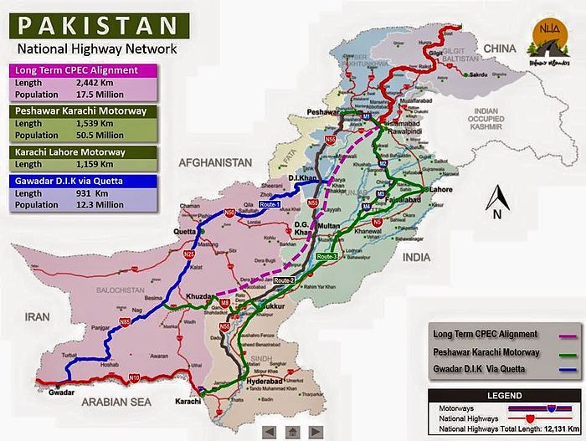

Challenges for CPEC

There are two types of challenges which have to be face the CPEC.

Internal challenges

External challenges

Internal challenges
These are those challenges that emerged from within the country. These problems emerged from time to time and their nature depends upon social, political and economic system of the country.

Social problems
These problems emerged due to social issues such as lack of proper judicial system in society and lack of health facilities and inability of common person to have access to equal education opportunities.

Political problems
The uncertain political system of the country is no doubt is a big challenge in the completion of this mega project. In uncertain political problems and environment, it seems extremely difficult for the project to be completed by due date.

Economic problems
The fluctuated economic system of the country is another major problem. Though the project is financed by china but the practice of corruption is common in the country which makes it difficult for the plan to be completed in due time without facing any financial problems.

External challenges
These are those challenges which emerged from outside of the country. Though there is no threat of their direct involvement in the failure of the project but still they can do so indirectly such as financing terrorist activities, inflaming social riots and so on.

India
There are high chances that India will try to stop this project or at minimum level, create some hurdles in the failure of this project in Pakistan. This is because of friendliness between Pakistan and china. Similarly, to contain any future of Gwadar port of Pakistan, which is one of the important points of CPEC project, India is building a similar port at Chabahar, Iran.

Afghanistan
Though there is no threat to Pakistan and also no problem with Afghanistan because of CPEC but threat is that the land of Afghanistan can be used against Pakistan.
Similarly, the Taliban is taking back control in the Afghanistan and the presence of such terrorist group is a threat for Pakistan because they target general public and such places.

Iran
The only problem that Iran may have with CPEC is its negative influence on its economy and seaports. So far Iran has created no objection against the construction of this project but time will reveal their real response in this regard.

USA
The completion of CPEC and similar projects in this region will further increase the influence of china in this region and this is what which USA do not like and do not want to see.

END OF QUESTION NO 2

