ASSIGNMENT
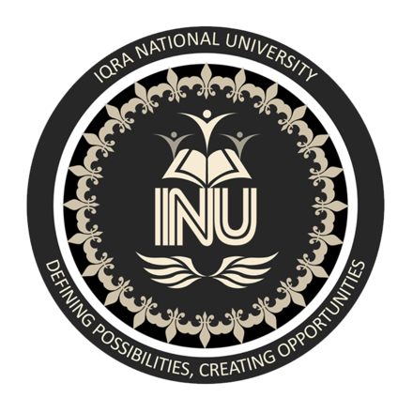

ASSIGNMENT: WRITING ON LIFE OF BIOINFORMATICIAN
SUBJECT: BIOINFORMATICS & PROTEIN STRUCTURE
SUBMITTED TO: MAM BAKHTAWAR
SUBMITTED BY: LATIF UR REHMAN
ID# 13808
SEMESTER: 6th
DATE: 9th July 2020

IQRA NATIONAL UNIVERSITY
- Choose any famous Bio-informatician of your choice in bioinformatics and write about his or her life in about 3 to 4 pages. Make sure it’s well-articulated and contains all necessary information about his life and achievements.
PEER BORK (German Bioinformatician)
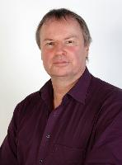
Peer Bork is born on 4 May 1963 in Germany. He is a German bioinformatician and head of structural and computational biology at the European Molecular Biology Laboratory in Heidelberg, in south-west Germany.
Professor Peer Bork is group leader, senior scientist and joint head of the Structural and Computational Biology unit at EMBL, a European research organization with headquarters in Heidelberg where he also serves as strategic head of bioinformatics. In addition, he holds an appointment at the Max-Delbrueck-Center for Molecular Medicine in Berlin.
He received his PhD in Biochemistry 1990 and his Habilitation in theoretical Biophysics 1995. He works in various areas of computational biology and systems analysis with a focus on function prediction, comparative analysis and data integration. He coauthored more than 500 research articles in international, peer-reviewed journals, among them more than 60 in Nature, Science and Cell. He also worked on the micro-biomes of humans and other animals. He is also on the board of editorial reviewers of Science, and is a senior editor of the journal Molecular Systems Biology.
According to ISI (analyzing 10 years spans), Dr. Bork was for many years the most cited European researcher in Molecular Biology and Genetics and is among the top 5 in Biochemistry and Biology. He is (was) on the editorial board of a number of journals including Science and PLoS Biology, and functions as senior editor of the journal Molecular Systems Biology.
Dr. Bork co-founded five successful biotech companies, two of which went public. More than 35 of his former associates now hold professorships or other group leader positions in prominent institutions all over the world. He received the "Nature Award for Creative Mentoring" for his achievements in nurturing and stimulating young scientists. He was also the recipient of the prestigious "Royal Society and Academie des Sciences Microsoft Award" for the advancement of science using computational methods and obtained a competitive "ERC advanced investigator grant".
In 2008 he received the Nature "mid-career achievement" award for science mentoring in Germany. He also received an honorary doctorate from the University of Utrecht in 2017.
RESEARCH
His most cited peer-reviewed papers are on human genome, mouse genome, yeast proteome, and Simple Modular Architecture Research Tool (SMART). He has published on the human gut micro-biome defining basic enterotypes and an interactive Tree of Life.
PRESENT AND PREVIOUS POSITIONS
- Nov. 2011 Strategic head of bioinformatics at EMBL HD, coordinating all bioinformatics activities at EMBL-HD
- July 2001 Head of Structural and Computational Biology Unit, EMBL Heidelberg, Germany (curr. with C. Müller)
- Jun. 1999 Senior scientist , EMBL, Heidelberg
- Jun 1995 Group leader, EMBL, Heidelberg
- May 1992 - May 1995 Visiting scientist, EMBL, Heidelberg
- Jun. 1995 Visiting group leader at the Max-Delbrück-Center for Molecular Medicine, Berlin
- May 1992 - May 1995 Project leader, at the Max-Delbrück-Center for Molecular Medicine, Berlin
- Apr. 1990 - Apr. 1992 Scientist at the Central Institute of Molecular Biology, Dept. of Bioinform., Berlin.

HONOURS AND AWARDS
- 1995 DFG Hess award to build a research group
- 1998 FEBS anniversary prize of the GBM
- 1999 “Dozentenstipendium” of the Fonds of the Chem. Industry
- 2000 Award of the Academy of Sciences Berlin/Brandenburg
- 2000 Elected EMBO member
- 2008 Nature Award for Creative Mentoring (Laudatio by German Research Minister)
- 2009 Royal Society and Academie des Sciences Microsoft Award
- 2011 ERC advanced research grant on human cancerbiome
- 2014 Elected Leopoldina member (German Acad. of Sciences)
- 2014 Honorary professorship, Univ. Würzburg, Germany
- 2014 Dr Tissier’s medal of the Bifidus foundation (Japan)
- 2015 ERC advanced research grant on human microbiome at strain resolution
- 2016 Felix Burda award for colon cancer research
- 2017 Honorary doctorate, Univ. Utrecht (Netherlands)
- 2018 Honorary professorship Fudan Univ. Shanghai (China)
- 2018 Heinz P.R. Seeliger award

