Department of Electrical Engineering
Assignment

Date: 13/04/2020

Course Details

Course Title: | Linear Circuit Analysis | Module: |  | 2
Instructor: |  | Total Marks: |  | 30

Student Details

Name: Muhammad Zubair Student ID: 16597

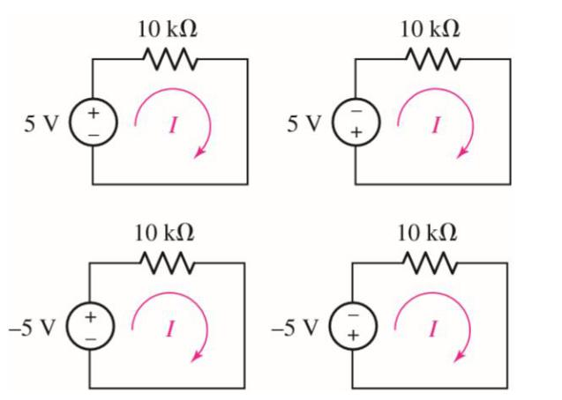
Q1 (a): For each of the circuits in figure, find the current I and compute the power absorbed by the resistor
A B

C D

Solution:
Power in Figure A:
Now power absorbed by the resistor is
P = V² / R = (5)² / 10 * 10³
P = 2.5mWatt
Power in Figure B:
Now power absorbed by the resistor is
P = V² / R = (-5)² / 10 * 10³
P = 2.5mWatt
Power in Figure C:
Now power absorbed by the resistor is
P = V² / R = (-5)² / 10 * 10³
P = 2.5mWatt
Power in Figure D:
Now power absorbed by the resistor is
P = V² / R = (-5)² / 10 * 10³
P = 2.5mWatt

Q1(b): Determine the power supplied by the leftmost element in the circuit of following figure
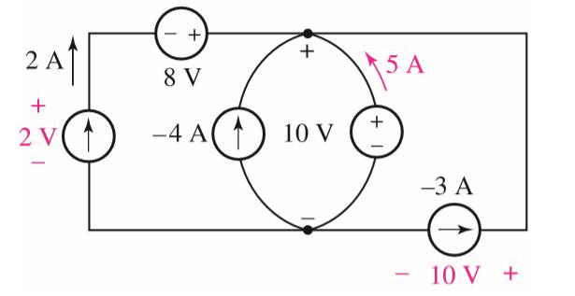

Solution:
We to look to the source which are from left to right and applying power formula
So
As we know that P = VI
Putting values
P = 2 * 2 = 4 Watt
Similarly for each source we done like that
P = 2 * 8 = 16 Watt
P = -4 * 10 = -40 Watt
P= 10 * 5 = 50 Watt
P = 10 * -3 = -30 Watt
Now the sum of all power supplied is expected to Zero .

Q1(c): Following figure depicts the current-voltage characteristic of three different resistive elements. Determine the resistance of each, assuming the voltage and current are deﬁned in accordance with the passive sign convention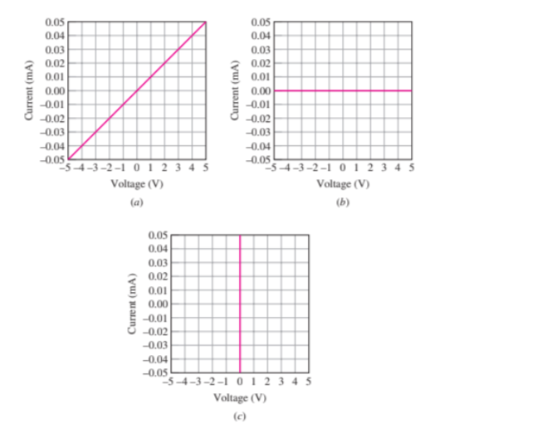
Solution:
- Now taking peak current and voltage rating for finding resistance
So,
According to the coordinate current= I= 0.05mAmp
Voltage = v = 5
As we know that
R = V/I
Putting the values
R = 5 / 0.05 * 10 ⁻³
R = 100 kΩ

(b): similarly for b
According to the coordinate current= I= 0mAmp
Voltage = v = 5
As we know that
R = V/I
Putting the values
R = 0 / 5
R = ∞
(c): similarly for c
According to the coordinate current= I= 0.05mAmp
Voltage = v = 0
As we know that
R = V/I
Putting the values
R = 0.05/ 0
R = 0

Q2(a): Refer to the circuits of following figures, and answer the following:
1. How many distinct nodes are contained in the circuit?
2. How many elements are contained in the circuit?
3. How many branches does the circuit have?
4. Determine if each of the following represents a path, a loop, both, or neither:
i. A to B
ii. B to D to C to E
iii. C to E to D to B to A to C
iv. C to D to B to A to C to E
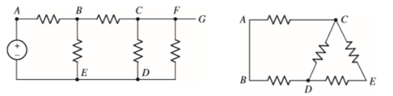
Fig 1 Fig 2

Solution:
1. How many distinct nodes are contained in the circuit?
There are four distinct nodes in and 1 reference node and 4 distinct nodes in Fig 2.
2. How many elements are contained in the circuit?
In Fig 1 there is 6 elements and in Fig 2 there is 5 elements contained.
3.How many branches does the circuit have?
The Fig 1 have 6 branches and Fig 2 have 5 branches.
4. Determine if each of the following represents a path, a loop, both, or neither:
i. A to B
it represents only a node.
ii. B to D to C to E
it represent a path only
iii. C to E to D to B to A to C
both represent path and loop
iv. C to D to B to A to C to E
it represent a loop and a path neither
Q(2)b. For the circuit of following figure (which is a model for the dc operation of a bipolar junction transistor biased in forward active region), I_{B} is measured to be 100 μA. Determine I_{C} and I_{E.}
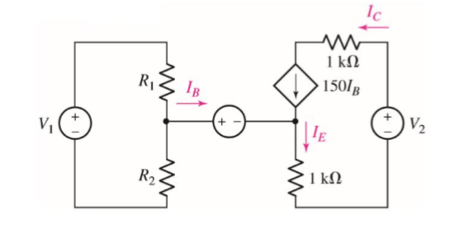
Given Data:
I_{B} = 100µAmp
β = 150
Required :
I_{C} = ?
I_{E.} = ?
Solution:
As we know that
I_{C} = β * I_{B}
Putting the values
I_{C} = 150 * 100 * 10 ⁻⁶
I_{C} = 15000 * 10 ⁻⁶
I_{C} =
I_{C} = 15 mAmp
Now as we know that the total incoming current is equal to the leaving current
So,
I_{E \}= I_{B} + I_{C}
Putting the values
I_{E \}= 100 * 10 ⁻⁶ + 15 * 10 ⁻³
taking common
I_{E} = (0.100 + 15) * 10 ⁻³
I_{E} = 15.1 mAmp

Q3(a): Although drawn so that it may not appear obvious at ﬁrst glance, the circuit of following figure is in fact a single-node-pair circuit. a. Determine the power absorbed by each resistor. b. Determine the power supplied by each current source. c. Show that the sum of the absorbed power calculated in (a) is equal to the sum of the supplied power calculated.
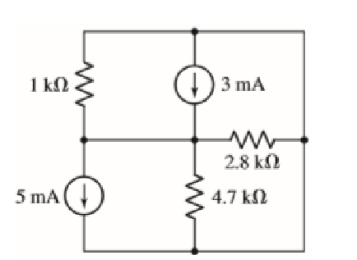

Solution:
Define the center node as +v; the other node is then the reference terminal.
KCL yields 3 * 10 ⁻³ – 5* 10 ⁻³ = v/ 1000 + v/ 4700 + v/ 2800
It will give a voltage of v = -1.274volts
- : power absorbed by 1K Ω resistor is
P = v² / R
P = (-1.274)² / 1000
P = 1.623 mW
- : power absorbed by 4.7K Ω resistor is
P = v² / R
P = (-1.274)² / 4700
P = 345.3µW
- : power absorbed by 2.8K Ω resistor is
P = v² / R
P = (-1.274)² / 2,8
P = 579.7µW
(b): power supplied by 3mAmp source:
P= VI
P = -1.274 * 3mAmp
P = - 3.833mW
power supplied by 5mAmp source:
P= VI
P = -1.274 * - 5mAmp
P = 6.370mW
(c ) sum of power supplied and power absorbed
∑A_{bsorbed} = 2.548 mW
∑P _{supplied} = 2.548 mW
Thus ∑A_{bsorbed} = ∑P _{supplied}
Q 3(b): Determine the power absorbed by the 15Ω resistor in the circuit of following figure
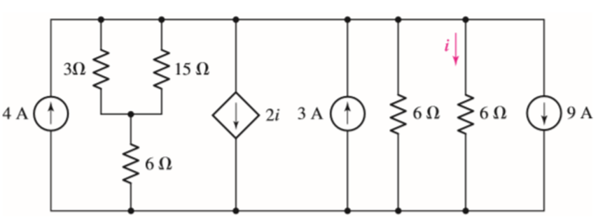
Solution :
We combine the left-hand set of resistors
Here 3 and 6Ω resistors are in series and 15Ω are in parallel
So 6+3//15
It will get
Total resistance at left side 9 // 15 = 8.5Ω
The independent sources may be combined into a single 4 + 3 – 9 = -2 A source (arrow pointing up). We leave the 6 Ω resistors; at least one has to remain as it controls the dependent source. A voltage v is defined across the simplified circuit, with the + terminal at the top node.
Applying KCL to the top node,
-2 – 2i = v/8.5 + v/6 + v/6 …………………………[1]
where i = v/6. Thus, Eq. [1] becomes -2 – 2v/6 = v/8.5 + 2v/6 or v = -19 V
. We have lost the 15 Ω resistor temporarily, however. Fortunately, the voltage we just found appears across the original resistor combination
we replaced. Hence, a current - 19/8.5 = -2.235 A flows downward through the combination. Hence, the voltage across the 3 Ω || 15 Ω combination i
so v – 6(-2.235) = -5.59 V
Thus, P15Ω = (-5.59)2/15 = 2.083 W

