Assignmentfor Viva

Course Title: Biomechanics And Ergonomics I
DPT 2nd semester section B
Instructor: Dr.M .Shahzeb khan (PT)
Name: Muhammad Abbas. ID #: 16805
Marks: 100

Note:
VIVA MARKS WILL BE GIVEN ON BASIS OF THIS ASSIGNMENT

Q1:(A) Draw a diagram of flexion, Extension, adduction, abduction, internal and external rotation on shoulder joint. 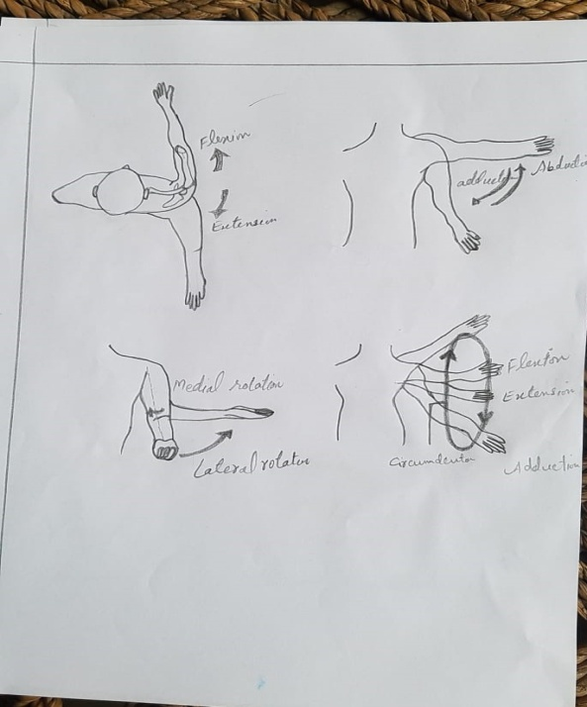

(B) Draw diagram of flexion, extension, supination and pronation on elbow joint
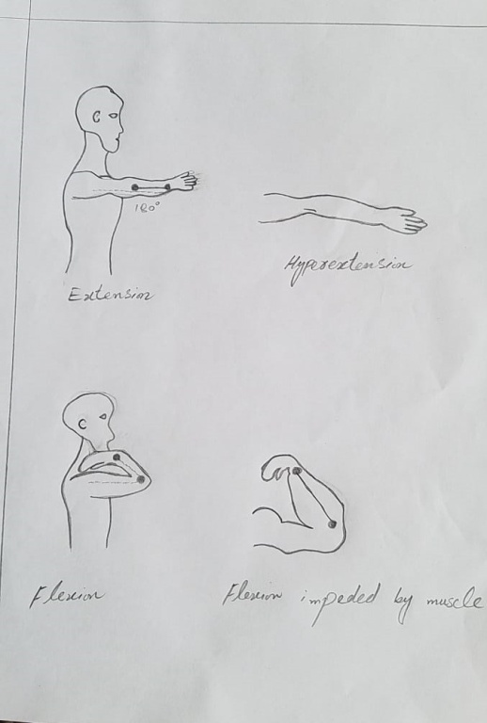

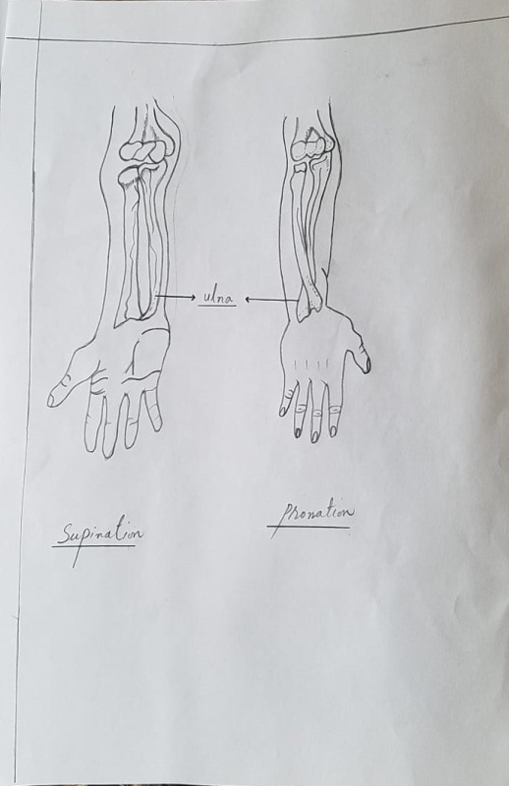

(C) Draw diagram of Flexion, extension, radial and ulnar deviation on wrist joint

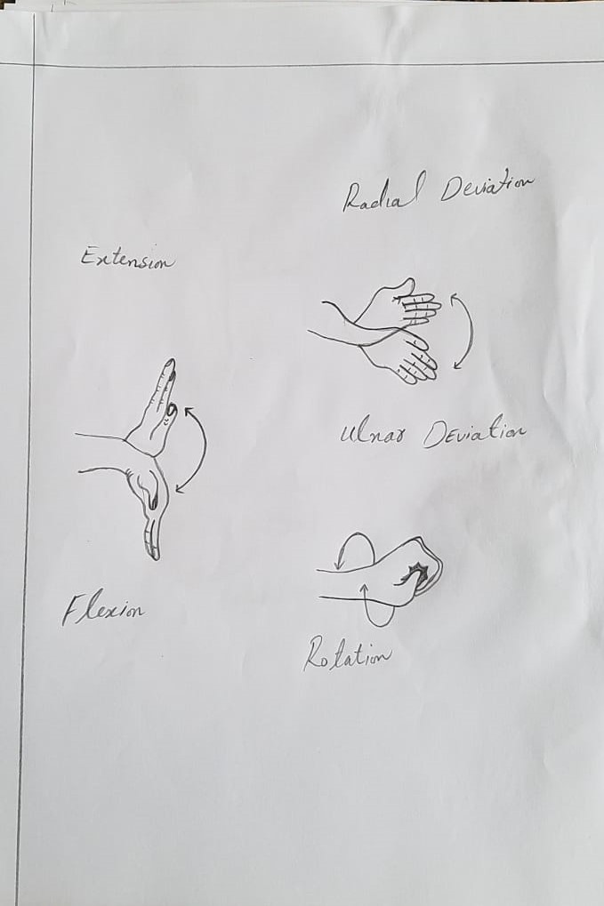

ALL THE STUDENTS ARE REQUESTED TO UPLOAD YOUR ASSINGMENT BEFORE SATURDAY (11-07-2020).

