name | Altaf hussain
I.D | 16630
Class and semister | Bs SE-2(SEC B)
ASSIGNMENT SUBMMITED | AYUB KHAN SIR
DATE | 29/05/2020

What is tic-tac-toe game?

Tic tac teo(American English),noughts and crosses(British English),xs and os is a papper and pencil game for two players,x and o,who take turns marking the spaces in a 3 mutiply 3 grid. the player who succeeds in placing 3 of their marks in a horizontal,vertical,or diagonal row in the winner.

Programe
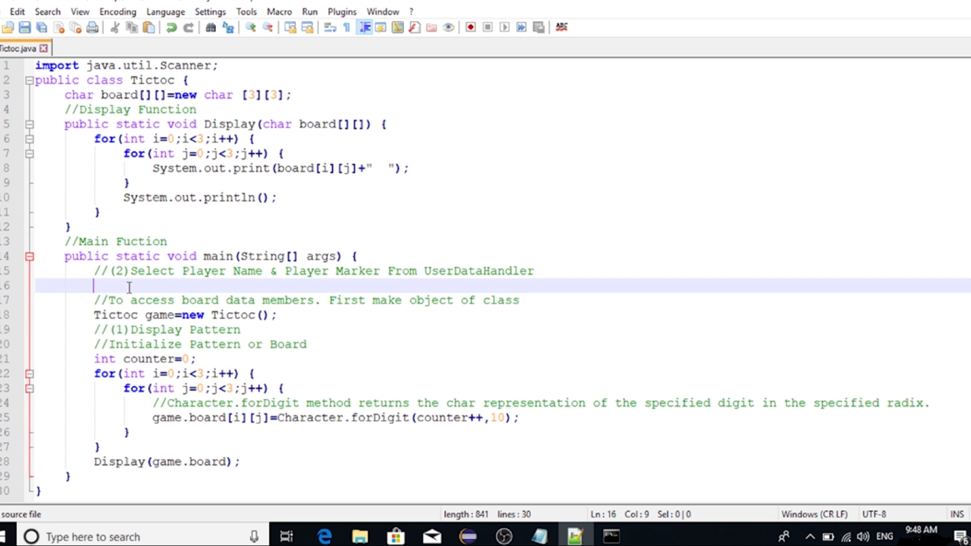
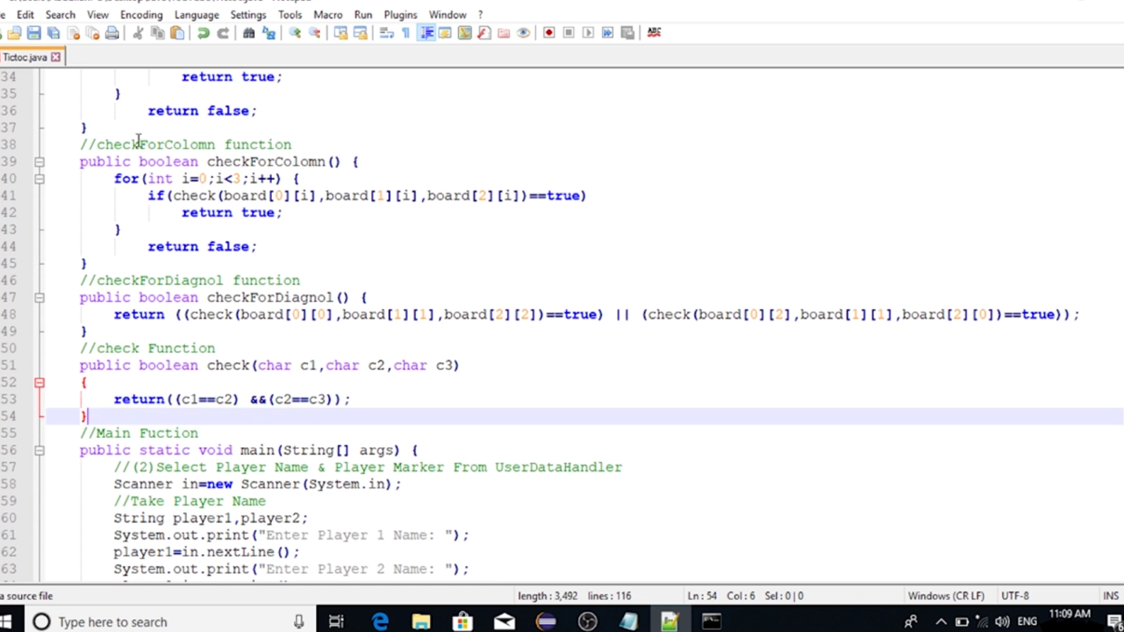

output

