DEPARTMENT:Bs Anesthesia
AASSIGnment: 1
SUBMITTED TO: Dr Arooba sajad
SUBMITTED BY: Muhammad Komail
ID: 1818O
SECTION: B
SEMISTER:1
Topic
---------
Upper limbs joints
Definition:
The upper limb has a wide range of precise movement associated with it to allow us to effectively interact with our environment.
Shoulder joint:
The shoulder joint (glenohumeral joint) is a ball and socket joint between the scapula and humerus.
It is the major joint connecting the upper limb to the trunk .
It is one of themost mobile joints in the human body , at the cost ofjoint stability . in this article,we shall look at the anotmy of the shoulder joint and its important clinical correlation.
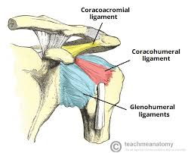
Shoulder joint Diagram

Capsule:
The joint capsule is a fibrous sheath which encloses the structuers of the joint. It extends from the anotmical nick of the humerus to the border or ‘rim’ of the glenoid fossa. The joint capsule is lax , premitting greater mobility (particulatory abduction)
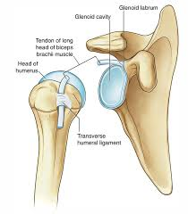
Diagram
Ligaments:
A jointis a watertight sac that sorrounds a joint. In the shoulder, the joint capsule is formed by a group of ligaments that connect the humerus to the glenoid. These ligaments are the main source of stability for the shoulder.they are the superior,middle and inferior glenohumeral ligaments.they help hold the shoulder in place and keep it from dislocating.

Elbow joints:
Articulation:
This occurs between the trochlea and capitellium of the humerus and the trochlera notch of the ulna and the head of the radius.
The articular surfaces are covered with hyaline cartilage.

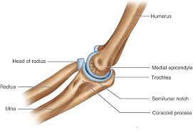DIAGRAM
Capsule:
the joint capsule is a fluid filled sac that sorrounds and lubricates the joint. The important ligaments of the elbow are the medial collateral ligaments (on the inside of the elbow )and the lateral collateral ligament (on the outside of the elbow.)
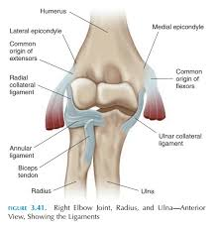DIAGRAM

LIGAMENTS :
Medial collateral ligament: located on the inside of the elbow this ligament connects the ulna to the humerus. Medial collateral ligament also called ulner-collateral ligaments.
The medial ligaments is also triangular and consists principally of three syrong bands;
The anterior band,which passes from the medial epicondyle of the humerus to the medial margin of the coronoid process;
The posterior band,which passses from the medial epicondyle of the humerus to the medialside of the olecranon process.
The transverseband,which passes between the ulnar attachments of the two preceding bands.

Lateral collateral ligaments: located on the outside of the elbow this ligament connects the radius to the humerus.lateral collateral ligaments also called the radial collateral ligament.
The lateral collateral ligaments is triangular and is attached :
By its appex the lateral epicondyle of the humerus.
By its base of the upper margin of the anular ligaments.

WRIST JOINT(RADIOCARPAL JOINT):
ARTICULATION:
Aove:the distal end of the radius and the articular disc.
Below: the scaphoid, lunate, and triquetral bones.
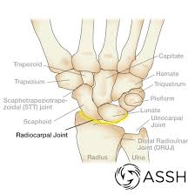

DIAGRAM
Capsule:the capsule encloses the joint and I attached:
Above:To the distal end of the radius and ulna
Below:To the proximal row of carpal bones
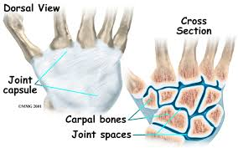
DIAGRAM

LIGAMENTS:
Radial and ulnar collateral ligaments-a pair of ligaments which bind the bones of the wrist and provide stability . volar radiocarpal ligaments- a complex web of ligaments that support the palm side of the wrist . dorsal radiocarpal ligaments-ligaments that support the back of the wrist

The medial ligament:
Origin: ulnar styloid process
Insertion:Triquetrum dorsally and and pisiform palmary
Provide medial stability

The lateral ligaments:
Origin: Styloid process of the radius
Insertion:scaphoid and trapezium
Provide lateral stability

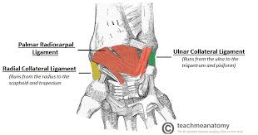
DIAGRAM

THE END--------

