Name: Ijaz Ulhaq
ID :14558
Programme: BS(MLT) 4th semester
Subject: Molecular Biology
Instructor: Sir Fazli Zahir
Question No 1
Fill in the blanks..
(1) James watson and Francis Crick discovered the double helical structure of the DNA molecule.
(2)Watson and Crick were awarded Nobel Prize in 1962.
(3 Nucleic Acids store, transmit, and help express hereditary information.
(4)The amino acid sequence of a polypeptide is programmed by a unit of inheritance called a Gene.
(5)Hundreds of Y-shaped regions of replicating DNA molecules where new strands are growing called Replication Forks.
(6) Topoisomerase are enzyme which relieves stress on the DNA molecule by allowing free rotation around a single strand.
(7) Genetic Code is a dictionary that corresponds with sequence of nucleotides and sequence of amino acids.
(8) Amino acylation/Charging is the process of covalently attaching an amino acid to the tRNA.
(9) Single Strand binding protein are proteins which attach and help keep the separated strands apart.
Question No 2
Write short notes on the following?
- Common tools of molecular biology?
Ans:- Common tools are as follow.
- Molecular Cloning
- Polymerase chain reaction
- Macromolecule blotting and probing
- DNA sequencing
- Enzymes microarray
- Allele specific oligonucleotide
- Electrophoretic separation of nucleic acid detection of genes

- Nucleic Acids
Ans:- Nucleic acids are classified molecules that are found in all living organisms. Responsible for storing genetic information and also responsible for protein synthesis. Nucleic acids are made up of monomers called nucleotide.

- Chargaff’s Rule
Ans:- Chargaff’s rule states that adenine must pair with thymine and guanine must pair with cytosine. Chargaff’s rule also says that the amount of nitrogenous bases given in a DNA molecule is about the same.

- Wobble Hypothesis
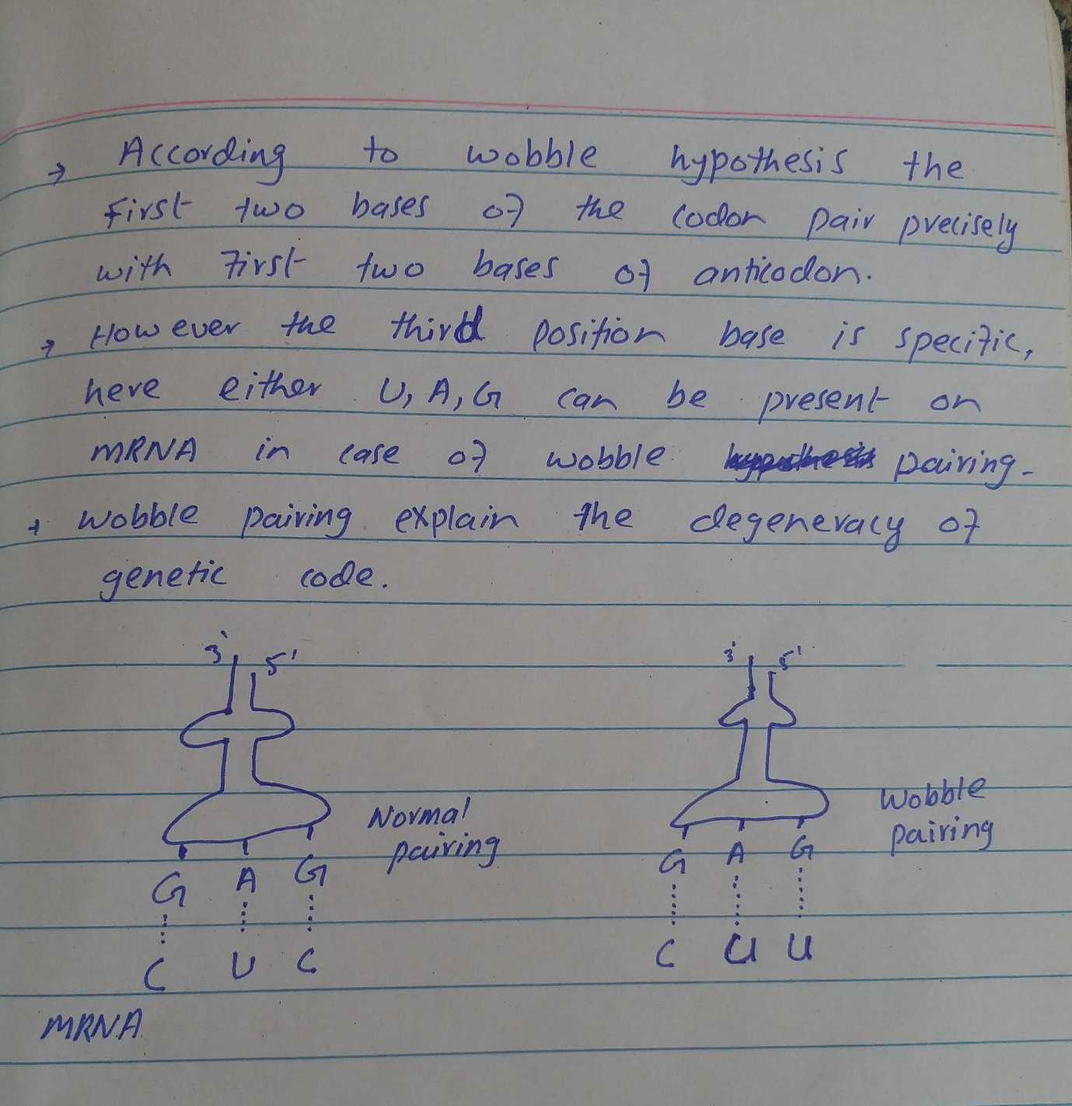
Ans:-

- Names of main steps in translation and transcription ?
Ans:- Translation includes
- Initiation
- Elongation
- Termination
- post- translation processing of the protein
Transcription includes
- Initiation
- Elongation
- Termination
- Processing

Question No 3
Explain the process of DNA Replication?
Ans:- DNA replication means self synthesis of DNA molecule. DNA replication completes in three phases.
- Initiation phase( formation of replication bubbles and replication forks)
• Origin of replication:- The point or place where in DNA where replication occur. Origin of replication is one in eukaryotes and more than one in prokaryotes.
• DNA Gyrase:-(Topoisomerase) It opens the turns of DNA from spiral ladder to straight ladder and makes replication bubbles.
• Replication Forks:- Both ends or corner of replication bubbles are called replication forks.
• DNA helicase:- Break down hydrogen bond due to which nitrogenous bases expose from each other.
• DNA polymerase:- It makes template strands of DNA.
• Single strand binding protein:- It is a kind of protein which prevent the reunion of the two strands of DNA replication.
- Extension ( polymerization phase)
Formation of new strand along the template strands by the
help of DNA polymerase.
• DNA polymerase l :- Termination phase of replication.
• DNA polymerase ll :- Repairing process of DNA damage during life time.
• DNA polymerase lll :- Main enzyme that synthesize new strand.
• Leading Strand :- The strand which is synthesize towards the replication fork and continuously formed.
• Lagging Strand:- The strand which is synthesize away from the replication fork. It is discontinuous in the form of small fragment which is called okazaki fragment.
• Proofreading:- If DNA polymerase makes a mistake in nitrogenous bases so then the mistake will be corrected by proofreading by placing the correct nitrogenous base.
- Termination phase
DNA polymerase l has an important role in termination phase.
• Replacement of primers by nucleotide :- It breaks the bond between primers and new chain and segment will separate from each other.
• DNA ligase :- It will join the separated segment and the at the end two strands of DNA are made.

