Iqra National University
Department of DPT
Paper Physiology 2
Submitted by Marwa zeb ( 15335)
Submitted to Mam Sara Naeem

Q1) .Explain the formation of T3 and T4 of thyroid gland.

Ans: FORMATION OF TE AND T4 OF THYRIOD GLAND :

STEPS :

1.Iodine trapping :
It is transported from blood through the basal membrane of thyroid cell by iodide pump , this is called iodide trapping . Thyroid stimulating hormone effects the rate of iodide trapping .

2.Oxidation of iodide ion :
The conversion of iodide ion to an oxidized form of iodine with the help of enzyme hydrogen peroxides . When the peroxides system is blocked or when it is hereditarily absent from the cells , the rate of formation of thyroid hormones falls to zero .

3.Organification :
The bonding of iodine with the thyroglobulin molecule is called , Organification . The major product is thyroxin and triiodothyronine .

4.Storage :
After synthesis , each thyroglobulin molecule contains up to 30 thyroxine molecule and a few triiodothyronine molecule in the follicle .
The amount stored sufficient to support to supply the body with its normal requirements of thyroid hormones for 2 to 3 months . Therefore, when synthesis of thyroid hormones ceases , the physiological effects of deficiency are not observed for several months .

5.Release of T4 and T3 from the thyroid gland :
T4 and T3 are first cleaved from the thyroglobulin molecule , then released as free hormones .
Pinocytic vesicles that enter the thyroid cell . Then lysosomes in the cell cytoplasm fuse with these vesicles to form digestive vesicles .

6.Proteases:
It digest the thyroglobulin molecule and release thyroxine and triiodothyronine . These then diffuse through the base of the thyroid cell into the surrounding capillaries . Thus, the thyroid hormone are released into the blood .
Monoiodothyronine and diiodothyronine during digestion are freed from thyroglobulin but are not secreted into the blood .

Iodine is cleaved from then by a deiodinase enzyme . This iodine available again for recycling within the gland for forming additional thyroid hormones .
In the congenital absence of this deiodinase enzymes , many person become iodine – deficient because of failure of thus recycling process .

7.Daily rate of secretion of T3 and T4 :
Thyroxine 93% and triiodothyronine 7% is released . One half of the thyroxine is slowly deiodinated to form additional triiodothyronine . Triiodothyronine is mainly delivered to and used by tissues .

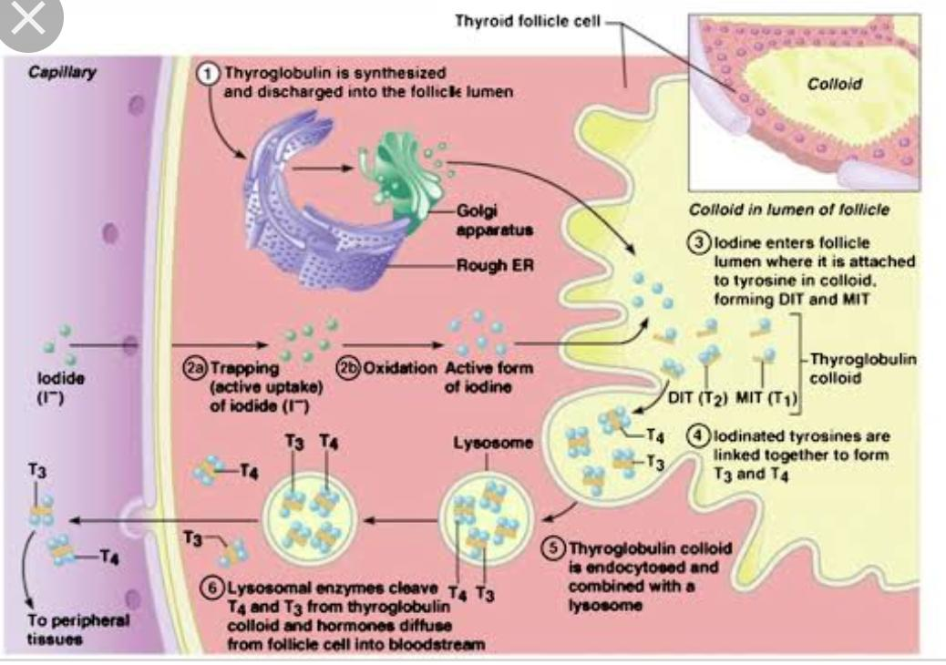
__________________________________________________
Q2) what are the role of anterior pituitary hormones in your body?

The anterior pituitary gland is controlled by releasing and inhibitory hormones secreted into the hypophyseal portal circulation. These hormones reach the anterior pituitary directly through his portal circulation with out entering the general circulation. Under control of these factors specific secretary cell type of the anterior pituitary secrets six major tropic hormones ( TSH, ACTH, FSH, LH, prolactin, and GH. Which act on distal endocrine glands. Tropic hormones are the target gland hormones have feedback effects on these endocrine systems designed to regulate blood level of the target gland hormone.
ACTH :adrenocorticotropic hormone
FSF: follicle stimulating hormone
GH : Growth hormone
IGF : insulin like growth factors
LH: luteinizing hormones
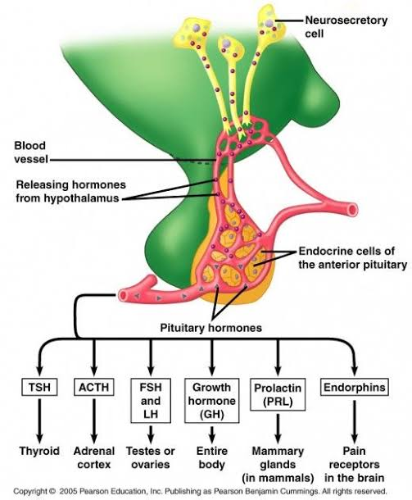
TSH : thyroid stimulating hormone

Adrenocorticotropic hormone
Adrenocorticotropic hormone (ACTH) or corticotrophin is produced by cell called corticotrophin it stimulate the development of the adrenal gland and their synthesis of various steroid hormones ACTH secretion is stimulated by a hypothalamic releasing hormone known as corticotrophin releasing hormone CRS.
Functions
1. It stimulate adrenal cortex to secrete glucocorticoid and androgen .
2. It stimulate the growth of adrenal cortex .

Follicle stimulating hormone
In females the ovaries are the targets for follicle stimulating hormone (FSH). Each month FSH initiates the development of several ovaries follicles, saclike arrangement of secretary cells that surround a developing egg (oocytes) FSH also stimulates follicular cell to secrete estrogens (female sex hormones). In males FSH stimulates sperm production in the testes. Gonadotropin releasing hormone (GnRH) from the hypothalamus stimulate FSH release. Release of GnRH and FSH is suppressed by estrogen in females and by testosterone in males through negative feedback system. There is no gonadotropin_inhibining hormone.
FUNCTION
1. In female it stimulate follicle cells in the ovary of female . These follicles become mature called graafian follicles .
2. It stimulates graafian follicles to secretes female sex hormone called Estrogen .
3. In male follicle stimulating hormone stimulates the development of the germinal epithelium of the testis and sperm production .

GROWTH HORMONE : ( Somatotropin )
Secretion : Growth hormone is releasing factor is secreted from hypothalamus throughout life which stimulated the synthesis and releasing of growth hormones from the anterior lobe of pituitary gland .
FUNCTION :
1.Growth hormone has a direct effect on growth and development of all body parts .
2. It stimulates and control growth of the body and skeleton during childhood and adolescence .
3. When growth has mostly ceased after adolescence the growth hormone continue to promote protein synthesis throughout the body by stimulate the uptake of amino acid into cell .

Insulin like growth factors :
Insulin like growth factor formerly called Somatomedin , any of several peptide hormones that function primarily to stimulate growth but also possess some ability to decrease blood glucose level.
FUNCTION :
1. It function as a major mediator of growth hormone stimulated somatic growth .
2. As well as mediator of growth hormone independent anabolic responses in many cells and tissues .

Luteinizing hormone
In females luteinizing hormones (LH) triggers ovulation the release of a secondary oocyte by an ovary. LH stimulates formation of the corpus luteum (structure formed after ovulation) in the ovary and the secretion of progesterone by the corpus luteum Together, FSH and LH also stimulate secreting of estrogen by ovarian cells. Estrogen and progesterone prepare the uterus for implantation of a fertilized ovum and help prepare the mammary glands for milk secretion. In males LH stimulates cells in the testes to secret testosterone secretion of LH, like that of FSH is controlled by gonadotropin_releasing hormone (GnRH).
FUCTION
1. It is responsible for development of egg in the ovaries .
2. It also control menstrual cycle .
3. It is also responsible for the formation of corpus luteum which then secretes progesteron hormone .
4. In male luteinizing hormone is also called intestinal cell stimulating hormone which stimulate interstitial cells in the testis of male to secrete male sex hormone called testosterone.

Thyroid stimulating hormone
Thyroid stimulating hormone (TSH) stimulates the synthesis and secretion of the two thyroid hormones, triiodothyronine (T3) and thyroxine (T4) both produced by the thyroid gland. Thyrotropin releasing hormone (TRH) from the hypothalamus controls TSH secretion. Release of TRH in turn depends on blood levels of T3 and T4. High levels of T3 and T4 inhibit secretion of TRH via negative feedback. There is no Thyrotropin inhibiting hormone.
FUNCTION
1. It control the development and functioning if thyroid gland .
2. Thyroid stimulating hormone also stimulates the thyroid gland to secrete thyroxine hormone .
3. Low level of thyroxine stimulates the secretion of thyroid stimulating hormone by negative feed back mechanism.
___________________________________________________________________________

Q3) Explain homeostatic mechanism regarding the control of calcium in the body with reference to parathyroid hormone and calcitonin.?

Three hormones are primarily concerned with the regulation of calcium and phosphate metabolism.
Parathyroid hormone (PTH)
Calcitonin
1,25-Dihydroxy-cholecalciferol (Vit.D )
Parathyroid gland Located in upper and lower pole of posterior surface of thyroid gland
Main site of action of PTH
Bone
Kidney
GIT
Functions of PTH
It increases the blood calcium level by
Reabsorption of ca++ and Phosphate from bone.
Reabsorption of ca+ and phosphate from intestine (via Vit.D).
Decreases excretion of calcium from kidney
Reabsorption of ca++ from bone occurs in two phases
Rapid phases (Osteolysis )
PTH activate the calcium pump which is located in osteocytic membrane system.
This ca++ pump calcium from bone fluid to ECF
Slow phases
PTH cause activation of osteoclast ( Already formed or New synthesis ).
Osteoclasts reabsorb boney matrix and release Calcium phosphate
Calcitonin:-
Calcitonin, a peptide hormone.
Secreted by Parafollicular cell of thyroid gland.
The primary stimulus for calcitonin secretion is increased plasma calcium ion concentration.
Function of Calcitonin:-Main function of Calcitonin is to decrease blood calcium level
Functions of calcitonin is opposite to PTH.
Bone
Decrease the absorptive activities of the osteoclasts.
Decrease the formation of new osteoclasts.
Calcitonin also has minor effects on calcium handling in the kidney tubules and the intestines.
Calcitonin Has a Weak Effect on Plasma Calcium Concentration in the Adult Human as function of calcitonin is overridden by PTH.
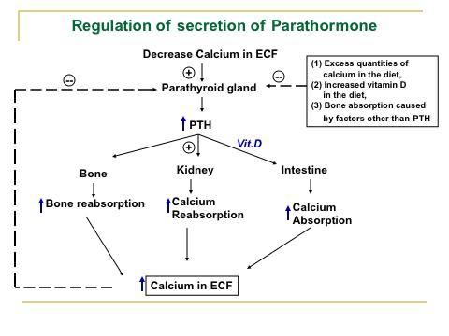
Calcium homeostasis refers to the maintenance of a constant concentration of calcium ions in the extracellular fluid. It includes all of the processes that contribute to maintaining calcium at its “set point.” Because plasma [Ca2+] rapidly equilibrates with the extracellular fluid, ECF [Ca2+] is kept constant by keeping the plasma [Ca2+] constant. Maintaining a constant plasma [Ca2+] is important for:
Nerve transmission
Nerve conduction
Muscle contraction
Cardiac contractility
Blood clotting
Bone formation
Excitation–secretion coupling
Cell-to-cell adhesion
Cell-to-cell communication.
Some of these (bone formation, blood clotting, and cell adhesion) depend directly on the extracellular [Ca2+]; others depend directly on intracellular [Ca2+]. But since ICF [Ca2+] depends indirectly on plasma [Ca2+], all are linked to plasma [Ca2+]. Calcium homeostasis can be viewed as having two components: a microcomponent dealing with the intracellular environment and a macrocomponent dealing with the extracellular environment.

